Q1\
SMART TV | Samsung JS9000  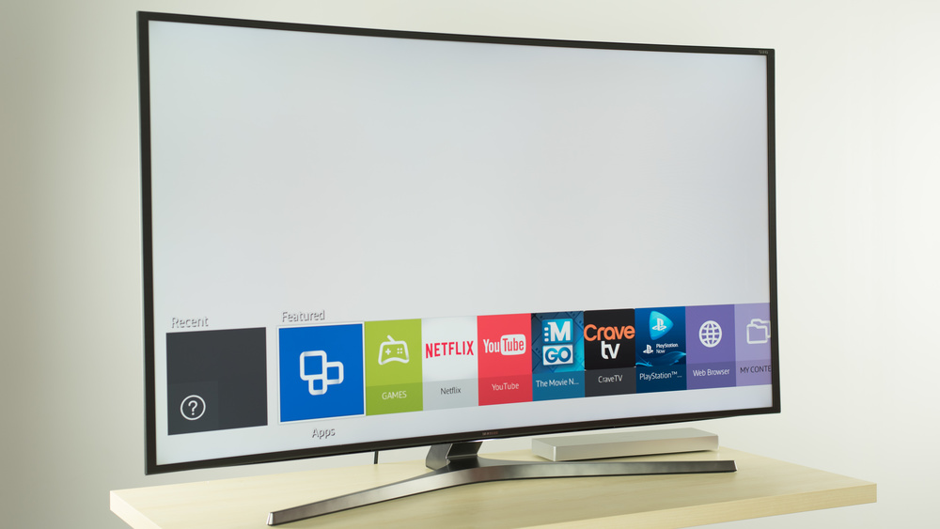 | Sony X930C  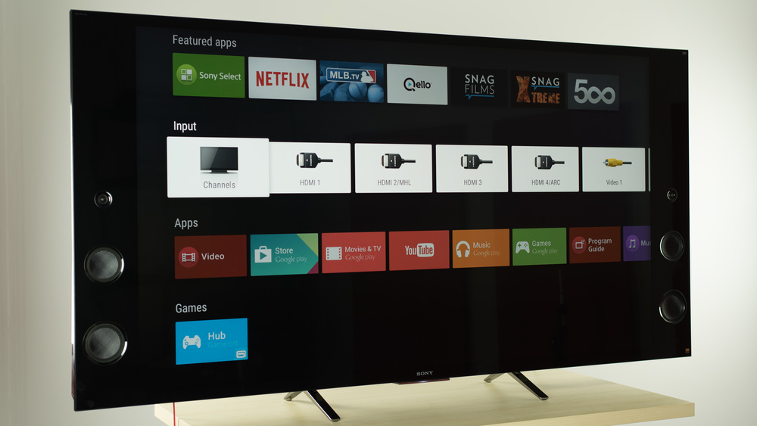
Graphical | 480p  720p  1080p  4k | 480p  720p  1080p  4k
Sound | The loudness and low-end cut off are very good for a TV, but the frequency response is poor. There seems to be pumping present at higher volumes. | The bass extension and the loudness are excellent. The frequency response is also good and remains relatively constant even under load. This is the best sounding TV we have tested.
Software | Smart OS: Tizen | Smart OS: Android
Design | The Samsung JS9000 is pretty eye-catching, thanks to its curved screen and gray back, and its stand is nice and stable. The bezel is not the thinnest, though. | The Sony X930C is very wide, due to its front facing speakers on both sides of the TV. It is thicker at the bottom than at the top.  The stand can be set to two positions. The wider one offers a bit more stability, but the narrow setting is good for smaller surfaces.
photo | 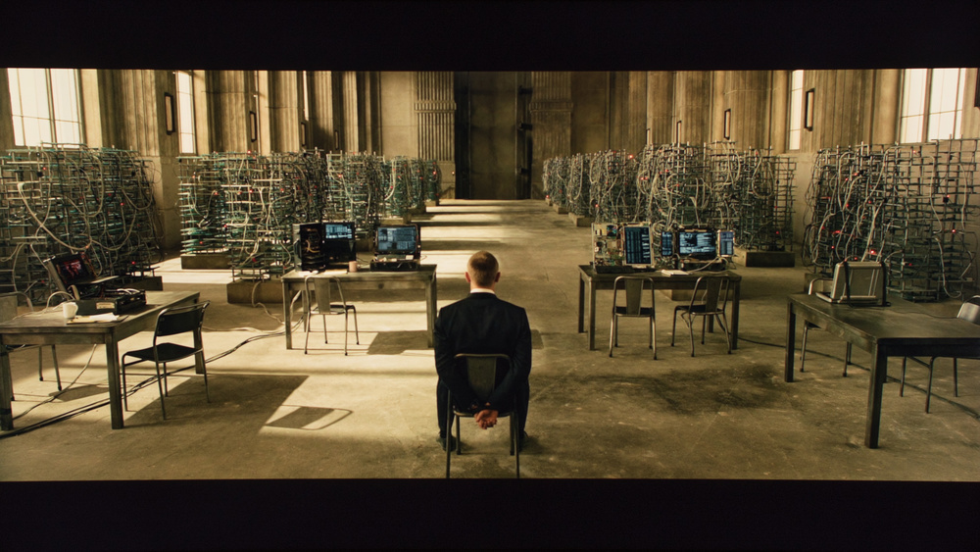 | 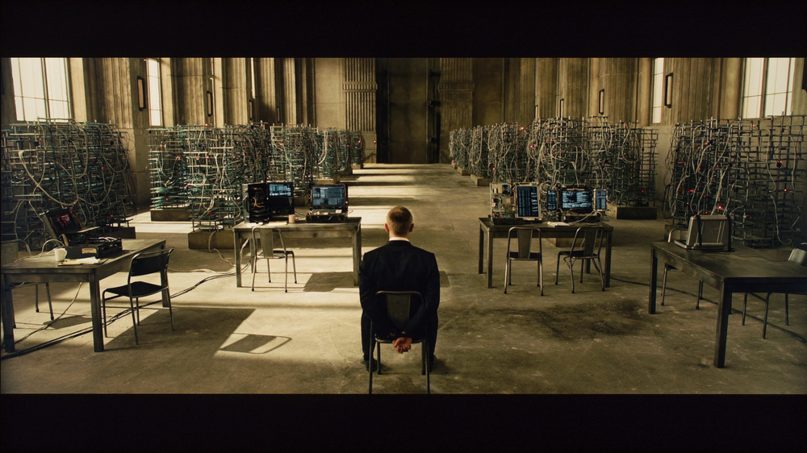

http://www.rtings.com/tv/reviews/by-type/smart/best
Q2\ it will assist to remove digital audio without loss the quality for sound

