Q1) is analysis and study all possible threats it can effect on business running and find solutions it can reduce effect continuality of and involve process as shown below photo
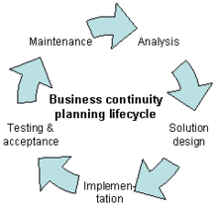
Q2)None Public Personal Information: all information which consider personal information must keep it secret such as :
1)National ID number.
2) Data of birth.
3)Number of credit cards numbers
No limited for NPPI but couple of example .

Q3)set of rule and standard set by US congress to govern protection health information including security, identifier ,privacy and transaction . HIPAA is used for apply security protection and NPPI witjin health care.
HIPPA apply on 4 section as follow:
Administrative, Physical , Technical and policy and procedures.

