Assignment 4
  - Deadline: Thursday 11/05/2017 @ 23:59
[Total Mark for this Assignment is 40]

Network Management
IT340

Instructions:
- This Assignment must be submitted on Blackboard via the allocated folder.
- Email submission will not be accepted.
- You are advised to make your work clear and well-presented, marks may be reduced for poor presentation.
- You MUST show all your work.
- Late submission will result in ZERO marks being awarded.
- Identical copy from students or other resources will result in ZERO marks for all involved students.
- Convert this Assignment to PDF just before submission.
Student Details:
Name: ###  CRN: ### |  | ID: ###

Question One
10 Marks
Learning Outcome(s):
Instructors: State the Learning Outcome(s) that match this question

The downstream channel bandwidth for the cable modem is 6 MHz. Calculate the bit rate if the signal is:a. QPSKb. 64-QAM
Answer:

- QPSK has a 2-bits per baud. The baud rate is the same as bandwidth. Hence, for a 6 MHz downstream bandwidth, baud rate is 6x10⁶, and bit rate is 12 Mbps.
- 64-QAM has 6 bits per baud (2⁶). Baud rate is the same as bandwidth. Hence, the bit rate is 36 Mbps.

Question Two
10 Marks
Learning Outcome(s):
Instructors: State the Learning Outcome(s) that match this question

Discuss the similarities and the differences between Multichannel multipoint distribution service (MMDS) and Local multipoint.

Answer
MMDS is based on point-to-multipoint architecture. It consists of a head end(BS), antennas, transceivers, and a cable modem equipment at both ends. The range between the base stations (BSs) is 50 km. It operates at 2.5 to 2.686 GHz band. Could operate on multichannels and hence capable of providing 2-way high-speed communication. Downstream propagation is TDM broadcast mode and upstream is TDMA transmission. The system is ideal for rural areas.
The architecture of LMDS is similar to MMDS (Point-to-multipoint architecture). It covers 5 km radius; hence the range between the base stations (BSs) is 10 km which is shorter than MMDS. It operates at 27-28.35 and 31-31.3 GHz bands. It is sensitive to rain attenuation. As in MMDS, it deploys cable modem equipment at both ends. It uses TDM broadcast mode for the downstream propagation and TDMA transmission for the upstream as MMDS.

Question Three
10 Marks
Learning Outcome(s):
Instructors: State the Learning Outcome(s) that match this question

Draw and explain HAVi protocol architecture.
Ans :
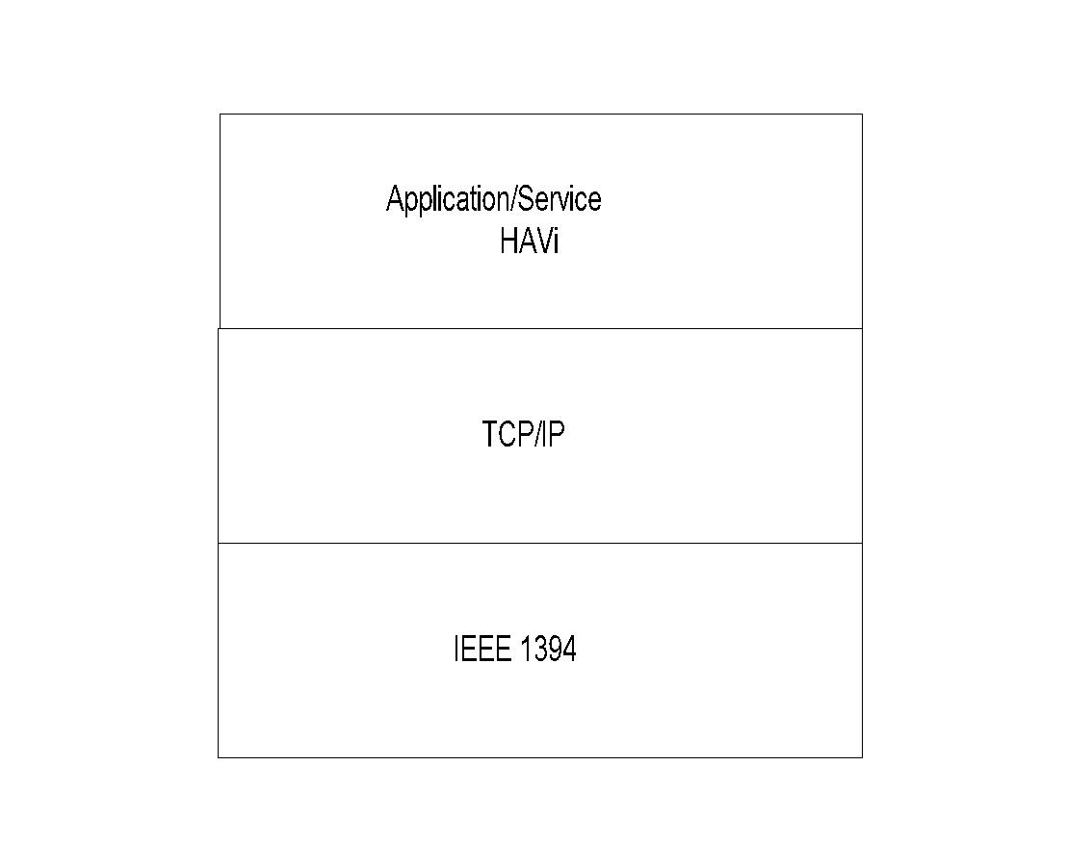
- Application for home entertainment and AV devices
- HAVi Components
  - Device
    - FAV (Full Audio Visual)
    - Intermediate AV
    - Base AV
    - Legacy AV
  - Device control module (DCM): Aggregate of
FCMs
  - Functional control module (FCM): Controls
application functions

- Peer-to-peer environment

Question Four (Bonus)
10 Marks
Learning Outcome(s):
Instructors: State the Learning Outcome(s) that match this question

Highlight the differences between the features of traditional networks and next generation networks.
Answer
Traditional Network features | Next generation network features
End-to-end transparency | Packet inspection, NAT
Peer-to-peer | NATs/firewalls/servers
Connectionless | MPLS
Best effort | Real-time demands, bandwidth demands
User back-off | QoS guarantees
Network empowerment | User empowerment
No flow state | Flow state
Trust | Hackers everywhere
Static addresses | DHCP, mobility
Fairness | QoS
Terminal-to-host | Mass public residential services, multiterminal, multi QoS
Flat network | Access and core domains
Simple protocol layering | Protocol maze
Research/Defence use | Commercialization, competition, consumer choice

