Assignment 2
  - Deadline: Tuesday 21/03/2017 @ 23:59
[Total Mark for this Assignment is 40]

Network Management
IT340

Instructions:
- This Assignment must be submitted on Blackboard via the allocated folder.
- Email submission will not be accepted.
- You are advised to make your work clear and well-presented, marks may be reduced for poor presentation.
- You MUST show all your work.
- Late submission will result in ZERO marks being awarded.
- Identical copy from students or other resources will result in ZERO marks for all involved students.
- Convert this Assignment to PDF just before submission.
Student Details:
Name: Munirah Alrushud  CRN: 21335 |  | ID: 140032004

Question One
10 Marks
Learning Outcome(s):
Instructors: State the Learning Outcome(s) that match this question

Suppose the following MIB for a certain enterprise BikesFun selling bikes and t-shirts.

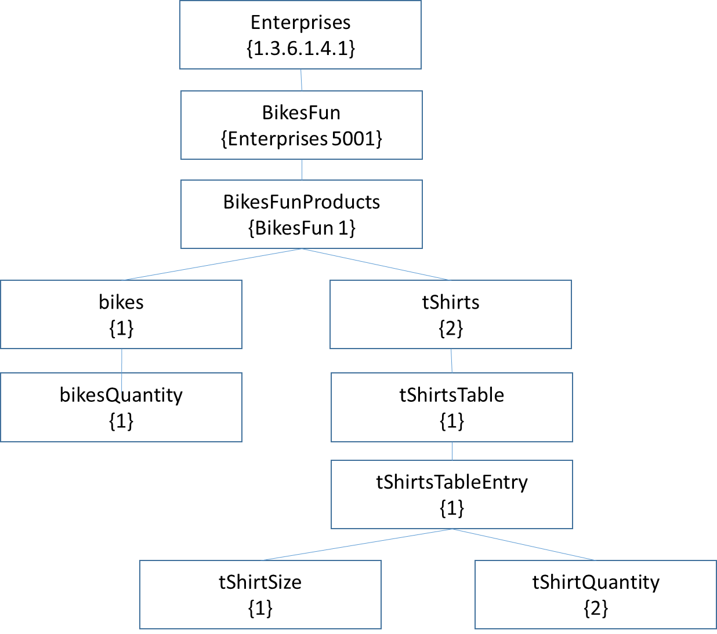
Draw request-response messages, as shown in figures 6.40 and 6.41 (chapter 6), to retrieve all columnar objects of the following table:

tShirtSize | tShirtQuantity
10 | 50
12 | 100
14 | 150
16 | 250
18 | 200
Provide responses when:
(a) using get-next –request and response
(b) Using get-bulk- request and response
Then compare.
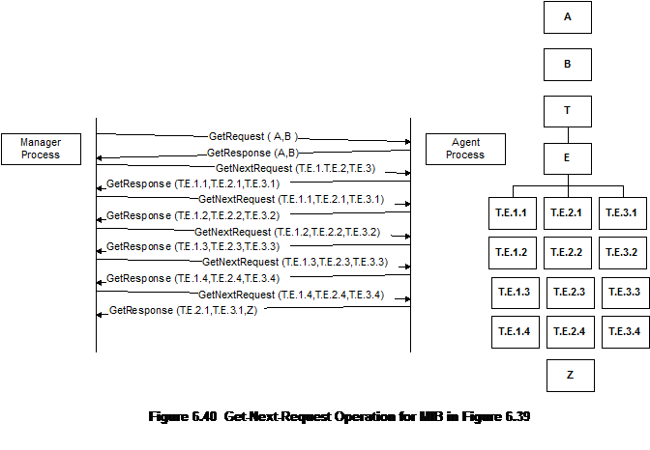
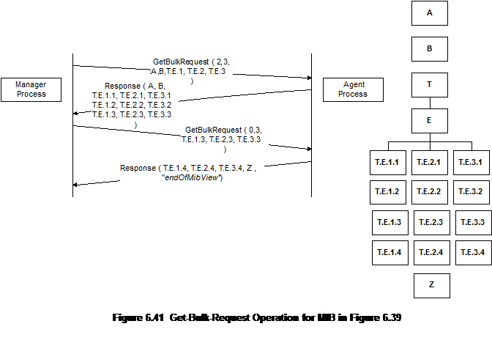

getNextRequest (1.3.6.1.4.1.5001.1.2.1.1.1.0 , 1.3.6.1.4.1.5001.1.2.1.1.2.0)
getResponse (1.3.6.1.4.1.5001.1.2.1.1.1=10 , 1.3.6.1.4.1.5001.1.2.1.1.2=50).. and so on…
(A)
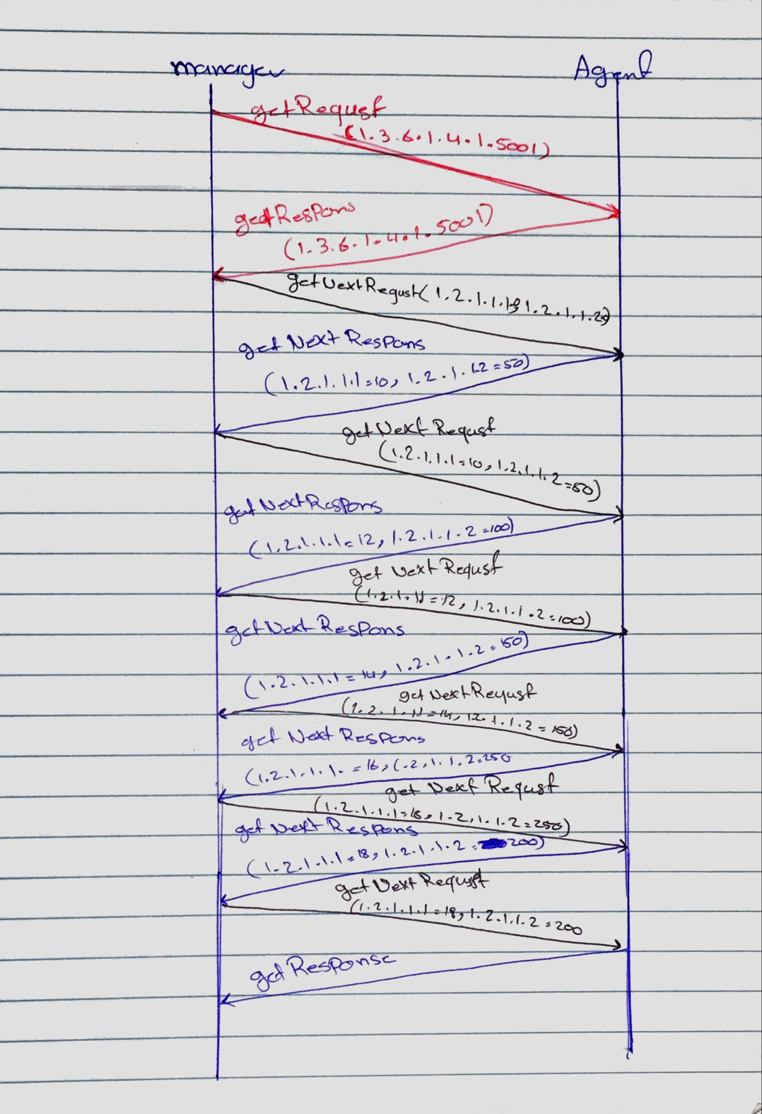
(B)
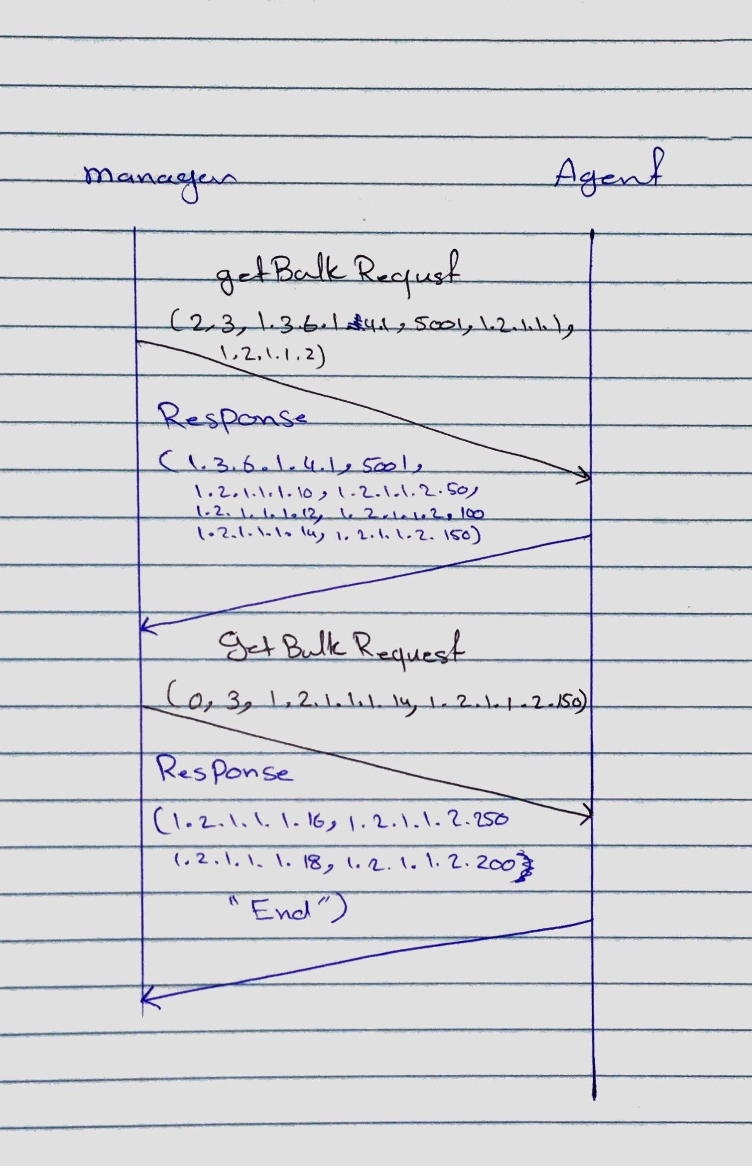

Question Two
10 Marks
Learning Outcome(s):
Instructors: State the Learning Outcome(s) that match this question

Describe the role of Notification / Proxy in SNMP.
SNMP manager can manage the non-SNMP community elements by the (proxy server) without the proxy server the SNMP cannot deal with other communities because the proxy server can convert the non-SNMP data to the SNMP.
The proxy server also allows 2 different versions to communicate using the proxy server.
Notification creator is generating trap and inform messages and determines the target.
Notification receiver is register with SNMP engine and receives notification messages

Question Three
10 Marks
Learning Outcome(s):
Instructors: State the Learning Outcome(s) that match this question

Provide at least two advantages of using RMON in remotely network monitoring.

- Increasing productivity for administrators
- Fast fault diagnosis.
- Does not need a direct visibility by NMS, so the information is more reliable.
- Monitoring and analyzing locally and relays data so the load is less on the network

Question Four
10 Marks
Learning Outcome(s):
Instructors: State the Learning Outcome(s) that match this question

Discuss the enhancement carried by RMON2 compared to RMON1 in terms of monitoring capability.

RMONv1 deals with data that associated with the OSI data link layer. The success of RMON1 leads to develop the RMON2. RMON2 extends the monitoring capability from one layer to next layer either (the network layer to the application layer). Also monitor the packets and clients through the network.
RMON2 focuses on higher layers of traffic at a higher level of the Medium Access Control (MAC) layer.

