Network Management
IT340

Student Details:
Name: Munirah Alrushud  CRN: 21335 |  | ID: 140032004

Assignment 1
  - Deadline: Day 04/03/2017 @ 23:59
[Total Mark for this Assignment is 40]

Question One
Learning Outcome(s):
Describe the features of and services provided by each layer of the OSI protocol/model
10 Marks
Which protocol belonging to the transport layer can provide a reliable communication and explain how.

TCP is providing a reliable communication. So, it guarantees that the packet will be delivered to the destination. How is that!!

TCP provides tow way communication when establishing a connection it will wait for ACK to make sure that the destination is available, and when sending a packet will wait for ACK as well to make sure that the packet will be delivered…. until the termination. In this way the TCP will guarantees that the packet will be delivered.

Question Two
Learning Outcome(s):
Compare and contrast different management models

Reference: Book

10 Marks
Explain the difference between the database of an NMS and MIB. How do you implement each in a Network Management System?

NMS has a database that managed objects for management data which contains MIB which is based on information about the objects and the second one is based on the values of the objects. And they are often confused with each other.
So MIB is a virtual database that contains the necessary information for processes to exchange information. However, MIB is need to be there whenever a NMS discovered a new object in the network.
How to implement each in network management system:
NMS is automatically discovering any component in the network while the component has a management agent. So, NMS can identify a new object after the MIB schema of the object is compiled to the NMS software.

Question Three
10 Marks
Learning Outcome(s):
Discuss the five areas of functions of SNMP

Describe the System Architecture of SNMP Manager and SNMP Agent.

SNMP consists of network agent and network manager processes. The agent is on the managed object, and the manager process is on the network management system and manages the managed object. Both they are software modules.

SNMP It is the data path between the manager application process and the agent application process through the transport function protocols (UDP, IP, DLC, and Physical).

Direction of the messages is Three from manager and two from agent Network ---
There are four Services Get, Set, GetNext, Trap
And there are five SNMP Messages which are Get Request, Set Request, GetNext Request, Get Response, Trap Request.

• Get Request Retrieve values of objects in the MIB from the agent.
• Get-Next Request Retrieve values of next objects in the MIB from the agent.
• Set Request Update values of objects in the MIB from the agent.
(Cont. Q3)
Learning Outcome(s):
Discuss the five areas of functions of SNMP

Reference: Chapter 5 Slide 3

• Trap Request Report an extraordinary event to the manager…..

As the figure from the slide ch5, slide 3
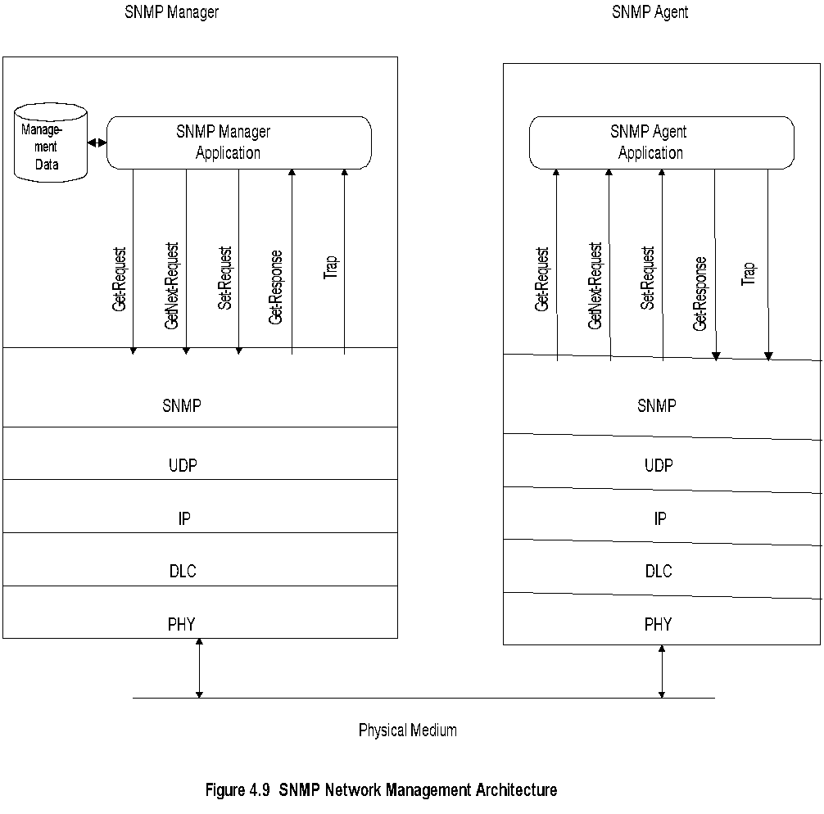

Question Four
10 Marks
Learning Outcome(s):
Administrative structure of SNMP Management including community-based model and access policy

Draw the SNMP Access Policy (as in Figure ) for the following scenario. Suppose a corporation with headquarters in Riyadh and domains or network sites in Riyadh, Jeddah, and Dammam. Let Manager 1 and community 1 be associated with Jeddah, Manager 2 and community 2 be associated with Riyadh, and Manager 3 and community 3 be associated with Dammam. Let Manager 4 be the overall network management system, the Manager of Managers (MOM). Each Manager manages 2 Agents associated with network elements in its domain only. So that, Manger 1 does not have the view of Riyadh or Dammam, Manger 2 cannot perform operations on network elements belonging to Jeddah or Dammam domains, and Manger 3 cannot communicate with Agents in Jeddah or Riyadh. However, Manger 4 has all community names defined in its profile and hence has the view of the total enterprise network in Riyadh, Jeddah, and Dammam.
Figure 1
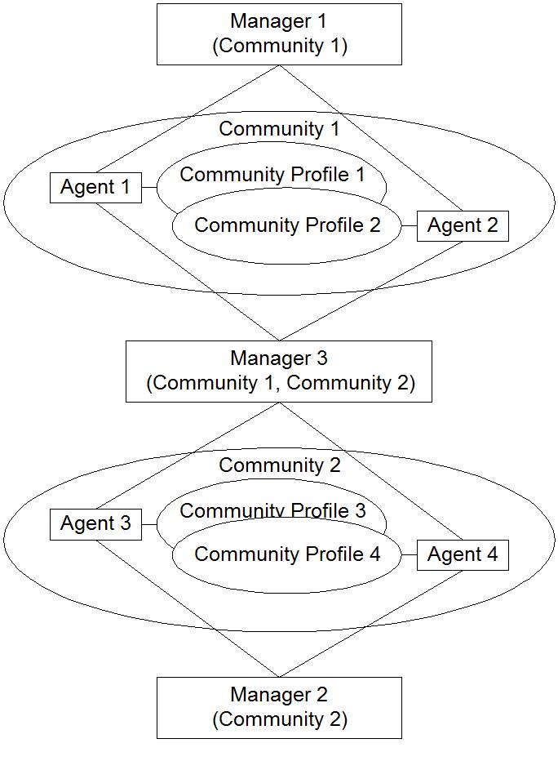

(Cont. Q4)

