Assignment1 Answer key
  - Deadline: Day 04/03/2017 @ 23:59
[Total Mark for this Assignment is 40]

Network Management
IT340

Instructions:
- This Assignment must be submitted on Blackboard via the allocated folder.
- Email submission will not be accepted.
- You are advised to make your work clear and well-presented, marks may be reduced for poor presentation.
- You MUST show all your work.
- Late submission will result in ZERO marks being awarded.
- Identical copy from students or other resources will result in ZERO marks for all involved students.
- Convert this Assignment to PDF just before submission.
Student Details:
Name: ###  CRN: ### |  | ID: ###

Question One
10 Marks
Learning Outcome(s):
Describe the features of and services provided by each layer of the OSI protocol/model

Which protocol belonging to the transport layer can provide a reliable communication and explain how.
Answer :
TCP using the ACK to make sure the reception of data, using the checksum to detect errors at the side of the destination, and using window size for congestion control.
Scale :
TCP protocol : 4 marks
ACK request : 2 marks
Checksum : 2 marks
Windows size : 2 marks

Question Two
10 Marks
Learning Outcome(s):
Compare and contrast different management models

Explain the difference between the database of an NMS and MIB. How do you implement each in a Network Management System?
Answer :
A database of an NMS is a physical database containing the network objects and values. (3 marks)
It is implemented using any proprietary database software. (2 marks)
MIB is a virtual database that is used by network management and agent applications to exchange information about the network objects. (3 marks)
It has a hierarchical structure and the schema of the MIB is compiled into the management and agent management software. ( 2marks)

Question Three
10 Marks
Learning Outcome(s):
Discuss the five areas of functions of SNMP

Describe the System Architecture of SNMP Manager and SNMP Agent.

Answer :
SNMP is based on the Internet standard and takes part of the application layer. (2 marks). SNMP uses the UDP transport protocol and not TCP (1 mark).
The communication of management information among management entities is realized through exchange of just five protocol messages. Three of these (get-request, get-next-request, and set-request) are initiated by the manager application process. The other two messages, get-response and trap, are generated by the agent process (5 marks : one mark for each request). The Management Information Base (MIB) is used by the manager and agent to specify the Object Identifier of the managed object in each SNMP request. (2 marks)

Question Four
10 Marks
Learning Outcome(s):
Administrative structure of SNMP Management including community-based model and access policy

Draw the SNMP Access Policy (as in Figure ) for the following scenario. Suppose a corporation with headquarters in Riyadh and domains or network sites in Riyadh, Jeddah, and Dammam. Let Manager 1 and community 1 be associated with Jeddah, Manager 2 and community 2 be associated with Riyadh, and Manager 3 and community 3 be associated with Dammam. Let Manager 4 be the overall network management system, the Manager of Managers (MOM). Each Manager manages 2 Agents associated with network elements in its domain only. So that, Manger 1 does not have the view of Riyadh or Dammam, Manger 2 cannot perform operations on network elements belonging to Jeddah or Dammam domains, and Manger 3 cannot communicate with Agents in Jeddah or Riyadh. However, Manger 4 has all community names defined in its profile and hence has the view of the total enterprise network in Riyadh, Jeddah, and Dammam.
Figure 1
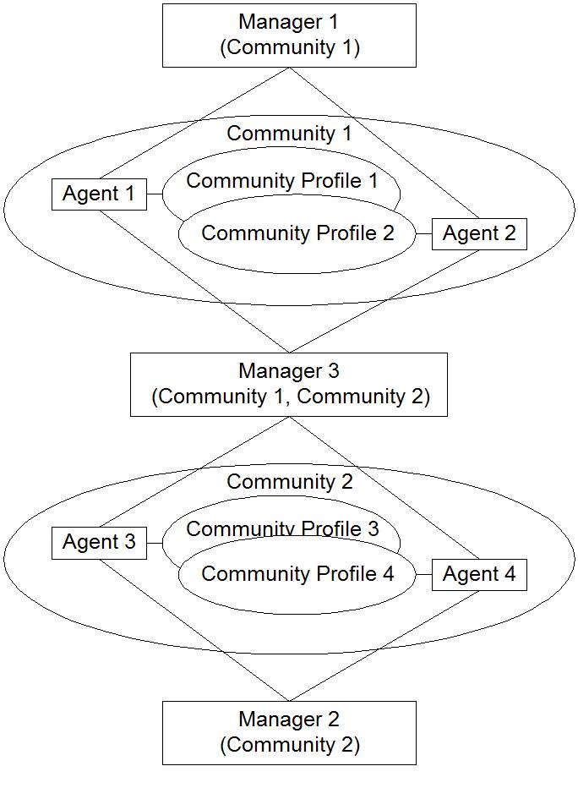

Answer
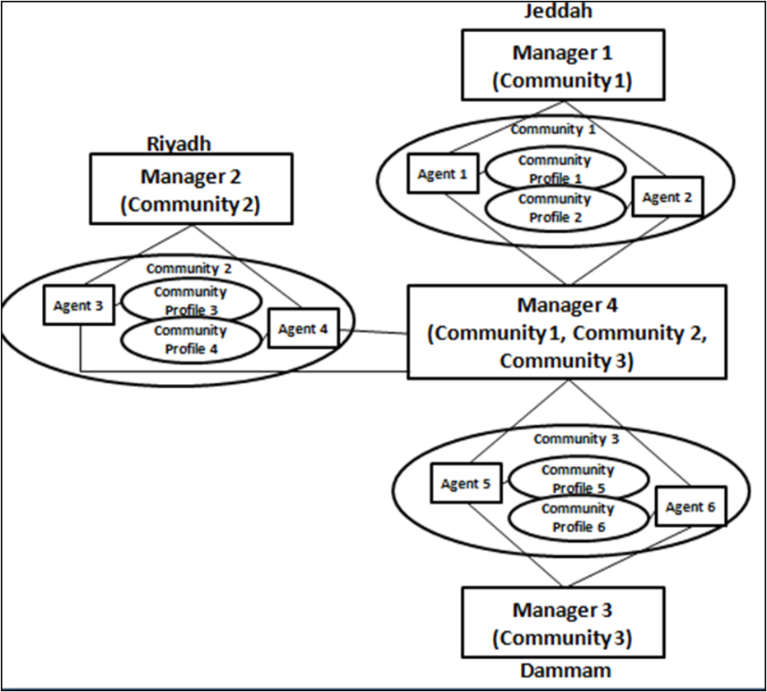
Scale :
2 marks by indicating manager 1 community 1 (Jeddah)
2 marks by indicating manager 2 community 2 (Riyadh)
2 marks by indicating manager 3 community 3 (Dammam)
4 marks by indicating manager 4 for community 1,2 and 3 (Jeddah)

