08
Fall

ECOM-101: E-Commerce 12053
#5 Assignment

Name: Salfah Alsakran.
ID: 120003351
Instructor: Layan BinSaleh.

- Discuss EDI and its stages are being used to automate the complete e-com business environment.
EDI stands for Electronic Data Interchange and it’s a communications standard for sharing business documents and settlement information among a small number of firms.

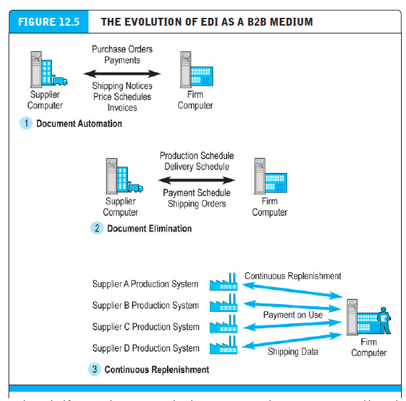

Stage #1 | Focused on document automation.
Procurement agents created purchase orders electronically and sent them to trading partners.
Trading partners in turn shipped order fulfillment and shipping notices electronically back to the purchaser.
These implementations replaced the postal system for document transmission, and resulted in same-day shipping of orders, reduced errors, and lower costs.

Stage #2 | Evolved to become a system for document elimination.
The large automation of internal industrial processes and movement toward just-in-time production and continuous production required EDI to support them, introducing greater flexibility in scheduling, shipping, and financing of supplies. In this stage EDI became a system for document elimination and used to eliminate purchase orders and other documents entirely, replacing them with production schedules and inventory balances. Supplier firms were sent monthly statements of production requirements and precise scheduled delivery times, and the orders would be fulfilled continuously, with inventory and payments being adjusted at the end of each month.

Stage #3 | Enabled the era of continuous replenishment
The purchasing firm gave the suppliers online access to the production and delivery schedules and expected them to meet the schedules on their own without the purchasing agents intervention “under long-term contract” The new manufacturing an business processes required much closer relationships with suppliers, who were required to be more precise in delivery scheduling and more flexible in inventory management that could never been achieved by human purchasing agents.

- Describe major types of auctions also discuss their benefits and costs.
- Sealed-bid auction (B2B): Multiple vendors competing against one another. The winner is chosen from lowest bidders at acceptable quality levels.
- English auction: Single seller offers one item for sale and set a reserve bid. Many buyers bid against each other within specific time frame and the highest bidder win the item as long as his bid is higher then the reserve bid, any bid lower than it the sellers refuse to sell.
- Traditional Dutch auction: Seller with many identical items sold in lots list. Starting price and time for opening the bid, as the time go the price get lower till a participant is willing to buy by that price.
- Dutch Internet auction: seller with many identical items sold in lots list. Starting price and time for opening the bid. The buyers indicate both bidding price and quantity desired. The lowest winning bid that clears the available quantity is paid by all winning bidders. Those with the highest bid are assured of receiving the quantity they desire, but only pay the amount of the lowest successful bid
- Name your own price “reverse” auction: in the reverse auction the role of the buyers and seller is reversed. The Buyers specify the prices they are willing to pay for an item, and multiple sellers bid for their business and the prices will typically decrease rather than increase.
- Group buying “demand aggregation” auction: The more people sign to buy an item the lower it price fall.
Auction benefits:
- Liquidity: Connects buyers and sellers in a global marketplace.
- Price discover: Ability decide prices competitively based on supply and demand even for the item that are difficult to price.
- Price transparency: The asking and bidding prices can be seen form all over the world through the auction site.
- Market efficiency: The goods that are impossible-to-access physically are offered for consumer selection.
- Lower transaction costs: The reduction of costs in comparison to physical marketplace benefit both the merchant and consumer.
- Consumer aggregation: it’s convenience to the seller that a large number of consumer who want to but the item are gathered together in one marketplace.
- Network effects: The marketplace become valuable because of the great benefit the large auction site bring “ high number of users and products”
- Market-maker benefit: no inventory cost and no shipping cost make auctions the ideal online business.
Auction costs:
- Delayed consumption: Buyer cannot use the product right away because auctions can continue for days and then the product will be shipped to the buyer.
- Monitoring cost: Buyers spend time monitor the bidding
- Equipment cost: Buyers must buy and have knowledge of computer systems and Internet.
- Trust risk: Auctions are the largest source of Internet fraud, and users are afraid of the loss risk.
- Fulfillment costs: The buyers will not only pay the bidding price but also the shipping packing and insurance.
- Explain difference between traditional social network and an online social network.
Traditional social network is group of people that interact with each and are connected by a relationship in a specific area for a period of time.
Online social network connect people with same interest and build relationship with each other online, there’s no specific or limited area to bring them together.

- Discuss the role of private industrial networks in supporting collaborative commerce.\
Collaborating with business can take different forms and include different activities.
- Collaborative resource planning, forecasting, and replenishment (CPER), which is the most collaboration form. The goal of the activity involved should be achieved, and if so it can produce the largest benefits and excuse the costs of industrial networks development. This goal is to ensure that the whole and retail “shelf space” is replenished with the exact right amount of good. This goal is achieved by CPER that involve working with network members to forecast demand, develop production plans, coordinate shopping, warehousing, and stocking activates.
- Demand chain visibility that helps retailer to fully aware about the suppliers and product position and amount in the supply and distribution chain. This visibility wasn’t available before and the retailers were not aware of the overstocked shelves that causes exceed in capacity and inventory.
- Marketing coordination and product design helps in the coordination between internal design and marketing activities, and supply and distribution chain partners by involving them in the product design and marketing and insure that the product suit the marketplace.

- Discuss Collaborative Commerce and its benefits.
Collaborative commerce: is using digital technologies to allow organizations to share important information between suppliers and purchasers and integrate core business with customers, suppliers, and business partners to to collaboratively design, develop, build, and manage products through their life cycles.
- Collaborative commerce benefits:
- Collaborative commerce cause closer and efficient relationship with customers resulting an increase in customers’ retention and increase in the company’s revenue.
- The supplier-customer link helped companies in order fulfillment and resulted a reduction in costs and life cycle and improvement in quality.
- The line between the company and its suppliers and product development partners helped them in cutting the manufacturing and operations cost and cycle time and increase the introduction of new products and service.

- References:
YouTube | What is a reverse auction?‬ | https://www.youtube.com/watch?v=vdqPHgGKgjU
YouTube | Dutch Auction Explained | https://www.youtube.com/watch?v=otbtjUWKaMo
Collaborative commerce: compelling benefits, significant obstacle | A NerveWire, Inc. http://xml.coverpages.org/Nervewire200210.pdf

