08
Fall

ECOM-101: E-Commerce 12053
#2 Assignment

Name: Salfah Alsakran.
ID: 120003351
Instructor: Layan BinSaleh.

#1: What do you understand by SWOT. Using SWOT analysis describe the Strength, Weakness, Opportunities and threat of company which you know closely. Please use the diagram as well as references.
A SWOT analysis describes a firm’s strengths, weaknesses, opportunities, and threats. It is a simple but powerful method for strategizing about your business and understanding where you should focus your efforts.

Online ExtraStore.
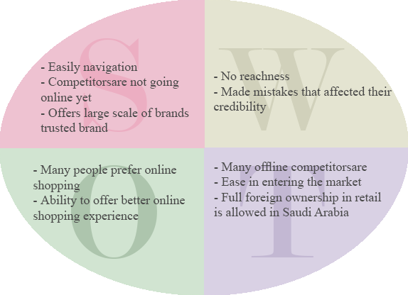

#2: Discuss most important factors for successful E-Commerce site designing.
- Functionality: working page that load quickly and get the customers the way you want easily.
- Informational: Search, and links so that customers can easily discover.
- Ease of use: Simple fool-proof navigation
- Redundant navigation: alternative navigation to the same content.
- Ease of purchase: one-to-two steps to purchase.
- Multi-browser functionality: The site should work with different popular browsers.
- Simple graphics: Avoid distraction, and avoid videos and audios that the user can’t control and stop.
- Legible text: Choose a good background that won’t make the text illegible.

#3: Discuss two tier and Multi Tier E-Commerce architecture.
- Two-tier architecture: e-commerce system architecture in which a Web server responds to requests for Web pages and a database server provides backend data storage
- Multi-tier architecture e-commerce system architecture in which the Web server is linked to a middle tier layer that typically includes a series of application servers that perform specific tasks as well as to a backend layer of existing corporate systems

#4: What is good E-Commerce security? Discuss three key points of vulnerability in e-commerce environment.
A good e-commerce security requires a set of laws, procedures, policies, and technologies that, to the extent feasible, protect individuals and organizations from unexpected behavior in the e-commerce marketplace

3 key points of vulnerability in e-commerce environment are:
- Client: such as home or business
- Server: such as the bank or merchant.
- Communications pipeline: The way of communication.

These are the 3 main points of vulnerability when dealing with e-commerce. During any of the above levels something may go wrong. For example if I’m going to use my credit card for purchasing something these are some risks that might happen (credit card theft, security breach or Wi-Fi listening wire tap …etc.)
There are some solutions for protection such as:

- Protecting Internet communications (encryption)
- Securing channels of communication (SSL, S-HTTP, VPNs)
- Protecting networks (firewalls)
- Protecting servers and clients

#5: What is the difference between hacking and cyberwar?
- Hacking is when an individual (hacker) gain unauthorized access to a computer system.
- Cyberwar:. Is actions by a nation-state to penetrate another nation's computers or networks for the purposes of causing damage or disruption

