08
Fall

ECOM-101: E-Commerce 12053
#1 Assignment

Name: Salfah Alsakran.
ID: 120003351
Instructor: Layan Binsaleh.

Questions
- Discuss E-Commerce and E-Business and how e-business is helping corporates in business.
In my opinion companies who are conducting e-business and using it in an efficient way are benefit a lot from it in many different ways.
E-commerce: is digitally enabling commercial transaction within and among individuals and organizations. “ involve exchange of value”
- E-business is depending mainly on IT and it helped the companies to integrate well writhing their own department to make the work more smooth and integrated. IT also helped in maintaining the huge number of data the companies own; whither it’s their customers’ information, suppliers’ information, sales information, or inventory management by using databases.
- E-business is also helping corporation in reducing their costs, faster the production line, easily find information about suppliers, easily contract with suppliers.

- Recognize and describe Web 2.0 applications with suitable example.
Web 2.0 is the apps or technologies that allow the user to create, edit, share content and build online community.
Example: Insagram is an app that helps the user to post a picture with a description (content), it also allow the user to edit that content and share it through many ways. It also helps in building online community by following other people and make relationship with them.
Other examples: YouTube, Twitter.

- Identify the factors that will define the future of e-commerce.

- E-commerce Technology: The web, Internet, platform such as smartphones, tablets are going to grow even more in the future. Purchases made via tablet or smartphone increased 48% in 2014 (2nd quarter), three times the growth in desktop purchasing. They have found that mobile commerce currently generates 22% of digital commerce revenue, and predicts mobile revenue in the U.S. will account for 50% by 2017.
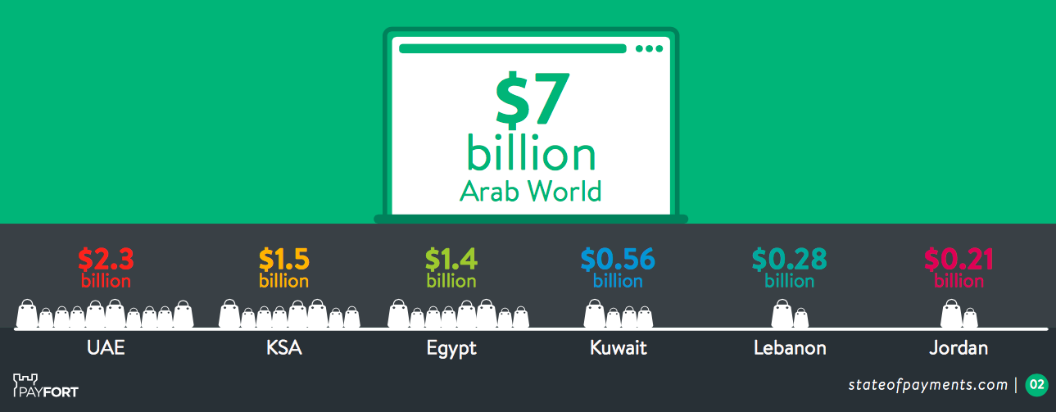
Market size in the Arab world in 2014! PayFort also predicted UAE and KSA will have a combined ecommerce market of over $10 billion. Refrence: Payfort stateofpayments.com

- E-commerce prices will rise to cover the real costs of doing business on the Web
- The margins and profit will rise to all retailers.
- Change in the cast players we will see and saw an increase of the start-ups that quickly gain large online audiences for new products and services not dominated by the large players such as http://afkar.me!
- The regulation of e-commerce and the Web by the government will continue to grow, and we have seen some actions that have been undertaken to protect the consumer such as the latest news of closing three Instagram accounts for selling fake products.

- Identify and describe the unique features of e-commerce technology and discuss their business significance.

E-commerce technology has eight unique features:
- Ubiquity: It available everywhere at anytime. The marketplace isn’t trapped in the traditional market boundaries anymore. Now we can shop from anywhere at anytime, it’s available through e-commerce all weekdays, 24 hours a day.
- Global reach: The marketplace has grown and the target audience has increased to include consumers from all around the world.
- Universal standards: Business-conducting e-commerce has a common technology standard that they all use, The Internet.
- Richness: The consuming experience is reach with many multimedia integrated as a marketing message such as videos, images..etc. to enhance the experience.
- Interactivity: Technology interacts with consumers and engage him in the dialogs.
- Information density: the costs of gathering, storing, connecting information are reduced. The information became more accurate, and easy to be gathered.
- Personalization/Customization: Not as the mass marketing companies used to perform, now the marketing message is more personalized and the products are customized to the consumers’ characteristics,
- Social technology: Contents are easily created and easily shared and disrupted through social networks.

- Discuss an example from your experience about any company conducting E-Commerce? You can include any necessary screenshots, charts, graphs, etc. which were helpful or harmful to your experience.

Pattz.com is a Saudi e-commerce website that sells babies needs. They are using e-commerce in an efficient way. The web site is easy to use, have a search tool, displaying the important information, and answers for the FAQ in the top of the page, using many social media channels, and giving the consumers different payment methods.

The customers can easily find out if the product is in the stock or not, and there’s an option to find out when will the product be available.

- Define e-commerce and describe how it differs from e-business. What are the Eight Key Elements of a Business Model and discuss value preposition.

E-commerce is digitally enabling commercial transaction among organizations and individuals. It must be consistent with all the three parts: (organization and individuals; means the e-commerce happens between the two parties, commercial transaction; in e-commerce there must be an exchange of money, digitally; the commercial transactions happens in a digital for through the Internet, web, mobile app…).
E-business is digitally enabling transactions and processes within the firm. The main different between E-commerce and E-business, that is in E-business there is no exchange of money.
Eight key elements of business model:
- Value proposition
Value proposition is related to the question why should the customer buy from you? The companies must answer this question by defining how will the company’s products and services fulfill their customers’ needs and wants
- Revenue model
- Market opportunity
- Competitive environment
- Competitive advantage
- Market strategy
- Organizational development
- Management team

