Moussa Academy

Stat101 – Assignment 3 – 2016

True or False:
- True
- False
- True
- True
- False
- True

Multiple Choice Questions:
- a
- c
- c
- d
- c
- a

Essay Type Questions:
- H₀: P = 0.2
H₁: P < 0.2 “Left tailed test”
p̂ = 0.15
α = 0.01
n = 100
q = 1 – p = 1 – 0.2 = 0.8

Z = $\frac{\hat{p}-p}{\sqrt{\frac{pq}{n}}}$ = $\frac{0.15-0.2}{\sqrt{\frac{0.2*0.8}{100}}}$ = -1.25
Using p-value:
From z distribution table: at α = 0.05
p-value = 0.1056
P > α
Fail to reject null hypothesis
There is no sufficient evidence to support the claim that less than 20% of American adults are allergic to the medication.

- H₀: µ = 20
H₁: µ > 20 “right-tailed test”
σ is known
n = 49
x̄ = 22.6
σ = 5.5
α = 0.05
Z = $\frac{\bar{x}-µ}{\frac{σ}{\sqrt{n}}}$ = $\frac{22.6-20}{\frac{5.5}{\sqrt{49}}}$ = 3.31
Using P-value:
From z table the probability at z = 3.31 equal: 0.9995
Since this is a right tailed test, and the values in table are cumulative from the lift
p-value = 1 – 0.9995 = 0.0005
and α = 0.05
p < α
Reject Null hypothesis
There is sufficient evidence to support the claim that the typical amount spent per customer is more than $20.00.

- H₀: µ = 500
H₁: µ ≠ 500 “Two-tailed test”
n = 36
x̄ = 546
s = 120
α = 0.05
σ is not known
t = $\frac{\bar{x}-µ}{\frac{s}{\sqrt{n}}}$ = $\frac{546-500}{\frac{120}{\sqrt{36}}}$ = 2.3
Critical Region:
Getting critical value from t table at: α = 0.05, Two-tailed, df = n – 1 = 35 – 1 = 36
t_{α/2} = ±2.03
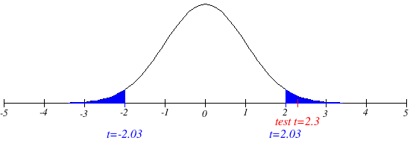
t falls in Critical Region
Reject null hypothesis
There is sufficient evidence to support the claim that their mean score is different from the mean that is expected from all applicants.

- n1 = 200 x1 = 120
n2 = 200 x2 = 150
p̂₁ = $\frac{x1}{n1}$ = $\frac{120}{200}$ = 0.6
p̂₂ = $\frac{x2}{n2}$ = $\frac{150}{200}$ = 0.75
α = 0.05
Pooled sample proportion: p̄ = $\frac{x1+x2}{n1+n2}$ = $\frac{120+150}{200 +200}$ = $\frac{270}{400}$ = 0.675
q̄ = 1 – p̄ = 1 – 0.675 = 0.325
H₀: p₁ = p₂
H₁: p₁ < p₂ “Left-tailed test”
Z = $\frac{\left(\hat{p}1-\hat{p}2\right)-(p1-p2)}{\sqrt{\frac{\bar{p}*\bar{q}}{n1}+\frac{\bar{p}*\bar{q}}{n2}}}$ = $\frac{\left(0.6-0.75\right)-(0)}{\sqrt{\frac{0.675*0.325}{200}+\frac{0.675*0.325}{200}}}$ = -3.2
P-value: “left-tailed” , from z table at z = -3.2
P = 0.007
P < α
Reject null hypothesis
There is sufficient evidence to support the claim that college faculty vote at a lower rate
than college students.

- H₀: µ₁ = µ₂
H₁: µ₁ ≠ µ₂ “Two-tailed test”
α = 0.05
t = $\frac{\left(\bar{x}1-\bar{x}2\right)-(µ1-µ2)}{\sqrt{\frac{{s1}^{2}}{n1}+\frac{{s2}^{2}}{n2}}}$ = $\frac{\left(43-41\right)-(0)}{\sqrt{\frac{{4.5}^{2}}{23}+\frac{{5.1}^{2}}{13}}}$ = 1.178
Critical Value:
From t table at α = 0.05, df = 13 – 1 = 12, two tailed test
t_{α/2} = ±2.179
critical region
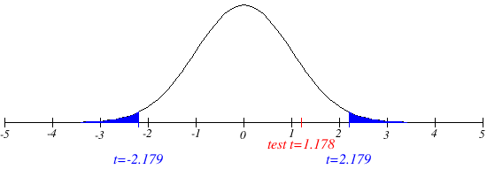
Test t does not fall in critical region
Fail to reject null hypothesis
There is no sufficient evidence to support the claim that 𝜇1 ≠ 𝜇2.

- E = t_{α/2}$\sqrt{\frac{{s1}^{2}}{n1}+\frac{{s2}^{2}}{n2}}$ = 2.179$\sqrt{\frac{{4.5}^{2}}{23}+\frac{{5.1}^{2}}{13}}$ = 3.699
0.95 confidence interval: → α = 0.05, t_{α/2} = 2.179 “from table”
$\left(\bar{x}1-\bar{x}2\right)-E<(µ1-µ2)$ < $\left(\bar{x}1-\bar{x}2\right)+E$
(43 – 41) – 3.699 < µ1 - µ2 < (43 – 41) + 3.699
2 – 3.699 < µ1 - µ2 < 2 + 3.699
“Confidence Interval”: -1.7 < µ1 - µ2 < 5.7

