***Introduction to database-IT244 Project***

***Database***

***Of***

***University***

***Instructor's name: Afra alrubaiaan.***

***Student's names: Sarab AL-Ahmer-130007503***

***Suha AL-Awbathani-130005417***

* ***The an ER diagram for the database and convert to Relational Schema***

***C:\Users\Toshiba\Downloads\ER UNI (4).png***

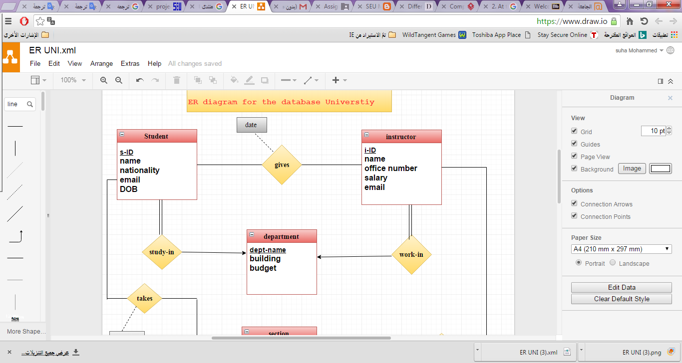

.

***\*Relational Schema :***

**Student (s-ID, name , nationality , dept_name ,email, DOB)**

**Instructor ( i-ID . name , dept_name , salary ,office number, email )**

**gives( s-ID , i-ID , date)**

**Department (dept-name , building ,budget)**

**Course (course id , title )**

**section ( course id, sec id, semester, year, building, room number)**

**takes (s-ID, course id, sec id, semester, year, grade)**

**teaches (i-ID, course id, sec id, semester, year)**

**classroom (building, room number, capacity)**

* ***The normalization process. (show each table in 1NF, 2NF, 3NF)***

**We have seven (9) table our university database .**

**1- Student - table**

|  |  |  |  |  |  |
| --- | --- | --- | --- | --- | --- |
| **s-ID** | **name** | **nationality** | **dept_name** | **email** | **DOB** |
| **123** | **Suha Mohammad** | **Yameni** | **IT** | [**s.@gmail.com**](mailto:s.@gmail.com)  [**s.12@hotmail.com**](mailto:s.12@hotmail.com) | **1-1-1986** |
| **145** | **Hind Ahmad** | **saudi** | **History** | [**hind@yahoo.com**](mailto:hind@yahoo.com) | **2-9-1988** |
| **156** | **Sara Hassan** | **saudi** | **IT** | [**Ssaa.156@hotmail.com**](mailto:Ssaa.156@hotmail.com) | **3-7-1987** |
| **167** | **Amal Salem** | **syrian** | **Biology** | [**amal@gmail.com**](mailto:amal@gmail.com) | **11-6-1990** |
| **190** | **Rana Fahad** | **Egyptian** | **Physics** | [**Rana@hotmail.com**](mailto:Rana@hotmail.com)  [**R190@gmail.com**](mailto:R190@gmail.com) | **7-12-1991** |

1. ***First Normal Form (1NF)***

***In 1NF we remove multi value attribute and repeating group.***

**R1(s-email)**

|  |  |  |
| --- | --- | --- |
| **email-ID** | **s-ID** | **email** |
| **661** | **123** | [**s.@gmail.com**](mailto:s.@gmail.com) |
| **662** | **123** | [**s.12@hotmail.com**](mailto:s.12@hotmail.com) |
| **663** | **145** | [**hind@yahoo.com**](mailto:hind@yahoo.com) |
| **664** | **156** | [**Ssaa.156@hotmail.com**](mailto:Ssaa.156@hotmail.com) |
| **665** | **167** | [**amal@gmail.com**](mailto:amal@gmail.com) |
| **666** | **190** | [**Rana@hotmail.com**](mailto:Rana@hotmail.com) |
| **668** | **190** | [**R190@gmail.com**](mailto:R190@gmail.com) |

**R2**

|  |  |  |  |  |
| --- | --- | --- | --- | --- |
| **s-ID** | **name** | **Nationality** | **dept_name** | **DOB** |
| **123** | **Suha Mohammad** | **Yameni** | **IT** | **1-1-1986** |
| **145** | **Hind Ahmad** | **Saudi** | **History** | **2-9-1988** |
| **156** | **Sara Hassan** | **Saudi** | **IT** | **3-7-1987** |
| **167** | **Amal Salem** | **Syrian** | **Biology** | **11-6-1990** |
| **190** | **Rana Fahad** | **Egyptian** | **Physics** | **7-12-1991** |

## *2- Second Normal Form (2NF)*

***In 2NF we remove partial dependency***

***In student table we don't have partial dependency – we have one primary key.***

## *3- Third Normal Form (3NF)*

***In 3NF we remove transitive dependency***

***In student table we don't have transitive dependency – it means there is not noun prime attribute depending on noun prime attribute.***

**2-Instructor -table**

|  |  |  |  |  |  |
| --- | --- | --- | --- | --- | --- |
| **i-ID** | **name** | **dept_name** | **salary** | **office number** | **email** |
| **2222** | **Ahmad** | **IT** | **7000** | **12** | [**ahmad@hotmail.com**](mailto:ahmad@hotmail.com) |
| **1212** | **Hamid** | **History** | **10000** | **11** | [**H1212@gmail.com**](mailto:H1212@gmail.com)  [**hamid@yahoo.com**](mailto:hamid@yahoo.com) |
| **4556** | **Ali** | **IT** | **15000** | **14** | [**Ali@hotmail.com**](mailto:Ali@hotmail.com) |
| **8381** | **Omar** | **Biology** | **9000** | **11** | [**oomar@gmail.com**](mailto:oomar@gmail.com) |
| **1010** | **Hani** | **Physics** | **13000** | **17** | [**hani@hotmail.com**](mailto:hani@hotmail.com) |

1. ***First Normal Form (1NF)***

***In 1NF we remove multi value attribute and repeating group.***

**R1**

|  |  |  |
| --- | --- | --- |
| **email-ID** | **i-ID** | **email** |
| **121** | **2222** | [**ahmad@hotmail.com**](mailto:ahmad@hotmail.com) |
| **122** | **1212** | [**H1212@gmail.com**](mailto:H1212@gmail.com) |
| **123** | **1212** | [**hamid@yahoo.com**](mailto:hamid@yahoo.com) |
| **124** | **4556** | [**Ali@hotmail.com**](mailto:Ali@hotmail.com) |
| **125** | **8381** | [**oomar@gmail.com**](mailto:oomar@gmail.com) |
| **126** | **1010** | [**hani@hotmail.com**](mailto:hani@hotmail.com) |

**R2**

|  |  |  |  |  |
| --- | --- | --- | --- | --- |
| **i-ID** | **name** | **dept_name** | **salary** | **office number** |
| **2222** | **Ahmad** | **IT** | **7000** | **12** |
| **1212** | **Hamid** | **History** | **10000** | **11** |
| **4556** | **Ali** | **IT** | **15000** | **14** |
| **8381** | **Omar** | **Biology** | **9000** | **11** |
| **1010** | **Hani** | **Physics** | **13000** | **17** |

## *2- Second Normal Form (2NF)*

***In 2NF we remove partial dependency***

***In* Instructor *table we don't have partial dependency – we have one primary key.***

## *3- Third Normal Form (3NF)*

***In 3NF we remove transitive dependency***

***In* Instructor *table we don't have transitive dependency – it means there is not noun prime attribute depending on noun prime attribute.***

**3- Gives - table**

|  |  |  |
| --- | --- | --- |
| **s-ID** | **i-ID** | **date** |
| **123** | **2222** | **2-8-2016** |
| **145** | **1212** | **4-9-2015** |
| **156** | **4556** | **7-4-2016** |
| **167** | **8381** | **2-5-2016** |
| **190** | **1010** | **3-5-2016** |

1. ***First Normal Form (1NF)***

***In 1NF we remove multi value attribute and repeating group.***

***In* Gives *- table we don't have remove multi value attribute and repeating group.***

***2- Second Normal Form (2NF)***

***In 2NF we remove partial dependency***

***In* Gives *- table we don't have partial dependency.***

## *3- Third Normal Form (3NF)*

***In 3NF we remove transitive dependency***

***In* Gives *table we don't have transitive dependency – it means there is not noun prime attribute depending on noun prime attribute.***

**4- Department - table**

|  |  |  |
| --- | --- | --- |
| **dept_name** | **building** | **budget** |
| **IT** | **Riyadh** | **120000** |
| **History** | **Dammam** | **50000** |
| **IT** | **Jeddah** | **80000** |
| **Biology** | **Riyadh** | **120000** |
| **Physics** | **Dammam** | **70000** |

* 1. ***First Normal Form (1NF)***

***In 1NF we remove multi value attribute and repeating group.***

***In* Department – table *we don't have remove multi value attribute and repeating group.***

***2- Second Normal Form (2NF)***

***In 2NF we remove partial dependency***

***In* Department – table *we don't have partial dependency.* We have one primary key.**

## *3- Third Normal Form (3NF)*

***In 3NF we remove transitive dependency***

***In* Department - *table we don't have transitive dependency – it means there is not noun prime attribute depending on noun prime attribute.***

**5-Course - table**

|  |  |
| --- | --- |
| **course id** | **title** |
| **IT244** | **Introduction of database** |
| **BIO123** | **Introduction of Biology** |
| **IT210** | **Comp. Network** |
| **HIS222** | **Intro. History** |
| **PHY321** | **Intro. Physics** |

* 1. ***First Normal Form (1NF)***

***In 1NF we remove multi value attribute and repeating group.***

***In* Course – table *we don't have remove multi value attribute and repeating group.***

***2- Second Normal Form (2NF)***

***In 2NF we remove partial dependency***

***In* Course – table *we don't have partial dependency.* We have one primary key.**

## *3- Third Normal Form (3NF)*

***In 3NF we remove transitive dependency***

***In* Course - *table we don't have transitive dependency – it means there is not noun prime attribute depending on noun prime attribute.***

**6-Section-Table**

|  |  |  |  |  |  |
| --- | --- | --- | --- | --- | --- |
| **Course -id** | **Sec- id** | **Semester** | **Year** | **Building** | **Room number** |
| **IT -244** | **1** | **Summer** | **2016** | **Riyadh** | **555** |
| **IT-244** | **2** | **spring** | **2016** | **Riyadh** | **551** |
| **BIO-123** | **2** | **Fall** | **2015** | **Dammam** | **435** |
| **IT-210** | **4** | **Spring** | **2016** | **Dammam** | **567** |
| **HIS-222** | **3** | **Fall** | **2015** | **Jeddah** | **434** |

***1-First Normal Form (1NF)***

***In 1NF we remove multi value attribute and repeating group.***

***In* Section – table *we don't have remove multi value attribute and repeating group.***

***2-Second Normal Form (2NF)***

**R1:**

|  |  |  |  |
| --- | --- | --- | --- |
| **Course -id** | **Sec- id** | **Semester** | **Year** |
| **IT -244** | **1** | **Summer** | **2016** |
| **IT-244** | **2** | **spring** | **2016** |
| **BIO-123** | **2** | **Fall** | **2015** |
| **IT-210** | **4** | **Spring** | **2016** |
| **HIS-222** | **3** | **Fall** | **2015** |

**R2:**

|  |  |  |  |
| --- | --- | --- | --- |
| **Course -id** | **Sec- id** | **Building** | **Room number** |
| **IT -244** | **1** | **Riyadh** | **555** |
| **IT-244** | **2** | **Riyadh** | **551** |
| **BIO-123** | **2** | **Dammam** | **435** |
| **IT-210** | **4** | **Dammam** | **567** |
| **HIS-222** | **3** | **Jeddah** | **434** |

## *3- Third Normal Form (3NF)*

**R1:SECTION_R1:**

|  |  |  |  |
| --- | --- | --- | --- |
| **Course -id** | **Sec- id** | **Semester** | **Year** |
| **IT -244** | **1** | **Summer** | **2016** |
| **IT-244** | **2** | **spring** | **2016** |
| **BIO-123** | **2** | **Fall** | **2015** |
| **IT-210** | **4** | **Spring** | **2016** |
| **HIS-222** | **3** | **Fall** | **2015** |

**R2: SECTION2_R2:**

|  |  |  |  |
| --- | --- | --- | --- |
| **Course -id** | **Sec- id** | **Building** | **Room number** |
| **IT -244** | **1** | **Riyadh** | **555** |
| **IT-244** | **2** | **Riyadh** | **551** |
| **BIO-123** | **2** | **Dammam** | **435** |
| **IT-210** | **4** | **Dammam** | **567** |
| **HIS-222** | **3** | **Jeddah** | **434** |

**R3: SECTION_R3:**

|  |  |
| --- | --- |
| **Building** | **Room number** |
| **Riyadh** | **555** |
| **Riyadh** | **551** |
| **Dammam** | **435** |
| **Dammam** | **567** |
| **Jeddah** | **434** |

**7-Takes –Table :**

|  |  |  |  |  |  |
| --- | --- | --- | --- | --- | --- |
| **S-id** | **Course-id** | **Sec-id** | **Semester** | **Year** | **grade** |
| **123** | **IT -244** | **1** | **Summer** | **2016** | **99** |
| **156** | **IT-244** | **2** | **spring** | **2016** | **80** |
| **167** | **BIO-123** | **2** | **Fall** | **2015** | **97** |
| **123** | **IT-210** | **4** | **Spring** | **2016** | **88** |
| **145** | **HIS-222** | **3** | **Fall** | **2015** | **89** |

***1-First Normal Form (1NF)***

***In 1NF we remove multi value attribute and repeating group.***

***In* Takes– table *we don't have remove multi value attribute and repeating group.***

***2-Second Normal Form (2NF)***

**R1: TAKES_R1:**

|  |  |  |  |  |
| --- | --- | --- | --- | --- |
| **S-id** | **Course-id** | **Sec-id** | **Semester** | **Year** |
| **123** | **IT-210** | **4** | **Spring** | **2016** |
| **123** | **IT -244** | **1** | **Summer** | **2016** |
| **145** | **HIS-222** | **3** | **Fall** | **2015** |
| **156** | **IT-244** | **2** | **spring** | **2016** |
| **167** | **BIO-123** | **2** | **Fall** | **2015** |

**R2: TAKES_R2**

|  |  |  |
| --- | --- | --- |
| **S-id** | **Course-id** | **grade** |
| **123** | **IT -244** | **99** |
| **156** | **IT-244** | **80** |
| **167** | **BIO-123** | **97** |
| **123** | **IT-210** | **88** |
| **145** | **HIS-222** | **89** |

## *3- Third Normal Form (3NF)*

***In 3NF we remove transitive dependency***

***In*Takes- *table we don't have transitive dependency – it means there is not noun prime attribute depending on noun prime attribute.***

**8-Teaches-Table:**

|  |  |  |  |  |
| --- | --- | --- | --- | --- |
| **i-ID** | **Course- id** | **Sec-id** | **Semester** | **year** |
| **2222** | **IT -244** | **1** | **Summer** | **2016** |
| **2222** | **IT-244** | **2** | **spring** | **2016** |
| **8381** | **BIO-123** | **2** | **Fall** | **2015** |
| **4556** | **IT-210** | **4** | **Spring** | **2016** |
| **1212** | **HIS-222** | **3** | **Fall** | **2015** |

***1-First Normal Form (1NF)***

***In 1NF we remove multi value attribute and repeating group.***

***In* Teaches– table *we don't have remove multi value attribute and repeating group.***

***2-Second Normal Form (2NF)***

***In 2NF we remove partial dependency***

***In* Teaches – table *we don't have partial dependency.***

## *3- Third Normal Form (3NF)*

***In 3NF we remove transitive dependency***

***In* Teaches- *table we don't have transitive dependency – it means there is not noun prime attribute depending on noun prime attribute.***

**9-classroom –Table:**

|  |  |  |
| --- | --- | --- |
| **buliding** | **Room number** | **capacity** |
| **Riyadh** | **555** | **30** |
| **Dammam** | **435** | **25** |
| **Jeddah** | **434** | **25** |
| **Abha** | **666** | **35** |
| **Madina** | **767** | **20** |

***1-First Normal Form (1NF)***

***In 1NF we remove multi value attribute and repeating group.***

***In* Class room– table *we don't have remove multi value attribute and repeating group.***

***2-Second Normal Form (2NF)***

***In 2NF we remove partial dependency***

***R1: CLASSROOM_R1:***

|  |  |
| --- | --- |
| **buliding** | **Room number** |
| **Riyadh** | **555** |
| **Dammam** | **435** |
| **Jeddah** | **434** |
| **Abha** | **666** |
| **Madina** | **767** |

***R2: CLASSROOM_R2:***

|  |  |
| --- | --- |
| **buliding** | **capacity** |
| **Riyadh** | **30** |
| **Dammam** | **25** |
| **Jeddah** | **25** |
| **Abha** | **35** |
| **Madina** | **20** |

## *3- Third Normal Form (3NF)*

***In 3NF we remove transitive dependency***

***In* Class room- *table we don't have transitive dependency – it means there is not noun prime attribute depending on noun prime attribute.***

* ***SQL statements for creating tables and inserting data***
* ***A screenshot for every created table and its data.***

**Note: The program MYSQL does not accept Add foreign key**

**( MYSQL server 5.7) I mentioned the correct way to you before each create table.**

***1-Student table:***

**Create table** student(

sID **int** primary key,

name  **varchar**(30),

nationality **varchar**(33),

deptname **varchar**(20) **references** department,

DOB **int);**

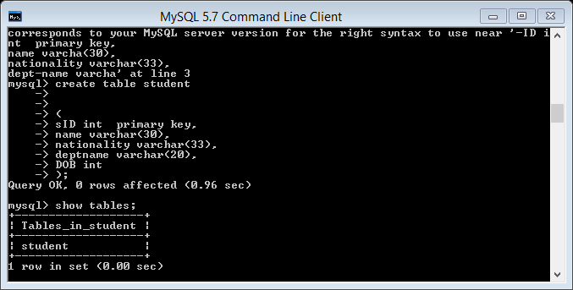

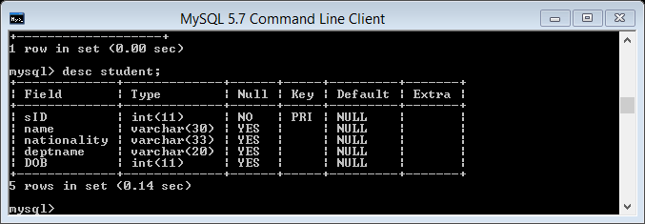

**Insert data in student table:**

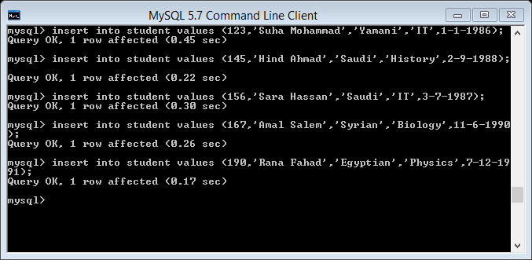

***2-s-email table***

**Create table** student(

EmailID **int** primary key,

sID **int references** student,

email **varchar**(30));

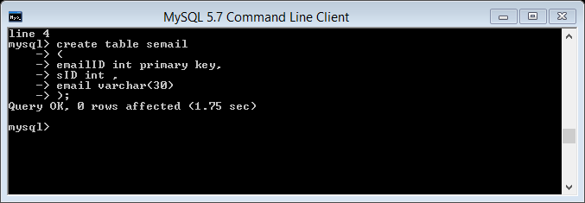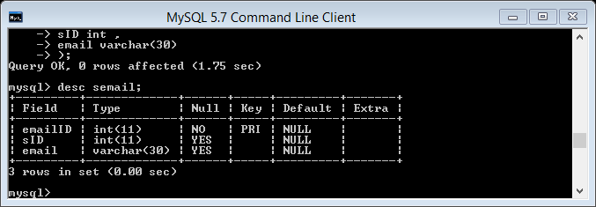

**Insert data in student table:**

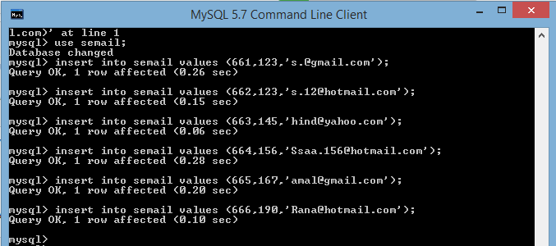

**3-Table instructor:**

**Create table** instructor (

iID **int** primary key,

name  **varchar**(20),

deptname **varchar**(30) **references** department,

salary **numeric** (8,2),

officeNO **int );**

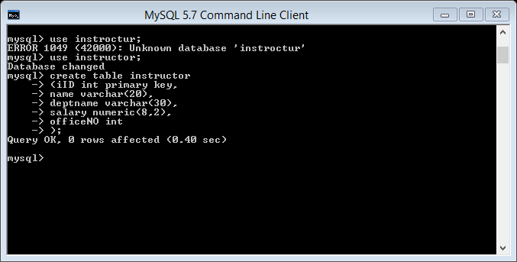

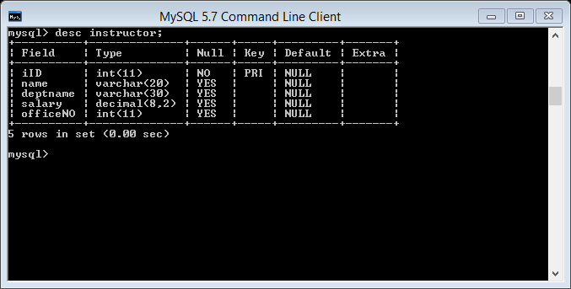

**Insert data in instructor table**: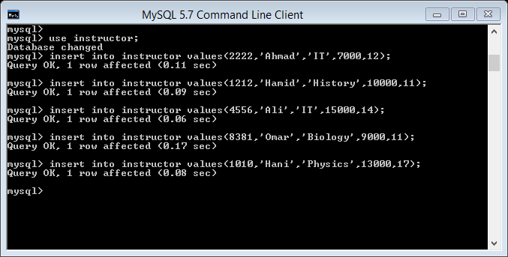

**4-i-email table:**

**Create table** iemail(

iemailID **int** primary key,

iID  **int references** instructor,

email **varchar**(30));

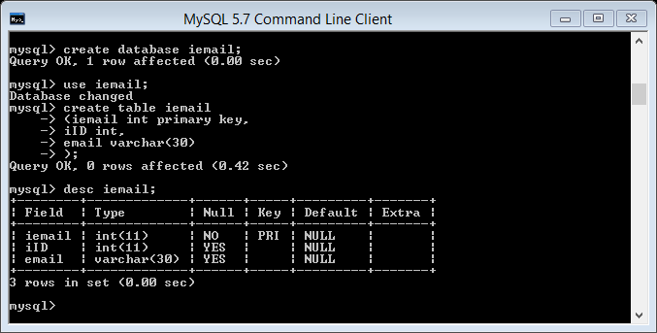

**Insert data in i-email table:**

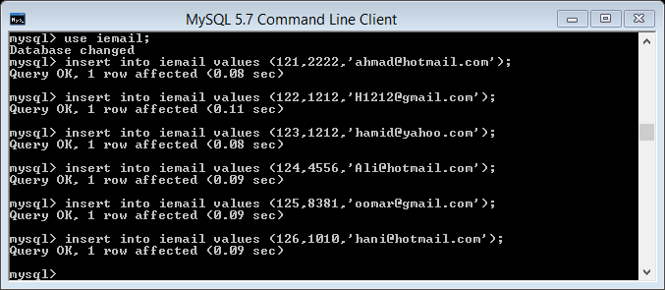

***5-Department table:***

**Create table** department(

deptname **varchar**(20),

bulding **varchar**(30),

budget **numeric**(8,2) **);**

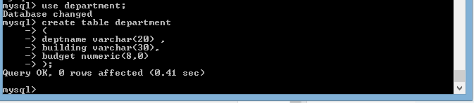

**Insert data in department table:**

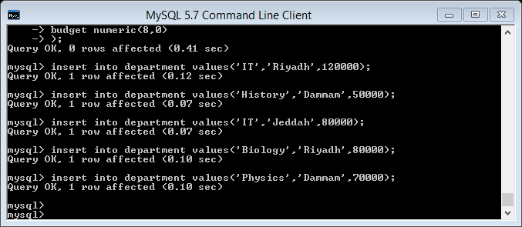

**6-Gives table:**

**Create table** gines(

Sid **varchar**(20),

Iid **varchar**(30),

date **date,**

**primary key** (Sid,iID) **);**

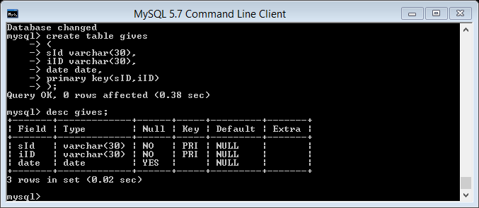

**Insert data in gives table:** 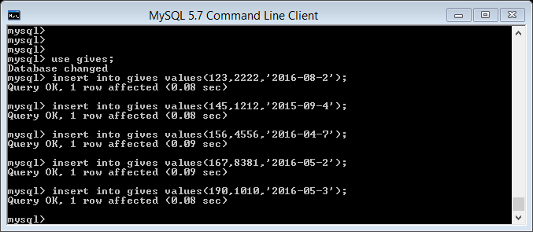

**7-Course table**:

**Create table** course(

courseID **varchar**(30) primary key,

title  **varchar**(80),

);

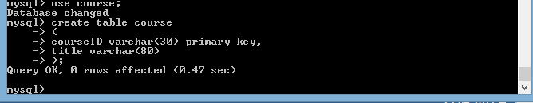

**Insert data in course table:**

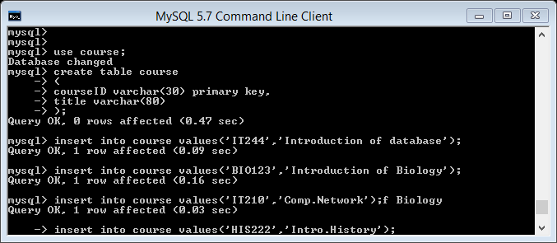

**8-SECTION –R1TABLE:**

**create table**section_R1(

Course ID  **varchar** (10) reference course,

SecID         **varchar** (10),

Semester  **varchar**(10),

Year   **numeric**(10),

**Constraint** pk_section_R1ID **primary key** (coursed ,secID,semester,year));

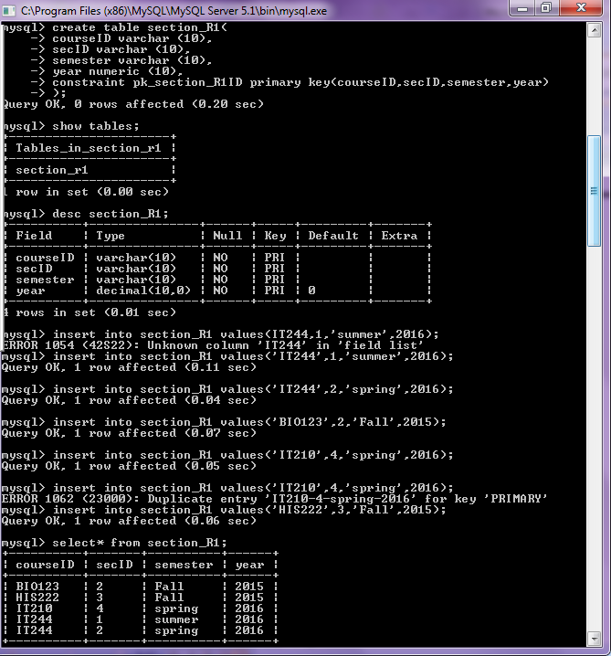

**Note: we complete the table in another version , here The program MYSQL accept Add foreign key(MYSQL server 5.1)**

***9-SECTION2_R2 TABLE:***

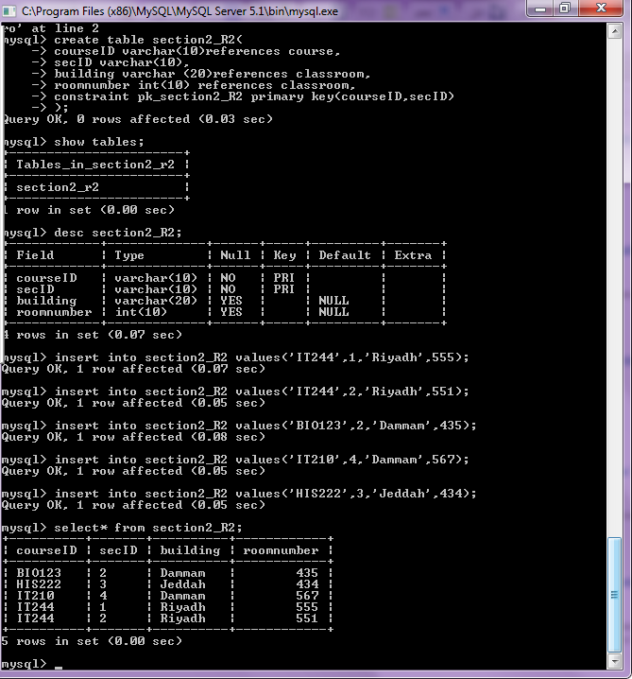

***10-SECTION2_R3 TABLE:***

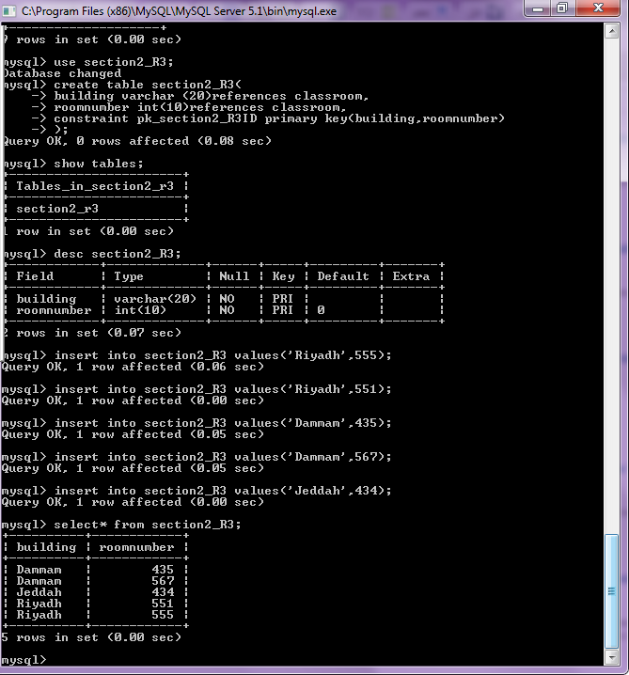

***11-TAKES_R1TABLE:***

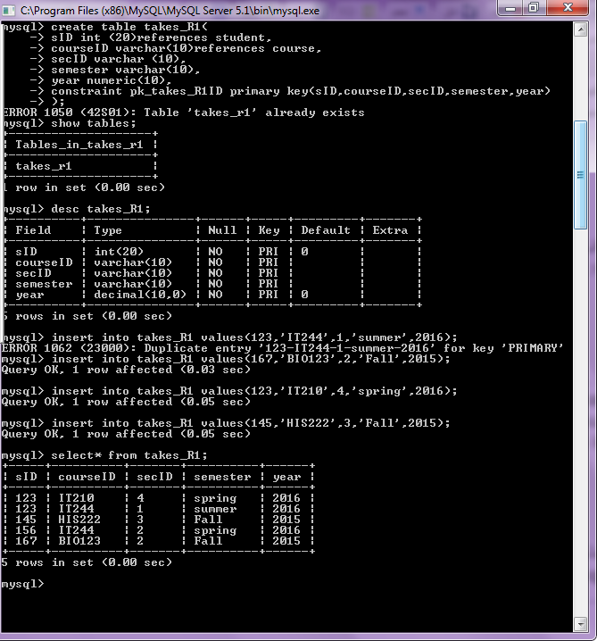

***12-TAKES_R2 TABLE:***

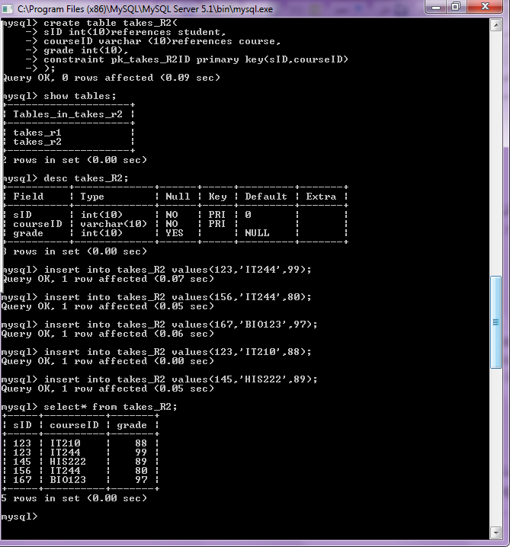

***13-TEACH ES TABLE:***

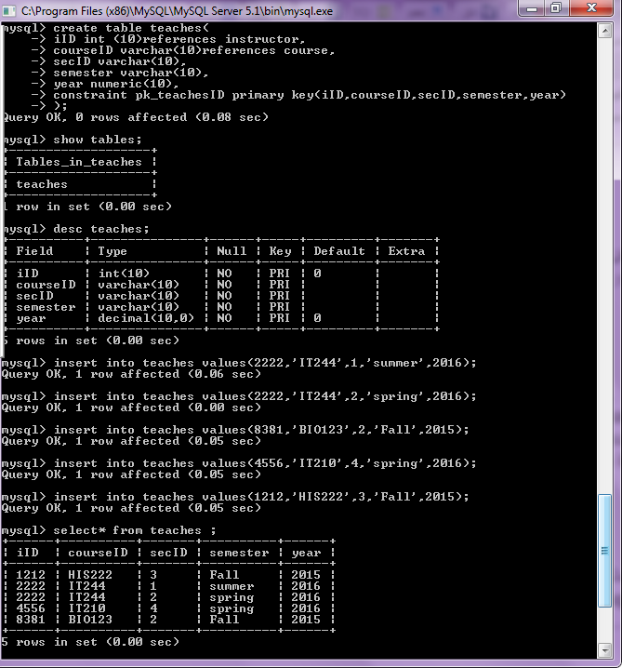

***14-Classroom _r1 table:***

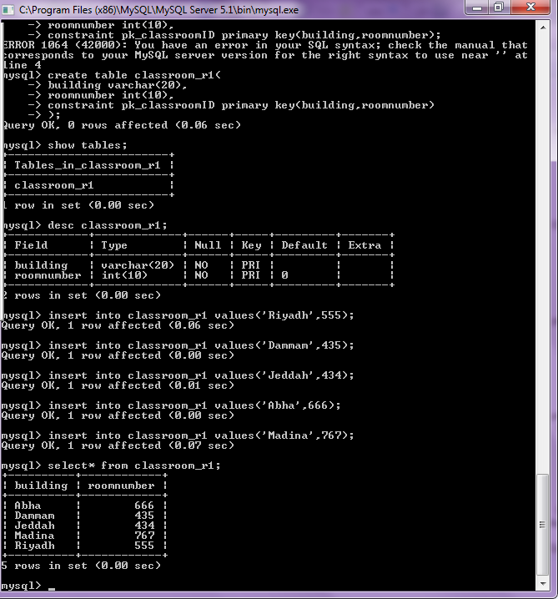

***15-Classroom_r2 table:***

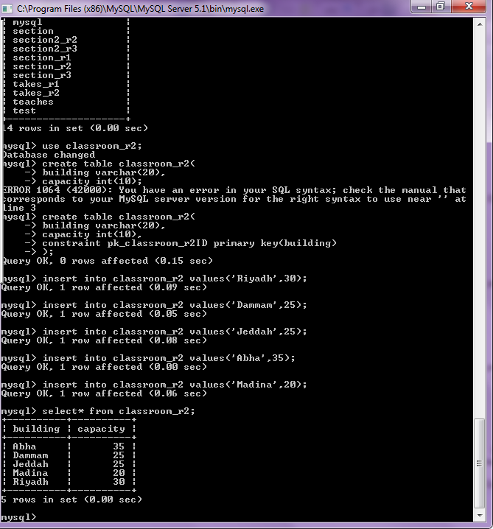

* ***SQL-5-queries and their results***.
* ***A screenshot for every queries and their results***.

1. **Find all instructors in IT dept with salary>5000?**

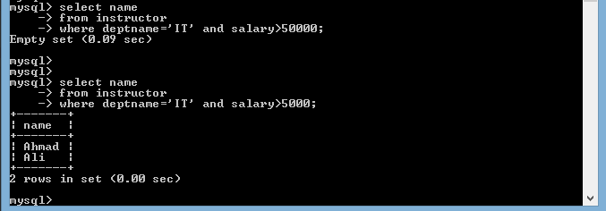

1. **Find all email for student who ID 1212?**

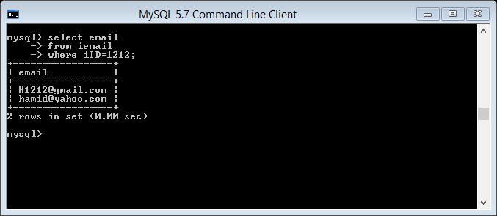

1. **Find all tuples if instructor ID=1212 ?**

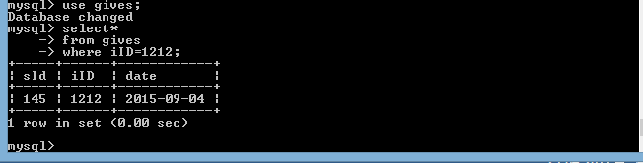

1. **Find all department name and building which budget 80000?**

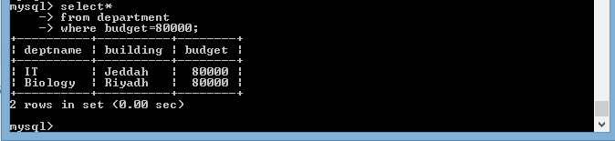

1. **Find course-offered in summer and spring 2016?**

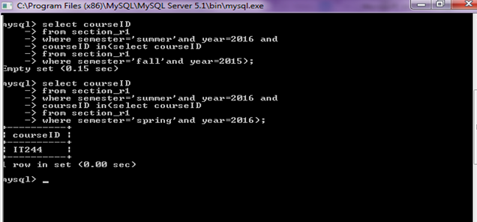

1. **Find section ID for the building in Riyadh?**

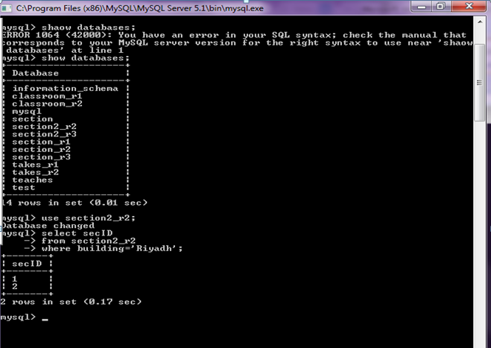

1. **FIND THE TOTAL NUMBER OF INSTRCTOR WHO TEACH A COURSE IN THE SPRING 2016?**

