COLLEGE OF COMPUTING AND INFORMATICS
Assignment – 2
Course Title : Introduction to Database Course Code : IT244
Note :
- Submission Deadline: 05/03/2016 at 23:59
- 5 Marks
- Copied assignment will be graded zero mark.
- Assignment submitted after due date will not be accepted, it will be considered to be late and will have zero mark.

Q1: Design an ER diagram for the following Dental Clinic database. Your diagram should have all the needed details. You may make any reasonable assumptions but you have to state them clearly. ₌
The clinic has several dentists. Each dentist has a unique Number, name, nationality, multiple room-number, salary, birth-date and home-address (Box, City, Zip).
Each client (patient) has a unique Code, name, home-phone, work-phone, address, and birth-date. Each client is assigned to one dentist. All future visits will be to the same dentist. A client can be insured or self-paying. An insured client should have an insurance company-name, and company-Phone, while a self-paying client must have a bank-name and a bank account.
Each visit of a client is described by a date, type, action, fee, and date-of-next-appointment

- Design an Entity Relationship (ER) Model to represent the above requirements. (2 Point)

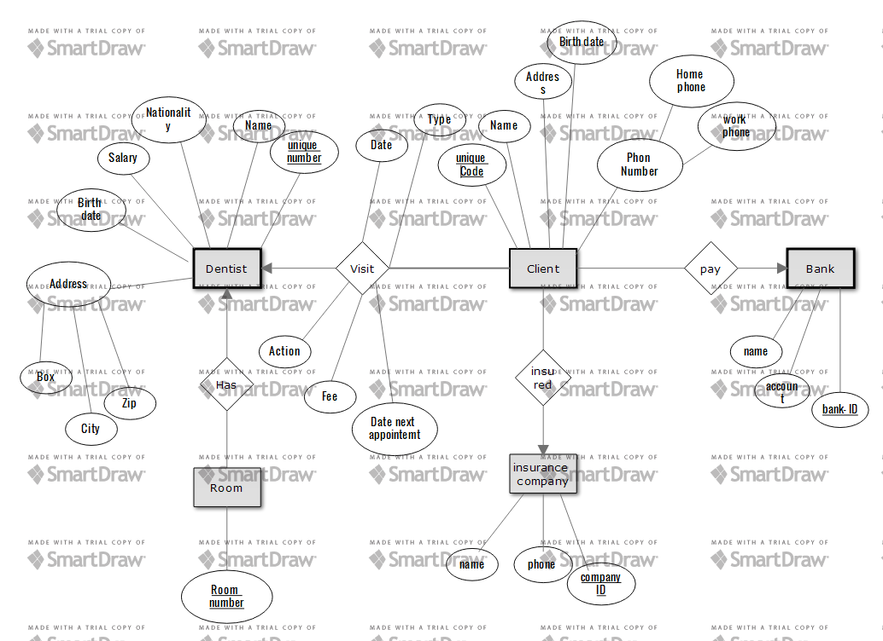

- Convert an ER Diagram that presented in part (A) to Rational Schema. (1 Point)
Dentist (unique number, name , nationality , salary, birth date, box, city, zip)
Dentist rooms (Dentist unique number , room number)
Visits (date, type, action, fee, next appointment date)
Client (unique code , name, home phone , work phone, address, birth date, dentist unique number , company ID, bank ID)
Insurance company (company_ID, name, phone)
Bank (bank_ID , name, account)

Q2.
- Explain the distinction between condition-defined and user-defined constraints. Which of these constraints can the system check automatically? (0.75 Point)
In design constraints on generalization–specialization should be determined entities can be members of lower level entity sets .
Condition –defined constraints | user-defined constraints
evaluated the membership in lower level entity-sets on the basis exist or not entity fulfill the explicit condition .like all customers over 70 years are members of senior-citizen entity set : senior-citizen ISA person | not constraint by membership condition in lower level entity sets , entities may belong to more than one lower level entity set at a single generalization

Condition-defined constraints can be automatically by the system.

- Explain the distinction between disjoint and overlapping constraints. (0.75 Point)
distinction | Overlapping
The entity can belong in only one lower level entity set. Example the student is entity can fulfill only one condition for the student type attribute graduate or ungraduate. | The entity can belong in more than one lower level entity set.

- Explain the distinction between total and partial constraints. (0.5 Point)
Total | Partial
each entity in high level should be belong to the lower level entity sets. | Some entity in high level not need to belong to any lower level entity sets.

