INTRODUCTION TO DATABASE (IT244)
ASSIGNMENT 1
(LAST DATE TO SUBMIT: 20/02/2016)
Q1: Consider the below schema for a library database and write relational algebra expressions for the following queries [1.5 Marks]
- Author ( authorname, citizenship, birthyear)
- Book (isbn, title, authorname)
- Topic (isbn, subject)
- Branch (libname, city)
- Instock (isbn, libname, quantity)

- Give all authors’ names born after 1940. [0.25 Point]
π _{authornames}(σ _{birthyears >1940}(Product))

- Give the names of libraries in Sydney. [0.25 Point]
π _{libname}(σ _{city=} _{Sydney} (Branch))

- Give the cities where each book is held. [0.25 Point]
π city,book.isbn(σ Branch.libname = Instock.libname and Instock.isbn = Book.isbn(Branch*Instock*Book))

- Give the title of each book on the topic of either alcohol or drugs. [0.25 Point]
π _{title of book} (σ _{subject=} alcohol OR subject =drugs (Book *Topic))

- Give the title and author of each book of which at least two copies are held in a branch located in Melbourne. [0.50 Point]
π title,author (σ quantity>=2 and city= Melbourne. (Book *Instock*Branch))

Q2. What are the responsibilities of a DBA? If we assume that the DBA is never interested in running his or her own queries, does the DBA still need to understand query optimization? Why? [1.5 Marks]
The responsibility of the DBA is include:
1-Schema definition: the person (DBA)is make main the database schema through implement set of data definition in DDL .
2- storage body and define the access method
3- Schema and physical-organization modification: The DBA execute changes on the schema and physical organization to invert all the needs changing of the organization or change the organization physical to progress performance.
4- Granting of authorization for data access.: the DBA can organize any part of data base allow to users can access by agree to give various kinds of authorization and keep the information in private system structure that the DB system confer whenever try anyone access to the data in system.
5- Routine maintenance.: the activities of Routine maintenance like support Periodically Up the DB to prevent loss data, and making sure if free disk space enough and control chances of work on DB and making sure the performance.
because the DBA needs to understand the query optimization untill if he or she not intersted in running because some of these responsibilities are linked to query optimization and if the DBA not undersatnd the performanceof the queries on wide range athen can not make good decisions
Q3: What are the drawbacks of using file system over database management system?
The drawbacks of using file system over DBMS are:
- • Data redundancy and inconsistency. different programmers making the files since a long time moreover the same information duplication in different files and and this duplication needs high storage and cost access and it may lead multiple file format and inconsistency.
- Difficulty in accessing data.: if i need names of student there living in particular city there more difficult either search all students manually or I need to create a new program to carry out each new task.
- Data isolation.: because the data is sparse in different files and the files in many formats and write new program to get data is more difficult.
- Integrity problems.: The data stored in the database should satisfy some types of certain limitations like( account balance >0) and can be difficult to add new constraints or change the previously existing constraints.
- Atomicity problems.: Computer system exposed to the failure of such a device must be in the case of system failure For example, when you drag the balance either the process complete or are not taken to withdraw the balance if the system fails and this gets in the file system.
- Concurrent-access by multiple users: if many users enter on system in the same time and modify on data not controlling to lead inconsistencies and concurrent access need performance
- Security problems.: must all user can access to some data not all example student not access to data for teachers but in file systems have security problems.
Q4: Consider the advisor relation shown in Figure 2, with s_id as the primary key of advisor. Suppose a student can have more than one advisor. Then, would s_id still be a primary key of the advisor relation? If not, what should the primary key of advisor be? [1 Marks]
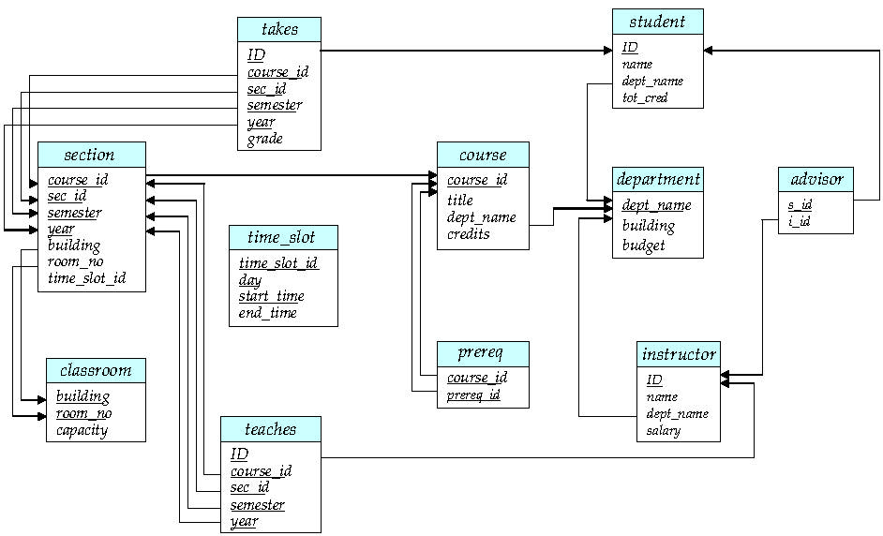
Schema Diagram for University Database.

NO, can not use the s_id a primary key of the advisor relation because may be two or many rows (tuples) for one student, congruent to 2 or many advisors ,
then, should be the primary key are s_id and i_id

