Q1
Normalize the following schema, with given constraints, to BCNF. (2 Point)
books(accessionn, isbn, title, author, publisher)
users(userid, name, deptid, deptname)

accessionno isbn
isbn title
isbn publisher
isbn author
userid name
userid deptid
deptid deptname
Answer
1NF :
Select primary key for each relation

books(accessionno, isbn, title, author, publisher)
users(userid, name, deptid, deptname)

2NF:
All relations are in 2NF because the primary key is single attribute

books(accessionno, isbn, title, author, publisher)
users(userid, name, deptid, deptname)

3NF
Prevent any transitively dependent in the 2NF relations
Also all relations are in BCNF

book(isbn, title, publisher,author)
accession(accessionno, isbn)
user(userid, name, deptid)
department(deptid,deptname)

Q2
Consider the relational database given below, where the primary keys are underlined. Give an expression in Tuple Relational Calculus and Domain Relational Calculus for each of the following queries: (0.5+0.5 = 1 Point)

a. Find all employees who work directly for “STC”
b. Find all cities of residence of all employees who work directly for “STC”
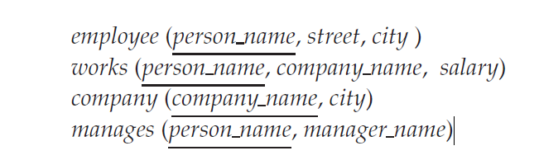

a.
Tuple Relational Calculus
{t | ∃ m ∈ manages (t[person name] = m[person name] ∧ m[manager name] = "STC")}
Domain Relational Calculus
{<p> | < p,m> ∈ manages ∧ m="STC” }

b.
Tuple Relational Calculus
{t | ∃ m ∈ manages ∃e ∈ employee(e[person name] = m[person name]
∧ m[manager name] = "STC" ∧ t[city] = e[city])}

Domain Relational Calculus
{<c> | ∃ p,s (<p,s,c> ∈ person ∧ ∃ m (<p,m> ∈ manages ∧ m = "STC" ))}

Q3
Consider the following database: (0.5+0.5+1= 2 Points)
person (driver_id, name, address)
car (license, model, year)
accident (report_number, date, location)
owns (driver_id, license)
participated (report_number, license, driver_id, damage_amount)
- Write SQL DDL corresponding to the following schema. Make any reasonable assumptions about data types, and be sure to declare primary and foreign keys.
- Find the number of accidents in which the cars belonging to “John Smith” were involved.
- Update the damage amount for the car with license number “AABB2000” in the accident with report number “AR2197” to $3000.

a-
create table person
(
driver_id char(10) primary key,
name varchar(40) not null,
address varchar(60)
)

create table car
(
license char(10) primary key,
model varchar(20) not null,
year int
)

create table accident
(
report_number char(10) primary key,
date varchar(20),
location varchar(40),
)
create table owns (
driver_id char(10) references driver,
license char(10) references car,
primary key(driver_id, license)
)
create table participated (
report_number char(10) primary key,
license char(10) references car,
driver_id char(10) references driver,
damage_amount dec(6,2),
)

b-
select count (distinct accident.report_number) Accidents
from person, accident, participated
where participated .report_number= accident.report_number
and participated.driver_id = person. driver_id
and person.name ="John Smith"

c-
update participated
set damage_amount = 3000
where report_number ="AR2197"
and license = "AABB2000"

