**Computer Networks (IT210)**

**Assignment 4**

**Due Date: --- December, 2016 Total Marks = 4**

**Important Instructions:**

1. Read and understand the questions carefully.

2. Take your assignment as an opportunity to raise your understanding for the course materials; work on it during the whole allowed period to provide original answers, do not wait for one day before the deadline to work on your assignment

3. This is an individual work, so make sure it is your own.

4. Search the textbook or other resources to have a better understanding of the questions.

5. Use ‘Word Processor’ to answer the questions, do not include text as image.

6. Submission must be through Blackboard only, no email submissions will be accepted.

7. Plagiarism will result in “0” mark.

1. **Explain about different connection services in transport layer with suitable diagram (0.5)**

* A transport-layer protocol, like a network-layer protocol, can provide two types of services:
  + Connectionless and
  + Connection-oriented.
* The nature of these services at the transport layer, however, is different from the ones at the network layer. At the network layer, a connectionless service may mean different paths for different datagrams belonging to the same message. Connectionless service at the transport layer means independency between packets; connection-oriented means dependency.

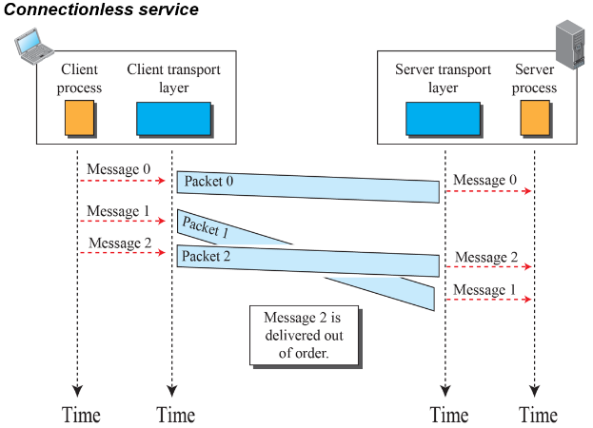

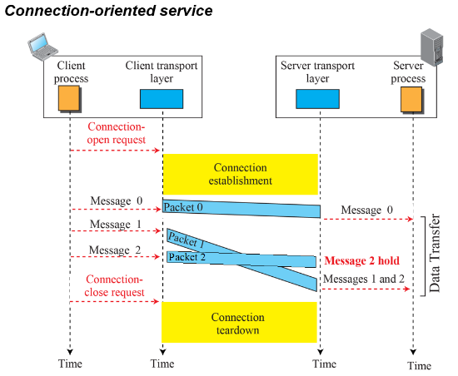

**What is the key difference between Go Back N-ARQ and Selective Repeat ARQ? (0.5)**

In Stop and Wait ARQ we have to wait for ACK after each packet.

In Selective Repeat ARQ we can send packets without ACK depending on window size and similarly receive frames depending on window size.

**Describe how a TCP connection is terminated. (0.5)**

The host sends a FIN (Finish) packet to the other connected host.

1. Host B sends a FIN packet to Host A indicating the data transmission is complete.
2. Host A responds with an ACK packet acknowledging the reception of the FIN packet.
3. Host A then sends Host B a FIN packet indicating that the connection is being terminated.
4. Host B replies with an ACK packet.

**Why is a connection establishment for mail transfer needed if TCP has already established a connection? (0.4)**

Connection establishment is needed for mail transfer because the messages sent relay necessary information about the communication to the client and server software, not just whether the computers have a connection via TCP.

**Tell the maximum send and receive window size for Go-Back-NARQ and Selective-Repeat ARQ while using five bit sequence numbers. (0.4)**

a.) Go Back N Send Window = 2^n - 1 = 2^5 - 1 = 32 - 1 = 31 Receive Window = 1

b.) Selective-Repeat ARQ Send Window = 24 =16 Receive Window = 16

**When closing a TCP connection, why is the two-segment-lifetime timeout not necessary on the transition from LAST ACK to CLOSED? (0.5)**

The two-segment-lifetime timeout results from the need to purge old late duplicates, and uncertainty of the sender of the last ACK as to whether it was received. For the first issue we only need one connection endpoint in TIMEWAIT; for the second issue, a host in the LAST ACK state expects to receive the last ACK, rather than send it.

**Explain why FTP does not have a message format. (0.2)**

FTP does not need a message format because there is no need to send additional information back and forth aside from the commands and responses, which use the control connection.

**Give short answers of the following questions (1)**

1. **In electronic mail, what is MIME?**

Multipurpose Internet Mail Extension (MIME) is a supplementary protocol that allows non-ASCII data to be sent through SMTP.

1. **What is the purpose of FTP?**

FTP copies a file from one host to another.

1. **Why was there a need for DDNS?**

DDNS is needed because the many address changes makes manual updating inefficient.

1. **What is an advantage of a hierarchical name space over a flat name space for a system the size of the Internet?**

When the name space is large, searching a name in hierarchical structure (tree) is much faster that searching it in a flat structure (linear). The first can use a binary search; the second needs to use a sequential search.

1. **Describe the functions of the two FTP connections**

One connection is for data transfer, the other connection is for control information.