Assignment 2 Answer

Q1. Draw the taxonomy of Multiple-access Protocols.

Answer:

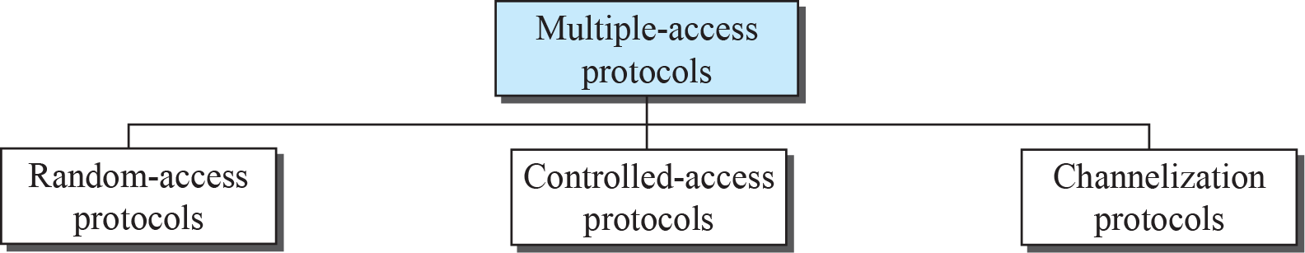

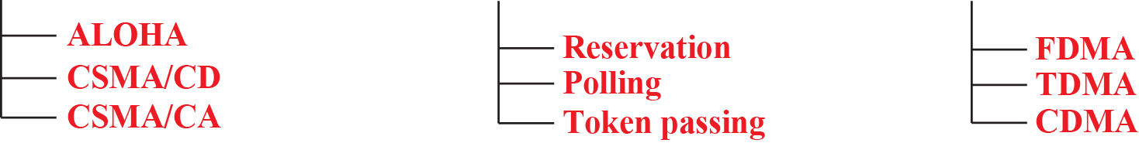

Q2. What is the advantage of token passing protocol over CSMA/CD protocol?

Answer: The CSMA/CD is not a deterministic protocol. A packet may be delivered after many (up to 15) collisions leading to long variable delay. An unfortunate packet may not get delivered at all. This feature makes CSMA/CD protocol unsuitable for real-time applications.

On the other hand, token passing protocol is a deterministic approach, which allows a packet to be delivered within a known time frame. It also allows priority to be assigned to packets.

Q3. What are the different types of cabling supported by standard Ethernet?

Answer:

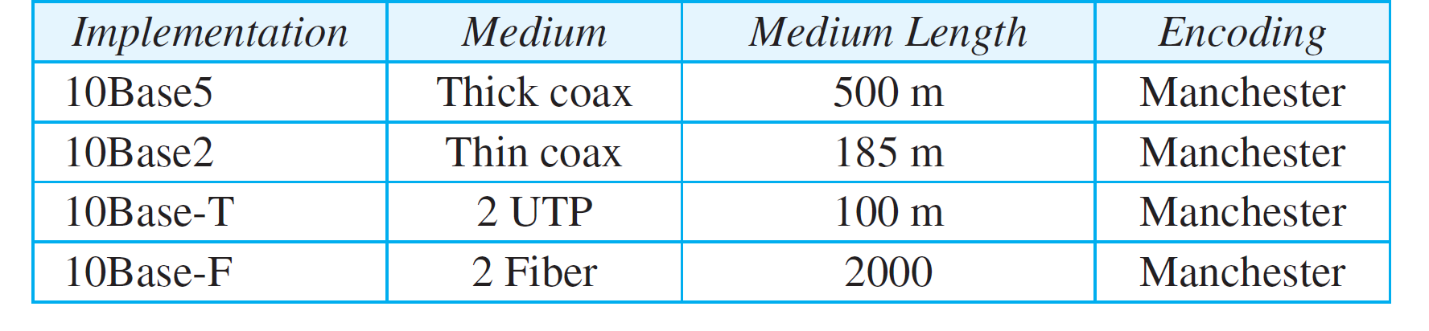

Q4. What is the difference between Piconet and Scatternet?

Answer: A piconet is the type of connection that is formed between two or more Bluetooth-enabled devices, one device takes the role of 'master', and all other devices assume a 'slave' role for synchronization reason.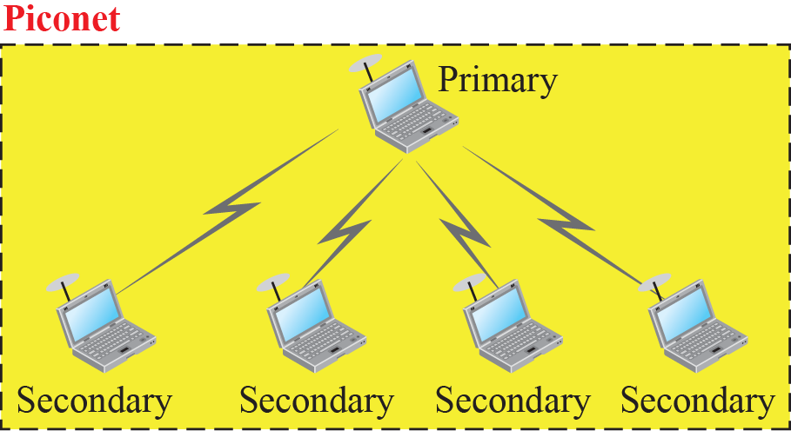

A scatternet is a number of interconnected piconets that supports communication between more than 8 devices. Scatternets can be formed when a member of one piconet (either the master or one of the slaves) elects to participate as a slave in a second, separate piconet.

