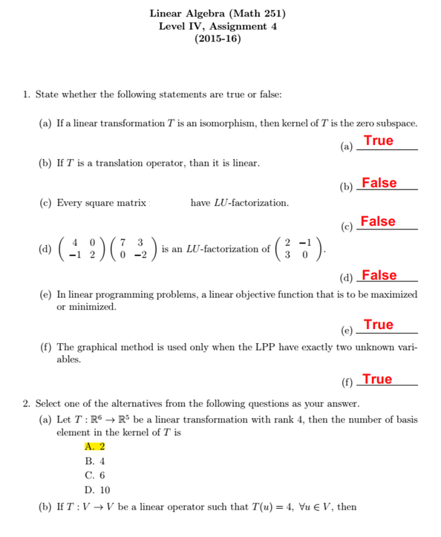

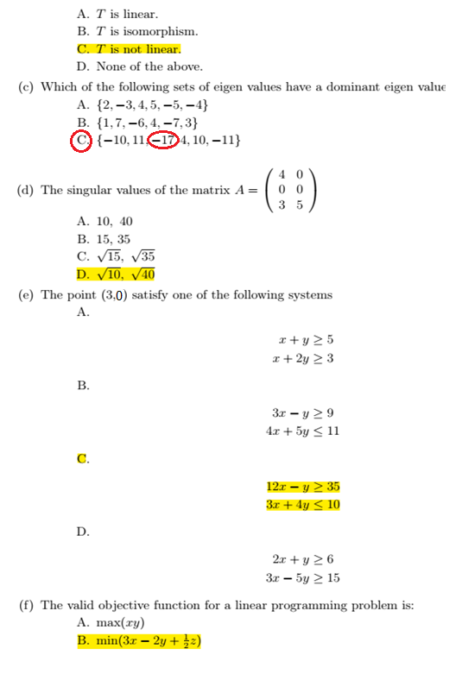
3. Show that the map T : R ² → R ² given by T(x, y) = (x + y, x − y) is linear.
T(x,y) = (x+y , x-y) ……… 1
If a = (a_{1,}a₂) and b = (b_{1,}b₂)
We have to show two things to be linear
1. T(a +b) = T(a)+T(b). (additivity.)
2. T(k a) = k T(a). (homogeneity.)

1. T(a +b) = T(a)+T(b). (additivity.)
T(a +b) = T((a_{1,}a₂) +(b_{1,}b₂))
= T(a₁₊b_{1,} a₂+b₂)
= (a₁ + b₁+ a₂+ b₂, a₁+b₁- a₂- b₂) from………. 1
= ( (a₁+ a₂) + (b₁+b₂) , (a₁- a₂) + (b₁- b₂) )
= (a₁+ a₂ , a₁- a₂) + (b₁+ b₂ , b₁- b₂) ……… 2
T(a) = T(a_{1,}a₂)
= (a₁+ a₂ , a₁- a₂) from………. 1
T(b) = T( b_{1,}b₂)
= (b₁+ b₂ , b₁- b₂) from………. 1
T(a)+T(b) = (a₁+ a₂ , a₁- a₂) + (b₁+ b₂ , b₁- b₂) ……… 3
While 2 = 3 then T(a +b) = T(a)+T(b)

2. T(k a) = k T(a). (homogeneity.)

T(k a) = T(k(a_{1,}a₂) )
= T(ka_{1,} ka₂)
= (ka₁+ ka_{2,} ka₁- ka₂) from………. 1
= k(a₁+ a_{2,} a₁- a₂)
= kT(a_{1,} a₂)
= kT(a)
So T(k a) = k T(a)
Therefore , T is linear transformations
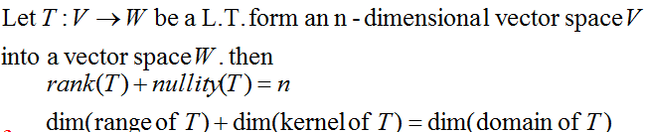
4. Verify rank-nullity theorem for the linear operator T : R ⁷ → R ⁷ having 4 elements in
the basis of kernel of T with 3 elements in the basis of image of T.

Rank(T) = dim(range or image of T) = 3
Nullity(T) = dim(kernel of T) = 4
Dim(domain of T)= n = 7
So 3 + 4 = 7 it is Achieves rank-nullity theorem
5. Find a LU-decomposition of the matrix A = $\left[\begin{matrix}5 & -1 \\ -1 & -1\end{matrix}\right]$
A= $\left[\begin{matrix}5 & -1 \\ -1 & -1\end{matrix}\right]$ $\left[\begin{matrix}* & 0 \\ * & *\end{matrix}\right]$
$\left[\begin{matrix}1 & -\frac{1}{5} \\ -1 & -1\end{matrix}\right]$ $\frac{1}{5}$ R₁ $\left[\begin{matrix}5 & 0 \\ * & *\end{matrix}\right]$
$\left[\begin{matrix}1 & -\frac{1}{5} \\ 0 & -\frac{6}{5}\end{matrix}\right]$ 1* R1 + R₂$→$ R₂ $\left[\begin{matrix}5 & 0 \\ -1 & *\end{matrix}\right]$
U= $\left[\begin{matrix}1 & -\frac{1}{5} \\ 0 & 1\end{matrix}\right]$ - $\frac{5}{6}$ R₂ L= $\left[\begin{matrix}5 & 0 \\ -1 & -\frac{6}{5}\end{matrix}\right]$
A = L * U
$\left[\begin{matrix}5 & -1 \\ -1 & -1\end{matrix}\right]$ = $\left[\begin{matrix}5 & 0 \\ -1 & -\frac{6}{5}\end{matrix}\right]$*$\left[\begin{matrix}1 & -\frac{1}{5} \\ 0 & 1\end{matrix}\right]$

6- Find the singular values of the matrix A = $\left[\begin{matrix}3 & 1 \\ 0 & 3 \\ 1 & 0\end{matrix}\right]$
The first step is to find the eigenvalues of the matrix
A^{T}A = $\left[\begin{matrix}3 & 0 & 1 \\ 1 & 3 & 0\end{matrix}\right]$ $\left[\begin{matrix}3 & 1 \\ 0 & 3 \\ 1 & 0\end{matrix}\right]$ = $\left[\begin{matrix}10 & 3 \\ 3 & 10\end{matrix}\right]$
Getting eigenvalues from characteristic equation of A^{T}A
Det (λ I-A)=0

$\left|\begin{matrix}λ-10 & -3 \\ -3 & λ-10\end{matrix}\right|$ = 0
${(λ-10)}^{2}$ – 9 = 0
$λ$² -20$λ$ + 100 -9 = 0
$λ$² -20$λ$ + 91 = 0
($λ$ -13)($λ$ -7) = 0
$λ$ = 13 , $λ$ = 7
singular values of the matrix A : $σ1$ = $\sqrt{13}$ , $σ2$ = $\sqrt{7}$

7. Find the maximum value of z = 50x + 18y subject to
2x + y ≤ 100
x + y ≤ 80
x ≥ 0, y ≥ 0
using graphical method.
For 2x+ y = 100
x | 0 | 50
y | 100 | 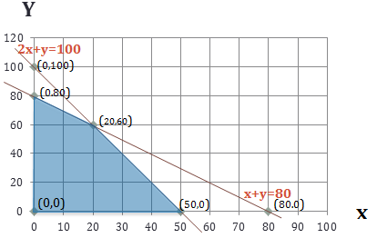  0
2*0+0$≤100$ True
For x+ y = 80
x | 0 | 80
y | 80 | 0
0+0$≤100$ True

By solving Two equation above we will get x and y of the point of the intersection of two lines
2x+ y = 100 2x+ y = 100
x+ y = 80 *-1 -x-y = -80 x = 20 , y = 60
Extreme Point | Value of z = 50x + 18y
(0,80)  (20,60)  (50,0)  (0,0) | 1440  2080  2500  0

The maximum value is $Z=2500$ and occurs at x = 50 and y = 0

