Linear Algebra (Math 251)
Level IV, Assignment 3
(2015-16)

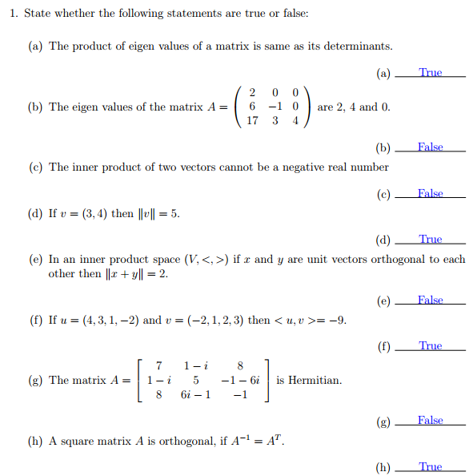

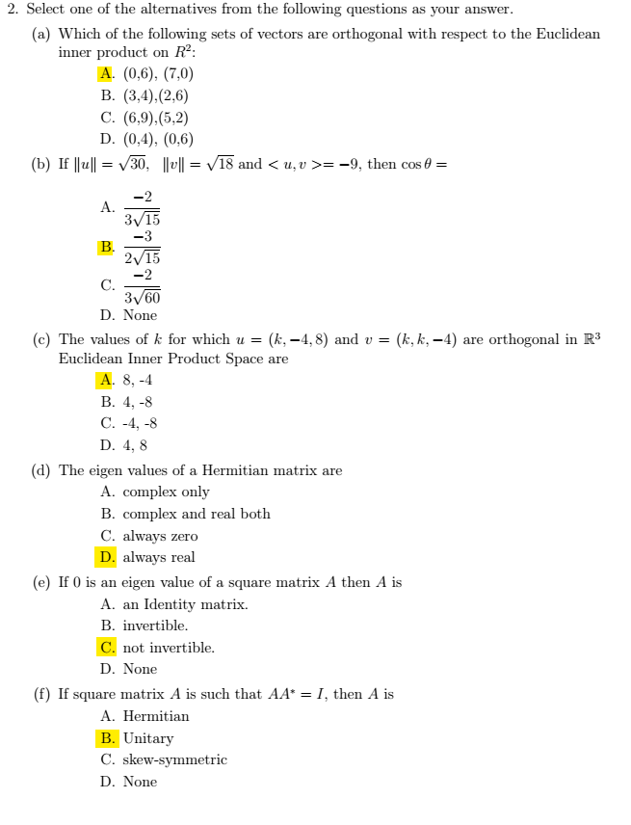

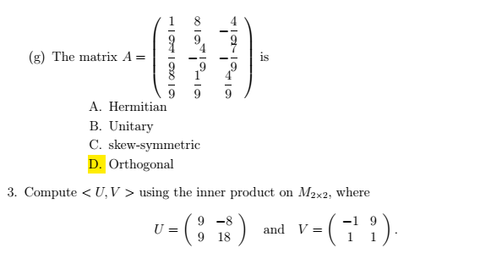
(U,V) = (9*-1)+(-8*9)+(9*1)+(18*1)
= -9-72+9+18 = -54
- Let R³ have the Euclidean inner product. Find the cosine of the angle θ between U =(-1,6,2) and V=(4,3,-5)
$$\cos{θ}=\frac{\left(\vec{u},\vec{v}\right)}{\left\|\vec{u}\right\|\left\|\vec{v}\right\|}$$
$$\left(\vec{u},\vec{v}\right)=\left(-1\right)\left(4\right)+\left(6\right)\left(3\right)+\left(2\right)\left(-5\right)=-4+18-10=4 \\ \left\|\vec{u}\right\|=\sqrt{{\left(-1\right)}^{2}+{\left(6\right)}^{2}+{\left(2\right)}^{2}}=\sqrt{1+36+4}=\sqrt{41}$$
$$\left\|\vec{v}\right\|=\sqrt{{\left(4\right)}^{2}+{\left(3\right)}^{2}+{\left(-5\right)}^{2}}=\sqrt{16+9+25}=\sqrt{50}$$
$$\cos{θ}=\frac{\left(\vec{u},\vec{v}\right)}{\left\|\vec{u}\right\|\left\|\vec{v}\right\|}= \frac{4}{\sqrt{41}\sqrt{50}}=\frac{4}{\sqrt{2050}}$$

- Find all the least squares solution of the linear equation

x₁ - x₂ = 2
2x₁ + 3x₂ = -1
4x₁ + 5x₂ = 2
$$A=\left[\begin{matrix}1 & -1 \\ 2 & 3 \\ 4 & 5\end{matrix}\right],b=\left[\begin{matrix}2 \\ -1 \\ 2\end{matrix}\right] \\ A^{T}A=\left[\begin{matrix}1 & 2 & 4 \\ -1 & 3 & 5\end{matrix}\right]\left[\begin{matrix}1 & -1 \\ 2 & 3 \\ 4 & 5\end{matrix}\right]=\left[\begin{matrix}21 & 25 \\ 25 & 35\end{matrix}\right]$$
$$A^{T}b=\left[\begin{matrix}1 & 2 & 4 \\ -1 & 3 & 5\end{matrix}\right]\left[\begin{matrix}2 \\ -1 \\ 2\end{matrix}\right]=\left[\begin{matrix}8 \\ 5\end{matrix}\right]$$
$$A^{T}Ax=A^{T}b$$
$$\left[\begin{matrix}21 & 25 \\ 25 & 35\end{matrix}\right]\left[\begin{matrix}x_{1} \\ x_{2}\end{matrix}\right]=\left[\begin{matrix}8 \\ 5\end{matrix}\right]$$
$$21x_{1}+25x_{2}=8$$
$$25x_{1}+35x_{2}=5$$
$$x_{1}=\frac{31}{22}, x_{2}=\frac{-19}{22}$$
6- Let $R^{3}$ have the Euclidean inner product. For which values of k are u and v orthogonal?
(a) u = (2, 1, 3); v = (1, 7, k) (b) u = (k, k, 1); v = (k, 5, 6)
When orthogonal U.V = 0 When orthogonal U.V = 0
(u.v)=(2*1)+(1*7)+(3k) = 0 (u.v)=$k^{2}+5k+6$ = 0
9+3k=0 3k= -9 (k+2)(k+3)=0
K= - 3 k = - 2, k = - 3
7- If P₂ have the usual inner product on polynomials and p = 1 - 2x + 3$x^{2}$, q = 3 + $x^{2}$ are the polynomials. Then find
(a)$\left\|p\right\|$
(b)$\left\|q\right\|$
(c) < p, q >

P=(1,-2,3), q=(3,0,1)
(a)$\left\|p\right\|$=$\sqrt{1^{2}+{(-2)}^{2}+3^{2}}=\sqrt{14}$
(b)$\left\|q\right\|$= $\sqrt{3^{2}+0^{2}+1^{2}}=\sqrt{10}$
(c) < p, q >=(1*3)+(-2*0)+(3*1)=6

8-Show that A= $\left[\begin{matrix}1 & i & 2+3i \\ -i & -3 & 1 \\ 2-3i & 1 & 2\end{matrix}\right]$ is Hermitian.
A square complex matrix A is said to be Hermitian * if
$A^{*}$= A
$A^{*}$= $\overline{A}$^{T}
$\overline{A}$= $\left[\begin{matrix}1 & -i & 2-3i \\ i & -3 & 1 \\ 2+3i & 1 & 2\end{matrix}\right]$

$\overline{A}$^{T}= $\left[\begin{matrix}1 & i & 2+3i \\ -i & -3 & 1 \\ 2-3i & 1 & 2\end{matrix}\right]=A^{*}$
While $A^{*}=A$
So A is Hermitian

