Due Date: 22 October 2015

- - - - - - - - - - - - - - - - - - - - - - - - - - - - - - - - - - - - - - - - - - -

Determine whether the statement is true or false:

- Vectors $\left(7,0,-2\right), \left(4,9,14\right)$ are orthogonal to each other. True
- $R^{2}is a subspace in R^{3}$. False
- All linearly independent set in a subspace $W$ is a basis for $W.$ False
- The transformation$T:R^{2}→R^{2}$, $T(x,y)=2x+3y$ is a linear transformation. True
- The column space of a $5 × 7$ matrix is in ${ R}^{5}.$ True
- If A is $m×n$ matrix then row space of A and column space of A have different dimension. False

- - - - - - - - - - - - - - - - - - - - - - - - - - - - - - - - - - - - - - - - - - -

For Each Question, Choose the Correct Answer from the Multiple-Choice List.

- If $u=(5,1,4)$ and $v=(-1, 0,2)$are two vectors in $R^{3}$. Then the cross product $u×v$:
a. $(-5, 0,8)$
b. $(4,2,6)$
c. $(2,-14, 1)$
d. $(0,0,0)$

- Let $T_{1}\left(v_{1},v_{2}\right)=\left(v_{1}-v_{2},v_{1}+v_{2}\right)$ and $T_{2}\left(v_{1},v_{2}\right)=\left(2v_{2},2v_{1}\right)$. The value of $T_{1}(T_{2}\left(v_{1},v_{2}\right))$ is:
- $(2v_{2}+2v_{1},2v_{1}-2v_{2})$
- $\left(2v_{2}-2v_{1},2v_{1}+2v_{2}\right)$
- $\left(2v_{1}-2v_{2},2v_{1}+2v_{2}\right)$
- $\left(2v_{1}+2v_{1},2v_{1}-2v_{2}\right)$

- Let $S=\{v_{1},v_{2},v_{3}\}$ is a basis of $V$ and $v_{2}=3v_{1}-5v_{2}.$ Then the coordinate vector of $V$ relative to $S ((v)_{s})$ is:

- $(3,5,0)$
- $(3,0,-5)$
- $(5,-3)$
- $(3,-5)$

$4.$A linear combination formed by the vectors$w_{1}=\left(1,1,0\right)$, $w_{2}=\left(0,1,-2\right)$ and $w_{3}=\left(2,0,4\right)$ is:

- $w_{3}={4w}_{1}-3w_{2}$
- $w_{2}=w_{1}+w_{3}$
- $w_{3}={2w}_{1}-2w_{2}$
- $w_{1}={-w}_{2}-w_{3}$
Solve the following questions:

- If $u=(6,-2, -3)$ and $v=(1,1,1)$. Find $cosθ$, where$θ$ is the angle between $u$ and $v$.

$cosθ$= $\frac{u.v}{\left\|u\right\|\left\|v\right\|}$ = $\frac{\left(6,-12,-3\right).(1,1,1)}{\sqrt{(}{6)}^{2}+({-2)}^{2}+({-3)}^{2}. \sqrt{{(1)}^{2}+{(1)}^{2}+{(1)}^{2}}}$

=$\frac{(6)+\left(-2\right)+(-3)}{\sqrt{49} . \sqrt{3}} cosθ$ = $\frac{1}{7\sqrt{3}}$
Let $W=\left\{\left[\begin{matrix}a+2b \\ 5b \\ 7a+b\end{matrix}\right], | a, b ϵ R\right\}$be a subset $R^{3}$. Find a $\left[\begin{matrix}a+2b \\ 5b \\ 7a+b\end{matrix}\right]=$ $\left[\begin{matrix}a \\ 0 \\ 7a\end{matrix}\right]+\left[\begin{matrix}2b \\ 5b \\ b\end{matrix}\right]=a\left[\begin{matrix}1 \\ 0 \\ 7\end{matrix}\right] +b\left[\begin{matrix}2 \\ 5 \\ 1\end{matrix}\right].$
$W=\left\{a\left[\begin{matrix}1 \\ 0 \\ 7\end{matrix}\right] +b\left[\begin{matrix}2 \\ 5 \\ 1\end{matrix}\right] | a,b ϵ R\right\}$is a subspace of $R^{3}.$
Let $S=\left\{\left[\begin{matrix}1 \\ 0 \\ 7\end{matrix}\right] ,\left[\begin{matrix}2 \\ 5 \\ 1\end{matrix}\right]\right\}.$
Since $W=Span (S)$, and S is linearly independent.
Then $S$ is a basis for $W$.

- Let $T\left(u_{1},u_{2}\right)=(2u_{1}, 2u_{2},{2u}_{1}+2u_{2}$), find the domain, codomain and the image of $\left(1,3\right)$.

Solution:
The domain is $R^{2}$ and the codomain is $R^{3}$.
The image of $\left(1,3\right)=(2,6,8)$.

- Given the $3×4$ matrix. Find the basis for Row space of A and its dimension.
$A$=$\left[\begin{matrix}1 & 4 & \begin{matrix}5 & 2\end{matrix} \\ 2 & 1 & \begin{matrix}3 & 0\end{matrix} \\ -1 & 3 & \begin{matrix}2 & 2\end{matrix}\end{matrix}\right]$

Reducing A to row echelon form
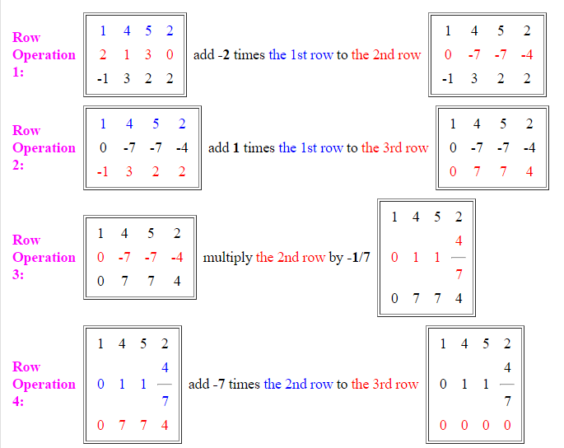

$R$=$\left[\begin{matrix}1 & 4 & \begin{matrix}5 & 2\end{matrix} \\ 0 & 1 & \begin{matrix}1 & \frac{4}{7}\end{matrix} \\ 0 & 0 & \begin{matrix}0 & 0\end{matrix}\end{matrix}\right]$

the nonzero row vectors of R form a basis for the row space of R and hence form a
basis for the row space of A. These basis vectors are:

$$r1=\left[1 4 5 2 \right]$$

$$r2=[0 1 1 \frac{4}{7} ]$$
and its dimension is 2 (the number of rwos with leading 1 ′s)

