**Chapter 8:**

**Memory Management Strategies**

* Background
* Swapping
* Contiguous Memory Allocation
* Segmentation
* Paging
* Structure of the Page Table
* Example: The Intel 32 and 64-bit Architectures
* Example: ARM Architecture

**Objectives**

* To provide a detailed description of various ways of organizing memory hardware
* To discuss various memory-management techniques, including paging and segmentation
* To provide a detailed description of the Intel Pentium, which supports both pure segmentation and segmentation with paging

**Background**

* Program must be brought (from disk) into memory and placed within a process for it to be run
* Main memory and registers are only storage CPU can access directly
* Memory unit only sees a stream of addresses + read requests, or address + data and write requests
* Register access in one CPU clock (or less)
* Main memory can take many cycles, causing a **stall**
* **Cache** sits between main memory and CPU registers
* Protection of memory required to ensure correct operation

**Base and Limit Registers**

* A pair of **base** and **limit** **registers** define the logical address space
* CPU must check every memory access generated in user mode to be sure it is between base and limit for that user

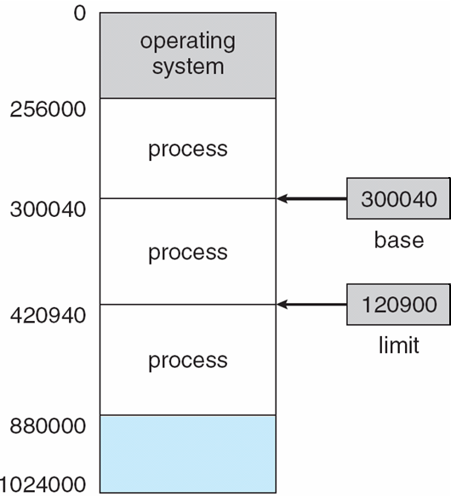

**Hardware Address Protection with Base and Limit Registers**

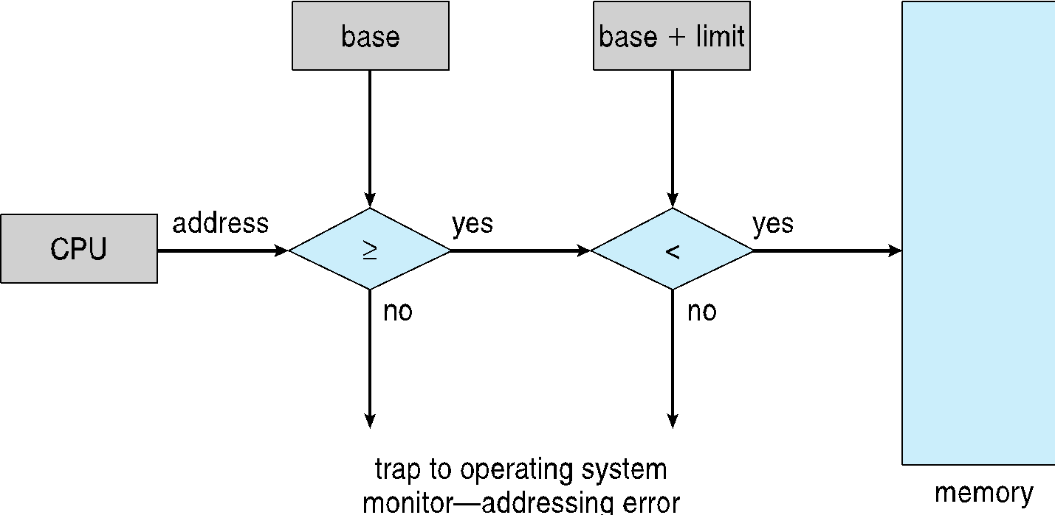

**Address Binding**

* **Programs on disk, ready to be brought into memory to execute form an input queue**
  + Without support, must be loaded into address 0000
* **Inconvenient to have first user process physical address always at 0000** 
  + How can it not be?
* **Further, addresses represented in different ways at different stages of a program’s life**
  + Source code addresses usually symbolic
  + Compiled code addresses **bind** to relocatable addresses
    - **i.e. “14 bytes from beginning of this module”**
  + Linker or loader will bind relocatable addresses to absolute addresses
    - **i.e. 74014**
  + Each binding maps one address space to another

**Binding of Instructions and Data to Memory**

* Address binding of instructions and data to memory addresses can happen at three different stages
  + **Compile time:** If memory location known a priori, **absolute code** can be generated; must recompile code if starting location changes
  + **Load time**: Must generate **relocatable code** if memory location is not known at compile time
  + **Execution time**: Binding delayed until run time if the process can be moved during its execution from one memory segment to another
    - Need hardware support for address maps (e.g., base and limitregisters)

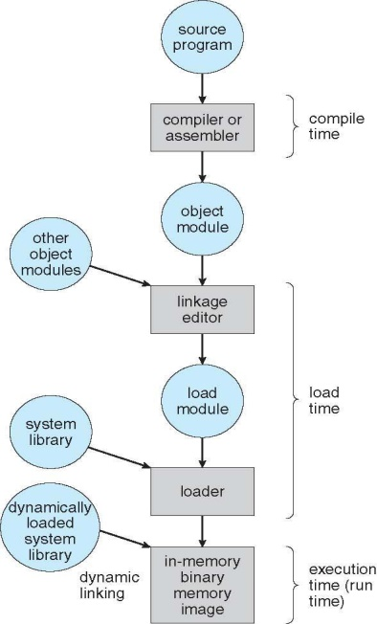

**Multistep Processing of a User Program**

**Logical vs. Physical Address Space**

* The concept of a logical address space that is bound to a separate **physical address space** is central to proper memory management
  + **Logical address** – generated by the CPU; also referred to as **virtual address**
  + **Physical address** – address seen by the memory unit
* Logical and physical addresses are the same in compile-time and load-time address-binding schemes; logical (virtual) and physical addresses differ in execution-time address-binding scheme
* **Logical address space** is the set of all logical addresses generated by a program
* **Physical address space** is the set of all physical addresses generated by a program

**Memory-Management Unit (MMU)**

* Hardware device that at run time maps virtual to physical address
* Many methods possible, covered in the rest of this chapter
* To start, consider simple scheme where the value in the relocation register is added to every address generated by a user process at the time it is sent to memory
  + Base register now called **relocation register**
  + MS-DOS on Intel 80x86 used 4 relocation registers
* The user program deals with *logical* addresses; it never sees the *real* physical addresses
  + Execution-time binding occurs when reference is made to location in memory
  + Logical address bound to physical addresses

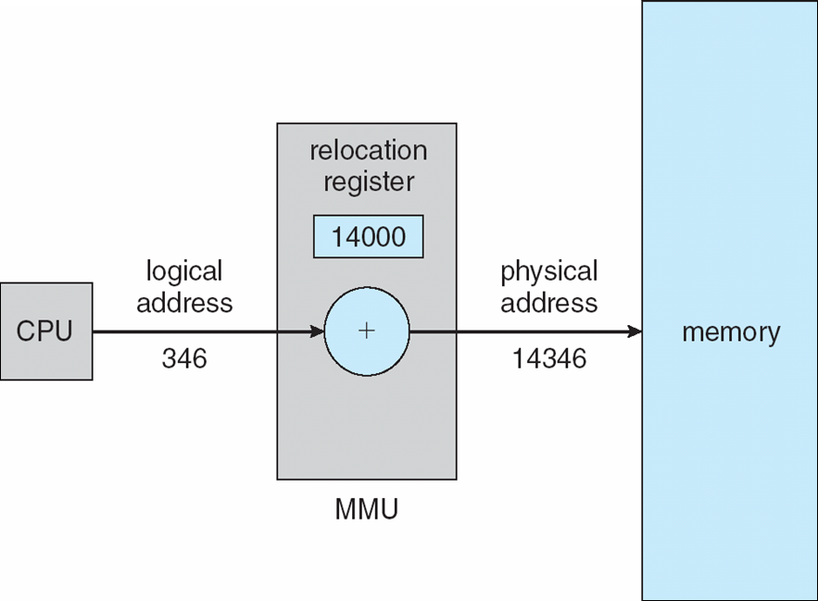**Dynamic relocation using a relocation register**

* Routine is not loaded until it is called
* Better memory-space utilization; unused routine is never loaded
* All routines kept on disk in relocatable load format
* Useful when large amounts of code are needed to handle infrequently occurring cases
* No special support from the operating system is required
  + Implemented through program design
  + OS can help by providing libraries to implement dynamic loading

**Dynamic Linking**

* **Static linking** – system libraries and program code combined by the loader into the binary program image
* Dynamic linking –linking postponed until execution time
* Small piece of code, **stub**, used to locate the appropriate memory-resident library routine
* Stub replaces itself with the address of the routine, and executes the routine
* Operating system checks if routine is in processes’ memory address
  + If not in address space, add to address space
* Dynamic linking is particularly useful for libraries
* System also known as **shared libraries**
* Consider applicability to patching system libraries
  + Versioning may be needed

**Swapping**

* A process can be **swapped** temporarily out of memory to a backing store, and then brought back into memory for continued execution
  + Total physical memory space of processes can exceed physical memory
* **Backing store** – fast disk large enough to accommodate copies of all memory images for all users; must provide direct access to these memory images
* **Roll out, roll in** – swapping variant used for priority-based scheduling algorithms; lower-priority process is swapped out so higher-priority process can be loaded and executed
* Major part of swap time is transfer time; total transfer time is directly proportional to the amount of memory swapped
* System maintains a **ready queue** of ready-to-run processes which have memory images on disk
* Does the swapped out process need to swap back in to same physical addresses?
* Depends on address binding method
  + Plus consider pending I/O to / from process memory space
* Modified versions of swapping are found on many systems (i.e., UNIX, Linux, and Windows)
  + Swapping normally disabled
  + Started if more than threshold amount of memory allocated
  + Disabled again once memory demand reduced below threshold

**Schematic View of Swapping**

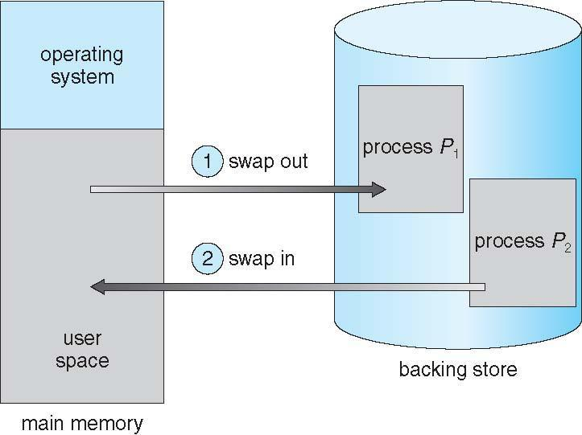

**Context Switch Time including Swapping**

* If next processes to be put on CPU is not in memory, need to swap out a process and swap in target process
* Context switch time can then be very high
* 100MB process swapping to hard disk with transfer rate of 50MB/sec
  + Swap out time of 2000 ms
  + Plus swap in of same sized process
  + Total context switch swapping component time of 4000ms (4 seconds)
* Can reduce if reduce size of memory swapped – by knowing how much memory really being used
  + System calls to inform OS of memory use via request memory() and release memory()
* Other constraints as well on swapping
  + Pending I/O – can’t swap out as I/O would occur to wrong process
  + Or always transfer I/O to kernel space, then to I/O device
    - Known as **double buffering**, adds overhead
* Standard swapping not used in modern operating systems
  + But modified version common
    - Swap only when free memory extremely low

**Swapping on Mobile Systems**

* **Not typically supported**
  + **Flash memory based**
    - Small amount of space
    - Limited number of write cycles
    - Poor throughput between flash memory and CPU on mobile platform
* **Instead use other methods to free memory if low**
  + **iOS asks apps to voluntarily relinquish allocated memory**
    - Read-only data thrown out and reloaded from flash if needed
    - Failure to free can result in termination
  + **Android terminates apps if low free memory, but first writes application state to flash for fast restart**
  + **Both OSes support paging as discussed below**

**Contiguous Allocation**

* Main memory must support both OS and user processes
* Limited resource, must allocate efficiently
* Contiguous allocation is one early method
* **Main memory usually into two partitions:**
  + Resident operating system, usually held in low memory with interrupt vector
  + User processes then held in high memory
  + Each process contained in single contiguous section of memory
* **Relocation registers used to protect user processes from each other, and from changing operating-system code and data**
  + Base register contains value of smallest physical address
  + Limit register contains range of logical addresses – each logical address must be less than the limit register
  + MMU maps logical address *dynamically*
  + Can then allow actions such as kernel code being **transient** and kernel changing size

**Hardware Support for Relocation and Limit Registers**

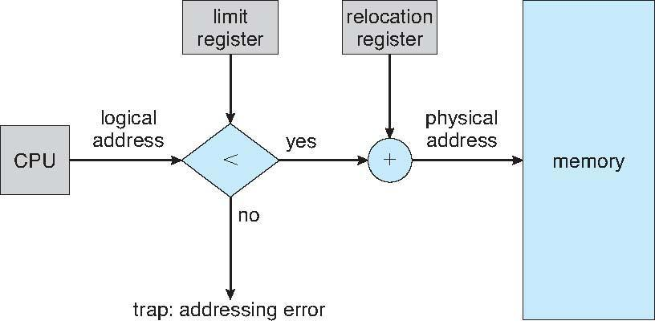

**Contiguous Allocation (Cont.)**

* Multiple-partition allocation
  + Degree of multiprogramming limited by number of partitions
  + **Variable-partition** sizes for efficiency (sized to a given process’ needs)
  + **Hole** – block of available memory; holes of various size are scattered throughout memory
  + When a process arrives, it is allocated memory from a hole large enough to accommodate it
  + Process exiting frees its partition, adjacent free partitions combined
  + Operating system maintains information about:  
    a) allocated partitions b) free partitions (hole)

OS

process 5

process 8

process 2

OS

process 5

process 2

OS

process 5

process 2

OS

process 5

process 9

process 2

process 9

process 10

**Dynamic Storage-Allocation Problem**

* **First-fit**: Allocate the ***first*** hole that is big enough
* **Best-fit**: Allocate the ***smallest*** hole that is big enough; must search entire list, unless ordered by size
  + Produces the smallest leftover hole
* **Worst-fit**: Allocate the ***largest*** hole; must also search entire list
  + Produces the largest leftover hole

**Fragmentation**

* **External Fragmentation** – total memory space exists to satisfy a request, but it is not contiguous
* **Internal Fragmentation** – allocated memory may be slightly larger than requested memory; this size difference is memory internal to a partition, but not being used
* First fit analysis reveals that given *N* blocks allocated, 0.5 *N* blocks lost to fragmentation
  + 1/3 may be unusable -> **50-percent rule**
* Reduce external fragmentation by **compaction**
  + Shuffle memory contents to place all free memory together in one large block
  + Compaction is possible *only* if relocation is dynamic, and is done at execution time
  + I/O problem
    - Latch job in memory while it is involved in I/O
    - Do I/O only into OS buffers
* Now consider that backing store has same fragmentation problems

**Segmentation**

* Memory-management scheme that supports user view of memory
* A program is a collection of segments
  + A segment is a logical unit such as:

main program

procedure

function

method

object

local variables, global variables

common block

stack

symbol table

arrays

**User’s View of a Program**

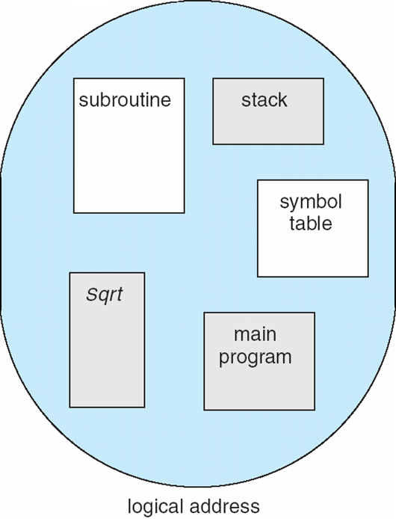

**Logical View of Segmentation**

1

3

2

4

1

4

2

3

physical memory space

user space

**Segmentation Architecture**

* Logical address consists of a two tuple:

<segment-number, offset>,

* **Segment table** – maps two-dimensional physical addresses; each table entry has:
  + **base** – contains the starting physical address where the segments reside in memory
  + **limit** – specifies the length of the segment
* **Segment-table base register (STBR)** points to the segment table’s location in memory
* **Segment-table length register (STLR)** indicates number of segments used by a program;

segment number ***s*** is legal if ***s*** < **STLR**

* **Protection**
  + With each entry in segment table associate:
    - validation bit = 0 ⇒ illegal segment
    - read/write/execute privileges
* Protection bits associated with segments; code sharing occurs at segment level
* Since segments vary in length, memory allocation is a dynamic storage-allocation problem
* A segmentation example is shown in the following diagram

**Segmentation Hardware**

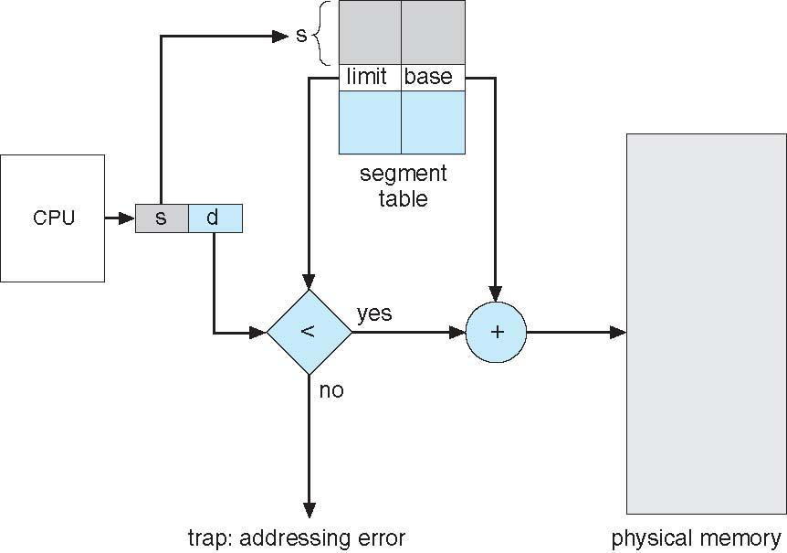

**Paging**

* Physical address space of a process can be noncontiguous; process is allocated physical memory whenever the latter is available
  + Avoids external fragmentation
  + Avoids problem of varying sized memory chunks
* Divide physical memory into fixed-sized blocks called **frames**
  + Size is power of 2, between 512 bytes and 16 Mbytes
* Divide logical memory into blocks of same size called **pages**
* Keep track of all free frames
* To run a program of size ***N***pages, need to find ***N*** free frames and load program
* Set up a **page table** to translate logical to physical addresses
* Backing store likewise split into pages
* Still have Internal fragmentation

**Address Translation Scheme**

* Address generated by CPU is divided into:
  + **Page number** (***p***) – used as an index into a **page table** which contains base address of each page in physical memory
  + **Page offset** (***d***) – combined with base address to define the physical memory address that is sent to the memory unit

page number

page offset

*p*

*d*

*m - n*

*n*

* + For given logical address space 2*m* and page size*2*n

**Paging Hardware**

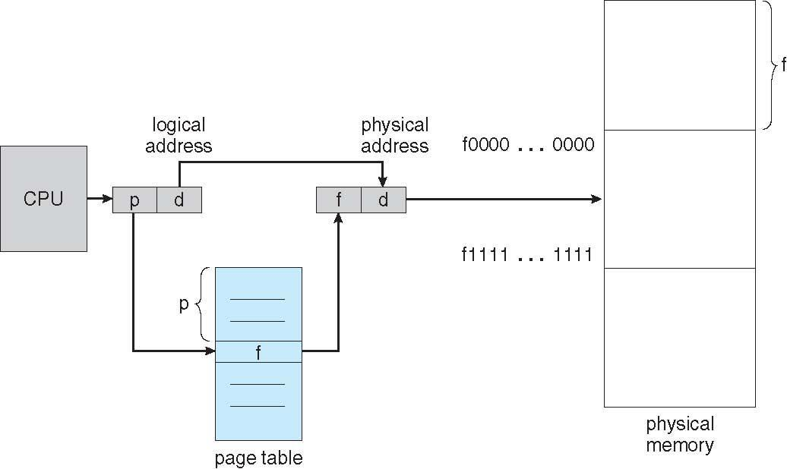

**Paging Model of Logical and Physical Memory**

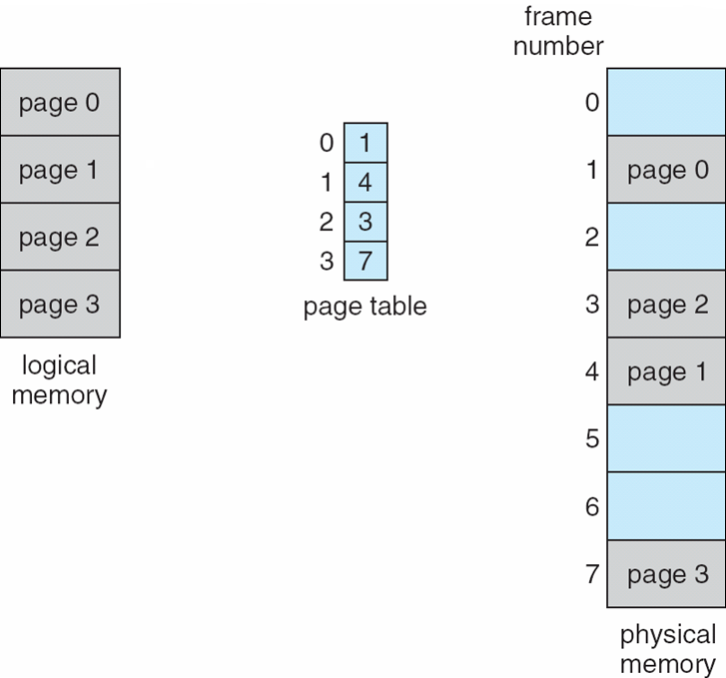

**Paging Example**

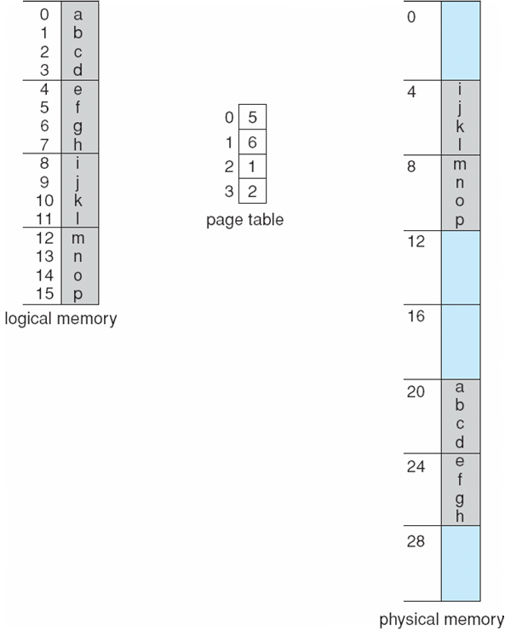

**Paging (Cont.)**

* Calculating internal fragmentation
  + Page size = 2,048 bytes
  + Process size = 72,766 bytes
  + 35 pages + 1,086 bytes
  + Internal fragmentation of 2,048 - 1,086 = 962 bytes
  + Worst case fragmentation = 1 frame – 1 byte
  + On average fragmentation = 1 / 2 frame size
  + So small frame sizes desirable?
  + But each page table entry takes memory to track
  + Page sizes growing over time
    - Solaris supports two page sizes – 8 KB and 4 MB
* Process view and physical memory now very different
* By implementation process can only access its own memory

**Free Frames**

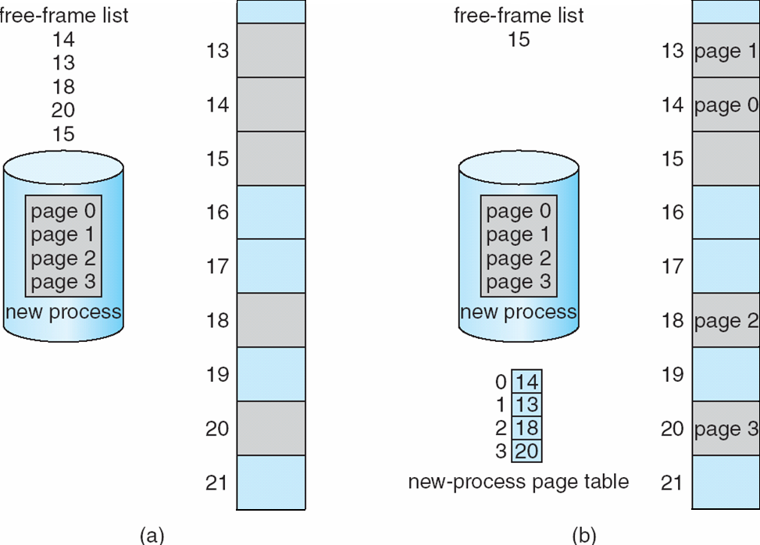

**Implementation of Page Table**

* Page table is kept in main memory
* **Page-table base register** (**PTBR**) points to the page table
* **Page-table length register** (**PTLR**) indicates size of the page table
* In this scheme every data/instruction access requires two memory accesses
  + One for the page table and one for the data / instruction
* The two memory access problem can be solved by the use of a special fast-lookup hardware cache called **associative memory** or **translation look-aside buffers** (**TLBs**)
* Some TLBs store **address-space identifiers** (**ASIDs**)in each TLB entry – uniquely identifies each process to provide address-space protection for that process
  + Otherwise need to flush at every context switch
* TLBs typically small (64 to 1,024 entries)
* On a TLB miss, value is loaded into the TLB for faster access next time
  + Replacement policies must be considered
  + Some entries can be **wired down** for permanent fast access

**Associative Memory**

* Associative memory – parallel search

Page #

Frame #

* Address translation (p, d)
  + If p is in associative register, get frame # out
  + Otherwise get frame # from page table in memory

**Paging Hardware With TLB**

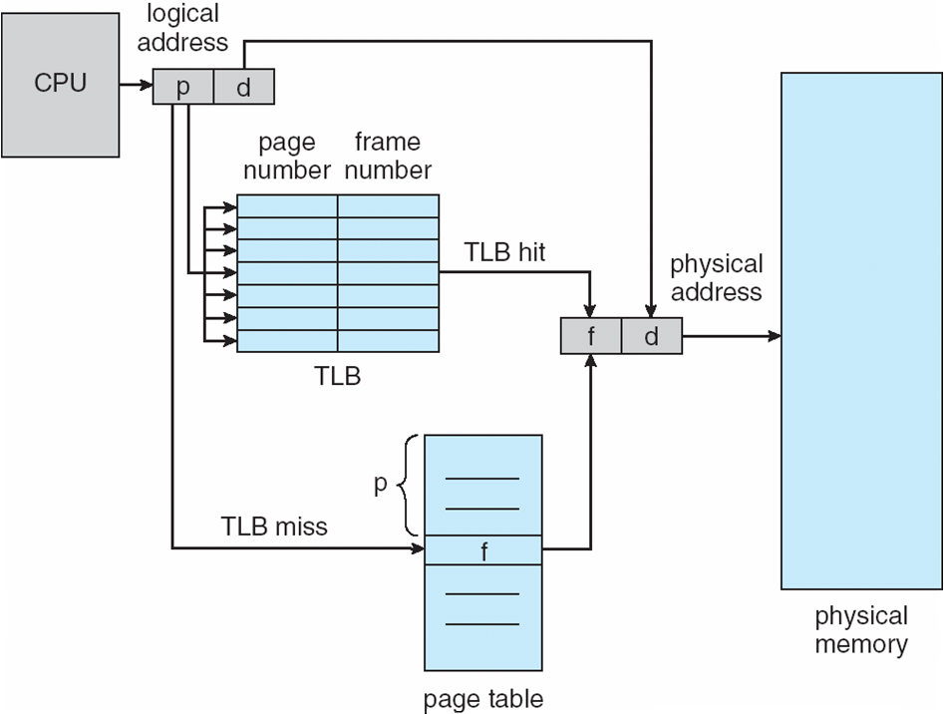

**Effective Access Time**

* Associative Lookup = ε time unit
  + Can be < 10% of memory access time
* Hit ratio = α
  + Hit ratio – percentage of times that a page number is found in the associative registers; ratio related to number of associative registers
* Consider α = 80%, ε = 20ns for TLB search, 100ns for memory access
* **Effective Access Time** (**EAT**)

EAT = (1 + ε) α + (2 + ε)(1 – α)

= 2 + ε – α

* Consider α = 80%, ε = 20ns for TLB search, 100ns for memory access
  + EAT = 0.80 x 100 + 0.20 x 200 = 120ns
* Consider more realistic hit ratio -> α = 99%, ε = 20ns for TLB search, 100ns for memory access
  + EAT = 0.99 x 100 + 0.01 x 200 = 101ns

**Memory Protection**

* Memory protection implemented by associating protection bit with each frame to indicate if read-only or read-write access is allowed
  + Can also add more bits to indicate page execute-only, and so on
* **Valid-invalid** bit attached to each entry in the page table:
  + “valid” indicates that the associated page is in the process’ logical address space, and is thus a legal page
  + “invalid” indicates that the page is not in the process’ logical address space
  + Or use **page-table length register** (**PTLR**)
* Any violations result in a trap to the kernel

**Valid (v) or Invalid (i) Bit In A Page Table**

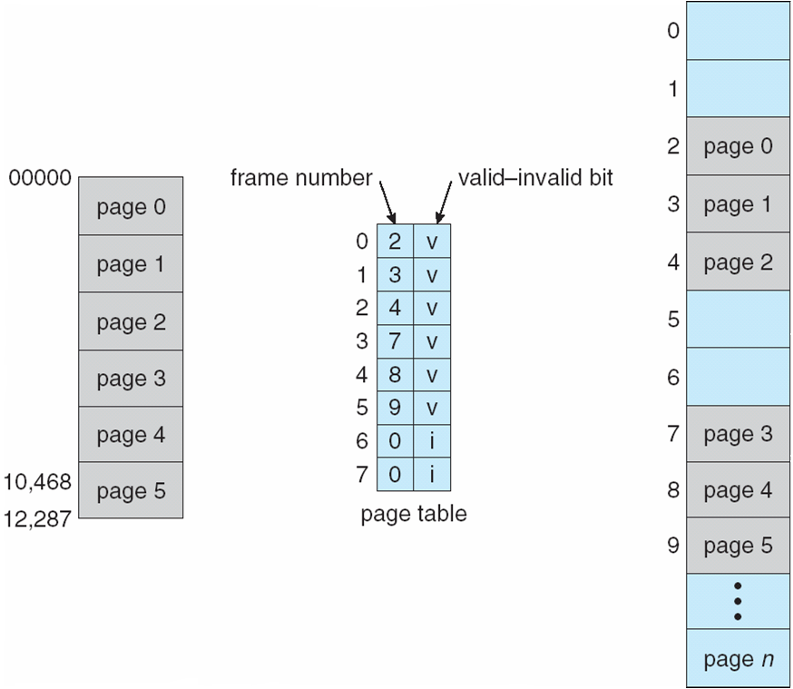

**Shared Pages**

* **Shared code**
  + One copy of read-only (**reentrant**) code shared among processes (i.e., text editors, compilers, window systems)
  + Similar to multiple threads sharing the same process space
  + Also useful for interprocess communication if sharing of read-write pages is allowed
* **Private code and data**
  + Each process keeps a separate copy of the code and data
  + The pages for the private code and data can appear anywhere in the logical address space

**Shared Pages Example**

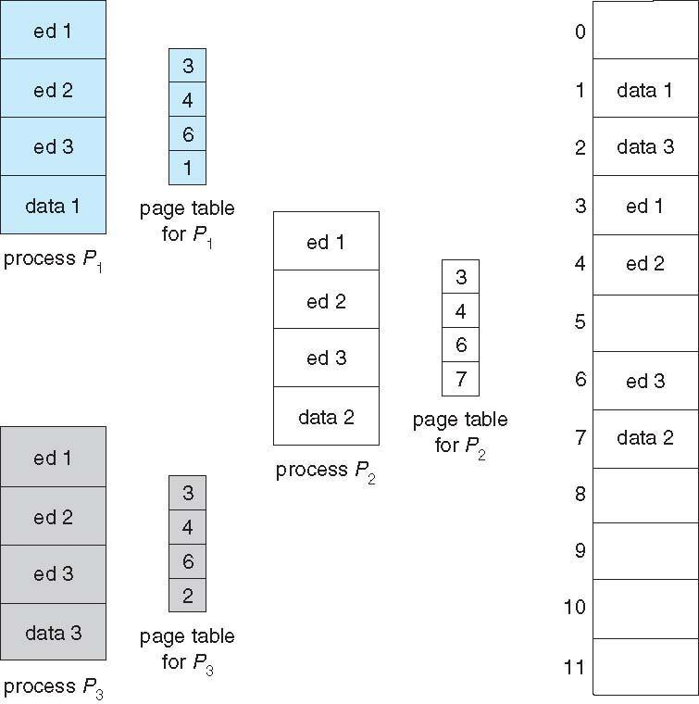

**Structure of the Page Table**

* Memory structures for paging can get huge using straight-forward methods
  + Consider a 32-bit logical address space as on modern computers
  + Page size of 4 KB (212)
  + Page table would have 1 million entries (232 / 212)
  + If each entry is 4 bytes -> 4 MB of physical address space / memory for page table alone
    - That amount of memory used to cost a lot
    - Don’t want to allocate that contiguously in main memory
* Hierarchical Paging
* Hashed Page Tables
* Inverted Page Tables

**Hierarchical Page Tables**

* Break up the logical address space into multiple page tables
* A simple technique is a two-level page table
* We then page the page table

**Two-Level Page-Table Scheme**

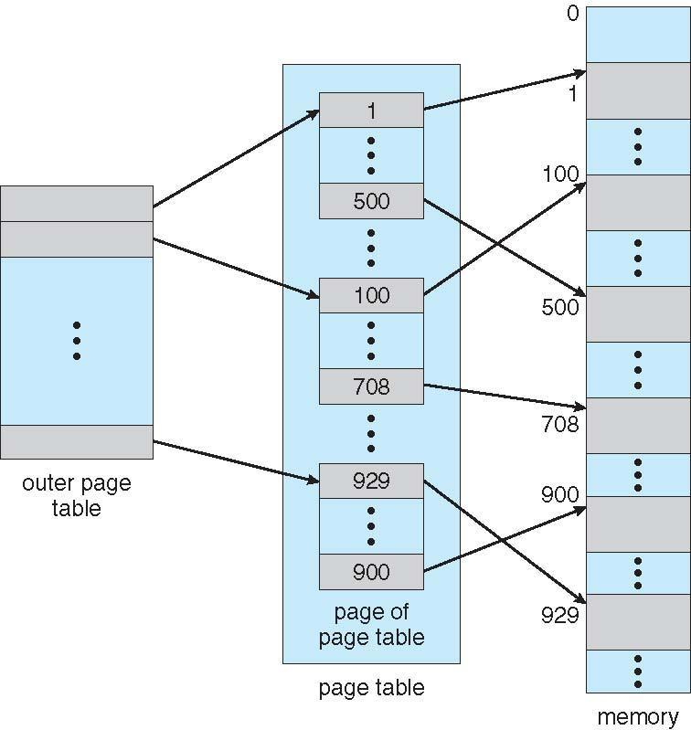

**Two-Level Paging Example**

* A logical address (on 32-bit machine with 1K page size) is divided into:
  + a page number consisting of 22 bits
  + a page offset consisting of 10 bits
* Since the page table is paged, the page number is further divided into:
  + a 12-bit page number
  + a 10-bit page offset
* Thus, a logical address is as follows:

page number

page offset

*p*1

*p*2

*d*

12

10

10

* where *p1* is an index into the outer page table, and *p2* is the displacement within the page of the inner page table
* Known as **forward-mapped page table**

**Address-Translation Scheme**

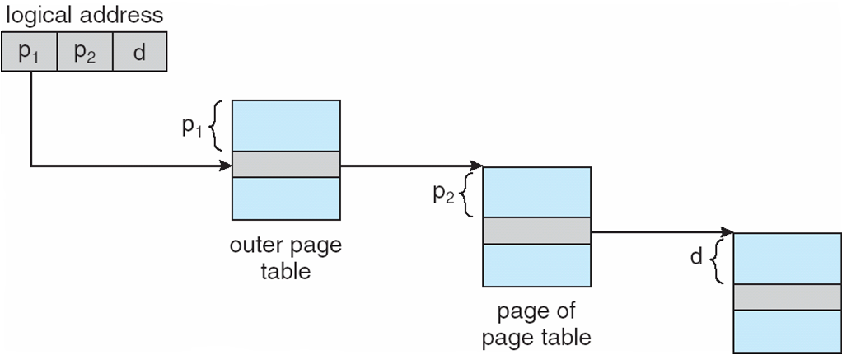

**64-bit Logical Address Space**

* Even two-level paging scheme not sufficient
* If page size is 4 KB (212)
  + Then page table has 252 entries
  + If two level scheme, inner page tables could be 210 4-byte entries
  + Address would look like

outer page

page offset

*p*1

*p*2

*d*

42

10

12

inner page

* + Outer page table has 242 entries or 244 bytes
  + One solution is to add a 2nd outer page table
  + But in the following example the 2nd outer page table is still 234 bytes in size
    - And possibly 4 memory access to get to one physical memory location

**Three-level Paging Scheme**

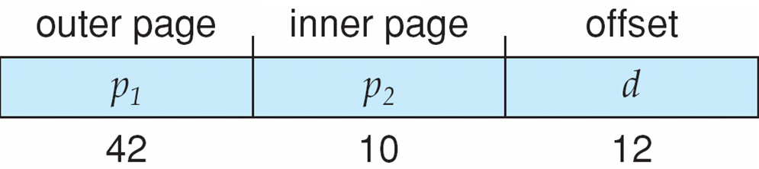

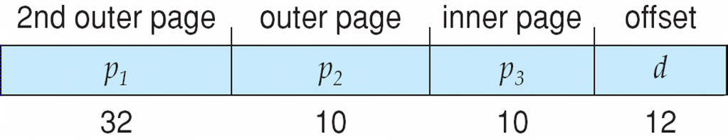

**Hashed Page Tables**

* Common in address spaces > 32 bits
* The virtual page number is hashed into a page table
  + This page table contains a chain of elements hashing to the same location
* Each element contains (1) the virtual page number (2) the value of the mapped page frame (3) a pointer to the next element
* Virtual page numbers are compared in this chain searching for a match
  + If a match is found, the corresponding physical frame is extracted
* Variation for 64-bit addresses is **clustered page tables**
  + Similar to hashed but each entry refers to several pages (such as 16) rather than 1
  + Especially useful for **sparse** address spaces (where memory references are non-contiguous and scattered)

**Hashed Page Table**

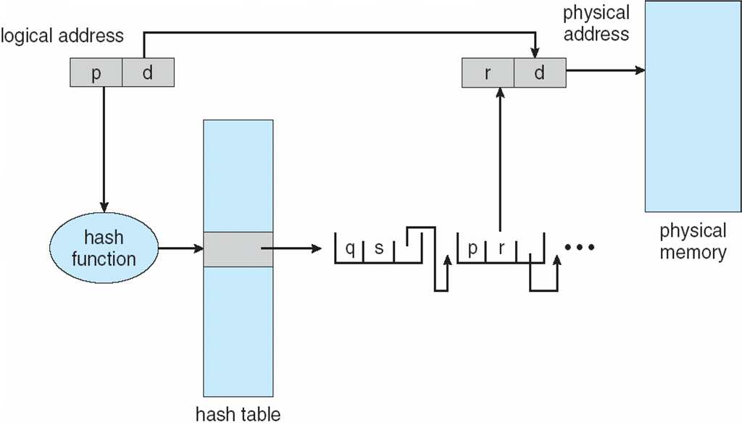

**Inverted Page Table**

* Rather than each process having a page table and keeping track of all possible logical pages, track all physical pages
* One entry for each real page of memory
* Entry consists of the virtual address of the page stored in that real memory location, with information about the process that owns that page
* Decreases memory needed to store each page table, but increases time needed to search the table when a page reference occurs
* Use hash table to limit the search to one — or at most a few — page-table entries
  + TLB can accelerate access
* But how to implement shared memory?
  + One mapping of a virtual address to the shared physical address

**Inverted Page Table Architecture**

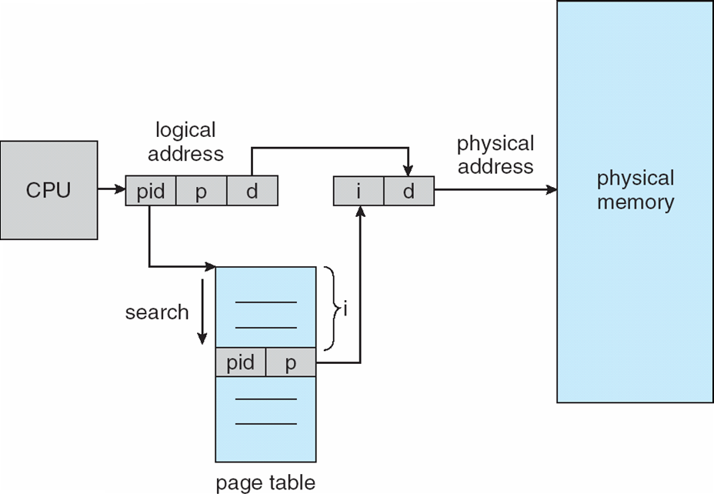

**Oracle SPARC Solaris**

* Consider modern, 64-bit operating system example with tightly integrated HW
  + Goals are efficiency, low overhead
* Based on hashing, but more complex
* Two hash tables
  + One kernel and one for all user processes
  + Each maps memory addresses from virtual to physical memory
  + Each entry represents a contiguous area of mapped virtual memory,
    - More efficient than having a separate hash-table entry for each page
  + Each entry has base address and span (indicating the number of pages the entry represents)
* TLB holds translation table entries (TTEs) for fast hardware lookups
  + A cache of TTEs reside in a translation storage buffer (TSB)
    - Includes an entry per recently accessed page
* Virtual address reference causes TLB search
  + If miss, hardware walks the in-memory TSB looking for the TTE corresponding to the address
    - If match found, the CPU copies the TSB entry into the TLB and translation completes
    - If no match found, kernel interrupted to search the hash table
      * The kernel then creates a TTE from the appropriate hash table and stores it in the TSB, Interrupt handler returns control to the MMU, which completes the address translation.

**Example: The Intel 32 and 64-bit Architectures**

* Dominant industry chips
* Pentium CPUs are 32-bit and called IA-32 architecture
* Current Intel CPUs are 64-bit and called IA-64 architecture
* Many variations in the chips, cover the main ideas here

**Example: The Intel IA-32 Architecture**

* Supports both segmentation and segmentation with paging
  + Each segment can be 4 GB
  + Up to 16 K segments per process
  + Divided into two partitions
    - First partition of up to 8 K segments are private to process (kept in **local descriptor table** (**LDT**))
    - Second partition of up to 8K segments shared among all processes (kept in **global descriptor table** (**GDT**))
* CPU generates logical address
  + Selector given to segmentation unit
    - Which produces linear addresses
  + Linear address given to paging unit
    - Which generates physical address in main memory
    - Paging units form equivalent of MMU
    - Pages sizes can be 4 KB or 4 MB

**Logical to Physical Address Translation in IA-32**

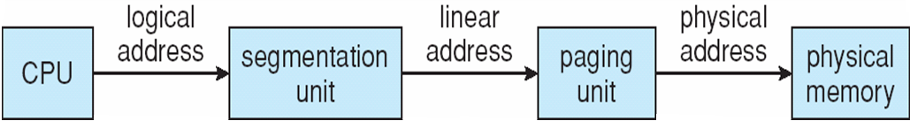

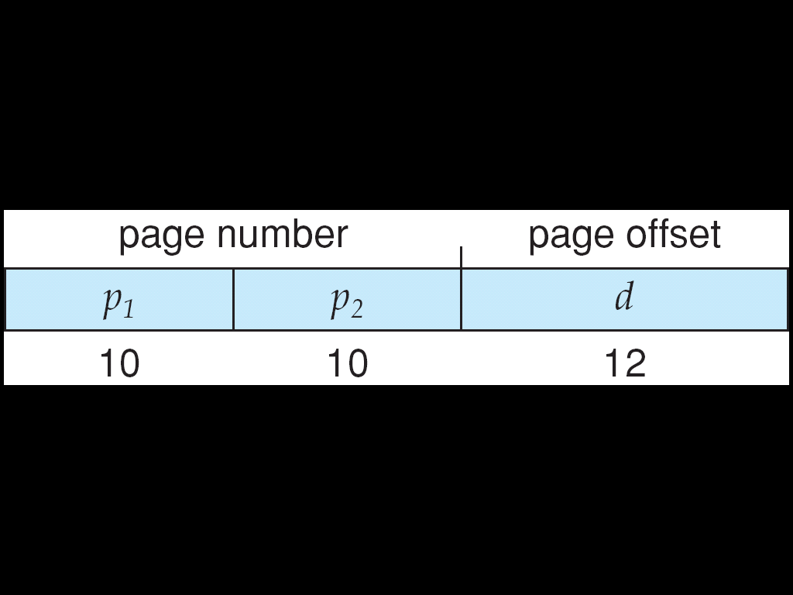

**Intel IA-32 Segmentation**

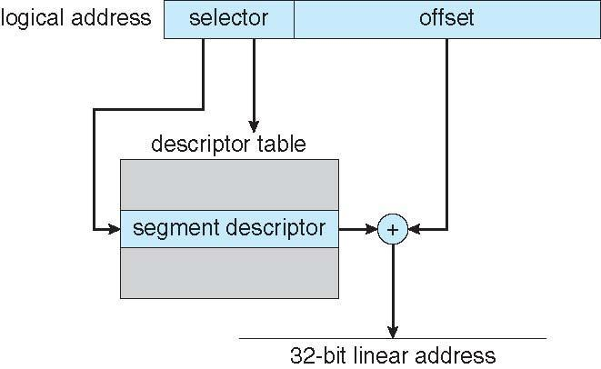

**Intel IA-32 Paging Architecture**

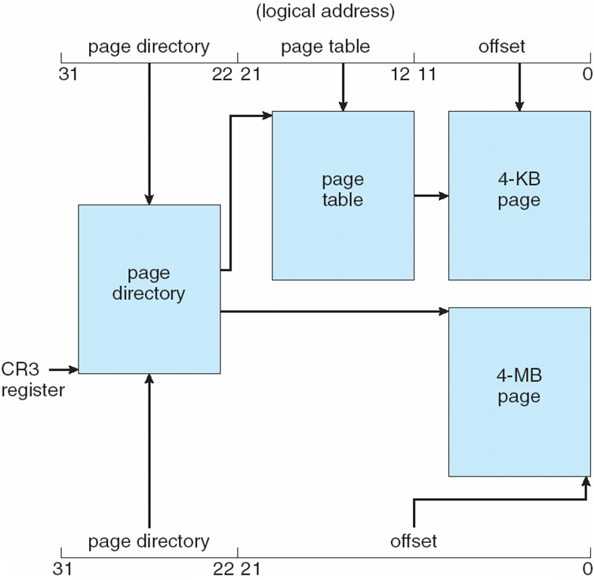

**Intel IA-32 Page Address Extensions**

* 32-bit address limits led Intel to create **page address extension** (**PAE**), allowing 32-bit apps access to more than 4GB of memory space
  + Paging went to a 3-level scheme
  + Top two bits refer to a **page directory pointer table**
  + Page-directory and page-table entries moved to 64-bits in size
  + Net effect is increasing address space to 36 bits – 64GB of physical memory

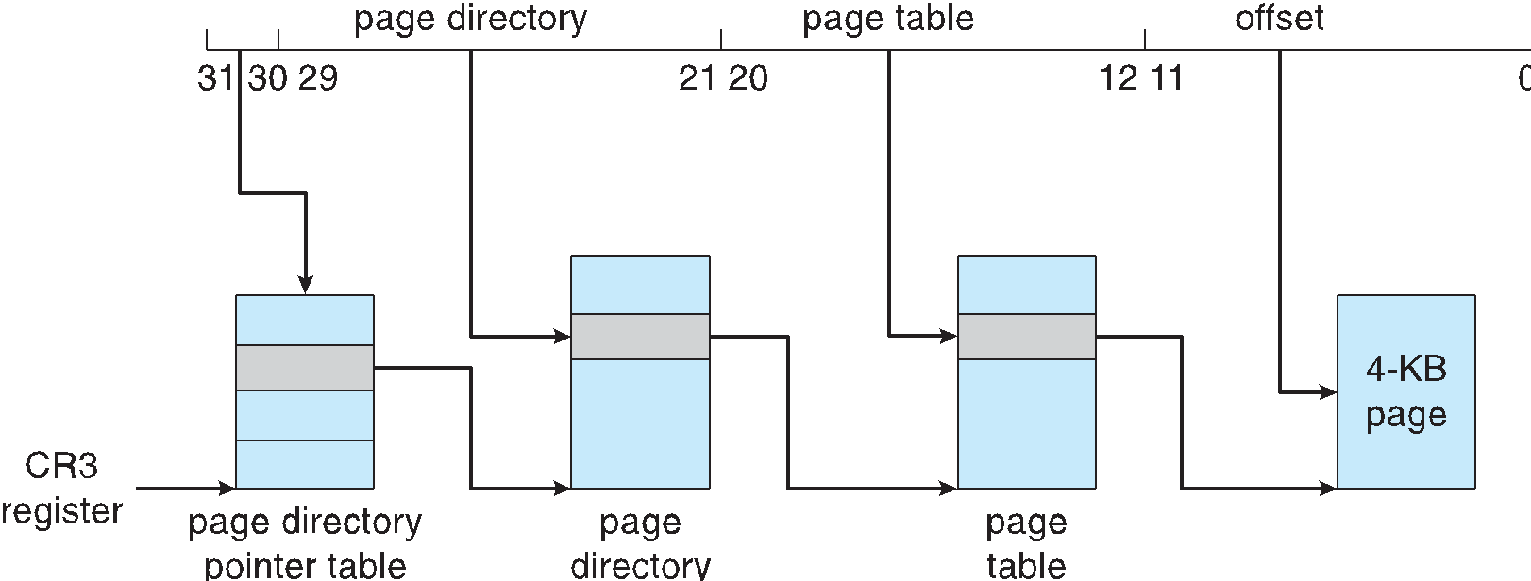

**Intel x86-64**

* Current generation Intel x86 architecture
* 64 bits is ginormous (> 16 exabytes)
* In practice only implement 48 bit addressing
  + Page sizes of 4 KB, 2 MB, 1 GB
  + Four levels of paging hierarchy
* Can also use PAE so virtual addresses are 48 bits and physical addresses are 52 bits



**Example: ARM Architecture**

* (Apple iOS and Google Android devices for example)
* Modern, energy efficient, 32-bit CPU
* 4 KB and 16 KB pages
* 1 MB and 16 MB pages (termed **sections**)
* One-level paging for sections, two-level for smaller pages
* Two levels of TLBs
  + Outer level has two micro TLBs (one data, one instruction)
  + Inner is single main TLB
  + First inner is checked, on miss outers are checked, and on miss page table walk performed by CPU

