**Chapter 6:**

**Process Scheduling**

**Process Scheduling**

* Background
* The Critical-Section Problem
* Peterson’s Solution
* Synchronization Hardware
* Mutex Locks
* Semaphores
* Classic Problems of Synchronization
* Monitors
* Synchronization Examples
* Alternative Approaches

**Objectives**

* To introduce the critical-section problem, whose solutions can be used to ensure the consistency of shared data
* To present both software and hardware solutions of the critical-section problem
* To examine several classical process-synchronization problems
* To explore several tools that are used to solve process synchronization problems

**Background**

* Processes can execute concurrently
  + May be interrupted at any time, partially completing execution
* Concurrent access to shared data may result in data inconsistency
* Maintaining data consistency requires mechanisms to ensure the orderly execution of cooperating processes
* Illustration of the problem:  
  Suppose that we wanted to provide a solution to the consumer-producer problem that fills ***all*** the buffers. We can do so by having an integer **counter** that keeps track of the number of full buffers. Initially, **counter** is set to 0. It is incremented by the producer after it produces a new buffer and is decremented by the consumer after it consumes a buffer.

**Producer**

while (true) {  
 /* produce an item in next produced */

while (counter == BUFFER SIZE) ;

/* do nothing */

buffer[in] = next produced;

in = (in + 1) % BUFFER SIZE;

counter++;

}

**Consumer**

while (true) {

while (counter == 0)

; /* do nothing */

next consumed = buffer[out];

out = (out + 1) % BUFFER SIZE; counter--;

/* consume the item in next consumed */

}

**Race Condition**

* **counter++** could be implemented as  
    
   **register1 = counter  
   register1 = register1 + 1  
   counter = register1**
* **counter--** could be implemented as  
    
   **register2 = counter  
   register2 = register2 - 1  
   counter = register2**
* Consider this execution interleaving with “count = 5” initially:

S0: producer execute **register1 = counter** {register1 = 5}  
S1: producer execute **register1 = register1 + 1** {register1 = 6}   
S2: consumer execute **register2 = counter** {register2 = 5}   
S3: consumer execute **register2 = register2 – 1** {register2 = 4}   
S4: producer execute **counter = register1** {counter = 6 }   
S5: consumer execute **counter = register2** {counter = 4}

**Critical Section Problem**

* Consider system of ***n*** processes {***p0, p1, … pn-1***}
* Each process has **critical section** segment of code
  + Process may be changing common variables, updating table, writing file, etc
  + When one process in critical section, no other may be in its critical section
* ***Critical section problem*** is to design protocol to solve this
* Each process must ask permission to enter critical section in **entry section**, may follow critical section with **exit section**, then **remainder section**

**Critical Section**

* General structure of process ***pi***is

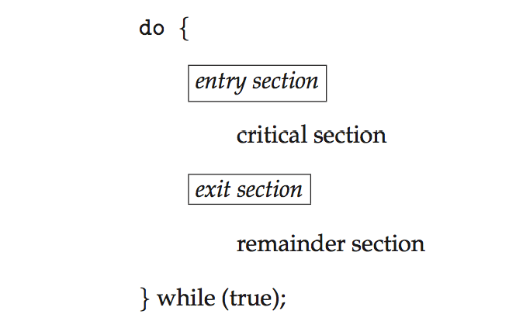

**Solution to Critical-Section Problem**

1. **Mutual Exclusion** - If process ***Pi*** is executing in its critical section, then no other processes can be executing in their critical sections

2. **Progress** - If no process is executing in its critical section and there exist some processes that wish to enter their critical section, then the selection of the processes that will enter the critical section next cannot be postponed indefinitely

3. **Bounded Waiting** - A bound must exist on the number of times that other processes are allowed to enter their critical sections after a process has made a request to enter its critical section and before that request is granted

* + Assume that each process executes at a nonzero speed
  + No assumption concerning **relative speed** of the ***n*** processes
* Two approaches depending on if kernel is preemptive or non-preemptive
  + **Preemptive** – allows preemption of process when running in kernel mode
  + **Non-preemptive** – runs until exits kernel mode, blocks, or voluntarily yields CPU
    - Essentially free of race conditions in kernel mode

**Peterson’s Solution**

* Good algorithmic description of solving the problem
* Two process solution
* Assume that the **load** and **store** instructions are atomic; that is, cannot be interrupted
* The two processes share two variables:
  + **int turn;**
  + **Boolean flag[2]**
* The variable **turn** indicates whose turn it is to enter the critical section
* The **flag** array is used to indicate if a process is ready to enter the critical section. **flag[i] = true** implies that process **Pi** is ready!

**Algorithm for Process Pi**

**do {**

**flag[i] = true;**

**turn = j;**

**while (flag[j] && turn == j);**

**critical section**

**flag[i] = false;**

**remainder section**

**} while (true);**

**Provable that**

1. Mutual exclusion is preserved
2. Progress requirement is satisfied
3. Bounded-waiting requirement is met

**Synchronization Hardware**

* Many systems provide hardware support for critical section code
* **All solutions below based on idea of** **locking**
  + Protecting critical regions via locks
* **Uniprocessors** – could disable interrupts
  + Currently running code would execute without preemption
  + Generally too inefficient on multiprocessor systems
    - Operating systems using this not broadly scalable
* **Modern machines provide special atomic hardware instructions**
  + - **Atomic** = non-interruptible
  + Either test memory word and set value
  + Or swap contents of two memory words

**Solution to Critical-section Problem Using Locks**

**do {**

**acquire lock**

**critical section**

**release lock**

**remainder section**

**} while (TRUE);**

**test_and_set Instruction**

* Definition:

**boolean test_and_set (boolean *target)**

**{**

**boolean rv = *target;**

**\*target = TRUE;**

**return rv:**

**}**

**Solution using test_and_set()**

* Shared boolean variable lock, initialized to FALSE

**Solution:**

**do {  
 while (test_and_set(&lock))**

**; /* do nothing */**

**/* critical section */**

**lock = false;**

**/* remainder section */**

**} while (true);**

**compare_and_swap Instruction**

* **Definition:**

**int compare and swap(int *value, int expected, int new value) {**

**int temp = *value;**

**if (*value == expected)**

**\*value = new value;**

**return temp; }**

**Solution using compare_and_swap**

* Shared Boolean variable lock initialized to FALSE; Each process has a local Boolean variable key
* **Solution**:

**do {  
 while (compare and swap(&lock, 0, 1) != 0)**

**; /* do nothing */**

**/* critical section */**

**lock = 0;**

**/* remainder section */**

**} while (true);**

**Bounded-waiting Mutual Exclusion with test_and_set**

**do {  
 waiting[i] = true;  
 key = true;  
 while (waiting[i] && key)**

**key = test_and_set(&lock);**

**waiting[i] = false;**

**/* critical section */**

**j = (i + 1) % n;**

**while ((j != i) && !waiting[j])**

**j = (j + 1) % n;**

**if (j == i)**

**lock = false;**

**else**

**waiting[j] = false;**

**/* remainder section */**

**} while (true);**

**Mutex Locks**

* Previous solutions are complicated and generally inaccessible to application programmers
* OS designers build software tools to solve critical section problem
* Simplest is mutex lock
* Product critical regions with it by first **acquire()** a lock then **release()** it
  + Boolean variable indicating if lock is available or not
* Calls to **acquire()** and **release()** must be atomic
  + Usually implemented via hardware atomic instructions
* But this solution requires **busy waiting**
  + - This lock therefore called a **spinlock**

**acquire() and release()**

**acquire() {  
 while (!available)**

**do {**

***acquire lock***

**critical section**

***release lock***

**remainder section**

**} while (true);**

**; /* busy wait */**

**available = false;;**

**}**

**release() {**

**available = true;**

**}**

**Semaphore**

* Synchronization tool that does not require busy waiting
* Semaphore ***S*** – integer variable
* **Two standard operations modify *S***: **wait()** and **signal()**
  + Originally called **P()** and **V()**
* Less complicated
* Can only be accessed via two indivisible (atomic) operations

**wait (S) {**

**while (S <= 0)**

**; // busy wait**

**S--;**

**}**

**signal (S) {**

**S++;**

**}**

**Semaphore Usage**

* **Counting semaphore** – integer value can range over an unrestricted domain
* **Binary semaphore** – integer value can range only between 0 and 1
  + Then a **mutex lock**
* Can implement a counting semaphore ***S*** as a binary semaphore
* Can solve various synchronization problems
* Consider ***P1***  and ***P2*** that require ***S1*** to happen before ***S2***

**P1:**

**S1;**

**signal(synch);**

**P2:**

**wait(synch)**;

**S2;**

**Semaphore Implementation**

* Must guarantee that no two processes can execute **wait ()** and **signal ()** on the same semaphore at the same time
* Thus, implementation becomes the critical section problem where the wait and signal code are placed in the critical section
  + Could now have **busy waiting** in critical section implementation
    - But implementation code is short
    - Little busy waiting if critical section rarely occupied
* Note that applications may spend lots of time in critical sections and therefore this is not a good solution

**Semaphore Implementation with no Busy waiting**

* With each semaphore there is an associated waiting queue
* Each entry in a waiting queue has two data items:
  + value (of type integer)
  + pointer to next record in the list
* Two operations:
  + **block** – place the process invoking the operation on the appropriate waiting queue
  + **wakeup** – remove one of processes in the waiting queue and place it in the ready queue

**Semaphore Implementation with no Busy waiting (Cont.)**

**typedef struct{**

**int value;**

**struct process *list;**

**} semaphore;**

**wait(semaphore *S) {**

**S->value--;**

**if (S->value < 0) {  
 add this process to S->list;**

**block();**

**}**

**}**

**signal(semaphore *S) {**

**S->value++;**

**if (S->value <= 0) {  
 remove a process P from S->list;**

**wakeup(P);**

**}**

**}**

**Deadlock and Starvation**

* **Deadlock** – two or more processes are waiting indefinitely for an event that can be caused by only one of the waiting processes
* Let ***S*** and ***Q*** be two semaphores initialized to 1

***P*0** ***P1***

**wait(S); wait(Q);**

**wait(Q); wait(S);**

**. .**

**signal(S); signal(Q);**

**signal(Q); signal(S);**

* **Starvation** – **indefinite blocking** 
  + A process may never be removed from the semaphore queue in which it is suspended
* **Priority Inversion** – Scheduling problem when lower-priority process holds a lock needed by higher-priority process
  + Solved via **priority-inheritance protocol**

**Classical Problems of Synchronization**

* Classical problems used to test newly-proposed synchronization schemes
  + Bounded-Buffer Problem
  + Readers and Writers Problem
  + Dining-Philosophers Problem

**Bounded-Buffer Problem**

* ***n*** buffers, each can hold one item
* Semaphore **mutex** initialized to the value 1
* Semaphore **full** initialized to the value 0
* Semaphore **empty** initialized to the value n

**Bounded Buffer Problem (Cont.)**

* The structure of the producer process

**do {**

**...  
 /* produce an item in next_produced */**

**...**

**wait(empty);**

**wait(mutex);**

**...  
 /* add next produced to the buffer */**

**...**

**signal(mutex);**

**signal(full);**

**} while (true);**

**Bounded Buffer Problem (Cont.)**

* The structure of the consumer process

**do {**

**wait(full);**

**wait(mutex);**

**...  
 /* remove an item from buffer to next_consumed */**

**...**

**signal(mutex);**

**signal(empty);**

**...  
 /* consume the item in next consumed */**

**...  
} while (true);**

**Readers-Writers Problem**

* A data set is shared among a number of concurrent processes
  + Readers – only read the data set; they do ***not*** perform any updates
  + Writers – can both read and write
* Problem – allow multiple readers to read at the same time
  + Only one single writer can access the shared data at the same time
* Several variations of how readers and writers are treated – all involve priorities
* Shared Data
  + Data set
  + Semaphore **rw_mutex** initialized to 1
  + Semaphore **mutex** initialized to 1
  + Integer **read_count** initialized to 0
* The structure of a writer process

**do {  
 wait(rw mutex);**

**...  
 /* writing is performed */**

**...**

**signal(rw mutex);**

**} while (true);**

**Readers-Writers Problem (Cont.)**

* The structure of a reader process

* do {  
  wait(mutex);  
  read count++;  
  if (read count == 1)
* wait(rw mutex); signal(mutex);
* ...  
  /* reading is performed */
* ... wait(mutex);  
  read count--;  
  if (read count == 0)
* signal(rw mutex); signal(mutex);
* } while (true);

**Readers-Writers Problem Variations**

* *First* variation – no reader kept waiting unless writer has permission to use shared object
* *Second* variation – once writer is ready, it performs write asap
* Both may have starvation leading to even more variations
* Problem is solved on some systems by kernel providing reader-writer locks

**Dining-Philosophers Problem**

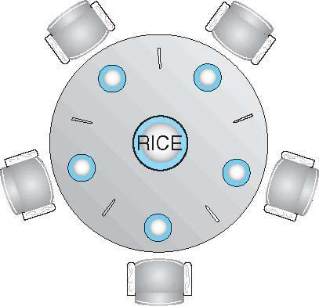

* Philosophers spend their lives thinking and eating
* Don’t interact with their neighbors, occasionally try to pick up 2 chopsticks (one at a time) to eat from bowl
  + Need both to eat, then release both when done
* In the case of 5 philosophers
  + **Shared data** 
    - Bowl of rice (data set)
    - Semaphore chopstick [5] initialized to 1

**Dining-Philosophers Problem Algorithm**

* **The structure of Philosopher *i*:**

do {

wait ( chopstick[i] );

wait ( chopStick[ (i + 1) % 5] );

// eat

signal ( chopstick[i] );

signal (chopstick[ (i + 1) % 5] );

// think

} while (TRUE);

* What is the problem with this algorithm?

**Problems with Semaphores**

* Incorrect use of semaphore operations:
  + signal (mutex) …. wait (mutex)
  + wait (mutex) … wait (mutex)
  + Omitting of wait (mutex) or signal (mutex) (or both)
* Deadlock and starvation

**Monitors**

* A high-level abstraction that provides a convenient and effective mechanism for process synchronization
* *Abstract data type*, internal variables only accessible by code within the procedure
* Only one process may be active within the monitor at a time
* But not powerful enough to model some synchronization schemes

monitor monitor-name

{

// shared variable declarations

procedure P1 (…) { …. }

procedure Pn (…) {……}

Initialization code (…) { … }

}

}

**Schematic view of a Monitor**

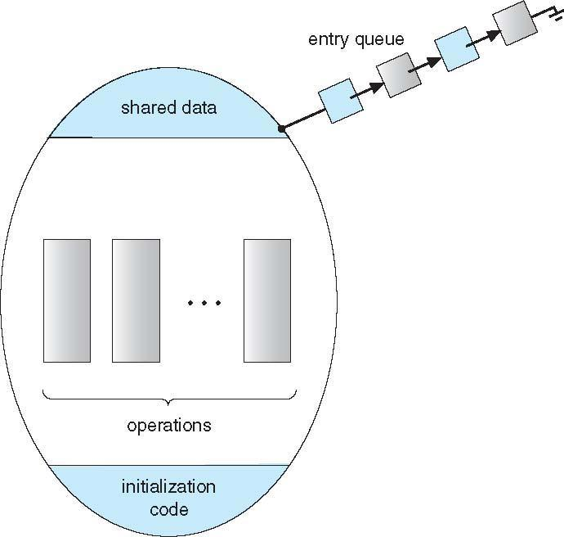

**Condition Variables**

* condition x, y;
* **Two operations on a condition variable:**
  + **x.wait ()** – a process that invokes the operation is suspended until x.signal ()
  + **x.signal ()** – resumes one of processes (if any) that invoked x.wait ()
    - If no x.wait () on the variable, then it has no effect on the variable

**Monitor with Condition Variables**

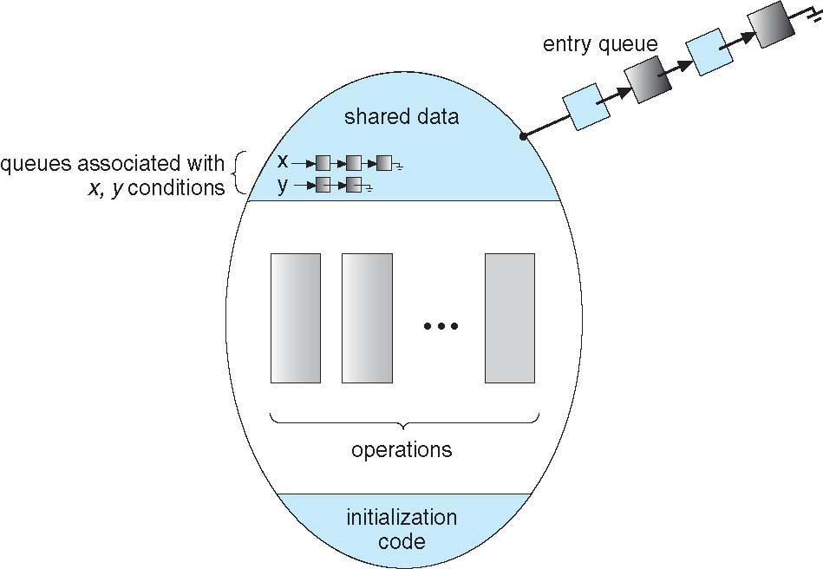

**Condition Variables Choices**

* If process P invokes x.signal (), with Q in x.wait () state, what should happen next?
  + If Q is resumed, then P must wait
* Options include
  + **Signal and wait** – P waits until Q leaves monitor or waits for another condition
  + **Signal and continue** – Q waits until P leaves the monitor or waits for another condition
  + Both have pros and cons – language implementer can decide
  + Monitors implemented in Concurrent Pascal compromise
    - P executing signal immediately leaves the monitor, Q is resumed
  + Implemented in other languages including Mesa, C#, Java

**Solution to Dining Philosophers**

**monitor DiningPhilosophers**

{

enum { THINKING; HUNGRY, EATING) state [5] ;

condition self [5];

void pickup (int i) {

state[i] = HUNGRY;

test(i);

if (state[i] != EATING) self [i].wait;

}

void putdown (int i) {

state[i] = THINKING;

// test left and right neighbors

test((i + 4) % 5);

test((i + 1) % 5);

}

void test (int i) {

if ( (state[(i + 4) % 5] != EATING) &&

(state[i] == HUNGRY) &&

(state[(i + 1) % 5] != EATING) ) {

state[i] = EATING ;

self[i].signal () ;

}

}

initialization_code() {

for (int i = 0; i < 5; i++)

state[i] = THINKING;

}

}

* Each philosopher *i* invokes theoperations pickup()and putdown() in the following sequence:

DiningPhilosophers.pickup (i);

EAT

DiningPhilosophers.putdown (i);

* No deadlock, but starvation is possible

**Monitor Implementation Using Semaphores**

* Variables

semaphore mutex; // (initially = 1)

semaphore next; // (initially = 0)

int next_count = 0;

* Each procedure ***F*** will be replaced by

wait(mutex);

…

body of *F*;

…

if (next_count > 0)

signal(next)

else

signal(mutex);

* Mutual exclusion within a monitor is ensured

**Monitor Implementation – Condition Variables**

* **For each condition variable *x*, we have:**

semaphore x_sem; // (initially = 0)

int x_count = 0;

* **The operation x.wait can be implemented as:**

x-count++;

if (next_count > 0)

signal(next);

else

signal(mutex);

wait(x_sem);

x-count--;

* The operation x.signal can be implemented as:

if (x-count > 0) {

next_count++;

signal(x_sem);

wait(next);

next_count--;

}

**Resuming Processes within a Monitor**

* If several processes queued on condition x, and x.signal() executed, which should be resumed?
* FCFS frequently not adequate
* **conditional-wait** construct of the form x.wait(c)
  + Where c is **priority number**
  + Process with lowest number (highest priority) is scheduled next

**A Monitor to Allocate Single Resource**

monitor ResourceAllocator

{

boolean busy;

condition x;

void acquire(int time) {

if (busy)

x.wait(time);

busy = TRUE;

}

void release() {

busy = FALSE;

x.signal();

}

initialization code() {

busy = FALSE;

}

}

**Synchronization Examples**

* Solaris
* Windows XP
* Linux
* Pthreads

**Solaris Synchronization**

* Implements a variety of locks to support multitasking, multithreading (including real-time threads), and multiprocessing
* Uses **adaptive mutexes** for efficiency when protecting data from short code segments
  + Starts as a standard semaphore spin-lock
  + If lock held, and by a thread running on another CPU, spins
  + If lock held by non-run-state thread, block and sleep waiting for signal of lock being released
* Uses **condition variables**
* Uses **readers-writers** locks when longer sections of code need access to data
* Uses **turnstiles** to order the list of threads waiting to acquire either an adaptive mutex or reader-writer lock
  + Turnstiles are per-lock-holding-thread, not per-object
* Priority-inheritance per-turnstile gives the running thread the highest of the priorities of the threads in its turnstile

**Windows XP Synchronization**

* Uses interrupt masks to protect access to global resources on uniprocessor systems
* Uses **spinlocks** on multiprocessor systems
  + Spinlocking-thread will never be preempted
* Also provides **dispatcher objects** user-land which may act mutexes, semaphores, events, and timers
  + **Events**
    - An event acts much like a condition variable
  + Timers notify one or more thread when time expired
  + Dispatcher objects either **signaled-state** (object available) or **non-signaled state** (thread will block)

**Linux Synchronization**

* **Linux:**
  + Prior to kernel Version 2.6, disables interrupts to implement short critical sections
  + Version 2.6 and later, fully preemptive
* **Linux provides:**
  + semaphores
  + spinlocks
  + reader-writer versions of both
* On single-cpu system, spinlocks replaced by enabling and disabling kernel preemption

**Pthreads Synchronization**

* Pthreads API is OS-independent
* **It provides:**
  + mutex locks
  + condition variables
* **Non-portable extensions include:**
  + read-write locks
  + spinlocks

**Atomic Transactions**

* System Model
* Log-based Recovery
* Checkpoints
* Concurrent Atomic Transactions

**System Model**

* Assures that operations happen as a single logical unit of work, in its entirety, or not at all
* Related to field of database systems
* Challenge is assuring atomicity despite computer system failures
* Transaction - collection of instructions or operations that performs single logical function
  + Here we are concerned with changes to stable storage – disk
  + Transaction is series of read and write operations
  + Terminated by commit (transaction successful) or abort (transaction failed) operation
  + Aborted transaction must be rolled back to undo any changes it performed

**Types of Storage Media**

* Volatile storage – information stored here does not survive system crashes
  + Example: main memory, cache
* Nonvolatile storage – Information usually survives crashes
  + Example: disk and tape
* Stable storage – Information never lost
  + Not actually possible, so approximated via replication or RAID to devices with independent failure modes

Goal is to assure transaction atomicity where failures cause loss of information on volatile storage

**Log-Based Recovery**

* Record to stable storage information about all modifications by a transaction
* Most common is write-ahead logging
  + Log on stable storage, each log record describes single transaction write operation, including
    - Transaction name
    - Data item name
    - Old value
    - New value
  + <Ti starts> written to log when transaction Ti starts
  + <Ti commits> written when Ti commits
* Log entry must reach stable storage before operation on data occurs

**Log-Based Recovery Algorithm**

* **Using the log, system can handle any volatile memory errors**
  + Undo(Ti) restores value of all data updated by Ti
  + Redo(Ti) sets values of all data in transaction Ti to new values
* **Undo(Ti) and redo(Ti) must be idempotent**
  + Multiple executions must have the same result as one execution
* **If system fails, restore state of all updated data via log**
  + If log contains <Ti starts> without <Ti commits>, undo(Ti)
  + If log contains <Ti starts> and <Ti commits>, redo(Ti)

**Checkpoints**

* Log could become long, and recovery could take long
* Checkpoints shorten log and recovery time.
* **Checkpoint scheme:**
  1. Output all log records currently in volatile storage to stable storage
  2. Output all modified data from volatile to stable storage
  3. Output a log record <checkpoint> to the log on stable storage
* Now recovery only includes Ti, such that Ti started executing before the most recent checkpoint, and all transactions after Ti All other transactions already on stable storage

**Concurrent Transactions**

* Must be equivalent to serial execution – serializability
* Could perform all transactions in critical section
  + Inefficient, too restrictive
* Concurrency-control algorithms provide serializability

**Serializability**

* Consider two data items A and B
* Consider Transactions T0 and T1
* Execute T0, T1 atomically
* Execution sequence called schedule
* Atomically executed transaction order called serial schedule
* For N transactions, there are N! valid serial schedules

**Schedule 1: T0 then T1**

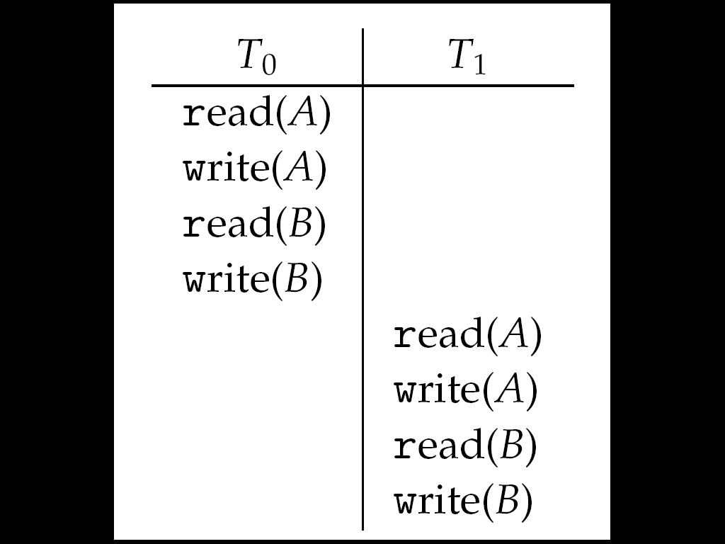

**Nonserial Schedule**

* **Nonserial schedule allows overlapped execute**
  + Resulting execution not necessarily incorrect
* **Consider schedule S, operations Oi, Oj**
  + Conflict if access same data item, with at least one write
* **If Oi, Oj consecutive and operations of different transactions & Oi and Oj don’t conflict**
  + Then S’ with swapped order Oj Oi equivalent to S
* **If S can become S’ via swapping nonconflicting operations**
  + S is conflict serializable

**Schedule 2: Concurrent Serializable Schedule**

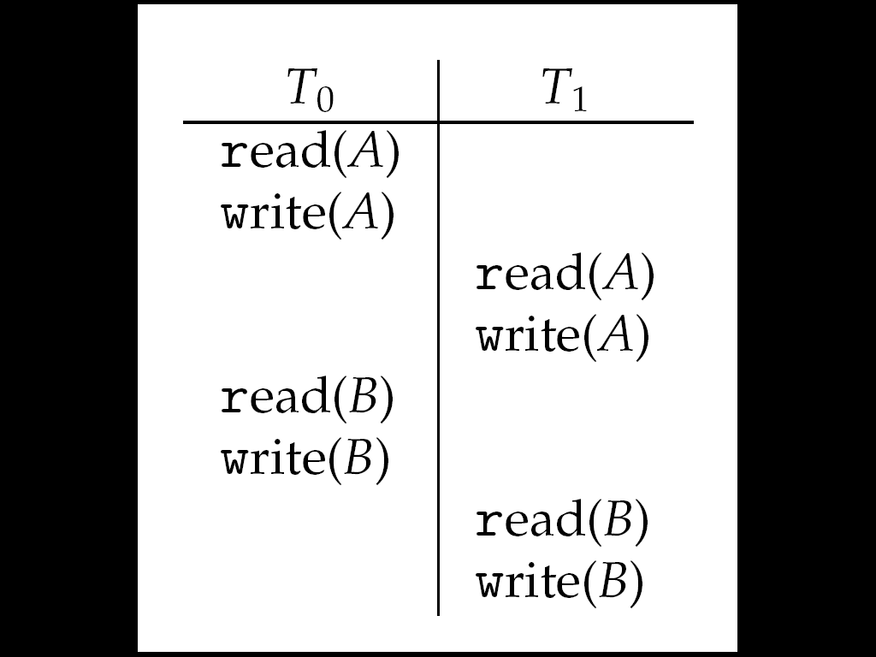

**Locking Protocol**

* Ensure serializability by associating lock with each data item
  + Follow locking protocol for access control
* **Locks**
  + **Shared –** Ti has shared-mode lock (S) on item Q, Ti can read Q but not write Q
  + **Exclusive –** Ti has exclusive-mode lock (X) on Q, Ti can read and write Q
* Require every transaction on item Q acquire appropriate lock
* If lock already held, new request may have to wait
  + Similar to readers-writers algorithm

**Two-phase Locking Protocol**

* Generally ensures conflict serializability
* Each transaction issues lock and unlock requests in two phases
  + Growing – obtaining locks
  + Shrinking – releasing locks
* Does not prevent deadlock

**Timestamp-based Protocols**

* Select order among transactions in advance – timestamp-ordering
* **Transaction Ti associated with timestamp TS(Ti) before Ti starts**
  + TS(Ti) < TS(Tj) if Ti entered system before Tj
  + TS can be generated from system clock or as logical counter incremented at each entry of transaction
* **Timestamps determine serializability order**
  + If TS(Ti) < TS(Tj), system must ensure produced schedule equivalent to serial schedule where Ti appears before Tj

**Timestamp-based Protocol Implementation**

* Data item Q gets two timestamps
  + W-timestamp(Q) – largest timestamp of any transaction that executed write(Q) successfully
  + R-timestamp(Q) – largest timestamp of successful read(Q)
  + Updated whenever read(Q) or write(Q) executed
* Timestamp-ordering protocol assures any conflicting read and write executed in timestamp order
* **Suppose Ti executes read(Q)**
  + **If TS(Ti) < W-timestamp(Q), Ti needs to read value of Q that was already overwritten**
    - read operation rejected and Ti rolled back
  + **If TS(Ti) ≥ W-timestamp(Q)**
    - read executed, R-timestamp(Q) set to max(R-timestamp(Q), TS(Ti))

**Timestamp-ordering Protocol**

* **Suppose Ti executes write(Q)**
  + If TS(Ti) < R-timestamp(Q), value Q produced by Ti was needed previously and Ti assumed it would never be produced
    - Write operation rejected, Ti rolled back
  + If TS(Ti) < W-timestamp(Q), Ti attempting to write obsolete value of Q
    - Write operation rejected and Ti rolled back
  + Otherwise, write executed
* Any rolled back transaction Ti is assigned new timestamp and restarted
* Algorithm ensures conflict serializability and freedom from deadlock

**Schedule Possible Under Timestamp Protocol**

