**Chapter 5:**

**Process Scheduling**

**Process Scheduling**

* Basic Concepts
* Scheduling Criteria
* Scheduling Algorithms
* Thread Scheduling
* Multiple-Processor Scheduling
* Real-Time CPU Scheduling
* Operating Systems Examples
* Algorithm Evaluation

**Objectives**

* To introduce CPU scheduling, which is the basis for multiprogrammed operating systems
* To describe various CPU-scheduling algorithms
* To discuss evaluation criteria for selecting a CPU-scheduling algorithm for a particular system
* 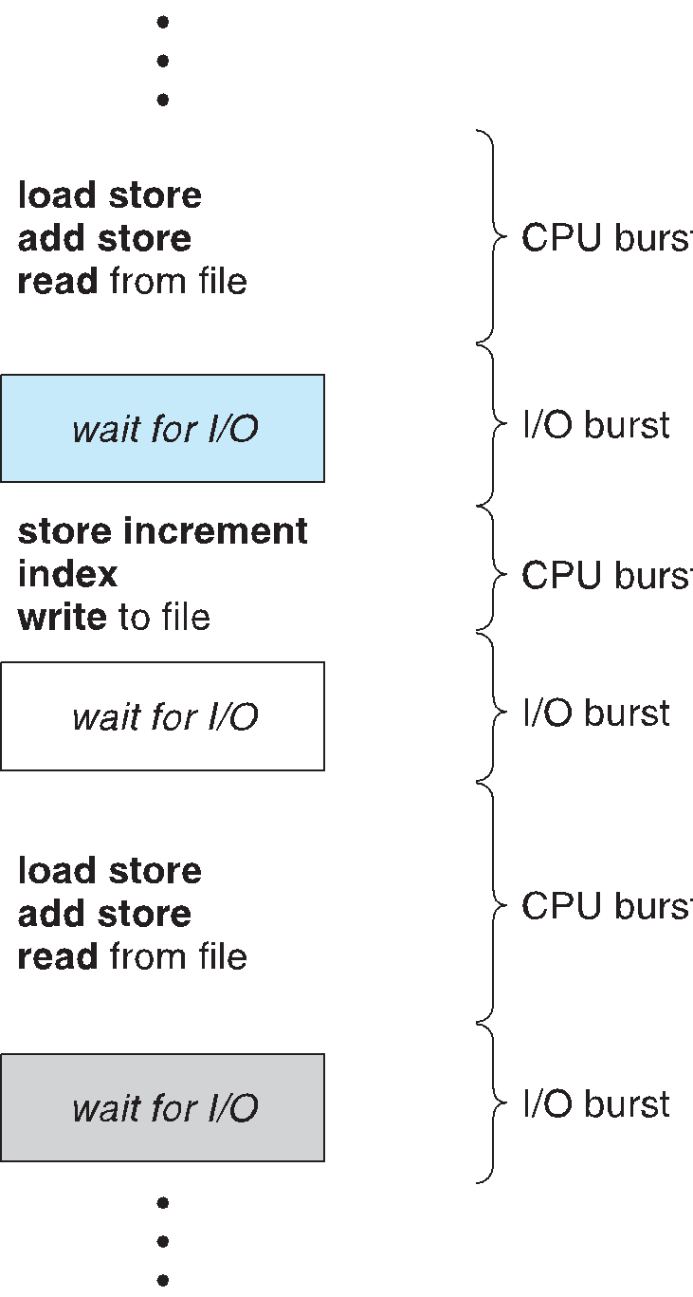To examine the scheduling algorithms of several operating systems

**Basic Concepts**

* Maximum CPU utilization obtained with multiprogramming
* CPU–I/O Burst Cycle – Process execution consists of a **cycle** of CPU

execution and I/O wait

* **CPU burst** followed by **I/O burst**
* CPU burst distribution is of main concern

**Histogram of CPU-burst Times**

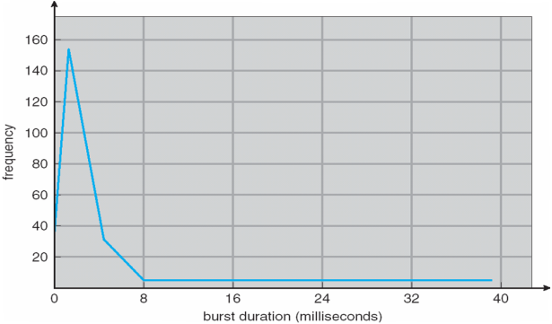

**CPU Scheduler**

* **Short-term scheduler** selects from among the processes in ready queue, and allocates the CPU to one of them
  + Queue may be ordered in various ways
* **CPU scheduling decisions may take place when a process:**

1. Switches from running to waiting state
2. Switches from running to ready state
3. Switches from waiting to ready
4. Terminates

* **Scheduling under 1 and 4 is** **nonpreemptive**
* **All other scheduling is** **preemptive**
  + Consider access to shared data
  + Consider preemption while in kernel mode
  + Consider interrupts occurring during crucial OS activities

**Dispatcher**

* Dispatcher module gives control of the CPU to the process selected by the short-term scheduler; this involves:
  + switching context
  + switching to user mode
  + jumping to the proper location in the user program to restart that program
* **Dispatch latency** – time it takes for the dispatcher to stop one process and start another running

**Scheduling Criteria**

* **CPU utilization** – keep the CPU as busy as possible
* **Throughput** – # of processes that complete their execution per time unit
* **Turnaround time** – amount of time to execute a particular process
* **Waiting time** – amount of time a process has been waiting in the ready queue
* **Response time** – amount of time it takes from when a request was submitted until the first response is produced, not output (for time-sharing environment)

**Scheduling Algorithm Optimization Criteria**

* Max CPU utilization
* Max throughput
* Min turnaround time
* Min waiting time
* Min response time

**First-Come, First-Served (FCFS) Scheduling**

Process Burst Time

*P1* 24

*P2* 3

*P3* 3

* Suppose that the processes arrive in the order: *P1* , *P2* , *P3*The Gantt Chart for the schedule is:
* Waiting time for *P1* = 0; *P2* = 24; *P3* = 27
* Average waiting time: (0 + 24 + 27)/3 = 17

**Suppose that the processes arrive in the order:**

*P2* , *P3* , *P1*

* **The Gantt chart for the schedule is:**
* **Waiting time for *P1 =* 6*;P2* = 0*; P3 =* 3**
* **Average waiting time: (6 + 0 + 3)/3 = 3**
* **Much better than previous case**
* **Convoy effect** - short process behind long process
  + Consider one CPU-bound and many I/O-bound processes

**Shortest-Job-First (SJF) Scheduling**

* **Associate with each process the length of its next CPU burst**
  + Use these lengths to schedule the process with the shortest time
* **SJF is optimal – gives minimum average waiting time for a given set of processes**
  + The difficulty is knowing the length of the next CPU request
  + Could ask the user

**Example of SJF**

ProcessArriva l Time Burst Time

*P1* 0.0 6

*P2* 2.0 8

*P3* 4.0 7

*P4* 5.0 3

* **SJF scheduling chart**
* **Average waiting time = (3 + 16 + 9 + 0) / 4 = 7**

**Determining Length of Next CPU Burst**

* Can only estimate the length – should be similar to the previous one
  + Then pick process with shortest predicted next CPU burst
* Can be done by using the length of previous CPU bursts, using exponential averaging

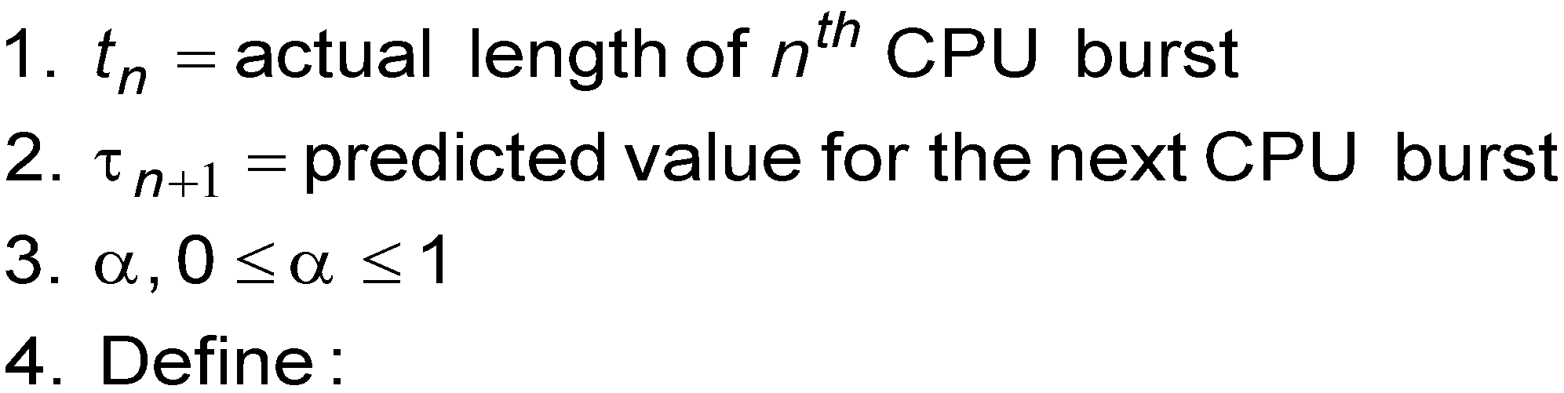

* Commonly, α set to ½
* Preemptive version called **shortest-remaining-time-first**

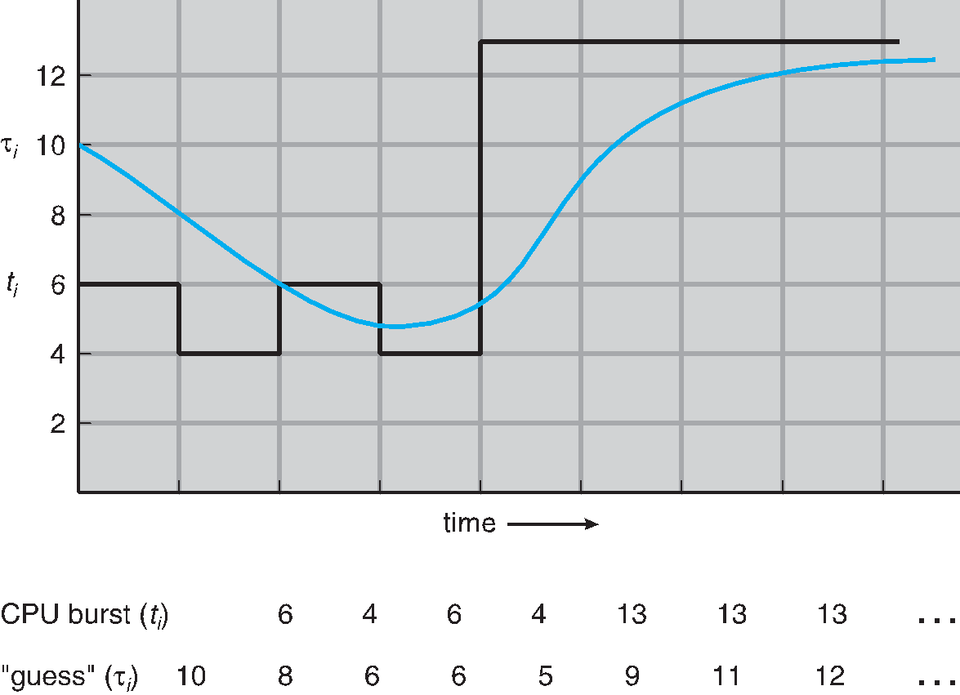**Prediction of the Length of the Next CPU Burst**

**Examples of Exponential Averaging**

* **α =0**
  + τn+1 = τn
  + Recent history does not count
* **α =1**
  + τn+1 = α *t*n
  + Only the actual last CPU burst counts
* If we expand the formula, we get:

τ*n*+1 = α t*n*+(1 *-* α*)*α *tn* -1+ …

*+(*1 - α *)j*α *tn* -*j* + …

*+(*1 - α *)n* +1 τ0

* Since both α and (1 - α) are less than or equal to 1, each successive term has less weight than its predecessor

**Example of Shortest-remaining-time-first**

* Now we add the concepts of varying arrival times and preemption to the analysis

ProcessA arri *Arrival*  TimeT Burst Time

*P1* 0 8

*P2* 1 4

*P3* 2 9

*P4* 3 5

* *Preemptive* SJF Gantt Chart
* Average waiting time = [(10-1)+(1-1)+(17-2)+5-3)]/4 = 26/4 = 6.5 msec

**Priority Scheduling**

* A priority number (integer) is associated with each process
* The CPU is allocated to the process with the highest priority (smallest integer ≡ highest priority)
  + Preemptive
  + Nonpreemptive
* SJF is priority scheduling where priority is the inverse of predicted next CPU burst time
* Problem ≡ **Starvation** – low priority processes may never execute
* Solution ≡ **Aging** – as time progresses increase the priority of the process

**Example of Priority Scheduling**

ProcessA arri Burst TimeT Priority

*P1* 10 3

*P2* 1 1

*P3* 2 4

*P4* 1 5

*P5* 5 2

* Priority scheduling Gantt Chart
* Average waiting time = 8.2 msec

**Round Robin (RR)**

* Each process gets a small unit of CPU time (**time quantum** *q*), usually 10-100 milliseconds. After this time has elapsed, the process is preempted and added to the end of the ready queue.
* If there are *n* processes in the ready queue and the time quantum is *q*, then each process gets 1/*n* of the CPU time in chunks of at most *q* time units at once. No process waits more than (*n*-1)*q* time units.
* Timer interrupts every quantum to schedule next process
* Performance
  + *q* large ⇒ FIFO
  + *q* small ⇒ *q* must be large with respect to context switch, otherwise overhead is too high

**Example of RR with Time Quantum = 4**

Process Burst Time

*P1* 24

*P2* 3

*P3*  3

* **The Gantt chart is:**
* Typically, higher average turnaround than SJF, but better ***response***
* q should be large compared to context switch time
* q usually 10ms to 100ms, context switch < 10 usec

**Time Quantum and Context Switch Time**

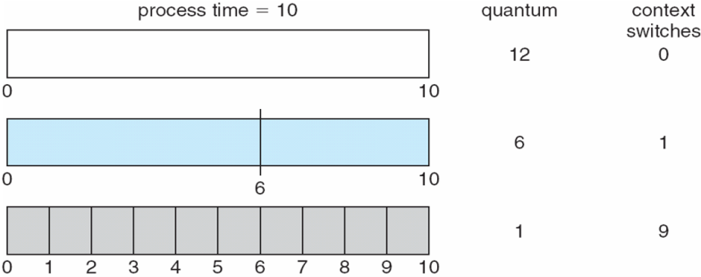

**Turnaround Time Varies With The Time Quantum**

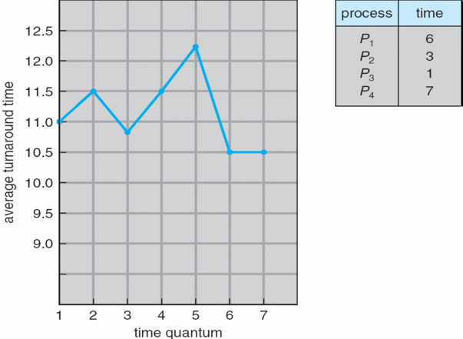

**Multilevel Queue**

* **Ready queue is partitioned into separate queues, eg:**
  + **foreground** (interactive)
  + **background** (batch)
* Process permanently in a given queue
* **Each queue has its own scheduling algorithm:**
  + foreground – RR
  + background – FCFS
* **Scheduling must be done between the queues:**
  + Fixed priority scheduling; (i.e., serve all from foreground then from background). Possibility of starvation.
  + Time slice – each queue gets a certain amount of CPU time which it can schedule amongst its processes; i.e., 80% to foreground in RR
  + 20% to background in FCFS

**Multilevel Queue Scheduling**

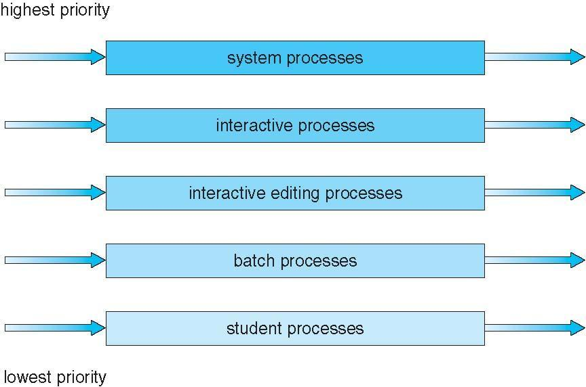

**Multilevel Feedback Queue**

* A process can move between the various queues; aging can be implemented this way
* **Multilevel-feedback-queue scheduler defined by the following parameters:**
  + number of queues
  + scheduling algorithms for each queue
  + method used to determine when to upgrade a process
  + method used to determine when to demote a process
  + method used to determine which queue a process will enter when that process needs service

**Example of Multilevel Feedback Queue**

* **Three queues:** 
  + *Q*0 – RR with time quantum 8 milliseconds
  + *Q*1 – RR time quantum 16 milliseconds
  + *Q*2 – FCFS
* 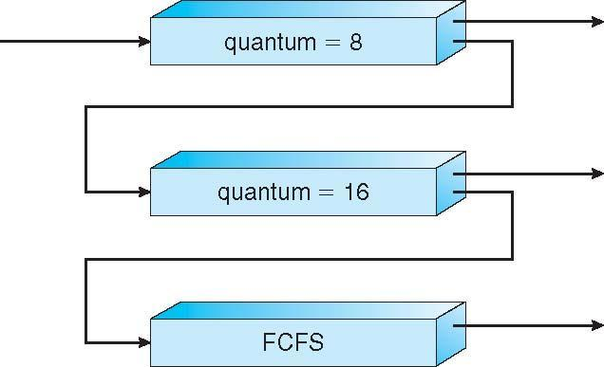**Scheduling**
  + **A new job enters queue *Q0* which is servedFCFS**
    - When it gains CPU, job receives 8 milliseconds
    - If it does not finish in 8 milliseconds, job is moved to queue *Q*1
  + **At *Q*1 job is again served FCFS and receives 16 additional milliseconds**
    - If it still does not complete, it is preempted and moved to queue *Q*2

**Thread Scheduling**

* Distinction between user-level and kernel-level threads
* When threads supported, threads scheduled, not processes
* Many-to-one and many-to-many models, thread library schedules user-level threads to run on LWP
  + Known as **process-contention scope (PCS)** since scheduling competition is within the process
  + Typically done via priority set by programmer
* Kernel thread scheduled onto available CPU is **system-contention scope (SCS)** – competition among all threads in system

**Pthread Scheduling**

* API allows specifying either PCS or SCS during thread creation
  + PTHREAD_SCOPE_PROCESS schedules threads using PCS scheduling
  + PTHREAD_SCOPE_SYSTEM schedules threads using SCS scheduling
* Can be limited by OS – Linux and Mac OS X only allow PTHREAD_SCOPE_SYSTEM

**Pthread Scheduling API**

**#include <pthread.h>**

**#include <stdio.h>**

**#define NUM THREADS 5**

**int main(int argc, char *argv[]) {**

**int i, scope;  
 pthread t tid[NUM THREADS];**

**pthread attr t attr;**

**/* get the default attributes */**

**pthread attr init(&attr);**

**/* first inquire on the current scope */  
 if (pthread attr getscope(&attr, &scope) != 0)**

**fprintf(stderr, "Unable to get scheduling scope\n");**

**else {**

**if (scope == PTHREAD SCOPE PROCESS)**

**printf("PTHREAD SCOPE PROCESS");**

**else if (scope == PTHREAD SCOPE SYSTEM)**

**printf("PTHREAD SCOPE SYSTEM");**

**else  
 fprintf(stderr, "Illegal scope value.\n"); }**

**Pthread Scheduling API**

**/* set the scheduling algorithm to PCS or SCS */**

**pthread attr setscope(&attr, PTHREAD SCOPE SYSTEM);**

**/* create the threads */  
 for (i = 0; i < NUM THREADS; i++)**

**pthread create(&tid[i],&attr,runner,NULL);**

**/* now join on each thread */  
 for (i = 0; i < NUM THREADS; i++)**

**pthread join(tid[i], NULL);**

**}**

**/* Each thread will begin control in this function */**

**void *runner(void *param)  
{**

**/* do some work ... */**

**pthread exit(0);**

**}**

**Multiple-Processor Scheduling**

* CPU scheduling more complex when multiple CPUs are available
* **Homogeneous processors** within a multiprocessor
* **Asymmetric multiprocessing** – only one processor accesses the system data structures, alleviating the need for data sharing
* **Symmetric multiprocessing (SMP)** – each processor is self-scheduling, all processes in common ready queue, or each has its own private queue of ready processes
  + Currently, most common
* **Processor affinity** – process has affinity for processor on which it is currently running
  + **soft affinity**
  + **hard affinity**
  + Variations including **processor sets**

**NUMA and CPU Scheduling**

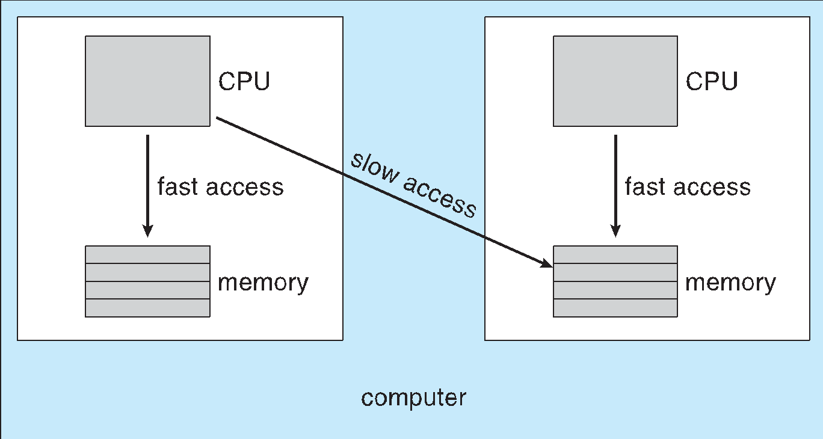

**Multiple-Processor Scheduling – Load Balancing**

* If SMP, need to keep all CPUs loaded for efficiency
* **Load balancing** attempts to keep workload evenly distributed
* **Push migration** – periodic task checks load on each processor, and if found pushes task from overloaded CPU to other CPUs
* **Pull migration** – idle processors pulls waiting task from busy processor

**Multicore Processors**

* Recent trend to place multiple processor cores on same physical chip
* Faster and consumes less power
* Multiple threads per core also growing
  + Takes advantage of memory stall to make progress on another thread while memory retrieve happens

**Multithreaded Multicore System**

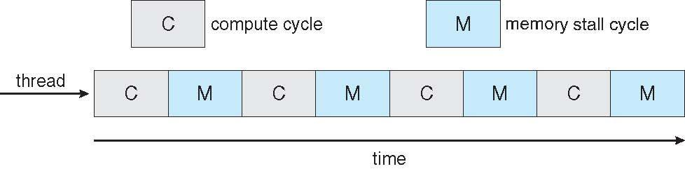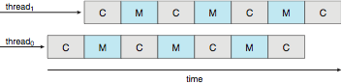

**Real-Time CPU Scheduling**

* Can present obvious challenges
* **Soft real-time systems** – no guarantee as to when critical real-time process will be scheduled
* **Hard real-time systems** – task must be serviced by its deadline
* **Two types of latencies affect performance**
  1. **Interrupt latency** – time from arrival of interrupt to start of routine that services interrupt
  2. **Dispatch latency** – time for schedule to take current process off CPU and switch to another

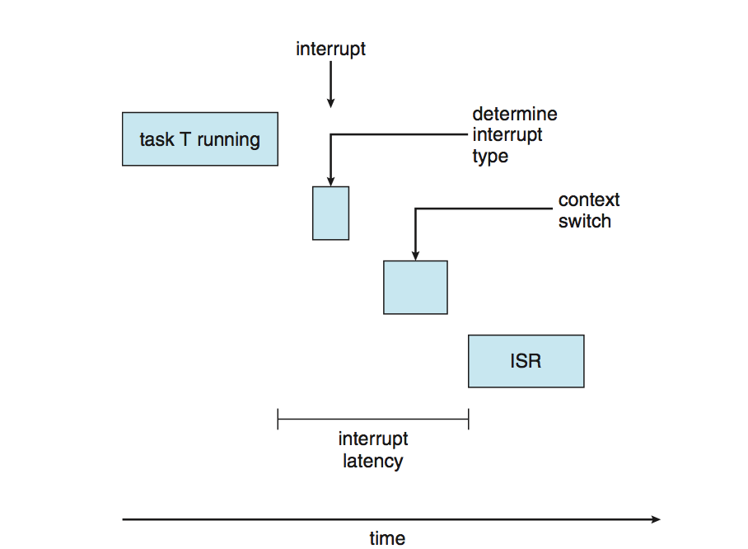

* **Conflict phase of dispatch latency:**
  1. Preemption of any process running in kernel mode
  2. Release by low-priority process of resources needed by high-priority processes

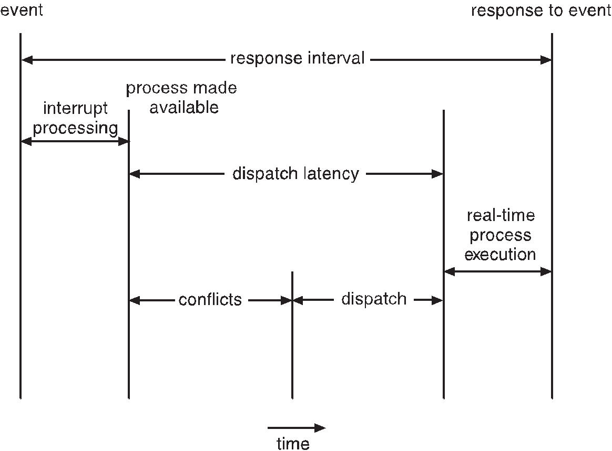

**Priority-based Scheduling**

* For real-time scheduling, scheduler must support preemptive, priority-based scheduling
  + But only guarantees soft real-time
* For hard real-time must also provide ability to meet deadlines
* Processes have new characteristics: **periodic** ones require CPU at constant intervals
  + Has processing time *t*, deadline *d,* period *p*
  + 0 ≤ *t* ≤ *d* ≤ *p*
  + **Rate** of periodic task is 1/*p*

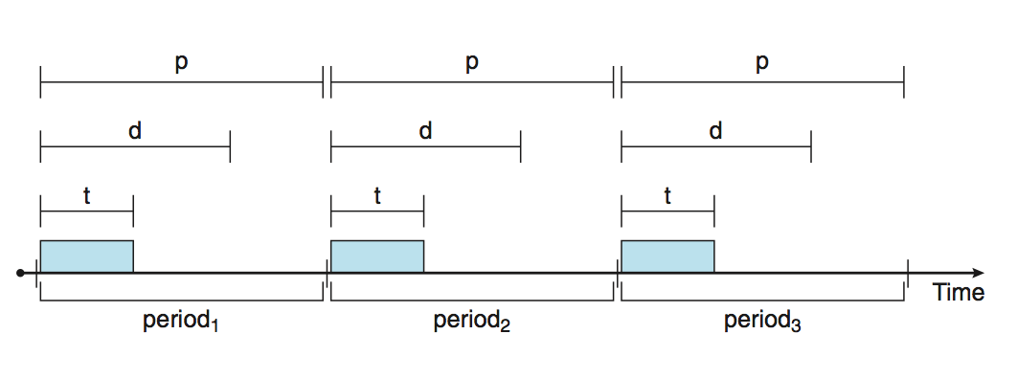

**Virtualization and Scheduling**

* Virtualization software schedules multiple guests onto CPU(s)
* Each guest doing its own scheduling
  + Not knowing it doesn’t own the CPUs
  + Can result in poor response time
  + Can effect time-of-day clocks in guests
* Can undo good scheduling algorithm efforts of guests

**Rate Montonic Scheduling**

* A priority is assigned based on the inverse of its period
* Shorter periods = higher priority;
* Longer periods = lower priority
* P1 is assigned a higher priority than P2.

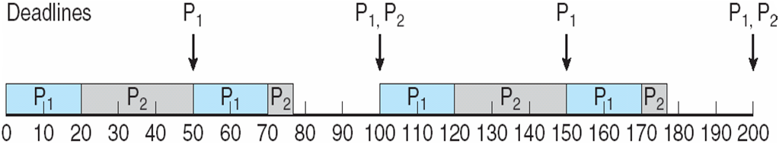

**Missed Deadlines with Rate Monotonic Scheduling**

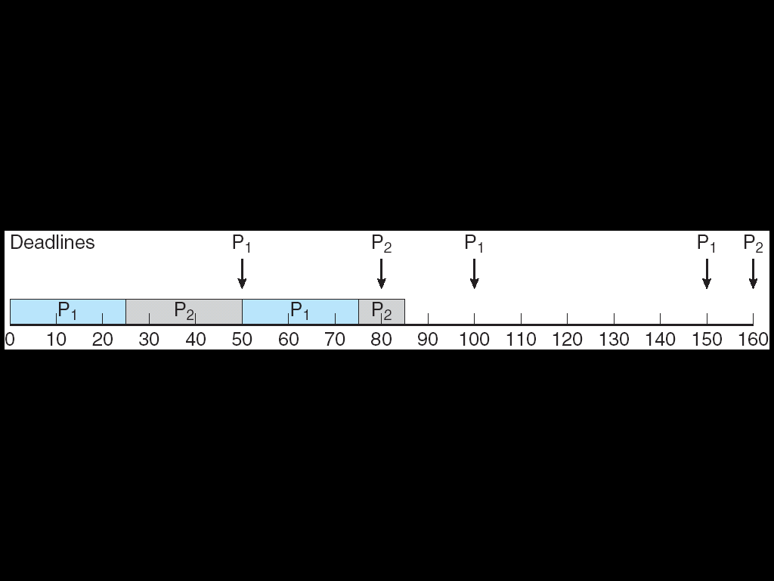

**Earliest Deadline First Scheduling (EDF)**

* Priorities are assigned according to deadlines:  
  the earlier the deadline, the higher the priority; the later the deadline, the lower the priority

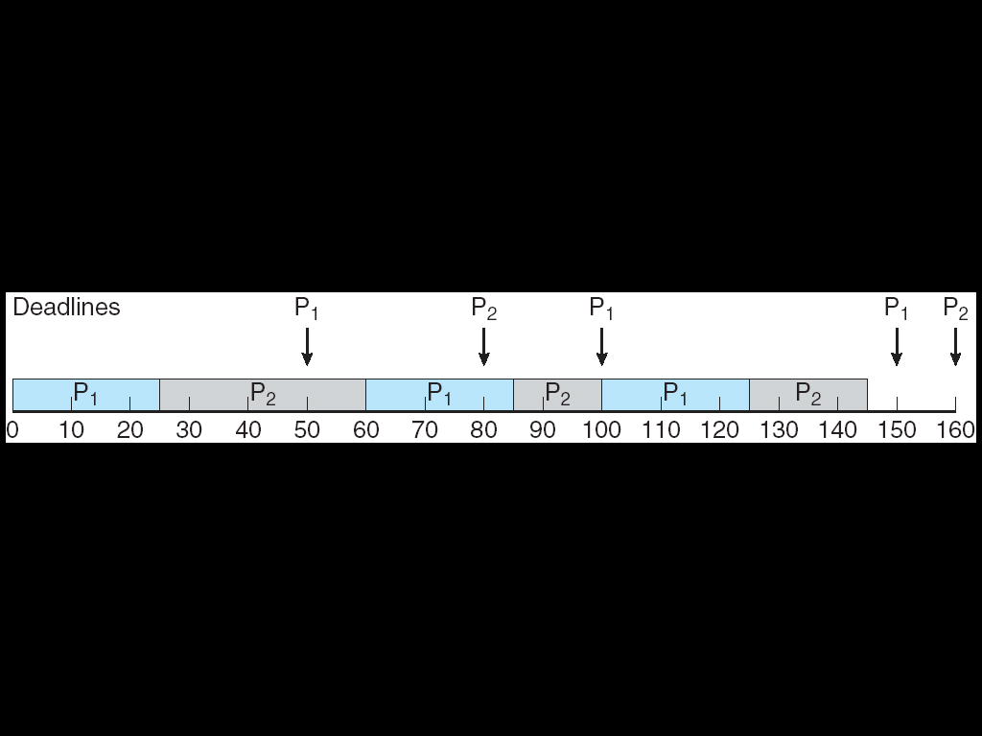

**Proportional Share Scheduling**

* *T* shares are allocated among all processes in the system
* An application receives *N* shares where *N < T*
* This ensures each application will receive ***N*** */ T* of the total processor time

**POSIX Real-Time Scheduling**

* The POSIX.1b standard
* API provides functions for managing real-time threads
* Defines two scheduling classes for real-time threads:

1. **SCHED_FIFO** - threads are scheduled using a FCFS strategy with a FIFO queue. There is no time-slicing for threads of equal priority
2. **SCHED_RR - similar to SCHED_FIFO** except time-slicing occurs for threads of equal priority

* **Defines two functions for getting and setting scheduling policy:**

1. **pthread attr getsched policy(pthread attr t *attr, int *policy)**
2. **pthread attr setsched policy(pthread attr t *attr, int policy)**

**POSIX Real-Time Scheduling API**

**#include <pthread.h>**

**#include <stdio.h>**

**#define NUM THREADS 5**

**int main(int argc, char *argv[])**

**{**

**int i, policy;  
 pthread t tid[NUM THREADS];**

**pthread attr t attr;**

**/* get the default attributes */**

**pthread attr init(&attr);**

**/* get the current scheduling policy */  
 if (pthread attr getschedpolicy(&attr, &policy) != 0)**

**fprintf(stderr, "Unable to get policy.\n");**

**else {**

**if (policy == SCHED OTHER) printf("SCHED OTHER\n");**

**else if (policy == SCHED RR) printf("SCHED RR\n");**

**else if (policy == SCHED FIFO) printf("SCHED FIFO\n");**

**}**

**/* set the scheduling policy - FIFO, RR, or OTHER */   
 if (pthread attr setschedpolicy(&attr, SCHED FIFO) != 0)**

**fprintf(stderr, "Unable to set policy.\n");**

**/* create the threads */  
 for (i = 0; i < NUM THREADS; i++)**

**pthread create(&tid[i],&attr,runner,NULL);**

**/* now join on each thread */  
 for (i = 0; i < NUM THREADS; i++)**

**pthread join(tid[i], NULL);**

**}**

**/* Each thread will begin control in this function */**

**void *runner(void *param)  
{**

**/* do some work ... */**

**pthread exit(0);**

**}**

**Operating System Examples**

* Linux scheduling
* Windows scheduling
* Solaris scheduling

**Linux Scheduling Through Version 2.5**

* Prior to kernel version 2.5, ran variation of standard UNIX scheduling algorithm
* Version 2.5 moved to constant order *O*(1) scheduling time
  + Preemptive, priority based
  + Two priority ranges: time-sharing and real-time
  + **Real-time** range from 0 to 99 and **nice** value from 100 to 140
  + Map into global priority with numerically lower values indicating higher priority
  + Higher priority gets larger q
  + Task run-able as long as time left in time slice (**active**)
  + If no time left (**expired**), not run-able until all other tasks use their slices
  + All run-able tasks tracked in per-CPU **runqueue** data structure
    - Two priority arrays (active, expired)
    - Tasks indexed by priority
    - When no more active, arrays are exchanged
  + Worked well, but poor response times for interactive processes

**Linux Scheduling in Version 2.6.23 +**

* ***Completely Fair Scheduler*** (**CFS**)
* **Scheduling classes**
  + Each has specific priority
  + Scheduler picks highest priority task in highest scheduling class
  + Rather than quantum based on fixed time allotments, based on proportion of CPU time
  + 2 scheduling classes included, others can be added
    1. default
    2. real-time
* **Quantum calculated based on nice value from -20 to +19**
  + Lower value is higher priority
  + Calculates **target latency** – interval of time during which task should run at least once
  + Target latency can increase if say number of active tasks increases
* **CFS scheduler maintains per task virtual run time in variable vruntime**
  + Associated with decay factor based on priority of task – lower priority is higher decay rate
  + Normal default priority yields virtual run time = actual run time
* **To decide next task to run, scheduler picks task with lowest virtual run time**

**CFS Performance**

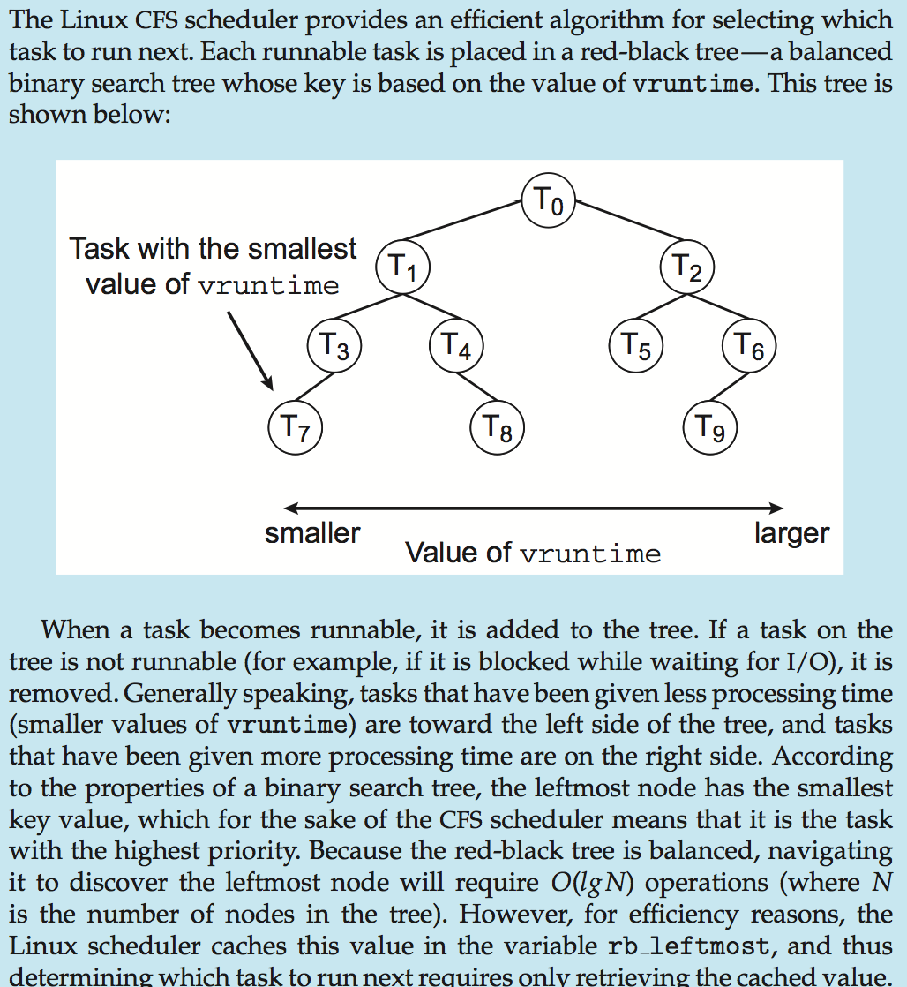

**Linux Scheduling (Cont.)**

* Real-time scheduling according to POSIX.1b
  + Real-time tasks have static priorities
* Real-time plus normal map into global priority scheme
* Nice value of -20 maps to global priority 100
* Nice value of +19 maps to priority 139

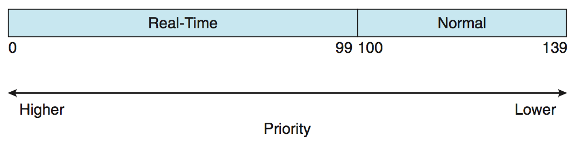

**Windows Scheduling**

* Windows uses priority-based preemptive scheduling
* Highest-priority thread runs next
* **Dispatcher**is scheduler
* Thread runs until (1) blocks, (2) uses time slice, (3) preempted by higher-priority thread
* Real-time threads can preempt non-real-time
* 32-level priority scheme
* **Variable class** is 1-15, **real-time class** is16-31
* Priority 0 is memory-management thread
* Queue for each priority
* If no run-able thread, runs **idle thread**

**Windows Priority Classes**

* Win32 API identifies several priority classes to which a process can belong
  + REALTIME_PRIORITY_CLASS, HIGH_PRIORITY_CLASS, ABOVE_NORMAL_PRIORITY_CLASS,NORMAL_PRIORITY_CLASS, BELOW_NORMAL_PRIORITY_CLASS, IDLE_PRIORITY_CLASS
  + All are variable except REALTIME
* A thread within a given priority class has a relative priority
  + TIME_CRITICAL, HIGHEST, ABOVE_NORMAL, NORMAL, BELOW_NORMAL, LOWEST, IDLE
* Priority class and relative priority combine to give numeric priority
* Base priority is NORMAL within the class
* If quantum expires, priority lowered, but never below base
* If wait occurs, priority boosted depending on what was waited for
* Foreground window given 3x priority boost
* Windows 7 added **user-mode scheduling** (**UMS**)
  + Applications create and manage threads independent of kernel
  + For large number of threads, much more efficient
  + UMS schedulers come from programming language libraries like C++ **Concurrent Runtime** (ConcRT) framework

**Windows Priorities**

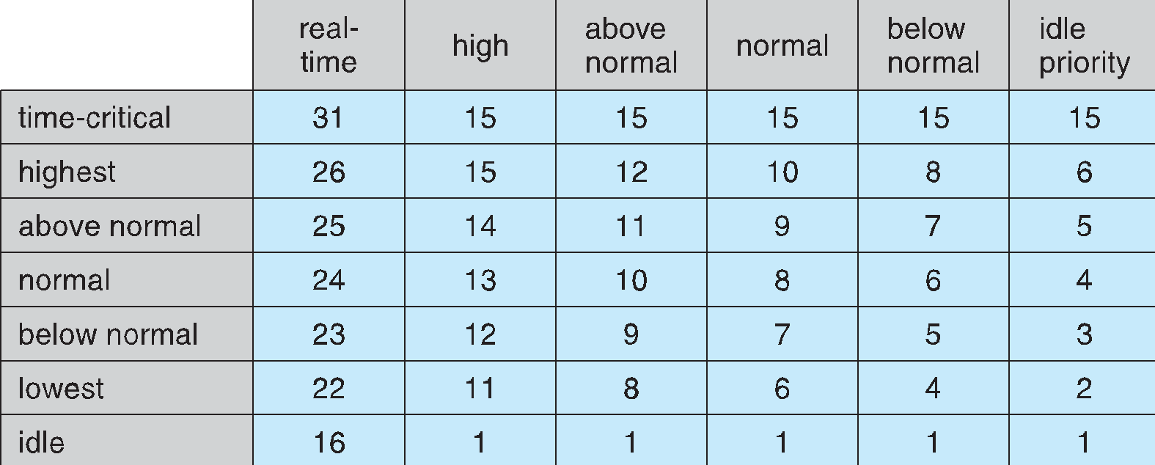

**Solaris**

* Priority-based scheduling
* Six classes available
  + Time sharing (default) (TS)
  + Interactive (IA)
  + Real time (RT)
  + System (SYS)
  + Fair Share (FSS)
  + Fixed priority (FP)
* Given thread can be in one class at a time
* Each class has its own scheduling algorithm
* Time sharing is multi-level feedback queue
  + Loadable table configurable by sysadmin

**Solaris Dispatch Table**

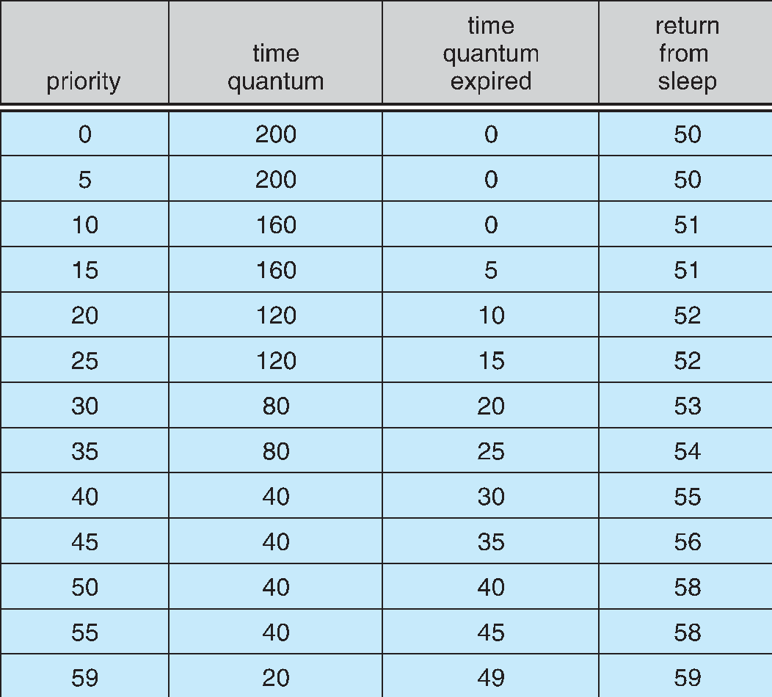

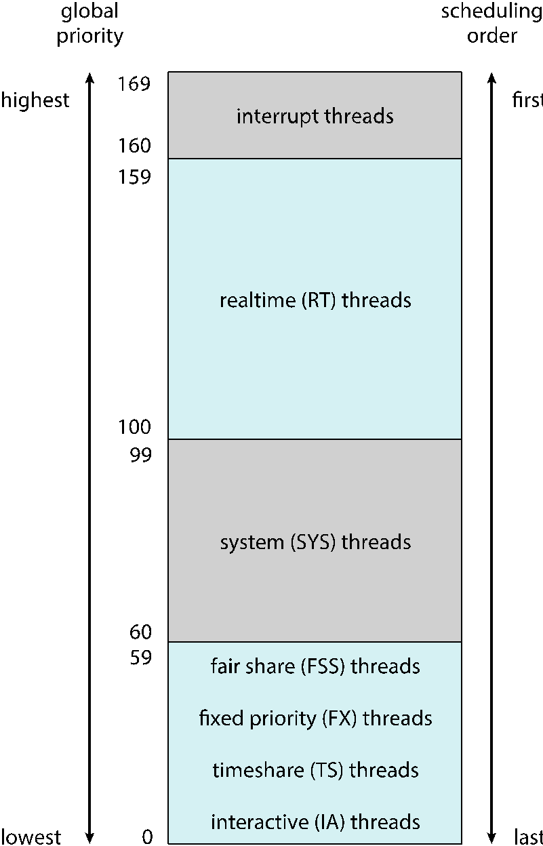

**Solaris Scheduling**

**Solaris Scheduling (Cont.)**

* **Scheduler converts class-specific priorities into a per-thread global priority**
  + Thread with highest priority runs next
  + Runs until (1) blocks, (2) uses time slice, (3) preempted by higher-priority thread
  + Multiple threads at same priority selected via RR

**Algorithm Evaluation**

* How to select CPU-scheduling algorithm for an OS?
* Determine criteria, then evaluate algorithms
* **Deterministic modeling**
  + Type of **analytic evaluation**
  + 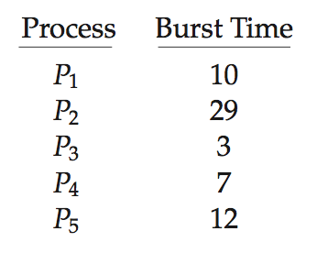Takes a particular predetermined workload and defines the performance of each algorithm for that workload
* **Consider 5 processes arriving at time 0:**

**Deterministic Evaluation**

* For each algorithm, calculate minimum average waiting time
* Simple and fast, but requires exact numbers for input, applies only to those inputs
  + **FCS is 28ms:**

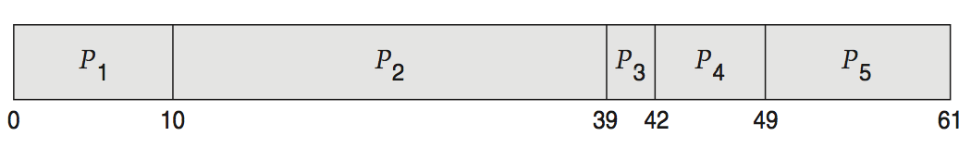

* + **Non-preemptive SFJ is 13ms:**

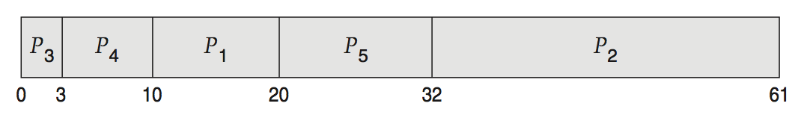

* + **RR is 23ms:**

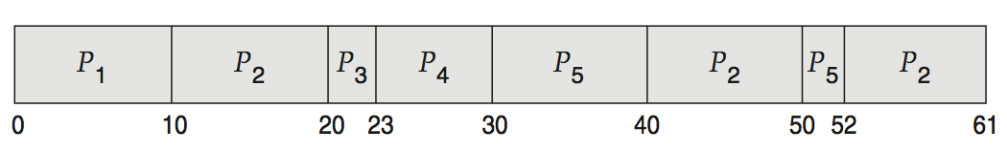

**Queueing Models**

* Describes the arrival of processes, and CPU and I/O bursts probabilistically
  + Commonly exponential, and described by mean
  + Computes average throughput, utilization, waiting time, etc
* **Computer system described as network of servers, each with queue of waiting processes**
  + Knowing arrival rates and service rates
  + Computes utilization, average queue length, average wait time, etc

**Little’s Formula**

* ***n* =** average queue length
* ***W =*** average waiting time in queue
* ***λ =*** average arrival rate into queue
* ***Little’s law –*** in steady state, processes leaving queue must equal processes arriving, thus  
  ***n = λ x W***
  + Valid for any scheduling algorithm and arrival distribution
* For example, if on average 7 processes arrive per second, and normally 14 processes in queue, then average wait time ***per process = 2 seconds***

**Simulations**

* Queueing models limited
* **Simulations** more accurate
  + Programmed model of computer system
  + Clock is a variable
  + Gather statistics indicating algorithm performance
  + Data to drive simulation gathered via
    - Random number generator according to probabilities
    - Distributions defined mathematically or empirically
    - Trace tapes record sequences of real events in real systems

**Evaluation of CPU Schedulers by SimulationImplementation**

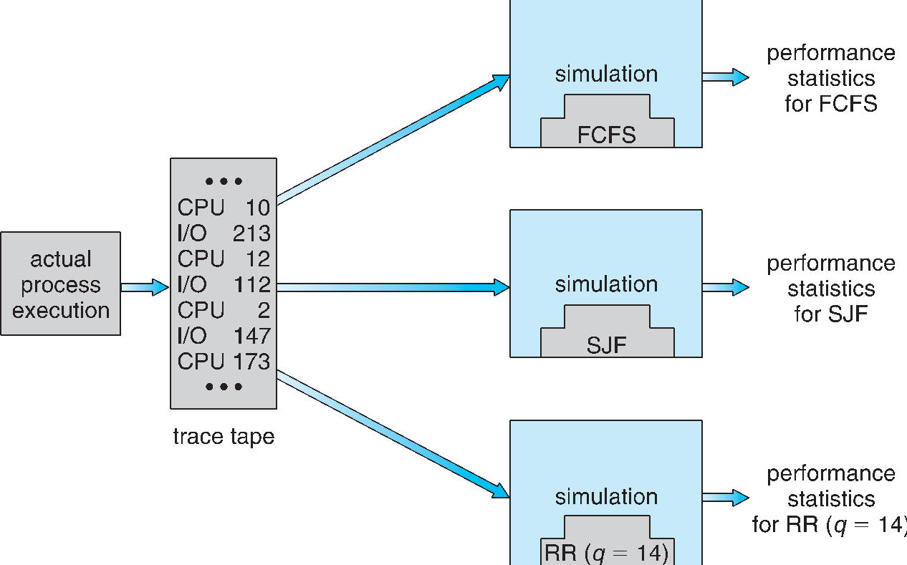

**Implementation**

* Even simulations have limited accuracy
* Just implement new scheduler and test in real systems
  + High cost, high risk
  + Environments vary
* Most flexible schedulers can be modified per-site or per-system
* Or APIs to modify priorities
* But again environments vary