**Chapter 3**

**Process Concept**

**Chapter 3: Process Concept**

* Process Concept
* Process Scheduling
* Operations on Processes
* Interprocess Communication
* Examples of IPC Systems
* Communication in Client-Server Systems

**Objectives**

* To introduce the notion of a process -- a program in execution, which forms the basis of all computation
* To describe the various features of processes, including scheduling, creation and termination, and communication
* To explore interprocess communication using shared memory and mes- sage passing
* To describe communication in client-server systems

**Process Concept**

* An operating system executes a variety of programs:
  + Batch system – **jobs**
  + Time-shared systems – **user programs** or **tasks**
* Textbook uses the terms ***job*** and ***process*** almost interchangeably
* **Process** – a program in execution; process execution must progress in sequential fashion
* Multiple parts
  + The program code, also called **text section**
  + Current activity including **program counter**, processor registers
  + **Stack** containing temporary data
    - Function parameters, return addresses, local variables
  + **Data section** containing global variables
  + **Heap** containing memory dynamically allocated during run time
* Program is ***passive*** entity stored on disk (**executable file**), process is ***active*** 
  + Program becomes process when executable file loaded into memory
* Execution of program started via GUI mouse clicks, command line entry of its name, etc
* One program can be several processes
  + Consider multiple users executing the same program

**Process in Memory**

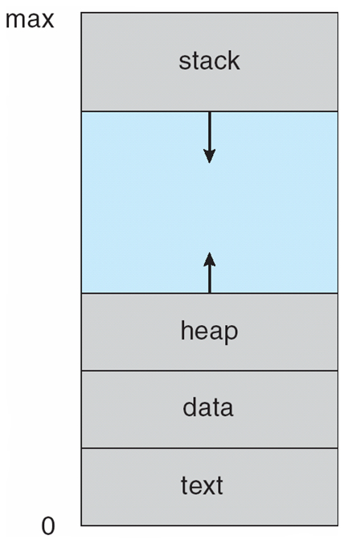

**Process State**

* As a process executes, it changes **state**
  + **new**: The process is being created
  + **running**: Instructions are being executed
  + **waiting**: The process is waiting for some event to occur
  + **ready**: The process is waiting to be assigned to a processor
  + **terminated**: The process has finished execution

**Diagram of Process State**

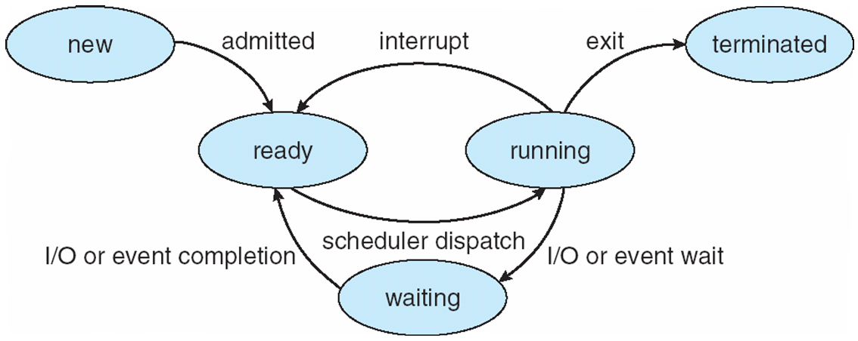

**Process Control Block (PCB)**

Information associated with each process

(also called **task control block**)

* Process state – running, waiting, etc
* Program counter – location of instruction to next execute
* CPU registers – contents of all process-centric registers
* CPU scheduling information- priorities, scheduling queue pointers
* Memory-management information – memory allocated to the process
* Accounting information – CPU used, clock time elapsed since start, time limits
* I/O status information – I/O devices allocated to process, list of open files

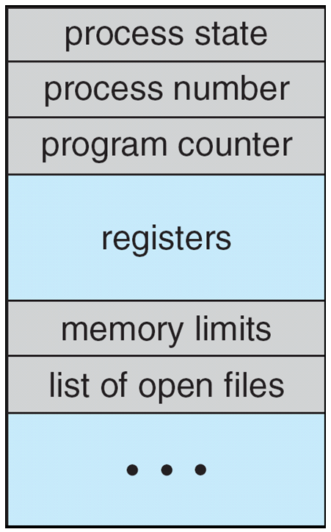

**CPU Switch From Process to Process**

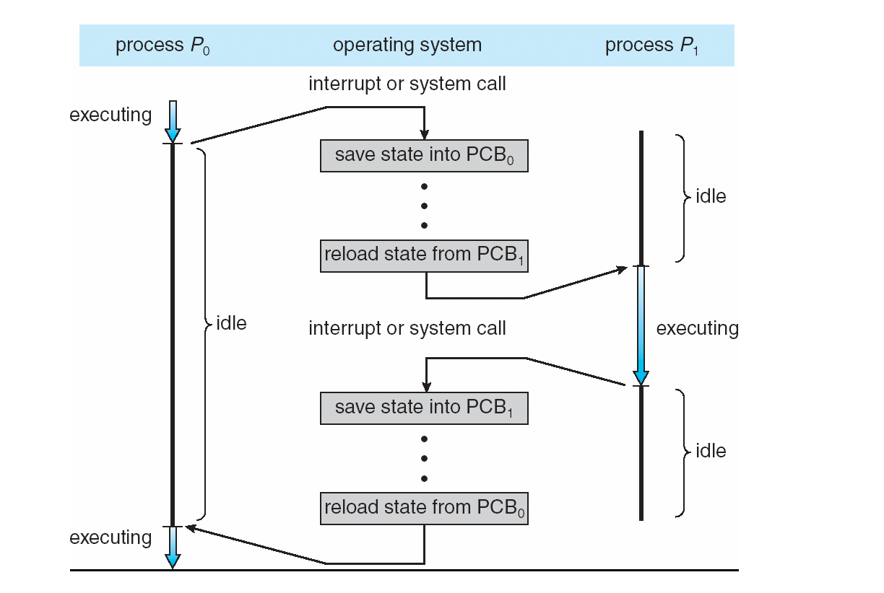

**Threads**

* So far, process has a single thread of execution
* Consider having multiple program counters per process
  + Multiple locations can execute at once
    - Multiple threads of control -> **threads**
* Must then have storage for thread details, multiple program counters in PCB
* See next chapter

**Process Representation in Linux**

* Represented by the C structure task_struct  
  pid t pid; /* process identifier */   
  long state; /* state of the process */   
  unsigned int time slice /* scheduling information */   
  struct task struct *parent; /* this process’s parent */   
  struct list head children; /* this process’s children */   
  struct files struct *files; /* list of open files */   
  struct mm struct *mm; /* address space of this process */

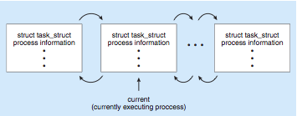

**Process Scheduling**

* Maximize CPU use, quickly switch processes onto CPU for time sharing
* **Process scheduler** selects among available processes for next execution on CPU
* Maintains **scheduling queues** of processes
  + **Job queue** – set of all processes in the system
  + **Ready queue** – set of all processes residing in main memory, ready and waiting to execute
  + **Device queues** – set of processes waiting for an I/O device
  + Processes migrate among the various queues

**Ready Queue And Various   
I/O Device Queues**

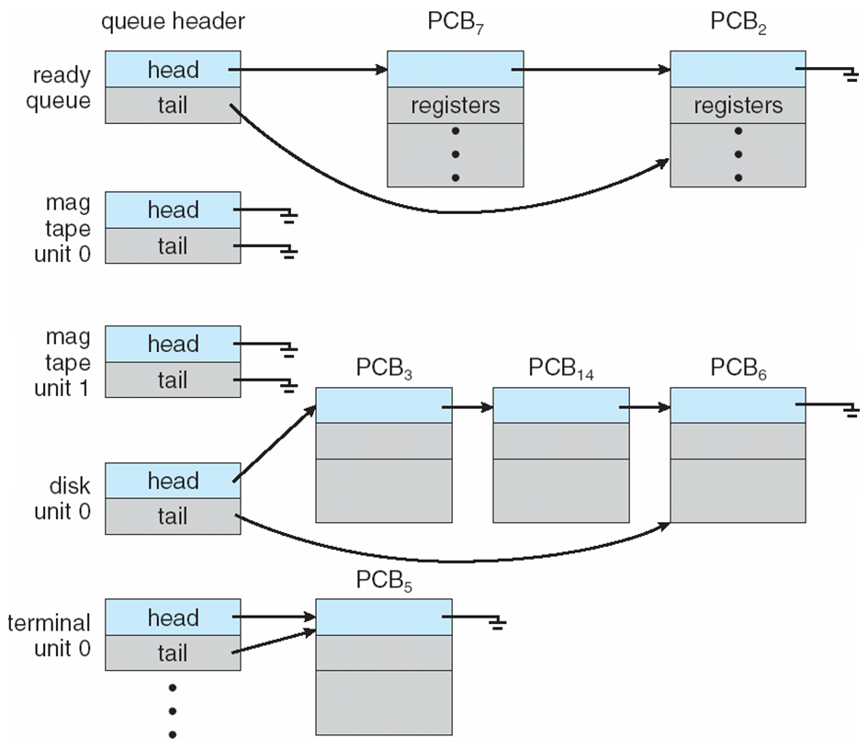

**Representation of Process Scheduling**

* **Queuing diagram** represents queues, resources, flows

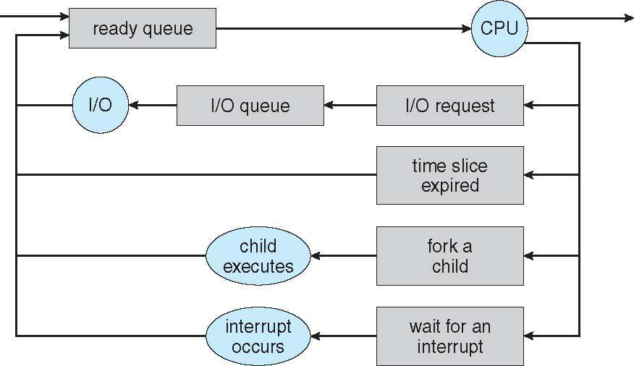

**Schedulers**

* **Long-term scheduler** (or **job scheduler**) – selects which processes should be brought into the ready queue
* **Short-term scheduler** (or **CPU scheduler**) – selects which process should be executed next and allocates CPU
  + Sometimes the only scheduler in a system
* Short-term scheduler is invoked very frequently (milliseconds) ⇒ (must be fast)
* Long-term scheduler is invoked very infrequently (seconds, minutes) ⇒ (may be slow)
* The long-term scheduler controls the **degree of multiprogramming**
* Processes can be described as either:
  + **I/O-bound process** – spends more time doing I/O than computations, many short CPU bursts
  + **CPU-bound process** – spends more time doing computations; few very long CPU bursts
* Long-term scheduler strives for good ***process mix***

**Addition of Medium Term Scheduling**

* **Medium-term scheduler** can be added if degree of multiple programming needs to decrease
  + Remove process from memory, store on disk, bring back in from disk to continue execution: **swapping**

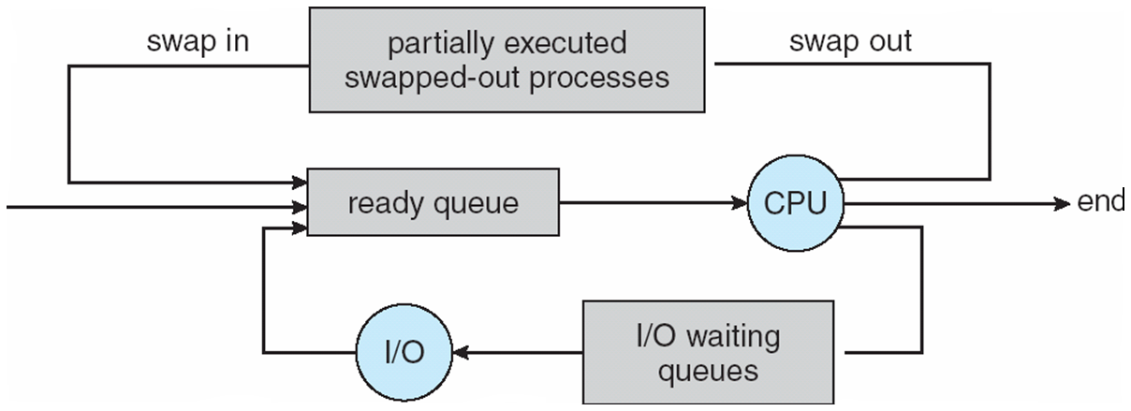

**Multitasking in Mobile Systems**

* Some systems / early systems allow only one process to run, others suspended
* Due to screen real estate, user interface limits iOS provides for a
  + Single **foreground** process- controlled via user interface
  + Multiple **background** processes– in memory, running, but not on the display, and with limits
  + Limits include single, short task, receiving notification of events, specific long-running tasks like audio playback
* Android runs foreground and background, with fewer limits
  + Background process uses a **service** to perform tasks
  + Service can keep running even if background process is suspended
  + Service has no user interface, small memory use

**Context Switch**

* When CPU switches to another process, the system must **save the state** of the old process and load the **saved state** for the new process via a **context switch**
* **Context** of a process represented in the PCB
* Context-switch time is overhead; the system does no useful work while switching
  + The more complex the OS and the PCB -> longer the context switch
* Time dependent on hardware support
  + Some hardware provides multiple sets of registers per CPU -> multiple contexts loaded at once

**Operations on Processes**

* System must provide mechanisms for process creation, termination, and so on as detailed next

**Process Creation**

* **Parent** process create **children** processes, which, in turn create other processes, forming a **tree** of processes
* Generally, process identified and managed via a **process identifier** (**pid**)
* **Resource sharing options**
  + Parent and children share all resources
  + Children share subset of parent’s resources
  + Parent and child share no resources
* **Execution options**
  + Parent and children execute concurrently
  + Parent waits until children terminate

**A Tree of Processes in Linux**

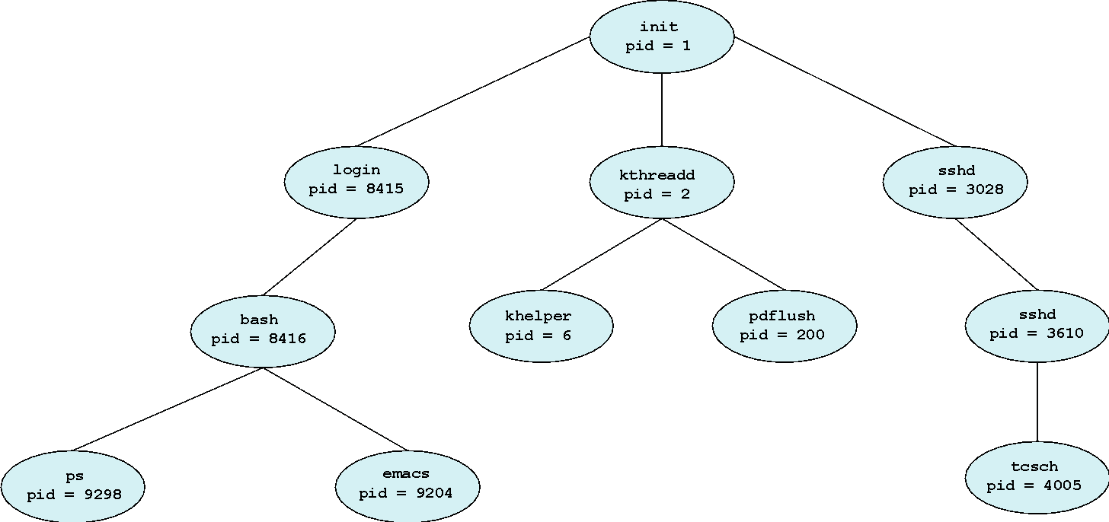

**Process Creation (Cont.)**

* **Address space**
  + Child duplicate of parent
  + Child has a program loaded into it
* **UNIX examples**
  + **fork()** system call creates new process
  + **exec()** system call used after a **fork()** to replace the process’ memory space with a new program

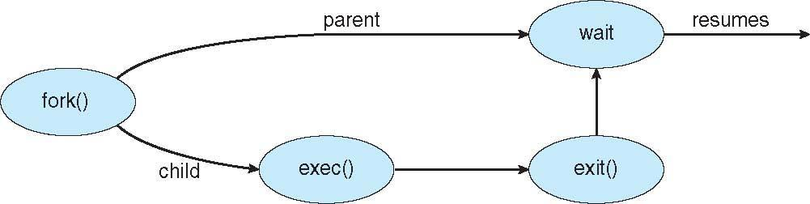

**C Program Forking Separate Process**

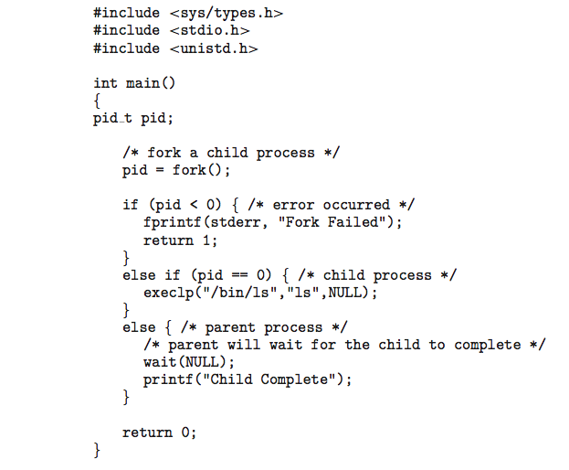

**Creating a Separate Process via Windows API**

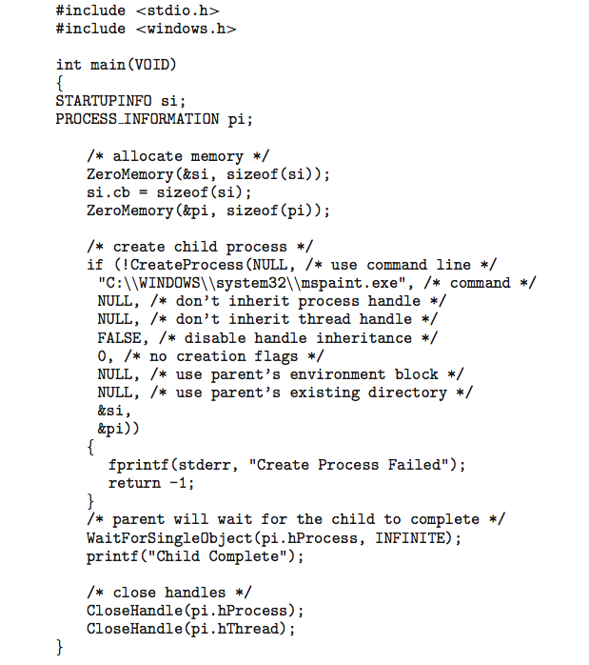

**Process Termination**

* Process executes last statement and asks the operating system to delete it (**exit()**)
  + Output data from child to parent (via **wait()**)
  + Process’ resources are deallocated by operating system
* Parent may terminate execution of children processes (**abort()**)
  + Child has exceeded allocated resources
  + Task assigned to child is no longer required
  + If parent is exiting
    - Some operating systems do not allow child to continue if its parent terminates
      * All children terminated - **cascading termination**
* Wait for termination, returning the pid:

**pid t pid; int status;**

**pid = wait(&status);**

* If no parent waiting, then terminated process is a **zombie**
* If parent terminated, processes are **orphans**

**Multiprocess Architecture – Chrome Browser**

* Many web browsers ran as single process (some still do)
  + If one web site causes trouble, entire browser can hang or crash
* Google Chrome Browser is multiprocess with 3 categories
  + **Browser** process manages user interface, disk and network I/O
  + **Renderer** process renders web pages, deals with HTML, Javascript, new one for each website opened
    - Runs in **sandbox** restricting disk and network I/O, minimizing effect of security exploits
  + **Plug-in** process for each type of plug-in

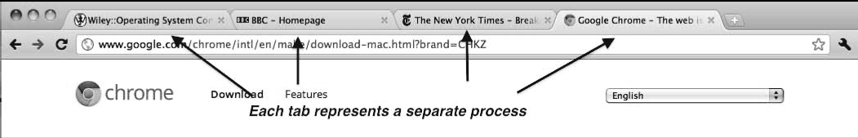

**Interprocess Communication**

* Processes within a system may be ***independent*** or ***cooperating***
* Cooperating process can affect or be affected by other processes, including sharing data
* Reasons for cooperating processes:
  + Information sharing
  + Computation speedup
  + Modularity
  + Convenience
* Cooperating processes need **interprocess communication** (**IPC**)
* Two models of IPC
  + **Shared memory**
  + **Message passing**

**Communications Models**

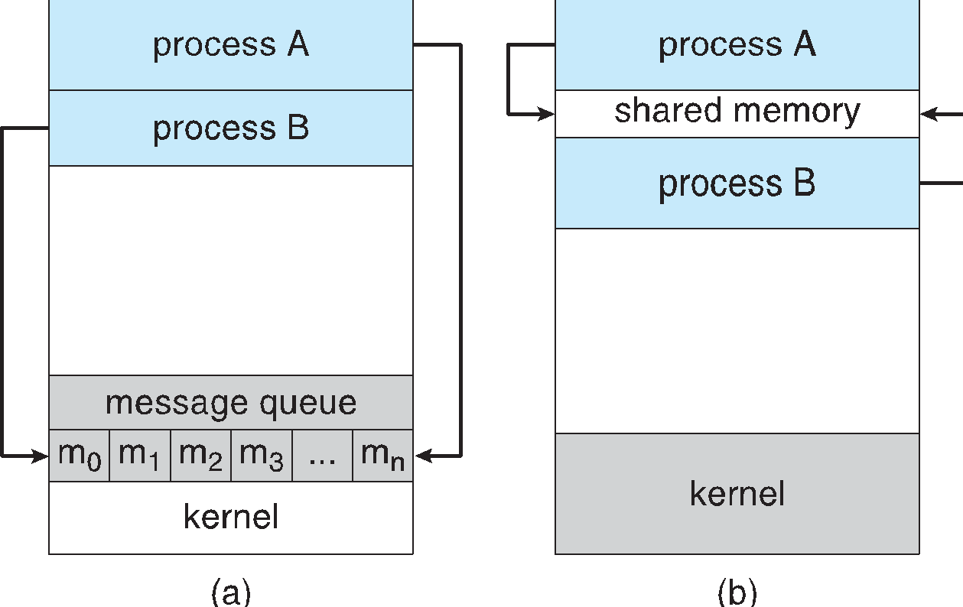

**Cooperating Processes**

* ***Independent*** process cannot affect or be affected by the execution of another process
* ***Cooperating*** process can affect or be affected by the execution of another process
* Advantages of process cooperation
  + Information sharing
  + Computation speed-up
  + Modularity
  + Convenience

**Producer-Consumer Problem**

* Paradigm for cooperating processes, *producer* process produces information that is consumed by a *consumer* process
  + **unbounded-buffer** places no practical limit on the size of the buffer
  + **bounded-buffer** assumes that there is a fixed buffer size

**Bounded-Buffer – Shared-Memory Solution**

* Shared data

#define BUFFER_SIZE 10

typedef struct {

. . .

} item;

item buffer[BUFFER_SIZE];

int in = 0;

int out = 0;

* Solution is correct, but can only use BUFFER_SIZE-1 elements

**Bounded-Buffer – Producer**

item next produced;

while (true) {

/* produce an item in next produced */

while (((in + 1) % BUFFER SIZE) == out)

; /* do nothing */

buffer[in] = next produced;

in = (in + 1) % BUFFER SIZE;

}

**Bounded Buffer – Consumer**

item next consumed;

while (true) {  
 while (in == out)

; /* do nothing */  
 next consumed = buffer[out];

out = (out + 1) % BUFFER SIZE;

/* consume the item in next consumed */

}

**Interprocess Communication – Message Passing**

* Mechanism for processes to communicate and to synchronize their actions
* Message system – processes communicate with each other without resorting to shared variables
* IPC facility provides two operations:
  + **send**(*message*) – message size fixed or variable
  + **receive**(*message*)
* **If *P* and *Q* wish to communicate, they need to:**
  + establish a ***communication* *link*** between them
  + exchange messages via send/receive
* **Implementation of communication link**
  + physical (e.g., shared memory, hardware bus)
  + logical (e.g., direct or indirect, synchronous or asynchronous, automatic or explicit buffering)

**Implementation Questions**

* How are links established?
* Can a link be associated with more than two processes?
* How many links can there be between every pair of communicating processes?
* What is the capacity of a link?
* Is the size of a message that the link can accommodate fixed or variable?
* Is a link unidirectional or bi-directional?

**Direct Communication**

* **Processes must name each other explicitly:**
  + **send** (*P, message*) – send a message to process P
  + **receive**(*Q, message*) – receive a message from process Q
* **Properties of communication link**
  + Links are established automatically
  + A link is associated with exactly one pair of communicating processes
  + Between each pair there exists exactly one link
  + The link may be unidirectional, but is usually bi-directional

**Indirect Communication**

* **Messages are directed and received from mailboxes (also referred to as ports)**
  + Each mailbox has a unique id
  + Processes can communicate only if they share a mailbox
* **Properties of communication link**
  + Link established only if processes share a common mailbox
  + A link may be associated with many processes
  + Each pair of processes may share several communication links
  + Link may be unidirectional or bi-directional
* **Operations**
  + create a new mailbox
  + send and receive messages through mailbox
  + destroy a mailbox
* **Primitives are defined as:**

**send**(*A, message*) – send a message to mailbox A

**receive**(*A, message*) – receive a message from mailbox A

* **Mailbox sharing**
  + *P1, P2,* and *P3* share mailbox A
  + *P1*, sends; *P2* and *P3* receive
  + Who gets the message?
* **Solutions**
  + Allow a link to be associated with at most two processes
  + Allow only one process at a time to execute a receive operation
  + Allow the system to select arbitrarily the receiver. Sender is notified who the receiver was.

**Synchronization**

* **Message passing may be either blocking or non-blocking**
* **Blocking** **is considered** **synchronous**
  + **Blocking send** has the sender block until the message is received
  + **Blocking receive** has the receiver block until a message is available
* **Non-blocking** **is considered** **asynchronous**
  + **Non-blocking** send has the sender send the message and continue
  + **Non-blocking** receive has the receiver receive a valid message or null}
* **Different combinations possible**
  + If both send and receive are blocking, we have a **rendezvous**
* **Producer-consumer becomes trivial**

message next produced;

while (true) {  
 /* produce an item in next produced */

send(next produced);

}

**Buffering**

* Queue of messages attached to the link; implemented in one of three ways

1. Zero capacity – 0 messages  
Sender must wait for receiver (rendezvous)

2. Bounded capacity – finite length of *n* messages  
Sender must wait if link full

3. Unbounded capacity – infinite length   
Sender never waits

**Examples of IPC Systems - POSIX**

* **POSIX Shared Memory**
  + Process first creates shared memory segment  
    **shm_fd = shm_open(name, O CREAT | O RDRW, 0666);**
  + Also used to open an existing segment to share it
  + Set the size of the object

**ftruncate(shm fd, 4096);**

* + Now the process could write to the shared memory

**sprintf(shared memory, "Writing to shared memory");**

**IPC POSIX Producer**

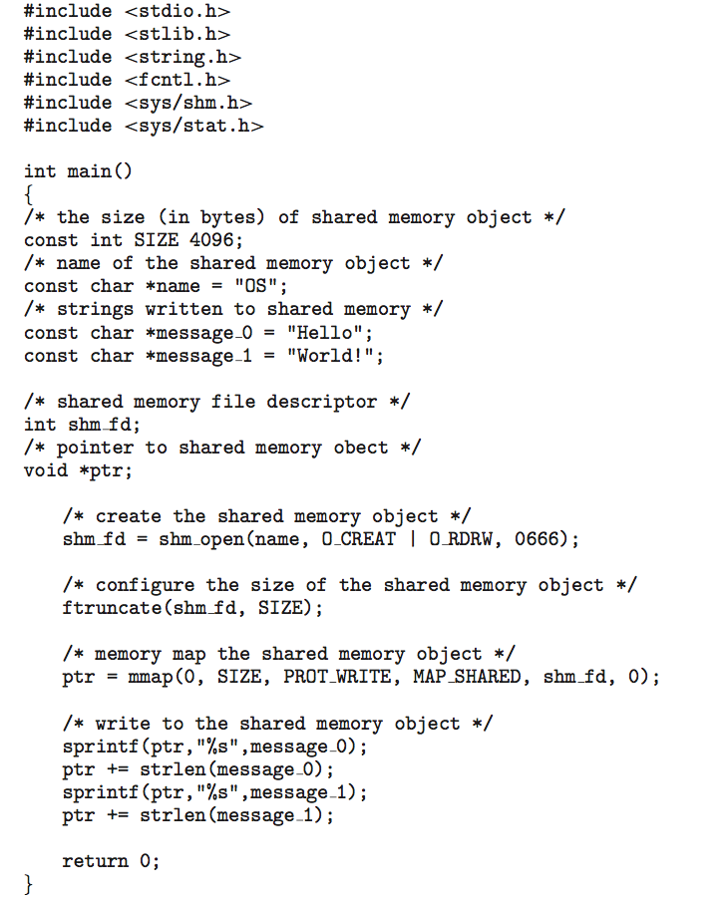

**IPC POSIX Consumer**

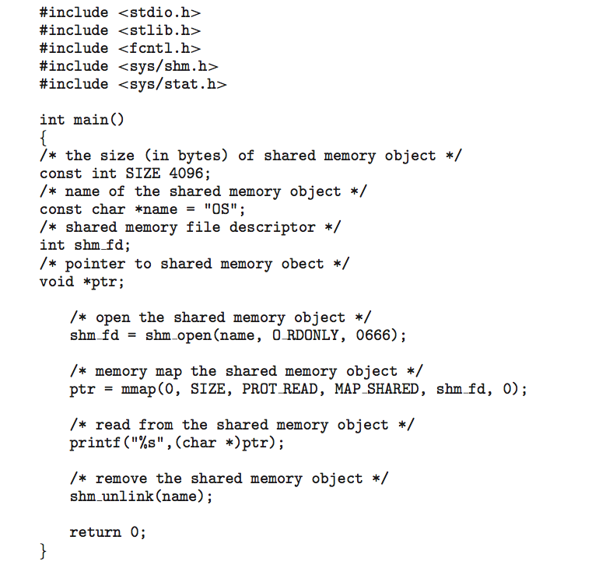

**Examples of IPC Systems - Mach**

* **Mach communication is message based**
  + Even system calls are messages
  + Each task gets two mailboxes at creation- Kernel and Notify
  + Only three system calls needed for message transfer

**msg_send(), msg_receive(), msg_rpc()**

* + Mailboxes needed for commuication, created via

**port_allocate()**

* + Send and receive are flexible, for example four options if mailbox full:
    - Wait indefinitely
    - Wait at most n milliseconds
    - Return immediately
    - Temporarily cache a message

**Examples of IPC Systems – Windows**

* Message-passing centric via **advanced local procedure call (LPC)** facility
  + Only works between processes on the same system
  + Uses ports (like mailboxes) to establish and maintain communication channels
  + **Communication works as follows:**
    - The client opens a handle to the subsystem’s **connection port** object.
    - The client sends a connection request.
    - The server creates two private **communication ports** and returns the handle to one of them to the client.
    - The client and server use the corresponding port handle to send messages or callbacks and to listen for replies.

**Local Procedure Calls in Windows XP**

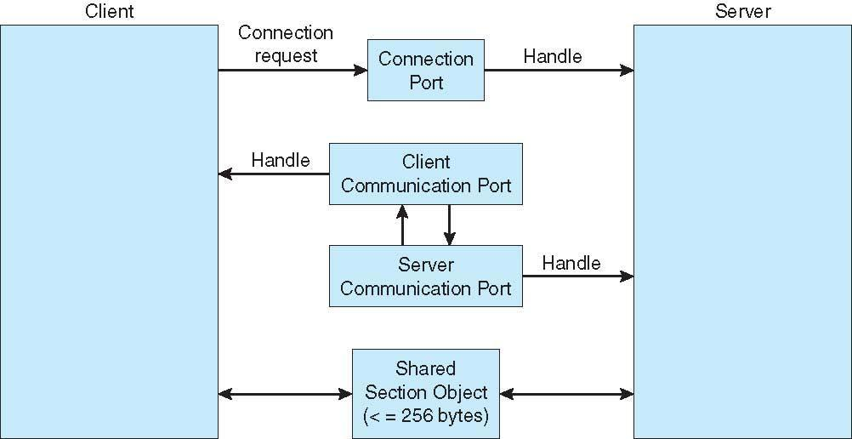

**Communications in Client-Server Systems**

* Sockets
* Remote Procedure Calls
* Pipes
* Remote Method Invocation (Java)

**Sockets**

* A **socket is defined as an endpoint for communication**
* Concatenation of IP address and **port** – a number included at start of message packet to differentiate network services on a host
* The socket **161.25.19.8:1625** refers to port **1625** on host **161.25.19.8**
* Communication consists between a pair of sockets
* All ports below 1024 are ***well known***, used for standard services
* Special IP address 127.0.0.1 (**loopback**) to refer to system on which process is running

**Socket Communication**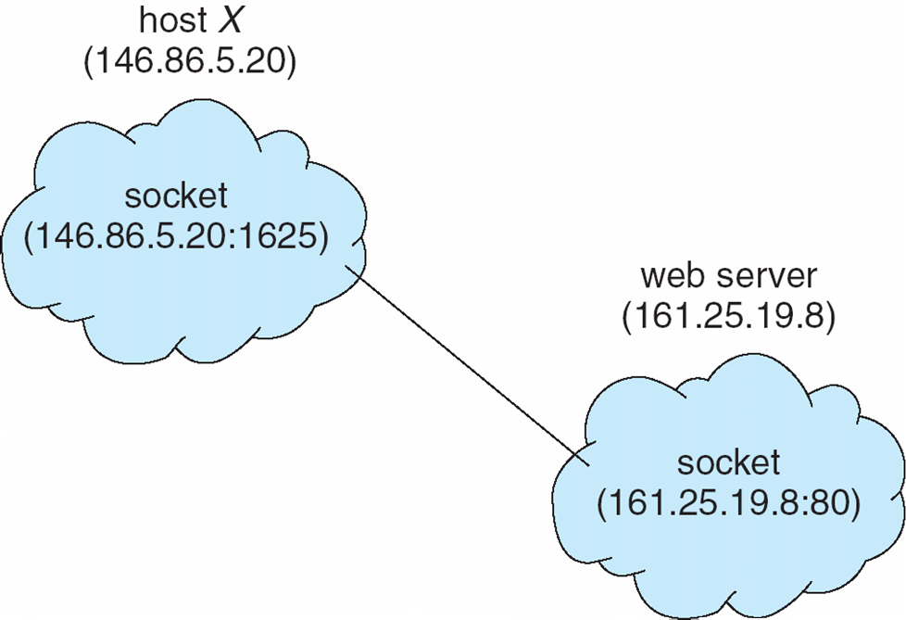

**Sockets in Java**

* **Three types of sockets**
  + **Connection-oriented** (**TCP**)
  + **Connectionless** (**UDP**)
  + **MulticastSocket** class– data can be sent to multiple recipients
* Consider this “Date” server:

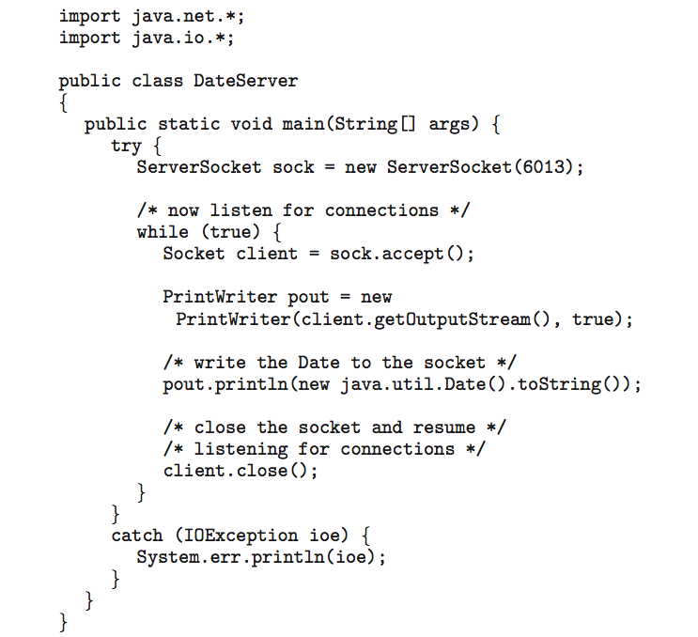

**Remote Procedure Calls**

* Remote procedure call (RPC) abstracts procedure calls between processes on networked systems
  + Again uses ports for service differentiation
* **Stubs** – client-side proxy for the actual procedure on the server
* The client-side stub locates the server and **marshalls** the parameters
* The server-side stub receives this message, unpacks the marshalled parameters, and performs the procedure on the server
* On Windows, stub code compile from specification written in **Microsoft Interface Definition Language** (**MIDL**)
* Data representation handled via **External Data Representation** (**XDL**) format to account for different architectures
  + **Big-endian** and **little-endian**
* Remote communication has more failure scenarios than local
  + Messages can be delivered ***exactly once*** rather than ***at most once***
* OS typically provides a rendezvous (or **matchmaker**) service to connect client and server

**Execution of RPC**

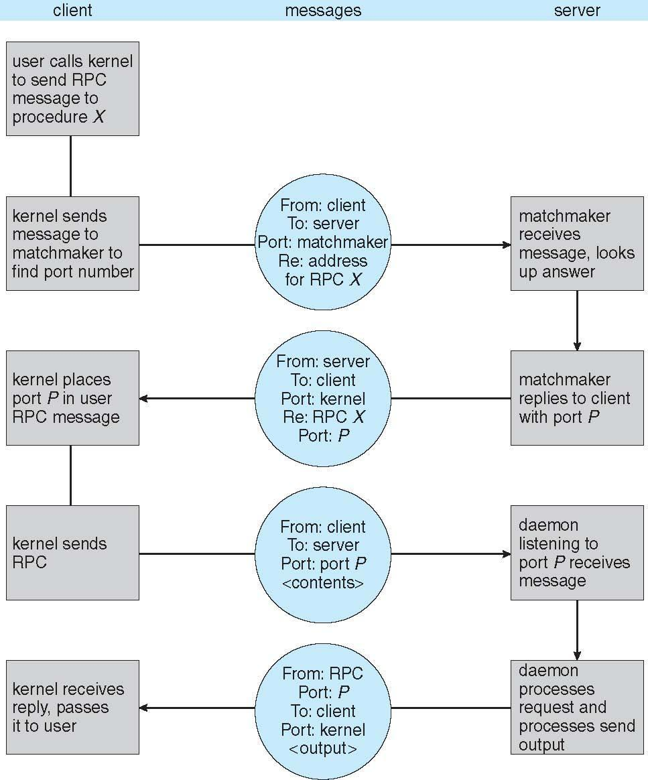

**Pipes**

* Acts as a conduit allowing two processes to communicate
* **Issues**
  + Is communication unidirectional or bidirectional?
  + In the case of two-way communication, is it half or full-duplex?
  + Must there exist a relationship (i.e. ***parent-child***) between the communicating processes?
  + Can the pipes be used over a network?

**Ordinary Pipes**

* Ordinary Pipesallow communication in standard producer-consumer style
* Producer writes to one end (the **write-end** of the pipe)
* Consumer reads from the other end (the **read-end**of the pipe)
* Ordinary pipes are therefore unidirectional
* Require parent-child relationship between communicating processes

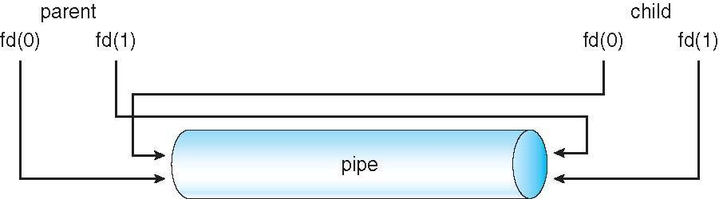

* Windows calls these **anonymous pipes**
* See Unix and Windows code samples in textbook

**Named Pipes**

* Named Pipes are more powerful than ordinary pipes
* Communication is bidirectional
* No parent-child relationship is necessary between the communicating processes
* Several processes can use the named pipe for communication
* Provided on both UNIX and Windows systems