Chapter 01 - Foundations of Information Systems in Business

A system is a set of interrelated components, with a clearly defined boundary, working together to achieve a common set of objectives.

An information system (IS) can be any organized combination of people, hardware, software, communications networks, data resources, and policies and procedures that stores, retrieves, transforms, and disseminates information in an organization.

An IS may be computerized or not. Examples:
- Smoke signals for communication
- Card catalogs in a library
- Your book bag, day planner, notebooks, and file folders
- The cash register at your favorite fast-food restaurant
- A paper-based accounting ledger

Framework of Major Areas:
- Foundation Concepts
Fundamental behavioral, technical, business, and managerial concepts about information systems. Examples include basic information system concepts derived from general systems theory or competitive strategy concepts used to develop business applications of information technology for competitive advantage.
- Information Technologies
Major concepts, developments, and management issues in IT
- Business Applications
Major uses of IS for operations, management, and competitive advantage
- Development Process
How an IS is planned, developed, and implemented to meet business opportunities
- Management Challenges
Effectively and ethically managing IT at the end-user, enterprise, and global levels of a business.

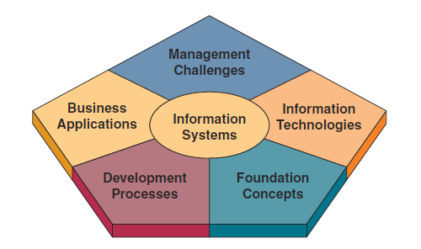

The fundamental Roles of IS in Business
- Support of business processes and operations.
- Support of decision making by employees and managers.
- Support of strategies for competitive advantage.
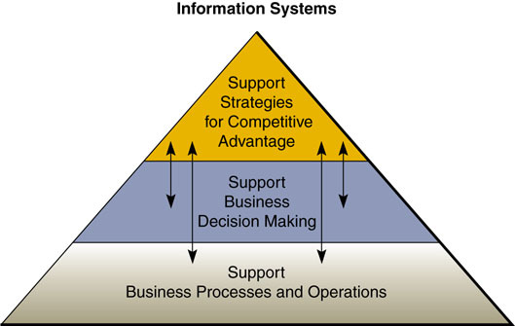

Trends in Information Systems
1960’s
- Electronic Data Processing (EDP)
- Management Information Systems (MIS)
1970’s
- Decision Support Systems (DSS)
1980’s
- End User Computing
- Executive Information Systems (EIS)
- Enterprise Resource Planning (ERP)
1990’s
- The Internet
- Intranets and extranets
- Global networks
2000’s
- Business Intelligence (BI) – all applications and technologies focused on gathering and analyzing data/information for strategic business decisions
- Internet-based/Web-enabled enterprises – dramatically changed the capabilities of IS in business.
- Global e-business and e-commerce – now commonplace.
- IS – is now solidly entrenched as a strategic resource in the modern organization.

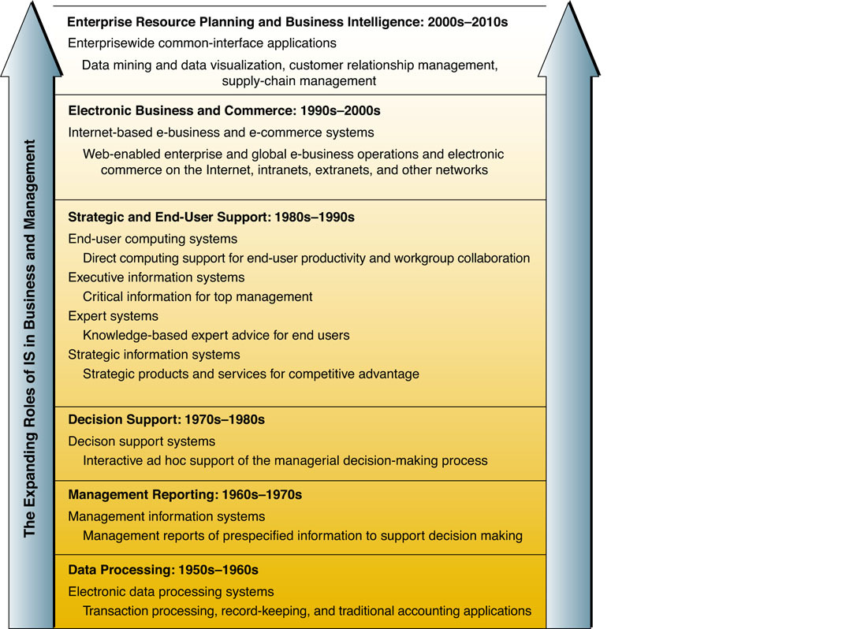

The Role of e-Business in Business
- E-Business
Use of Internet technologies to empower business processes, e-commerce, and enterprise collaboration within a firm and its customers, suppliers, and stakeholders.
- Enterprise Collaboration Systems
Support communication, coordination, and collaboration among networked teams/workgroups.
- E-Commerce
Buying, selling, marketing, and servicing products, services, and information over computer networks.

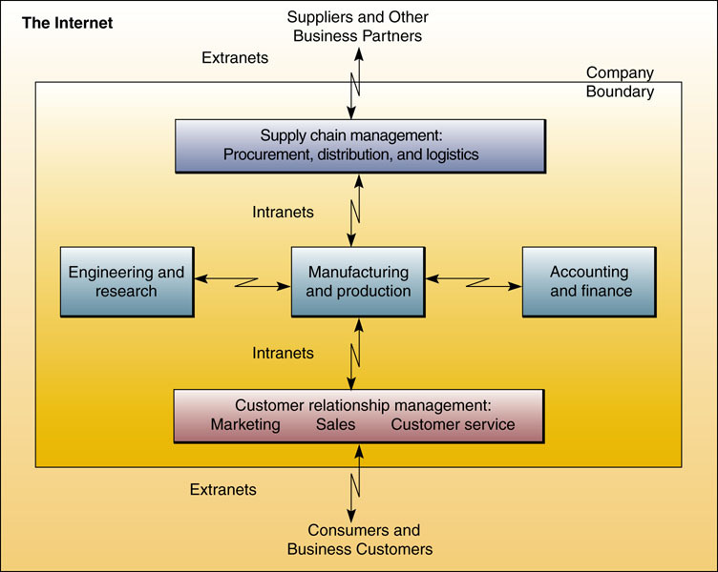

Types of Information Systems

Operations Support Systems
They help run the daily business, but do not provide much information for managerial decision-making.
- Transaction processing systems
Process data resulting from business transactions, update operational databases, and produce business documents. Examples: sales and inventory processing and accounting systems.
- Process control systems
Monitor and control industrial processes. Examples: petroleum refining, power generation, and steel production systems.
- Enterprise collaboration systems (Office Automation Systems)
Support team, workgroup, and enterprise communications and collaborations. Examples: e-mail, chat, and videoconferencing groupware systems.

Management Support Systems
They focus on providing information and support for effective decision making.
- Management information systems
Provide information in the form of prespecified reports and displays to support business decision making. Examples: sales analysis, production performance, and cost trend reporting systems.
- Decision support systems
Provide interactive ad hoc support for the decision-making processes of managers and other business professionals. Examples: product pricing, profitability forecasting, and risk analysis systems.
- Executive information systems
Provide critical information from MIS, DSS, BI, and other sources tailored to the information needs of executives. Examples: systems for easy access to analyses of business performance, actions of competitors, and economic developments to support strategic planning.

Other Classifications of Information Systems
- Expert systems
Knowledge-based systems that provide expert advice and act as expert consultants to users. Examples: credit application advisor, process monitor, and diagnostic maintenance systems.
- Knowledge management systems
Knowledge-based systems that support the creation, organization, and dissemination of business knowledge within the enterprise. Examples: intranet access to best business practices, sales proposal strategies, and customer problem resolution systems.
- Strategic information systems
Support operations or management processes that provide a firm with strategic products, services, and capabilities for competitive advantage. Examples: online stock trading, shipment tracking, and e-commerce Web systems.
- Functional business systems
Support a variety of operational and managerial applications of the basic business functions of a company. Examples: information systems that support applications in accounting, finance, marketing, operations management, and human resource management.

Managerial Challenges of Information Technology

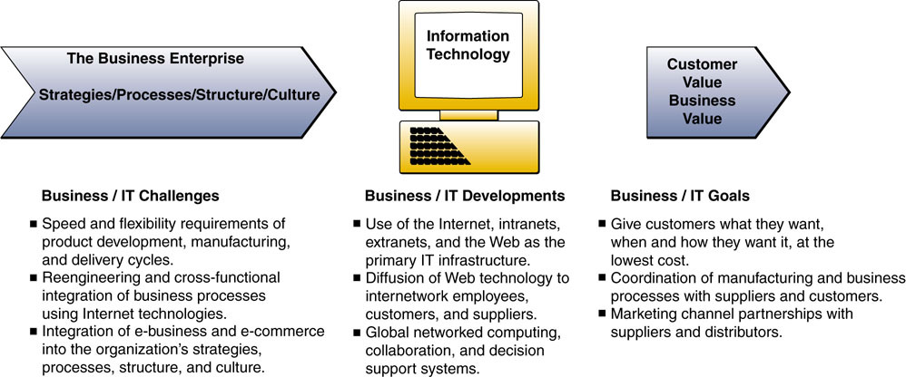
Success and Failure with IT
The success of an information system should not be measured only by its efficiency in terms of minimizing costs, time, and the use of information resources. Success should also be measured by the effectiveness of the information technology in supporting an organization’s business strategies, enabling its business processes, enhancing its organizational structures and culture, and increasing the customer and business value of the enterprise.

Responsibility and Accountability for Project Success (and Failure)
- If a project involving IT fails, who gets blamed? Why? Who should be accountable?
- If the project is successful, who gets credit?
- How can you go about changing mindsets about these projects?

Developing IS Solutions
an Information Systems is a Solution to a Business Problem
- Investigate (Plan) – recognize the problem exists
- Analyze – investigate the current system
- Design – designing the new system
- Implement – put the new system into effect
- Maintain (Use) – use, monitor, and maintain the new system

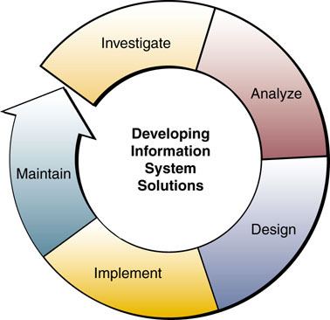

Modernize (Don’t Replace!) Your Legacy Applications
- What is a legacy system?
Technologies that were developed long ago and that, while still working today, are lacking in one or more major aspects.
- Why is it a problem?
The interface may look strange, business needs may have hanged, and there are new functions that the system can no longer perform. Documentation is often missing or outdated, and the original developers are long gone.
- What solutions are available?
There are tools that put a web-browser front-end between the old green screens of yore and the users of today. The point of contact with the legacy system can be completely revamped without modifying it in any significant way giving the IT staff time to gradually transition out of the legacy system.
Sometimes, it does make sense to replace the old system with a new one.
Other times, companies are faced with systems that are ugly, but otherwise work fine, or the necessary resources (budget, time) may not be there at this time. Extending the life of those systems with new and updated interfaces may be the way to go.

Challenges and Ethics of IT

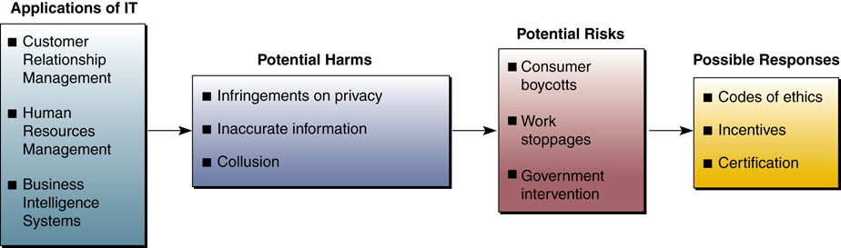

Challenges of IS and IT Careers
In business, if you are not in an IT career, you will work regularly with IS professionals
- Employment opportunities in IS are strong
- Business Technologist – a professional competent in both business and IT
- U.S. Department of Labor – IS positions expected to be among fastest growing for years to come

The IS Function
- A major functional area of business equally as important to business success as the functions of accounting, finance, operations management, marketing, and human resource management.
- An important contributor to operational efficiency, employee productivity and morale, and customer service and satisfaction.
- A recognized source of value to the firm.
- A major source of information and support needed to promote effective decision making by managers and business professionals.
- A vital ingredient in developing competitive products and services that give an organization a strategic advantage in the global marketplace.
- A dynamic, rewarding, and challenging career opportunity for millions of men and women.
- A key component of the resources, infrastructure, and capabilities of today’s networked business enterprises.
- A strategic resource.

System Concepts: The Foundation for Business Processes

What Is a System?
Systems have three basic functions:
- Input: Capture the data to be processed.
- Processing: Change the data into information.
- Output: Disseminate the information product to its destination.

Feedback and Control
Feedback – data about the performance of the system.
Control – monitoring the feedback to determine if the system is meeting its objectives.

Other System Characteristics
Environment and Subsystems: A system does not exist in a vacuum; rather, it exists and functions in an environment containing other systems. If a system is one of the components of a larger system, it is referred to as a subsystem , and the larger system is its environment.
Adaptive Systems: A system that has the ability to change itself or its environment to survive is called an adaptive system.
Interface: a shared boundary between systems
Open (and Closed) Systems: open systems interact with other systems (closed systems do not interact with other systems)

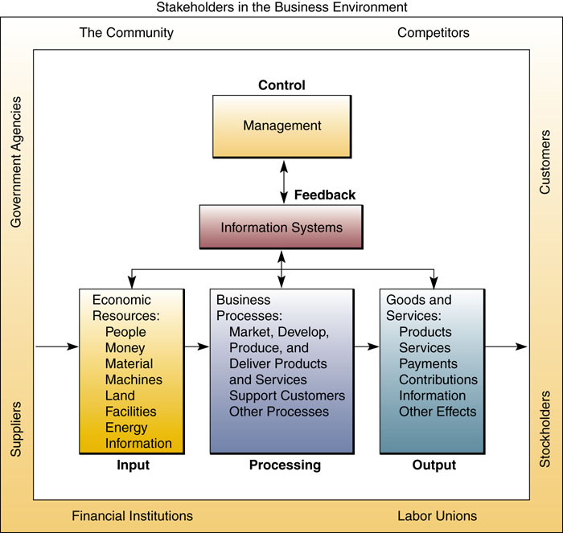

Components of Information Systems
- People, hardware, software, data, and networks are the basic resources of information systems.
- Data resources are transformed by information processing activities into a variety of information products for end users.
- Information processing consists of the system activities of input, processing, output, storage, and control.

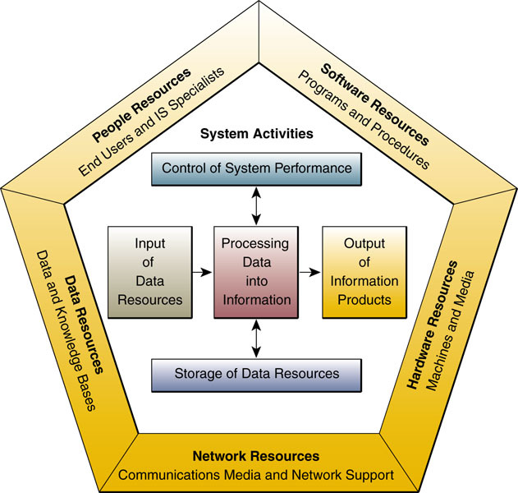

Information System Resources and Products
People Resources
- Specialists—systems analysts, software developers, systems operators.
- End Users—anyone else who uses information systems.
Hardware Resources
- Machines—computers, video monitors, magnetic disk drives, printers, optical scanners.
- Media—floppy disks, magnetic tape, optical disks, plastic cards, paper forms, removable storage media.
Software Resources
- Programs—instructions that tell the computer what to do. They include:
  - System Software – runs the computer
  - Application Software – a particular use by end users
  - Procedures – instructions on how to use the system
Data Resources
- Data – unorganized facts and figures.
- Information – data organized so that it has value to the organization.
Network Resources
Network resources include:
- Communications Media - the physical pathways over which signals travel.
- Network Infrastructure – hardware, software, and data technologies needed to support communications networks.
Information System Activities
- Input. Optical scanning of bar-coded tags on merchandise.
- Processing. Calculating employee pay, taxes, and other payroll deductions.
- Output. Producing reports and displays about sales performance.
- Storage. Maintaining records on customers, employees, and products.
- Control. Generating audible signals to indicate proper entry of sales data.

Information Products
- Management reports and business documents using text and graphics displays, audio responses, and paper forms.

Upgrade Your Legacy Systems in Three Steps
- Analyze the Current System in Place.
- Understand the Requirements for the New System.
- Make the Business Case for the New Project.

Recognizing Information Systems
You should be able to identify:
• The people, hardware, software, data, and network resources they use.
• The types of information products they produce.
• The way they perform input, processing, output, storage, and control activities.

Chapter 02 - Competing with Information Technology

Fundamentals of Strategic Advantage

STRATEGIC IT
Technology is no longer an afterthought in forming business strategy, but the actual cause and driver.

COMPETITIVE STRATEGY CONCEPTS
A major role of information systems applications in business is to provide effective support of a company’s strategies for gaining competitive advantage.

This role is accomplished through a strategic information architecture : the collection of strategic information systems that supports or shapes the competitive position and strategies of a business enterprise.

So a strategic information system can be any kind of information system that leverages information technology to help an organization:
- gain a competitive advantage
- reduce a competitive disadvantage
- meet other strategic enterprise objectives

Competitive Forces and Strategies
A company can survive and succeed in the long run only if it successfully develops strategies to confront five competitive forces that shape the structure of competition in its industry:
- the rivalry of competitors within its industry
- the threat of new entrants into an industry and its markets
- the threat posed by substitute products that might capture market share
- the bargaining power of customers
- the bargaining power of suppliers

Businesses can counter the threats of competitive forces that they face by implementing one or more of the five basic competitive strategies.
- Cost Leadership Strategy. Becoming a low-cost producer of products and services in the industry or finding ways to help suppliers or customers reduce their costs or increase the costs of competitors.
- Differentiation Strategy. Developing ways to differentiate a firm’s products and services from those of its competitors or reduce the differentiation advantages of competitors.
- Innovation Strategy. Finding new ways of doing business.
- Growth Strategies. Significantly expanding a company’s capacity to produce goods and services, expanding into global markets, diversifying into new products and services, or integrating into related products and services.
- Alliance Strategies. Establishing new business linkages and alliances with customers, suppliers, competitors, consultants, and other companies.

STRATEGIC USES OF INFORMATION TECHNOLOGY
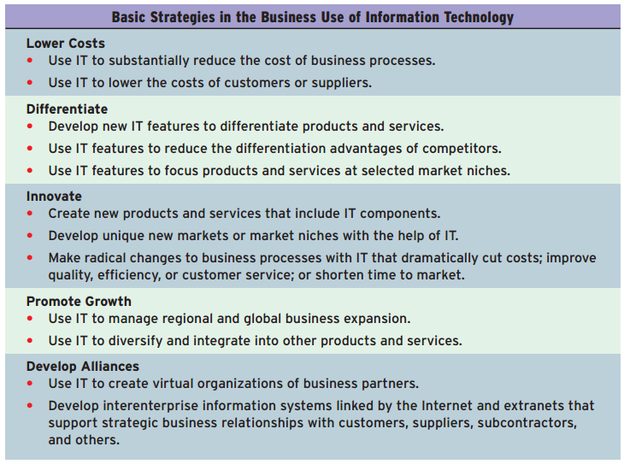

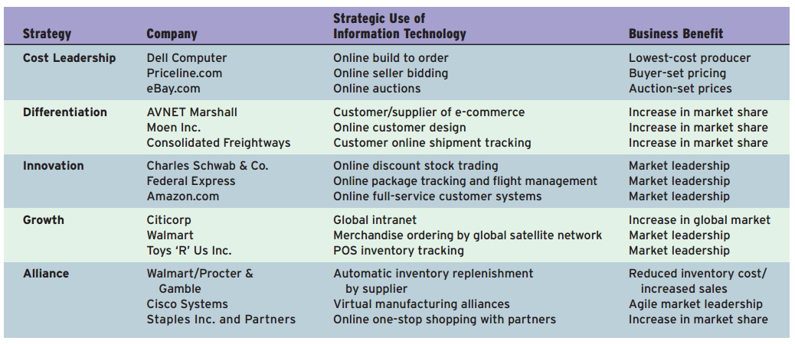

Other Strategic Initiatives

- Lock in customers and suppliers (and therefore lock out competitors): by building valuable new relationships with them.
- Create switching costs: investments in information systems technology can make customers or suppliers dependent on the continued use of innovative, mutually beneficial interenterprise information systems.
- Raise barriers to entry: it would discourage or delay other companies from entering a market. These barriers increase the amount of investment or the complexity of the technology required to compete in an industry or a market segment.
- Leverage investment in IT: by developing new products and services that would not be possible without a strong IT capability.

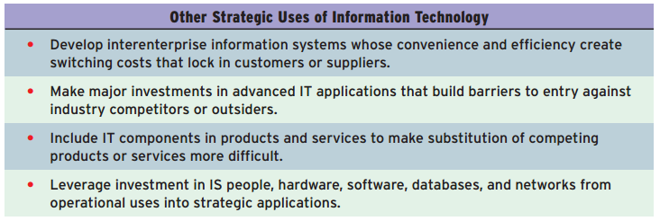

BUILDING A CUSTOMER-FOCUSED BUSINESS

The strategic focus on customer value recognizes that quality, rather than price, has become the primary determinant in a customer’s perception of value.
Internet technologies can make customers the focal point of e-business applications.

THE VALUE CHAIN AND STRATEGIC IS

The value chain concept views a firm as a series, chain, or network of basic activities that add value to its products and services and thus add a margin of value to both the firm and its customers.

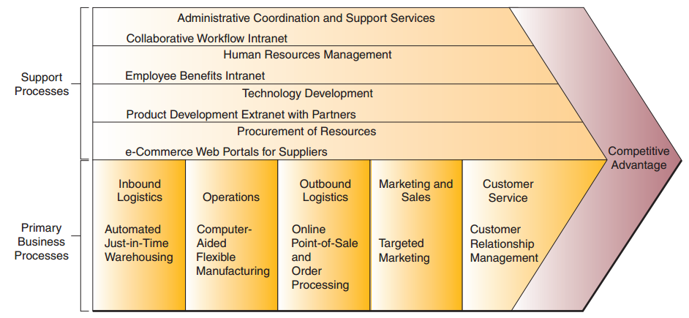

Primary processes are those business activities that are directly related to the manufacture of products or the
delivery of services to the customer.
Support processes are those business activities that help support the day-to-day operation of the business and that indirectly contribute to the products or services of the organization.

Using Information Technology for Strategic Advantage

STRATEGIC USES OF IT
Companies may choose to use information systems strategically (as a major competitive
Differentiator), or they may be content to use IT to support efficient everyday operations (non-strategic).

REENGINEERING BUSINESS PROCESSES
One of the most important implementations of competitive strategies is business process reengineering (BPR), often simply called reengineering .
Reengineering is a fundamental rethinking and radical redesign of business processes to achieve dramatic improvements in cost, quality, speed, and service.

Although the potential payback of reengineering is high, so too is its risk of failure and level of disruption to the organizational environment.

Many companies have found that organizational redesign approaches are an important enabler of reengineering, along with the use of information technology.
For example process teams in which employees from several departments or specialties, including engineering, marketing, customer service, and manufacturing, may work as a team on the product development process.
Another example is the use of case managers, who handle almost all tasks in a business process instead of splitting tasks among many different specialists.

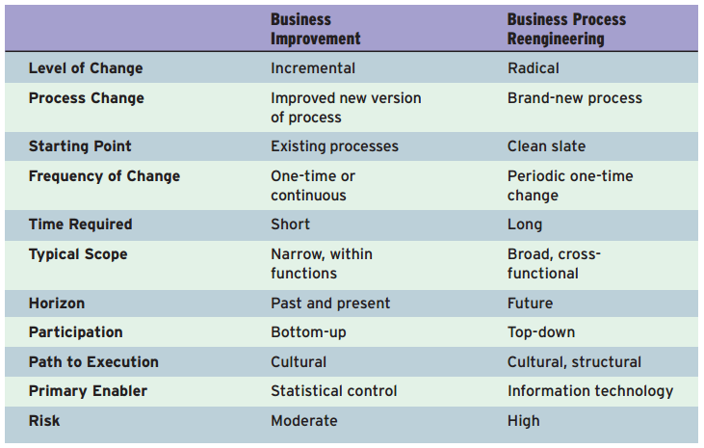

The Role of Information Technology
The speed, information-processing capabilities, and connectivity of computers and Internet technologies can substantially increase the efficiency of business processes, as well as communications and collaboration among the people responsible for their operation and management.
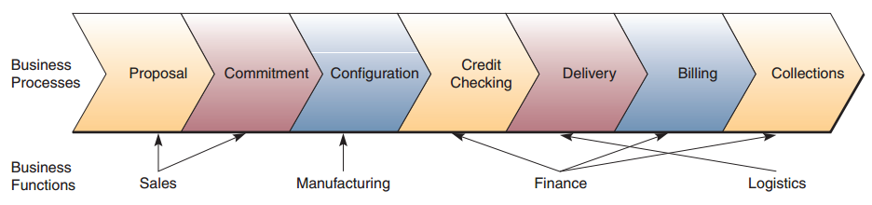

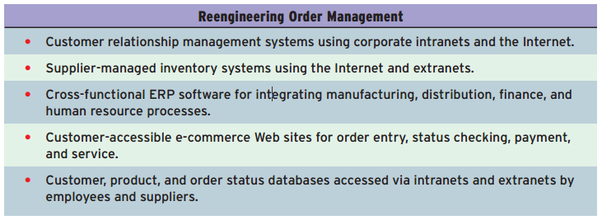

BECOMING AN AGILE COMPANY

To be an agile company, a business must use four basic strategies.
- The business must ensure that customers perceive the products or services of an agile company as
solutions to their individual problems.
- An agile company cooperates with customers, suppliers, other companies, and even with its competitors.
- An agile company organizes so that it thrives on change and uncertainty.
- An agile company leverages the impact of its people and the knowledge they possess.

Another useful way to think about agility in business:
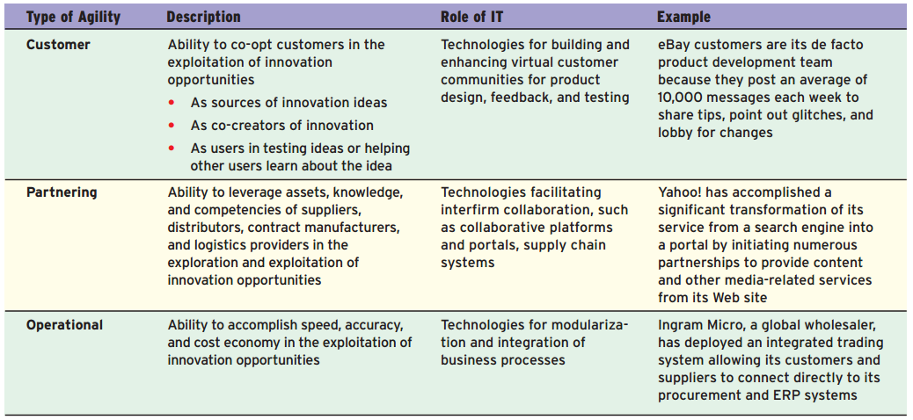

CREATING A VIRTUAL COMPANY
A virtual company (also called a virtual corporation or virtual organization) is an organization that uses information technology to link people, organizations, assets, and ideas.
Virtual companies typically form virtual workgroups and alliances with business partners that are interlinked by the Internet, intranets, and extranets.

Virtual Company Strategies
- Share infrastructure and risk with alliance partners
- Link complimentary core competencies
- Reduce concept-to-cash time through sharing
- Increase facilities and market coverage
- Gain access to new markets and share market or customer loyalty
- Migrate from selling products to selling solutions

BUILDING A KNOWLEDGE-CREATING COMPANY

That means consistently creating new business knowledge, disseminating it widely throughout the company, and quickly building the new knowledge into their products and services.
Knowledge-creating companies exploit two kinds of knowledge:
- Explicit knowledge ,which is the data, documents, and things written down or stored on computers.
- Tacit knowledge, or the “how-tos” of knowledge, which resides in workers. It is not recorded or codified anywhere because it has evolved in the employee’s mind through years of experience. Also much of this tacit knowledge is never shared with anyone who might be in a position to record it in a more formal way.
Successful knowledge management creates techniques, technologies, systems, and rewards for getting employees to share what they know.
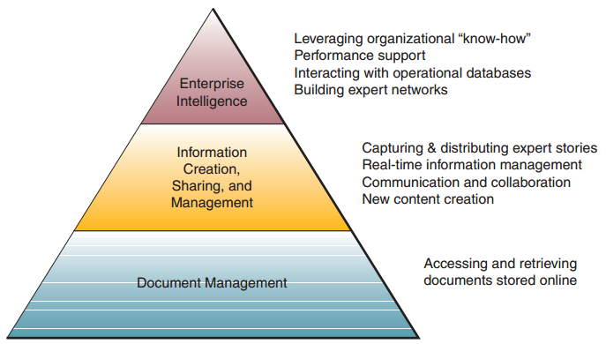

KNOWLEDGE MANAGEMENT SYSTEMS

Many companies are building knowledge management systems (KMS) to manage organizational learning and business know-how.
The goal of such systems is to help knowledge workers create, organize, and make available important business knowledge, wherever and whenever it’s needed in an organization.
Knowledge management systems also facilitate organizational learning and knowledge creation.
They are designed to provide rapid feedback to knowledge workers, encourage behavior changes by employees, and significantly improve business performance.
It helps the company become a more innovative and agile provider of high-quality products and customer services, as well as a formidable competitor in the marketplace.

Chapter 03 - Computer Hardware

Computer Systems: End User and Enterprise Computing

A BRIEF HISTORY OF COMPUTER HARDWARE

Blaise Pascal, a French mathematician, invented what is believed to be the first mechanical adding machine in 1642.

In 1674, Gottfried Wilhelm von Leibniz improved Pascal’s machine so that the machine could divide and multiply as easily as it could add and subtract.

The ENIAC (Electronic Numerical Integrator and Computer) was the first electronic digital computer. It was completed in 1946 at the Moore School of Electrical Engineering of the University of Pennsylvania.
ENIAC was programmable and had the capability to store problem calculations using vacuum tubes (about 18,000).
A computer that uses vacuum tube technology is called a first-generation computer.
The ENIAC could add in 0.2 of a millisecond, or about 5,000 computations per second.

In the 1950s, Remington Rand manufactured the UNIVAC I (Universal Automatic Calculator). It could calculate at the rate of 10,000 additions per second.

In 1957, IBM developed the IBM 704, which could perform 100,000 calculations per second.

In the late 1950s, transistors were invented and quickly replaced the thousands of vacuum tubes used in electronic computers. A transistor-based computer could perform 200,000–250,000 calculations per second.
The transistorized computer represents the second generation of computer.

In mid-1960s, the third generation of computers came into being. These were characterized by solid-state technology and integrated circuitry, coupled with extreme miniaturization.

In 1971, the fourth generation of computers was characterized by further miniaturization of circuits, increased multiprogramming, and virtual storage memory.

In the 1980s, the fifth generation of computers operated at speeds of 3–5 million calculations per second (for small-scale computers) and 10–15 million instructions per second (for large-scale computers).

The age of microcomputers began in 1975 when a company called MITS introduced the ALTAIR 8800.

In 1977 both Commodore and Radio Shack announced that they were going to make personal computers.
Steve Jobs and Steve Wozniak invented their computer in a garage while in college. Mass production
of the Apple began in 1979. In August 1982 the IBM PC was born.

TYPES OF COMPUTER SYSTEMS

By category: mainframe, midrange, and microcomputer systems
By use: personal computers, network servers, network computers, and technical workstations.

MICROCOMPUTER SYSTEMS
Usually called a personal computer ,or PC. PCs are available as handheld, notebook, laptop, tablet, portable, desktop, and floor-standing models.
Based on their use, they include home, personal, professional, workstation, and multiuser systems.
Workstation computers support applications with heavy mathematical computing and graphics display demands.
Network servers are usually more powerful microcomputers that coordinate telecommunications and resource sharing in small local area networks (LANs) and in Internet and intranet Web sites.

Computer Terminals
- Computer terminals ,essentially any device that allows access to a computer, are undergoing a major conversion to networked computer devices.
- Network terminals depend on network servers for Windows software, processing power, and storage.
- Internet terminals ,which depend on Internet or intranet Web site servers for their operating systems and application software.
- Intelligent terminals take many forms and can perform data entry and some information processing tasks independently (ATMs, POS).
These intelligent terminals use keypads, touch screens, bar code scanners, and other input methods to capture data and interact with end users during a transaction, while relying on servers or other computers in the network for further transaction processing.

Network Computers
- Network computers (NCs) are a microcomputer category (not full PCs) designed primarily for use with the Internet and corporate intranets by clerical workers, operational employees, and knowledge workers with specialized or limited computing applications.
- These NCs are low-cost, sealed microcomputers with no or minimal disk storage that are linked to the network.
- Users of NCs depend primarily on network servers for their operating system and Web browser, application software, and data access and storage.
Benefits:
- Lower TCO
- Ease of software distribution and licensing
- Computing platform standardization
- Reduced end-user support requirements
- Improved manageability through centralized management and enterprisewide control of computer network resources

Information Appliances
PDAs are some of the most popular devices in the information appliance category. BlackBerry, iPhones and iPads, and video games consoles are also popular.

MIDRANGE, MAINFRAME, AND SUPERCOMPUTER SYSTEMS
Midrange systems are primarily high-end network servers and other types of servers that can handle the large-scale processing of many business applications.

Mainframe systems are large, fast, and powerful computer systems. For example, mainframes can process thousands of million instructions per second (MIPS). Mainframes can also have large primary storage capacities.

Supercomputer describes a category of extremely powerful computer systems specifically designed for scientific, engineering, and business applications requiring extremely high speeds for massive numeric computations.

The Next Wave of Computing
The next wave is looking at harnessing the virtually infinite amount of unused computing power that exists in the myriad of desktops and laptops within the boundaries of a modern organization.
Distributed or grid computing in general is a special type of parallel computing that relies on complete computers connected to a network. The grid could be formed by harnessing the unused CPU power in all of the desktops and laptops in a single division of a company.

Advantage: each node can be purchased as commodity hardware; when combined, it can produce similar computing resources to a multiprocessor supercomputer, but at a significantly lower cost.

Disadvantages:
- The computers that are actually performing the calculations might not be entirely trustworthy.
- Lack of central control over the hardware.
- Some nodes may also be available for computation but not for network communications for unpredictable periods.

TECHNICAL NOTE: THE COMPUTER SYSTEM CONCEPT
- Input. The input devices of a computer system include computer keyboards, touch screens, pens, electronic mice, and optical scanners. They convert data into electronic form.
- Processing. The central processing unit (CPU) is the main processing component of a computer system. Subunits: the arithmetic-logic unit and the control unit.
- Output. The output devices of a computer system include video display units, printers, and audio response units. They convert electronic information produced by the computer system into human-intelligible form.
- Storage. primary storage unit ,or memory supported by secondary storage devices such as magnetic disk and optical disk drives.
- Control. The control unit of a CPU is the control component of a computer system.

Computer Processing Speeds
- milliseconds (thousandths of a second)
- microseconds (millionths of a second)
- nanosecond (billionth of a second)
- Picosecond (trillionth of a second)

most computers can now process program instructions at million instructions per second (MIPS) speeds.
Clock speed of a microprocessor:
- Megahertz (MHz), or millions of cycles per second
- Gigahertz (GHz), or billions of cycles per second

MOORE’S LAW: WHERE DO WE GO FROM HERE?
Gordon Moore, cofounder of Intel Corporation, made his famous observation in 1965.
In its form, Moore observed an exponential growth (doubling every 18 to 24 months) in the number of transistors per integrated circuit and predicted that this trend would continue.

Computer Peripherals: Input, Output, and Storage Technologies

PERIPHERALS
Peripherals is the generic name given to all input, output, and secondary storage devices that are part of a computer system but are not part of the CPU.
All peripherals are online devices; that is, they are separate from, but can be electronically connected to and controlled by a CPU.

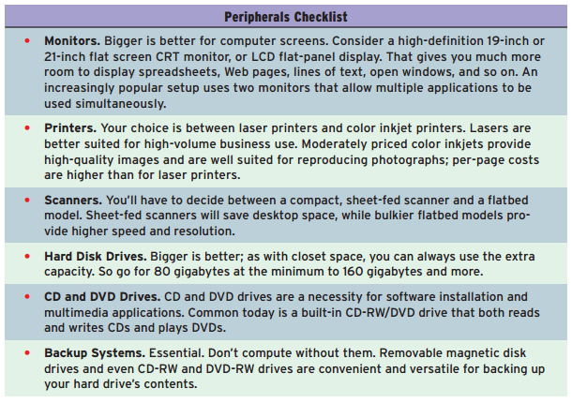

INPUT TECHNOLOGIES
Pointing devices like electronic mice and touch pads
Technologies like optical scanning, handwriting recognition, and voice recognition.

- A trackball is a stationary device related to the mouse. You turn a roller ball with only its top exposed outside its case to move the cursor on the screen.
- A pointing stick (also called a trackpoint) is a small button-like device. It is usually centered one row above the space bar of a keyboard. The cursor moves in the direction of the pressure you place on the stick.
- The touch pad is a small rectangular touch-sensitive surface usually placed below the keyboard. The cursor moves in the direction your finger moves on the pad.
- Touch screens are devices that allow you to use a computer by touching the surface of its video display screen.
- Pen-based computing technologies are still being used in many handheld computers and personal digital assistants.

Speech Recognition Systems
Early speech recognition products used discrete speech recognition ,for which you had to pause between each spoken word.
New continuous speech recognition software recognizes continuous, conversationally paced speech.

Speech recognition systems digitize, analyze, and classify your speech and its sound patterns. The software compares your speech patterns to a database of sound patterns in its vocabulary and passes recognized words to your application software.

Speaker-independent voice recognition systems, which allow a computer to understand a few words from a voice it has never heard before, are being built into products and used in a growing number of applications.

Optical Scanning
Optical scanning devices read text or graphics and convert them into digital input for your computer.
The OCR scanners can read the characters and codes on merchandise tags, product labels, credit card receipts, utility bills, insurance premiums, airline tickets, and other documents. In addition, OCR scanners are used to automatically sort mail, score tests, and process a wide variety of forms in business and government.
Devices such as handheld optical scanning wands are frequently used to read bar codes ,codes that use bars to represent characters.

Other Input Technologies
Magnetic stripe technology is a familiar form of data entry that helps computers read credit cards.
The coating of the magnetic stripe on the back of such cards can hold about 200 bytes of information.
Smart cards that embed a microprocessor chip and several kilobytes of memory into debit, credit, and other cards are popular in Europe and becoming available in the United States.
Digital cameras represent another fast-growing set of input technologies.
Magnetic ink character recognition (MICR) technology can magnetically read checks and deposit slips.

Video Output
Cathode ray tube (CRT) technology is similar to the picture tubes used in home television sets.
The biggest use of liquid crystal displays (LCDs) has been to provide a visual display capability for portable microcomputers and PDAs. Advances in technology such as active matrix and dual scan capabilities have improved the color and clarity of LCD displays.

Printed Output
Inkjet printers have become the most popular, low-cost printers for microcomputer systems.
Laser printers use an electrostatic process similar to a photocopying machine to produce many pages per minute of high-quality output.

STORAGE TRADE-OFFS
High-speed storage media cost more per byte and provide lower capacities. Large-capacity storage media cost less per byte but are slower.

Computer Storage Fundamentals
Binary representation (0s and 1s, on or off)
Byte = 8 bits
Storage capacities are measured in KB, MB, GB or TB

Direct and Sequential Access
- Primary storage media such as semiconductor memory chips are called direct access memory or random-access memory (RAM).
- Magnetic disk devices are frequently called direct access storage devices (DASDs).
- Media such as magnetic tape cartridges are known as sequential access devices. Sequential access storage media such as magnetic tape do not have unique storage addresses that can be directly addressed. Instead, data must be stored and retrieved using a sequential or serial process.

SEMICONDUCTOR MEMORY
The primary storage (main memory) of your computer consists of microelectronic semiconductor memory chips. There are 3 types:
- RAM, random-access memory (volatile).
- ROM, read-only memory. Nonvolatile random-access memory chips are used for permanent storage; ROM can be read but not erased or overwritten.
- Flash drives. Flash memory uses a small chip containing thousands of transistors that can be programmed to store data for virtually unlimited periods without power.

ReadyBoost
ReadyBoost is a disk cache component. It works by using the flash drive, SD card, or any kind of portable flash mass-storage system as a cache.

Solid-State Drive
A solid-state drive (SSD) is a data storage device that uses semiconductor memory to store persistent data with the intention of providing access in the same manner as that of a hard disk drive.
SSDs use microchips which retain data in nonvolatile memory chips and contain no moving parts.

MAGNETIC DISKS
Magnetic disk drives contain metal disks that are coated on both sides with an iron oxide recording material.

RAID Storage
Disk arrays of interconnected microcomputer hard disk drives have replaced large-capacity mainframe disk drives to provide virtually unlimited online storage. RAID units provide a fault-tolerant capacity.

Storage area networks (SANs) are high-speed fiber channel local area networks that can interconnect many RAID units and thus share their combined capacity through network servers with many users.

MAGNETIC TAPE
The read/write heads of magnetic tape drives record data in the form of magnetized spots on the iron oxide coating of the plastic tape.
Other major applications for magnetic tape include long-term archival storage and backup storage for PCs and other systems.

OPTICAL DISKS

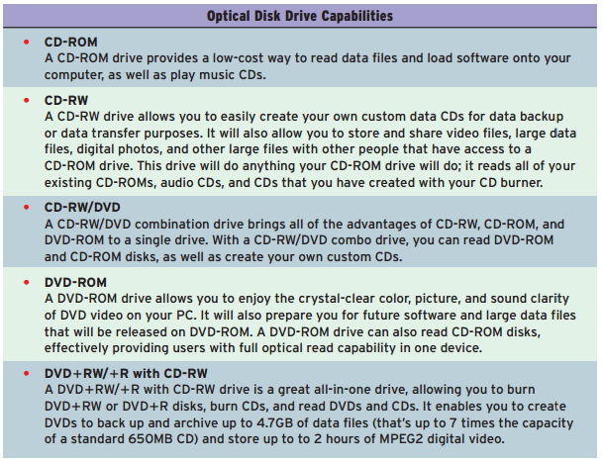
RADIO FREQUENCY IDENTIFICATION
Radio frequency identification (RFID) is a system for tagging and identifying mobile objects such as store merchandise, postal packages, and sometimes even living organisms (like pets).
The RFID technology works using small pieces of hardware called RFID chips .

Currently, there are two general types of RFID chips: passive and active.
- Passive RFID chips do not have a power source and must derive their power from the signal sent from the reader.
- Active RFID chips are self-powered and do not need to be close to the reader to transmit their signal.

RFID Privacy Issues
The two main privacy concerns regarding RFID are:
- Because the owner of an item will not necessarily be aware of the presence of an RFID tag, and the tag can be read at a distance without the knowledge of the individual, it becomes possible to gather sensitive data about an individual without consent.
- If a customer pays for a tagged item by credit card or in conjunction with a loyalty card, then it would be possible to deduce the identity of the purchaser indirectly by reading the globally unique ID of that item (contained in the RFID tag).

Chapter 04 - Computer Software

Application Software: End-User Applications

INTRODUCTION TO SOFTWARE

What Is Software?
Software is the general term for a myriad of programs used to operate and manipulate computers and their peripheral devices or to perform a specific task using a computer as the vehicle.

Types of Software
The two main categories available to computer users are application software and system software.

Application Software for End Users

General purpose application programs are programs that perform common information processing jobs for end users. For example, word processing, spreadsheet, database management, and graphics programs.

Custom software is the term used to identify software applications that are developed within an organization for use by that organization.
In contrast, COTS software (commercial off-the-shelf ) is developed with the intention of selling the software in multiple copies (and usually for a profit).

Open-source software: developers collaborate on the development of an application using programming standards that allow anyone to contribute to the software.

BUSINESS APPLICATION SOFTWARE
Function-specific application software support needs of end users in business, education, and day-to-day activities.

SOFTWARE SUITES AND INTEGRATED PACKAGES
Software suites bundle together a variety of general-purpose software applications.
Advantages:
- It generally costs a lot less than the total cost of buying its individual packages separately.
- All programs use a similar graphical user interface (GUI)
- They share common tools
- Their programs are designed to work together seamlessly and import each other’s files easily.
Disadvantages:
- Most end users never use many software suite features.
- The suites take up a lot of disk space

Integrated packages
Integrated packages combine some, but not all, of the functions of several programs into one software package. They are considered less powerful but require a lot less disk space and is frequently preinstalled on many low-end microcomputer systems.

WEB BROWSERS AND MORE
Browsers are software applications designed to support navigation through the point-and-click hyperlinked resources of the World Wide Web and the rest of the Internet, as well as corporate intranets and extranets.
Browsers are becoming the universal software platform from which end users launch information searches, e-mail, multimedia file transfers, discussion groups, and even productivity applications. That’s why browsers are sometimes called the universal client

ELECTRONIC MAIL, INSTANT MESSAGING, AND BLOGS
Computer users depend on e-mail software to communicate with one another by sending and receiving electronic messages and file attachments via the Internet or their organizations’ intranets or extranets.
E-mail packages enable you to edit and send graphics and multimedia files, as well as text, and provide computer conferencing capabilities. Many e-mail clients also include calendaring and contact management functions.

Instant messaging (IM) is an e-mail/computer-conferencing hybrid technology that has grown so rapidly that it has become a standard method of electronic messaging for millions of Internet users worldwide.

A blog is a Web site of personal or commercial origin that uses a dated log format updated, daily or very frequently, with new information about a particular subject or range of subjects.
A blog may be any individual’s recorded ideas (a sort of diary), a commercial information source open only to subscribers, or a complex collaboration open to anyone.

WORD PROCESSING AND DESKTOP PUBLISHING
Word processing packages computerize the creation, editing, revision, and printing of documents (e.g., letters, memos, reports) by electronically processing text data (words, phrases, sentences, and paragraphs).
Desktop publishing (DTP) software produces printed materials that look professionally published.

SPREADSHEETS
Spreadsheet packages are used by virtually every business for analysis, planning, and modeling. They help you develop an electronic spreadsheet ,which is a worksheet of rows and columns

PRESENTATION GRAPHICS
Presentation graphics software packages help you convert numeric data into graphics displays such as line charts, bar graphs, pie charts, and many other types of graphics.
Most of the top packages also help you prepare multimedia presentations of graphics, photos, animation, and video clips.

PERSONAL INFORMATION MANAGERS
The personal information manager (PIM) is a popular software package for end user productivity and collaboration, as well as a popular application for personal digital assistant (PDA) handheld devices.

GROUPWARE
Groupware is software that helps workgroups and teams collaborate to accomplish group assignments.
Groupware products rely on the Internet and corporate intranets and extranets to make collaboration possible on a global scale by virtual teams located anywhere in the world.

SOFTWARE ALTERNATIVES

Application Service Providers
Application service providers are companies that own, operate, and maintain application software and the computer system resources (servers, system software, networks, and IT personnel) required to offer the use of the application software for a fee as a service over the Internet.
Businesses are using an ASP instead of owning and maintaining their own software for many reasons. One of the biggest advantages is the low cost of initial investment, and in many cases, the short time needed to get the Web-based application set up and running. In addition, using an ASP eliminates or drastically reduces the need for much of the IT infrastructure.

Cloud Computing
Cloud computing is a style of computing in which software and, in some cases, virtualized hardware resources are provided as a service over the Internet.
Cloud computing users can avoid capital expenditure on hardware, software, and services, by simply paying a provider only for what they use.

Software Licensing
Software licensing is a complex topic that involves considerations of the special characteristics of software in the context of the underlying intellectual property rights, including copyright, trademark, and trade secrets, as well as traditional contract law, including the Uniform Commercial Code (UCC).
An individual or company that buys a software application has not purchased rights of ownership. Rather, the individual or company has purchased a license to use the software under the terms of the software licensing agreement.
In most cases, the license also gives the purchaser permission to sell or dispose of the rights provided by the license but not to duplicate or resell multiple copies of the software.

System Software: Computer System Management

System software consists of programs that manage and support a computer system and its information processing activities.
We can group system software into two major categories:
- System Management Programs. Programs that manage the hardware, software, network, and data resources of computer systems during the execution of the various information processing jobs of users.
- System Development Programs. Programs that help users develop information system programs and procedures and prepare user programs for computer processing.

OPERATING SYSTEMS
An operating system is an integrated system of programs that manages the operations of the CPU, controls the input/output and storage resources and activities of the computer system, and provides various support services as the computer executes the application programs of users.

Operating Systems Functions
- THE USER INTERFACE: Three main types of user interfaces are the command-driven, menu- driven ,and graphical user interfaces .
- RESOURCE MANAGEMENT: An operating system uses a variety of resource management
programs to manage the hardware and networking resources of a computer system.
- FILE MANAGEMENT: control the creation, deletion, and access of files of data and programs and keeping track of the physical location of files
- TASK MANAGEMENT: control which task gets access to the CPU and for how much time. Multitasking is a task management approach that allows for several computing tasks to be performed in a seemingly simultaneous fashion. There are two basic types
of multitasking:
- In preemptive multitasking, the task management functions parcel out CPU time slices to each program (mostly used by Windows and Unix).
- Cooperative multitasking allows each program to control the CPU for as long as it needs it (mostly used by Apple).

Microsoft Windows
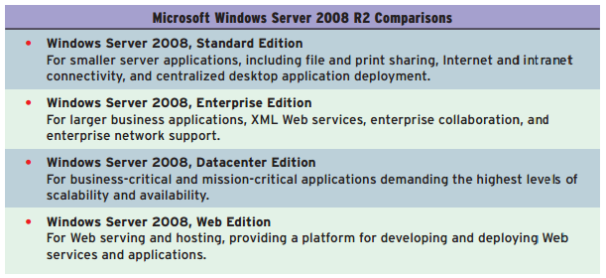

UNIX
Originally developed by AT&T, UNIX is now also offered by other vendors, including Solaris by Sun Microsystems and AIX by IBM.

Linux
Linux is a low-cost, powerful, and reliable UNIX-like operating system that is rapidly gaining market share from UNIX and Windows servers as a high-performance operating system for network servers and Web servers in both small and large networks.

Open-Source Software
The basic idea behind open source is very simple: When programmers can read, redistribute, and modify the source code for a piece of software, the software evolves.
There are several things open source is not: It is not shareware, public-domain software, freeware, or software viewers and readers made freely available without access to source code.
Shareware, whether or not the user registers it and pays the registration fee, typically allows no access to the underlying source code.
OSS is copyrighted and distributed with license terms designed to ensure that the source code will always be available.

OpenOffice.org 3
This product, built under the open-source standards by Sun Microsystems is a complete integrated office suite that provides all the common applications including word processing, spreadsheet, presentation graphics, and database management.

Mac OS X
Mac OS X was a radical departure from previous Macintosh operating systems; its underlying code base is completely different from previous versions. Its core, named Darwin, is an open-source, UNIX-like operating system.
Mac OS X also includes its own software development tools, most prominently an integrated development environment called Xcode.

Application Virtualization
Application virtualization is an umbrella term that describes software technologies that improve portability, manageability, and compatibility of applications by insulating them from the underlying operating system on which they are executed.
Application virtualization is just an extension of operating system virtualization where the same basic concepts fool the whole operating system into thinking it is running on a particular type of hardware when it is not.

OTHER SYSTEM MANAGEMENT PROGRAMS

- Utilities such as Norton Utilities perform miscellaneous housekeeping and file conversion functions. Examples include data backup, data recovery, virus protection, data compression, and file defragmentation.
Other examples of system support programs include performance monitors and security monitors.
- Middleware is software that helps diverse software applications and networked computer systems exchange data and work together more efficiently. Examples include application servers, Web servers, and enterprise application integration (EAI) software.

PROGRAMMING LANGUAGES
A programming language allows a programmer to develop the sets of instructions that constitute a computer program.

Machine Languages
Machine languages (or first-generation languages ) are the most basic level of programming languages. In the early stages of computer development, all program instructions had to be written using binary codes unique to each computer.

Assembler Languages
Assembler languages (or second-generation languages ) are the next level of programming languages. They were developed to reduce the difficulties in writing machine language programs. The use of assembler languages requires language translator programs called assemblers that allow a computer to convert the instructions of such language into machine instructions.

High-Level Languages
High-level languages (or third-generation languages ) use instructions, which are called statements ,that include brief statements or arithmetic expressions. Each individual statement generates several machine instructions when translated into machine language by high-level language translator programs called compilers or interpreters .
High-level language statements resemble the phrases or mathematical expressions required to express the problem or procedure being programmed.

Fourth-Generation Languages
The term fourth-generation language describes a variety of programming languages that are more nonprocedural and conversational than prior languages.
Most fourth-generation languages are nonprocedural languages that encourage users and programmers to specify the results they want, while the computer determines the sequence of instructions that will accomplish those results.
Natural languages are sometimes considered fifth-generation languages (5GLs) and are very close to English or other human languages.

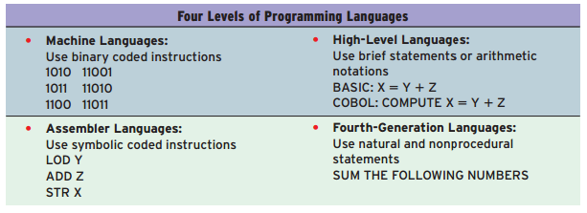

Object-Oriented Languages
Object-oriented languages like Visual Basic, C11, and Java are also considered fifth generation languages.
An object consists of data and the actions that can be performed on the data.

WEB AND INTERNET LANGUAGES AND SERVICES

HTML
HTML (Hypertext Markup Language) is a page description language that creates hypertext or hypermedia documents.
HTML inserts control codes within a document at points you can specify that create links ( hyperlinks ) to other parts of the document or to other documents anywhere on the World Wide Web.

XML
XML (eXtensible Markup Language) is not a Web page format description language like HTML. Instead, XML describes the contents of Web pages (including business documents designed for use on the Web) by applying identifying tags or contextual labels to the data in Web documents.
By classifying data in this way, XML makes Web site information much more searchable, easier to sort, and easier to analyze.

Java and .NET
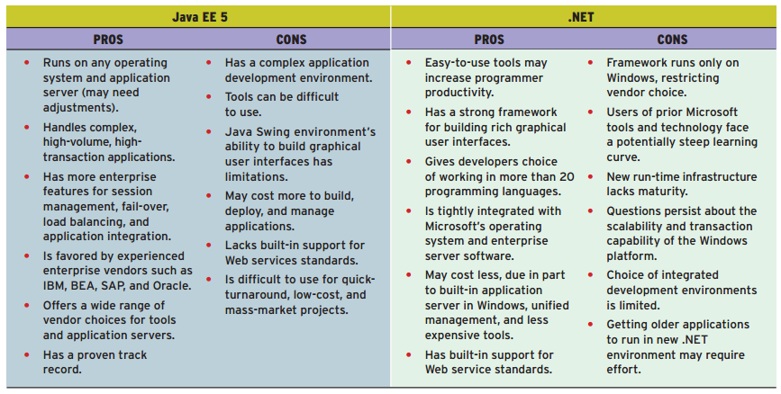

Web Services
Web services are software components that are based on a framework of Web and object-oriented standards and technologies for using the Web that electronically link the applications of different users and different computing platforms.

The basic steps in accomplishing a Web services application:
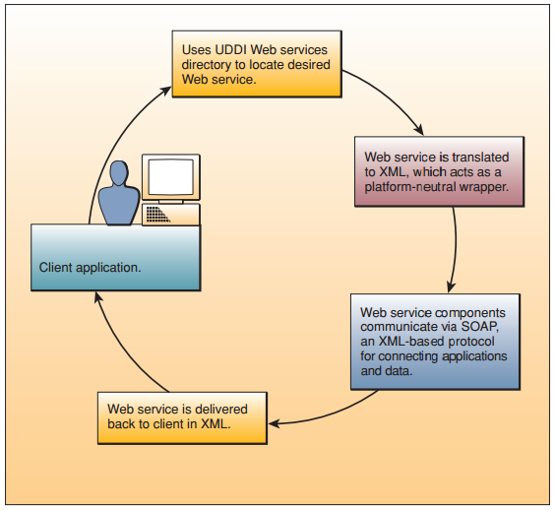

UDDI (Universal Description, Discovery, and Integration) is the “yellow pages” directory of all Web services and how to locate and use them.
SOAP (Simple Object Access Protocol) is an XML-based protocol of specifications for connecting applications to the data that they need.

PROGRAMMING SOFTWARE

Language Translator Programs
Computer programs consist of sets of instructions written in programming languages that must be translated by a language translator into the computer’s own machine language before they can be processed, or executed, by the CPU.
- An assembler translates the symbolic instruction codes of programs written in an assembler language into machine language instructions.
- A compiler translates high-level language statements.
- An interpreter is a special type of compiler that translates and executes each statement in a program one at a time.

Programming Tools
Software development and the computer programming process have been enhanced by adding graphical programming interfaces and a variety of built-in development capabilities.
Most software development programs now include powerful graphics-oriented programming editors and debuggers . These programming tools help programmers identify and minimize errors while they are programming.

As the range of support tools expanded, manufacturers began to integrate them into a single application using a common interface. Such tools were referred to as CASE tools(computer-aided software engineering).

Chapter 05 - Data Resource Management

Technical Foundations of Database Management

DATABASE MANAGEMENT SYSTEM
In all information systems, data resources must be organized and structured in some logical manner so that they can be accessed easily, processed efficiently, retrieved quickly, and managed effectively.

FUNDAMENTAL DATA CONCEPTS

Character
The most basic logical data element is the character ,which consists of a single alphabetic, numeric, or other symbol.

Field
The next higher level of data is the field ,or data item. A field consists of a grouping of related characters .
Specifically, a data field represents an attribute (a characteristic or quality) of some entity (object, person, place, or event).

Record
All of the fields used to capture, organize, and store the attributes of an entity are grouped to form a record.
Normally, the first field in a record is used to store some type of unique identifier for the record. This unique identifier is called the primary key (must be unique).
If no specific data can be found to serve as a primary key for a record, the database designer can simply assign a record a unique sequential number so that no two records will ever have the same primary key.

File
A group of related records is a data file (sometimes referred to as a table or flat file ).
When it is independent of any other files related to it, a single table may be referred to as a flat file.
Files are frequently classified (named) by:
- The application for which they are primarily used, such as a payroll file or an inventory file.
- The type of data they contain, such as a document file or a graphical image file.
- Their permanence, for example, a payroll master file versus a payroll weekly transaction file .

Database
A database is an integrated collection of logically related data elements . The data stored in a database are independent of the application programs using them and of the type of storage devices on which they are stored.

DATABASE STRUCTURES

Hierarchical Structure
The relationships between records form a hierarchy or treelike structure.
- All records are dependent and arranged in multilevel structures, consisting of one root record and any number of subordinate levels.
- All of the relationships among records are one-to-many because each data element is related to only one element above it.
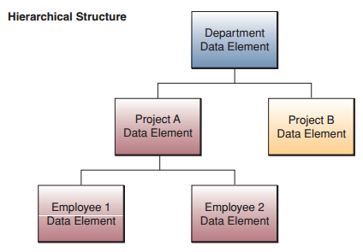

Network Structure
It allows many-to-many relationships among records; that is, the network model can access a data element by following one of several paths because any data element or record can be related to any number of other data elements.
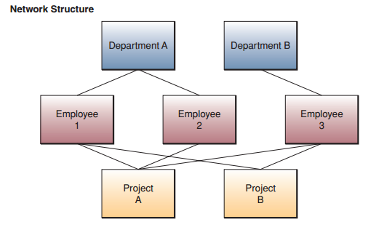
Relational Structure
In the relational model, all data elements within the database are viewed as being stored in the form of simple two-dimensional tables, sometimes referred to as relations .
The tables in a relational database are flat files that have rows and columns. Each row represents a single record in the file, and each column represents a field.
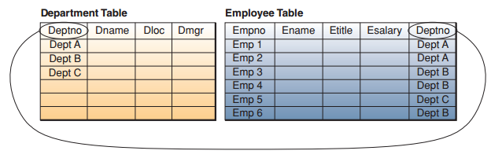

Relational Operations
- The select operation is used to create a subset of records that meet a stated criterion (filter).
- The join operation can be used to combine two or more tables temporarily so that a user can see relevant data in a form that looks like it is all in one big table.
- The project operation is used to create a subset of the columns contained in the temporary tables created by the select and join operations .

Multidimensional Structure

The multidimensional model is a variation of the relational model that uses multidimensional structures to organize data and express the relationships between data.

Each cell within a multidimensional structure contains aggregated data related to elements along each of its dimensions.

A major benefit of multidimensional databases is that they provide a compact and easy-to-understand way to visualize and manipulate data elements that have many interrelationships.

Multidimensional databases have become the most popular database structure for the analytical databases that support online analytical processing (OLAP) applications, in which fast answers to complex business queries are expected.

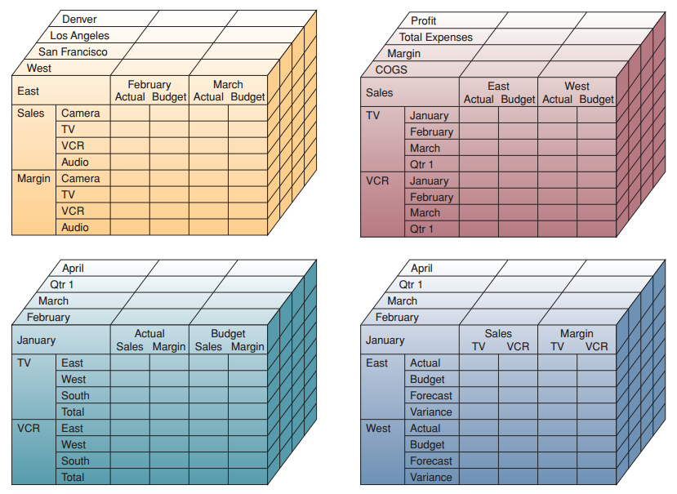

Object-Oriented Structure
An object consists of data values describing the attributes of an entity, plus the operations that can be performed upon the data.
This encapsulation capability allows the object-oriented model to handle complex types of data (graphics, pictures, voice, and text) more easily than other database structures.
The object-oriented model also supports inheritance which allows new objects to be automatically created by replicating some or all of the characteristics of one or more parent objects.

Evaluation of Database Structures
The major limitation of the relational model is that relational database management systems cannot process large amounts of business transactions as quickly and efficiently as those based on the hierarchical and network models; they also cannot process complex, high-volume applications as well as the object-oriented model. This performance gap has narrowed with the development of advanced relational database software with object-oriented extensions.

DATABASE DEVELOPMENT

Database management packages like Microsoft Access or Lotus Approach allow end users to develop the databases they need easily.
Large organizations usually place control of enterprisewide database development in the hands of database administrators (DBAs) and other database specialists.
Database developers use the data definition language (DDL) in database management systems to develop and specify the data contents, relationships, and structure of each database, and to modify these database specifications when necessary.
A data dictionary is a database management catalog or directory containing metadata (i.e., data about data).

Data Planning and Database Design

Database development may start with a top-down data planning process. Database administrators and designers work with corporate and end-user management to develop an enterprise model that defines the basic business process of the enterprise. They then define the information needs of end users in a business process.

Next, end users must identify the key data elements that are needed to perform their specific business activities by developing entity relationship diagrams (ERDs) that model the relationships among the many entities involved in business processes.

Such user views are a major part of a data modeling process, during which the relationships among data elements are identified.

A schema is an overall logical view of the relationships among the data elements in a database.
Subschema is a logical view of the data relationships needed to support specific end-user application programs that will access that database.

Data models represent logical views of the data and relationships of the database. Physical database design takes a physical view of the data that describes how data are to be physically stored and accessed on the storage devices of a computer system.

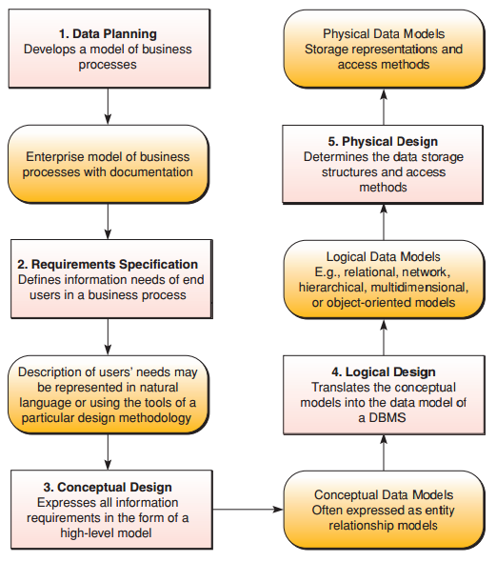

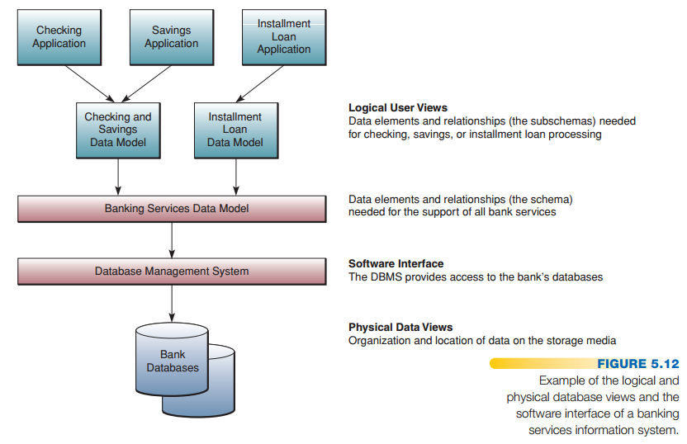

Managing Data Resources

DATA RESOURCE MANAGEMENT

Data resource management is a managerial activity that applies information systems technologies like database management, data warehousing, and other data management tools to the task of managing an organization’s data resources to meet the information needs of their business stakeholders.

TYPES OF DATABASES

Operational Databases
Operational databases store detailed data needed to support the business processes and operations of a company. They are also called subject area databases (SADB), transaction databases, and production databases.

Examples are a customer database, human resource database, inventory database, and other databases containing data generated by business operations.

Distributed Databases
Many organizations replicate and distribute copies or parts of databases to network servers at a variety of sites.
Distributed databases may be copies of operational or analytical databases, hypermedia or discussion databases, or any other type of database.
Advantages:
- Protection of valuable data
- Storage requirements
Challenges:
- Maintenance of data accuracy - accomplished by replication or duplication
  - Replication is updating distributed database using a specialized software application that looks at each distributed database and then finds the changes made to it (complex and consume a lot of time and computer resources).
  - Duplication process identifies one database as a master and then duplicates that database at a prescribed time after hours so that each distributed location has the same data (changes made only in master database).
- Extra computing power and bandwidth necessary to access multiple databases in multiple locations.

External Databases
Access to a wealth of information from external databases is available for a fee from commercial online services and with or without charge from many sources on the World Wide Web.

Hypermedia Databases
A Web site stores databases of hypertext and hypermedia documents in a hypermedia database consisting of hyperlinked pages of multimedia (text, graphic and photographic images, video clips,
audio segments, and so on).

DATA WAREHOUSES AND DATA MINING

Data Warehouse
A data warehouse stores data that have been extracted from the various operational, external, and other databases of an organization.

It is a central source of the data that have been cleaned, transformed, and cataloged so that they can be used by managers and other business professionals for data mining, online analytical processing, and other forms of business analysis, market research, and decision support.

Data warehouses may be subdivided into data marts, which hold subsets of data from the warehouse that focus on specific aspects of a company, such as a department or a business process.

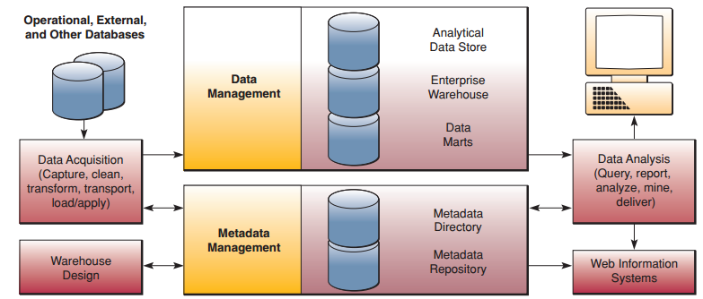

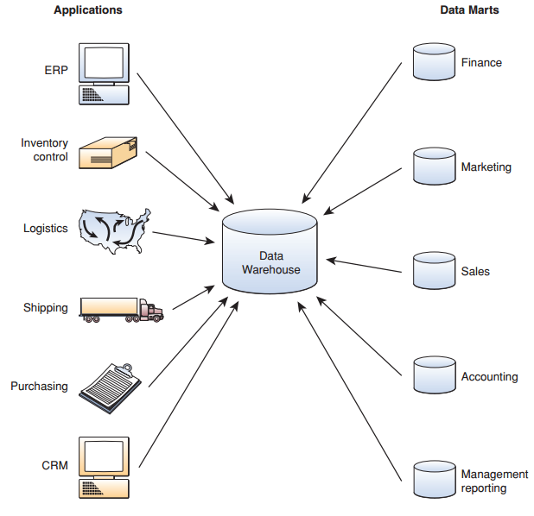

These data are then stored in the enterprise data warehouse, from which they can be moved into data marts or to an analytical data store that holds data in a more useful form for certain types of analysis.

Metadata (data that define the data in the data warehouse) are stored in a metadata repository and cataloged by a metadata directory.

Finally, a variety of analytical software tools can be provided to query, report, mine, and analyze the data for delivery via Internet and intranet Web systems to business end users.

Data in a data warehouse are static, which means that once the data are gathered up, formatted for storage, and stored in the data warehouse, they will never change.

Data Mining
Data mining is a major use of data warehouse databases and the static data they contain. In data mining, the data in a data warehouse are analyzed to reveal hidden patterns and trends in historical business activity.

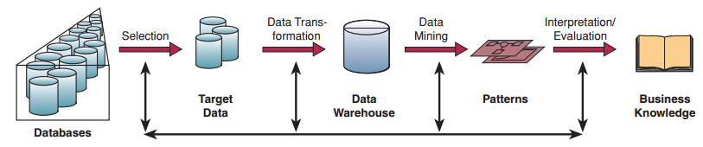

Data mining can discover new correlations, patterns, and trends in vast amounts of business data stored in data warehouses.

Many companies use data mining to:
- Perform market-basket analysis to identify new product bundles.
- Find root causes of quality or manufacturing problems.
- Prevent customer attrition and acquire new customers.
- Cross-sell to existing customers.
- Profile customers with more accuracy.

TRADITIONAL FILE PROCESSING
In file processing systems, data are organized, stored, and processed in independent files of data records.
In the traditional file processing approach that was used in business data processing for many years, each business application was designed to use one or more specialized data files containing only specific types of data records.

Problems of File Processing

DATA REDUNDANCY
Independent data files included a lot of duplicated data; the same data (such as a customer’s name and address) were recorded and stored in several files. This data redundancy caused problems when data had to be updated.

LACK OF DATA INTEGRATION
Having data in independent files made it difficult to provide end users with information for ad hoc requests that required accessing data stored in several different files.

DATA DEPENDENCE
In file processing systems, major components of a system—the organization of files, their physical locations on storage hardware, and the application software used to access those files—depended on one another in significant ways.

LACK OF DATA INTEGRITY OR STANDARDIZATION
The integrity (i.e., the accuracy and completeness) of the data was suspect because there was no control over their use and maintenance by authorized end users.
Thus, a lack of standards caused major problems in application program development and maintenance, as well as in the security and integrity of the data files needed by the organization.

THE DATABASE MANAGEMENT APPROACH

The database management approach was conceived as the foundation of modern methods for managing organizational data. The database management approach consolidates data records, formerly held in separate files, into databases that can be accessed by many different application programs.
A database management system (DBMS) serves as a software interface between users and databases, which helps users easily access the data in a database.

Database Management System
A database management system (DBMS) is the main software tool of the database management approach because it controls the creation, maintenance, and use of the databases of an organization and its end users.
In mainframe and server computer systems, the database management system is an important system software package that controls the development, use, and maintenance of the databases of computer-using organizations.

The three major functions of a database management system are:
- To create new databases and database applications
- To maintain the quality of the data in an organization’s databases
- To use the databases of an organization to provide the information that its end users need

- Database development involves defining and organizing the content, relationships, and structure of the data needed to build a database.
- Database application development involves using a DBMS to develop prototypes of queries, forms, reports, and Web pages for a proposed business application.
- Database maintenance involves using transaction processing systems and other tools to add, delete, update, and correct the data in a database.

Database Interrogation
End users can use a DBMS by asking for information from a database using a query feature or a report generator .
The query language feature lets you easily obtain immediate responses to ad hoc data requests.
The report generator feature allows you to specify a report format for information you want presented as a report.

SQL QUERIES
SQL is the language structure used to “ask a question” that the DBMS will retrieve the data to answer (SELECT, FROM, WHERE).

BOOLEAN LOGIC
Boolean logic allows us to refine our searches for specific information such that only the desired information is obtained (AND, OR, NOT). Example:
Cats OR Felines AND NOT Dogs OR Broadway.
By using this search query, we would retrieve any Web site with the word cats or felines but exclude any site that also has the words dogs or Broadway.

GRAPHICAL AND NATURAL QUERIES
Most end-user database management packages offer GUI (graphical user interface) point-and-click methods, which are easier to use and are translated by the software into SQL commands.
Other packages are available that use natural language query statements similar to conversational English (or other languages).

Database Maintenance
The database maintenance process is accomplished by transaction processing systems and other end-user applications, with the support of the DBMS

Application Development
End users, systems analysts, and other application developers can use the internal 4GL programming
language and built-in software development tools provided by many DBMS packages to develop custom application programs.

Chapter 06 - Telecommunications and Networks

The Networked Enterprise

NETWORKING THE ORGANIZATION
Businesses have become networked enterprises. The Internet, the Web, and intranets and extranets are networking business processes and employees together and connecting them to their customers, suppliers, and other business stakeholders.

THE CONCEPT OF A NETWORK
The term network means an interconnected or interrelated chain, group, or system.

Metcalfe’s Law
Robert Metcalfe founded 3Com Corp. and designed the Ethernet protocol for computer networks.
Metcalfe’s law states that the usefulness, or utility, of a network equals the square of the number of users. In other words, every time you add a new user to a network, the value of that network, in terms of potential connections among its members, exactly doubles!

TRENDS IN TELECOMMUNICATIONS
Telecommunications is the exchange of information in any form (voice, data, text, images, audio, video) over networks.

Industry Trends
The telecommunications industry has changed from government-regulated monopolies to a deregulated market with fiercely competitive suppliers of telecommunications services.

Technology Trends
Open systems with unrestricted connectivity, using Internet networking technologies as their technology platform, are today’s primary telecommunications technology drivers.
These technologies are being applied in Internet, intranet, and extranet applications, especially those for electronic commerce and collaboration.

Open systems are information systems that use common standards for hardware, software, applications, and networking.

Middleware is a general term for any programming that serves to glue together or mediate between two separate, and usually already existing, programs. A common application of middleware is to allow programs written for access to a particular database (e.g., DB2) to access other databases (e.g., Oracle) without the need for custom coding.

More recently, open-systems standards have become so prevalent that the need for middleware is diminishing.

Telecommunications systems have always depended on voice-oriented analog transmission systems designed to transmit the variable electrical frequencies generated by the sound waves of the human voice. However, local and global telecommunications networks are rapidly converting to digital transmission technologies that transmit information in the form of discrete pulses, as computers do.
Another major trend in telecommunications technology is a change from reliance on copper wire–based media and land-based microwave relay systems to fiber-optic lines and cellular, communications satellite, and other wireless technologies .

Business Application Trends
The trend toward more vendors, services, Internet technologies, and open systems, and the rapid growth of the Internet, the World Wide Web, and corporate intranets and extranets, dramatically increases the number of feasible telecommunications applications.

Internet2
Internet2 is a high-performance network that uses an entirely different infrastructure than the public Internet we know today. More than 300 universities and scientific founding institutions and 60,000 member institutions throughout the United States and the rest of the world are already part of the Internet2 network.
Its purpose is to build a road map that can be followed during the next stage of innovation for the current Internet.
The Internet2 network may never become totally open; it might remain solely in the domain of universities, research centers, and governments.
Most of the institutions and commercial partners on the Internet2 network are connected via Abilene, a network backbone that will soon support throughput of 10 gigabits per second (Gbps).

THE BUSINESS VALUE OF TELECOMMUNICATIONS NETWORKS

Use of the Internet, intranets, extranets, and other telecommunications networks can dramatically cut costs, shorten business lead times and response times, support e-commerce, improve the collaboration of workgroups, develop online operational processes, share resources, lock in customers and suppliers, and develop new products and services.

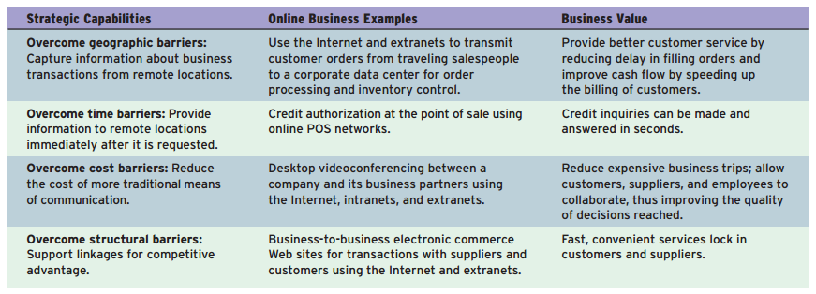

THE INTERNET REVOLUTION

The Internet has become the largest and most important network of networks today and has evolved into a global information superhighway.

When this network of networks began to grow in December 1991, it had about 10 servers. In January 2004, the Internet was estimated to have more than 46 million connected servers with a sustained growth rate in excess of 1 million servers per month.
In January 2007, the Internet was estimated to have more than 1 billion users with Web sites in 34 languages from English to Icelandic.
Today, the Internet handles 294 billion e-mails per day, has 255 million Web sites (with 10 percent of that occurring in 2010), and is estimated to have more than 75 million servers in its network.
There are 13 servers called root servers that are used to handle the bulk of the routing of traffic from one computer to another.

Internet Service Providers
An ISP, or Internet service provider, is a company that provides access to the Internet to individuals and organizations.
With this information (and some specialized hardware), you can then log onto the Internet, browse the World Wide Web, and send and receive e-mail.
ISPs serve large companies, providing a direct connection from the company’s networks to the Internet. These ISPs themselves are connected to one another through network access points.

Internet Applications
The most popular Internet applications are e-mail, instant messaging, browsing the sites on the World Wide Web, and participating in newsgroups and chat rooms.

Business Use of the Internet
Applications such as collaboration among business partners, providing customer and vendor support, and e-commerce have become major business uses of the Internet.
Companies are also using Internet technologies for marketing, sales, and customer relationship management applications, as well as for cross-functional business applications, and applications in engineering, manufacturing, human resources, and accounting.

The Business Value of the Internet
Substantial cost savings can arise because applications that use the Internet and Internet-based technologies (like intranets and extranets) are typically less expensive to develop, operate, and maintain than traditional systems.
Anytime you convert a business process from a manual one to a software-based version, the transaction costs associated with that process can be expected to go down by the order of several magnitudes.
Most companies are building Web sites to achieve six major business values:
- Generate new revenue from online sales.
- Reduce transaction costs through online sales and customer support.
- Attract new customers via Web marketing and advertising and online sales.
- Increase the loyalty of existing customers via improved Web customer service and support.
- Develop new Web-based markets and distribution channels for existing products.
- Develop new information-based products accessible on the Web.

THE ROLE OF INTRANETS

An intranet is a network inside an organization that uses Internet technologies to provide an Internet-like environment within the enterprise for information sharing, communications, collaboration, and the support of business processes.
A company’s intranet can also be accessed through the intranets of customers, suppliers, and other business partners via extranet links.

The Business Value of Intranets
- COMMUNICATIONS AND COLLABORATION: you can use your intranet browser and your PC or mobile device to send and receive e-mail, voice mail, pages, and even faxes to communicate with others within your organization, as well as externally through the Internet and extranets.
- WEB PUBLISHING: information products as varied as company newsletters, technical drawings, and product catalogs can be published in a variety of ways, including hypermedia Web pages, e-mail, and net broadcasting, and as part of in-house business applications.
- BUSINESS OPERATIONS AND MANAGEMENT: Intranets are also being used as the platform for developing and deploying critical business applications to support business operations and managerial decision making across the inter-networked enterprise.
- INTRANET PORTAL MANAGEMENT: Organizations must employ IT and IS professionals to manage the functions of the intranet, along with maintaining the various hardware and software components necessary for successful operations.

THE ROLE OF EXTRANETS

Extranets are network links that use Internet technologies to interconnect the intranet of a business with the intranets of its customers, suppliers, or other business partners.
Companies can establish direct private network links among themselves or create VPNs.
Or a company can use the unsecured Internet as the extranet link between its intranet and consumers and others but rely on the encryption of sensitive data and its own firewall systems to provide adequate security.

The business value of extranets is derived from several factors.
First, the Web browser technology of extranets makes customer and supplier access of intranet resources a lot easier and faster than previous business methods.
Second, as you will see in two upcoming examples, extranets enable a company to offer new kinds of interactive Web-enabled services to their business partners.
Also, extranets can enable and improve collaboration by a business with its customers and other business partners.

Telecommunications Network Alternatives

TELECOMMUNICATIONS NETWORK MODEL

Telecommunications component categories and examples:
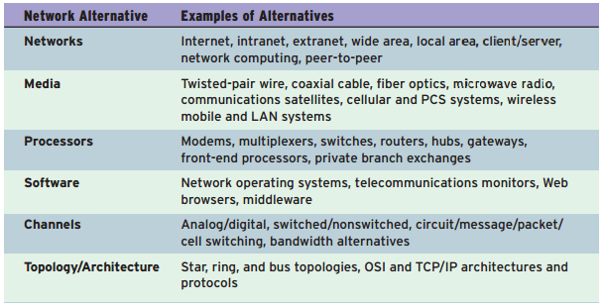

A communications network is any arrangement in which a sender transmits a message to a receiver over a channel consisting of some type of medium.
Categories of components:
- Terminals such as networked personal computers, network computers, net boxes, or information appliances.
- Telecommunications processors which support data transmission and reception between terminals and computers (modems, switches and routers). They convert data from digital to analog and back, code and decode data, and control the speed, accuracy, and efficiency of the communications flow between computers and terminals.
- Telecommunications channels over which data are transmitted and received (copper wires, coaxial cables, or fiber-optic cables, microwave, communications satellite, radio, and cellular systems.
- Computers are interconnected by telecommunications networks so that they can carry out their information processing assignments.
- Telecommunications control software consists of programs that control telecommunications activities and manage the functions of telecommunications networks.

TYPES OF TELECOMMUNICATIONS NETWORKS

Wide Area Networks
Telecommunications networks covering a large geographic area.
WANs are used by many multinational companies to transmit and receive information among their employees, customers, suppliers, and other organizations across cities, regions, countries, and the world.

Metropolitan Area Network
Optimizes a specific geographical area and can range from several blocks of buildings to entire cities.

Local Area Networks
Connect computers and other information processing devices within a limited physical area, such as an office, classroom, building, manufacturing plant, or other work site.

Virtual Private Networks
A virtual private network is a secure network that uses the Internet as its main backbone network but relies on network firewalls, encryption, and other security features of its Internet and intranet connections and those of participating organizations.

Client/Server Networks
In a client/server network, end-user computing workstations are the clients . They are interconnected by local area networks and share application processing with network servers, which also manage the networks.
A client/server approach can take one of two forms: thick client or thin client .
The thick approach uses the server to store data and the client to do all of the processing and computing.
The thin client approach makes the server do all the work. The server becomes the powerful processor and generally houses not only the data but the software applications needed to process the data.

Network Computing
“the network is the computer.” This network computing or network-centric concept views networks as the central computing resource of any computing environment.

In network computing, network computers and other thin clients provide a browser-based user interface for processing small application programs called applets.

Network computing is sometimes called a three-tier client/server model because it consists of thin clients, application servers, and database servers.

Peer-to-Peer Networks

- In the central server architecture, P2P file-sharing software connects your PC to a central server that contains a directory of all of the other users ( peers ) in the network.
Advantages and limitations:
  - Reliance on a central directory and server
  - Provides the network with a platform that can better protect the integrity and security of the content and users of the network

- The pure peer-to-peer network architecture has no central directory or server. First, the file-sharing software in the P2P network connects your PC with one of the online users in the network. Then an active link to your user name is transmitted from peer to peer to all the online users in the network that the first user (and the other online users) encountered in previous sessions.

DIGITAL AND ANALOG SIGNALS

Analog or digital refers to the method used to convert information into an electrical signal.
In an analog system, an electrical voltage or current is generated that is directly proportional to the quantity being observed.
In a digital system, the quantity being observed is expressed as a number. The principal advantage is that once the measurement is expressed in digital form, it can be entered into a computer or a microprocessor and manipulated as desired.

TELECOMMUNICATIONS MEDIA - WIRED

Twisted-Pair Wire
Ordinary telephone wire, consisting of copper wire twisted into pairs (twisted-pair wire), is the most widely used medium for telecommunications. Transmission speeds can range from 2 million bits per second (unshielded) to 100 million bits per second (shielded).

Coaxial Cable
Coaxial cable consists of a sturdy copper or aluminum wire wrapped with spacers to insulate and protect it.
They allow high-speed data transmission (200–500 Mbps) and are used instead of twisted-pair wire lines in high-service metropolitan areas, for cable television systems, and for short-distance connections of computers and peripheral devices.

Fiber Optics
Fiber optics uses cables consisting of one or more hair-thin filaments of glass fiber wrapped in a protective jacket (terabits per second, or Tbps).

The Problem of “The Last Mile”
The telecommunications provider adopts a new, faster, better technology that can provide higher bandwidths and faster telecommunication speeds to consumers.
The house it is connecting to is wired with twisted-pair wiring that just cannot handle the bandwidth provided by fiber.

TELECOMMUNICATIONS MEDIA - WIRELESS

Terrestrial Microwave
Terrestrial microwave involves earthbound microwave systems that transmit high-speed radio signals in a line-of-sight path between relay stations spaced approximately 30 miles apart.

Communications Satellites
Communications satellites also use microwave radio as their telecommunications medium. Typically, high-earth orbit (HEO) communications satellites are placed in stationary geosynchronous orbits approximately 22,000 miles above the equator.
Earth stations use dish antennas to beam microwave signals to the satellites that amplify and retransmit the signals to other earth stations thousands of miles away.

Cellular and PCS Systems
Cellular and PCS telephone and pager systems use several radio communications technologies. However, all of them divide a geographic area into small areas, or cells, typically from one to several square miles in area.

Wireless LANs
A prime example is a new open-standard wireless radio-wave technology technically known as IEEE 802.11b (11 Mbps), or more popularly as Wi-Fi.
A faster version (802.11g) with speeds of 54 Mbps promises to make this technology even more widely used.
The newest version, 802.11n, was finalized. This new standard offers speeds of up to 108 Mbps.

Bluetooth
Bluetooth serves as a cable-free wireless connection to peripheral devices such as computer printers and scanners and operating at approximately 1 Mbps with an effective range from 10 to 100 meters.

The Wireless Web
Smart telephones, pagers, PDAs, and other portable communications devices have become very thin clients in wireless networks.
The telecommunications industry continues to work on fourth-generation (4G) wireless technologies whose goal is to raise wireless transmission speeds to enable streaming video and multimedia applications on mobile devices.
The WAP standard specifies how Web pages in HTML or XML are translated into a wireless markup language (WML) by filter software and preprocessed by proxy software to prepare the Web pages for wireless transmission from a Web server to a Web-enabled wireless device.

TELECOMMUNICATIONS PROCESSORS

Modems
They convert the digital signals from a computer or transmission terminal at one end of a communications link into analog frequencies that can be transmitted over ordinary telephone lines.
A modem at the other end of the communications line converts the transmitted data back into digital form at a receiving terminal. This process is known as modulation and demodulation.
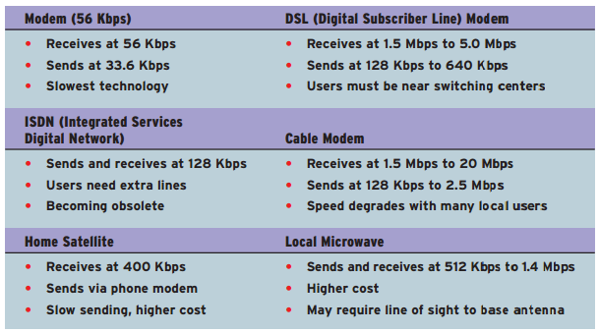

Inter-Network Processors
- A switch is a communications processor that makes connections between telecommunications circuits in a network.
- A bridge is a device that connects two or more local area networks that use the same communications rules or protocol.
- A router is an intelligent communications processor that interconnects networks based on different rules or protocols, so a telecommunications message can be routed to its destination.
- A hub is a port-switching communications processor.

Multiplexers
A multiplexer is a communications processor that allows a single communications channel to carry simultaneous data transmissions from many terminals.
In frequency division multiplexing (FDM), a multiplexer effectively divides a high-speed channel into multiple slow-speed channels.
In time division multiplexing (TDM), the multiplexer divides the time each terminal can use the high-speed line into very short time slots, or time frames.

TELECOMMUNICATIONS SOFTWARE
Telecommunications and network management software may reside in PCs, servers, mainframes, and communications processors.
Network management programs perform functions such as automatically checking client PCs for input/output activity, assigning priorities to data communications requests from clients and terminals, and detecting and correcting transmission errors and other network problems.

Network Management
- Traffic Management: Manage network resources and traffic to avoid congestion and optimize telecommunications service levels to users.
- Security: Telecommunications software must provide authentication, encryption, firewall, and auditing functions, and enforce security policies.
- Network Monitoring: Troubleshoot and watch over the network, informing network administrators of potential problems before they occur.
- Capacity Planning: Survey network resources and traffic patterns and users’ needs to determine how best to accommodate the needs of the network as it grows and changes.

NETWORK TOPOLOGIES
- A star network ties end-user computers to a central computer.
- A ring network ties local computer processors together in a ring on a more equal basis.
- A bus network is a network in which local processors share the same bus, or communications channel.
- A mesh network. It uses direct communications lines to connect some or all of the computers in the ring to one another.

NETWORK ARCHITECTURES AND PROTOCOLS

Protocols
A protocol is a standard set of rules and procedures for the control of communications in a network.

Network Architectures
The goal of network architectures is to promote an open, simple, flexible, and efficient telecommunications environment, accomplished by the use of standard protocols, standard communications hardware and software interfaces, and the design of a standard multilevel interface between end users and computer systems.

The OSI Model
The Open Systems Interconnection (OSI) model is a standard description or “reference model” for how messages should be transmitted between any two points in a telecommunications network.
The main idea in OSI is that the process of communication between two endpoints in a telecommunication network can be divided into layers, with each layer adding its own set of special, related functions.
OSI divides telecommunication into seven layers. The seven layers are:
- Layer 1: The physical layer. This layer conveys the bit stream through the network at the electrical and mechanical level. It provides the hardware means of sending and receiving data on a carrier.
- Layer 2: The data link layer. This layer provides synchronization for the physical level and does bit-stuffing for strings of 1’s in excess of 5. It furnishes transmission protocol knowledge and management.
- Layer 3: The network layer. This layer handles the routing of the data (sending it in the right direction to the right destination on outgoing transmissions and receiving incoming transmissions at the packet level). The network layer does routing and forwarding.
- Layer 4: The transport layer. This layer manages the end-to-end control (e.g., determining whether all packets have arrived) and error checking. It ensures complete data transfer.
- Layer 5: The session layer. This layer sets up, coordinates, and terminates conversations, exchanges, and dialogues between the applications at each end. It deals with session and connection coordination.
- Layer 6: The presentation layer. This layer, usually part of an operating system, converts incoming and outgoing data from one presentation format to another (e.g., from a text stream into a pop-up window with the newly arrived text). It’s sometimes called the syntax layer.
- Layer 7: The application layer. At this layer, communication partners are identified, quality of service is identified, user authentication and privacy are considered, and any constraints on data syntax are identified. (This layer is not the application itself, although some applications may perform application layer functions.)

The Internet’s TCP/IP
The Internet’s protocol suite is called Transmission Control Protocol/Interne t Protocol and is known as TCP/IP.
TCP/IP consists of five layers of protocols that can be related to the seven layers of the OSI architecture.

Voice over IP
Internet telephony is the practice of using an Internet connection to pass voice data using IP instead of using the standard public-switched telephone network. It is often referred to as voice over IP or VoIP.
Examples: Skype and Vonage

BANDWIDTH ALTERNATIVES

Bandwidth determines the channel’s maximum transmission rate.
The speed and capacity of data transmission rates are typically measured in bits per second (bps).
- Narrow-band channels typically provide low-speed transmission rates up to 64 Kbps but can now handle up to 2 Mbps. They are usually unshielded twisted-pair lines commonly used for telephone voice communications and for data communications by the modems of PCs and other devices.
- Medium-speed channels (medium-band) use shielded twisted-pair lines for transmission speeds up to 100 Mbps.
- Broadband channels provide high-speed transmission rates at intervals from 256 Kbps to several billion bps. Typically, they use microwave, fiber optics, or satellite transmission.

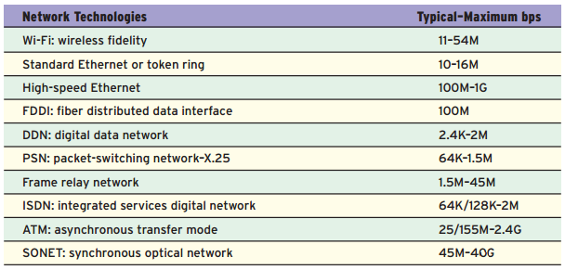

SWITCHING ALTERNATIVES

In message switching, a message is transmitted a block at a time from one switching device to another.
- Packet switching involves subdividing communications messages into fixed or variable length groups called packets. Early packet-switching networks were X.25 networks.
- Frame relay is considerably faster than X.25 and is better able to handle the heavy telecommunications traffic of interconnected local area networks within a company’s wide area client/server network.
- ATM ( asynchronous transfer mode switch breaks voice, video, and other data into fixed cells of 53 bytes (48 bytes of data and 5 bytes of control information) and routes them to their next destination in the network.

NETWORK INTEROPERABILITY

Network interoperability is concept which ensures that anyone anywhere on one network can communicate with anyone anywhere on another network without having to worry about speaking a common language from a telecommunications perspective.

Chapter 07 - e-Business Systems

e-Business Systems

CROSS-FUNCTIONAL ENTERPRISE APPLICATIONS

Cross-functional enterprise systems cross the boundaries of traditional business functions in order to reengineer and improve vital business processes all cross the enterprise.
These organizations view cross-functional enterprise systems as a strategic way to use IT to:
- share information resources
- improve the efficiency and effectiveness of business processes
- develop strategic relationships with customers, suppliers, and business partners

Instead of focusing on the information processing requirements of business functions (i.e., accounting, finance, or marketing), such enterprise software focuses on supporting integrated clusters of business processes involved in the operations of a business by providing a single software-based system that spans the traditional functional boundaries.

Enterprise Application Architecture

Figure 7.3 presents an enterprise application architecture ,which illustrates the interrelationships of the major cross-functional enterprise applications that many companies use or are installing today.
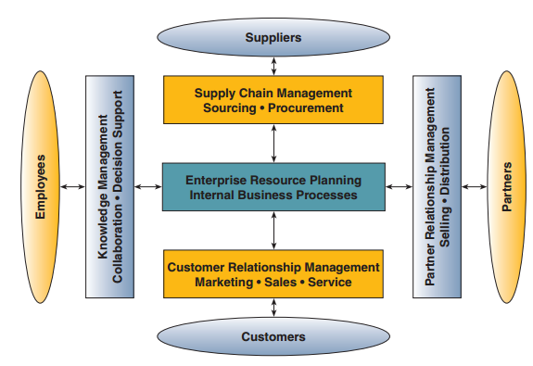
Enterprise applications focus on accomplishing fundamental business processes in concert with a company’s customer, supplier, partner, and employee stakeholders.

- Enterprise resource planning (ERP) concentrates on the efficiency and effectiveness of a firm’s internal production, distribution, and financial processes.
- Customer relationship management (CRM) focuses on acquiring and retaining profitable customers via marketing, sales, and service processes.
- Partner relationship management (PRM) aims to acquire and retain partners who can enhance the sale and distribution of a firm’s products and services.
- Supply chain management (SCM) focuses on developing the most efficient and effective sourcing and procurement processes with suppliers for the products and services that a business needs.
- Knowledge management (KM) applications provide a firm’s employees with tools that support group collaboration and decision support.

ENTERPRISE APPLICATION INTEGRATION
Enterprise application integration (EAI) software is being used by many companies to connect their major e-business applications.
- It enables users to model the business processes involved in the interactions that should occur between business applications
- It provides middleware that performs data conversion and coordination, application communication and messaging services, and access to the application interfaces involved.
- It can integrate a variety of enterprise application clusters by letting them exchange data according to rules derived from the business process models developed by users.
- It can integrate the front-office and back-office applications of a business so they work together in a seamless, integrated way.

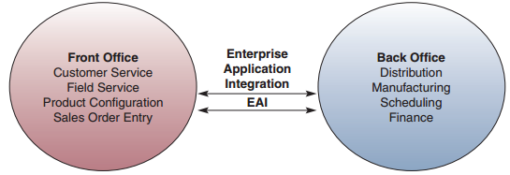

TRANSACTION PROCESSING SYSTEMS
Transaction processing systems (TPS) are cross-functional information systems that process data resulting from the occurrence of business transactions.
Transactions are events that occur as part of doing business, such as sales, purchases, deposits, withdrawals, refunds, and payments .

Online transaction processing systems play a strategic role in Web-enabled businesses. Many firms are using the Internet and other networks that tie them electronically to their customers or suppliers for online transaction processing (OLTP).

The Transaction Processing Cycle

- Data Entry. The first step of the transaction processing cycle is the capture of business data.
- Transaction Processing. Transaction processing systems process data in two basic ways:
(1) batch processing (accumulated over a period of time and processed periodically)
(2) real-time processing (online processing), where data are processed immediately after a transaction occurs.
- Database Maintenance. An organization’s databases must be updated by its transaction processing systems so that they are always correct and up-to-date.
- Document and Report Generation. Transaction processing systems produce a variety of documents and reports such as purchase orders, paychecks, sales receipts, invoices, and customer statements.
- Inquiry Processing. Many transaction processing systems allow you to use the Internet, intranets, extranets, and Web browsers or database management query languages to make inquiries and receive responses concerning the results of transaction processing activity.

ENTERPRISE COLLABORATION SYSTEMS
Enterprise collaboration systems (ECS) are cross-functional information systems that enhance communication, coordination, and collaboration among the members of business teams and workgroups. It helps us to:
- Communicate: Share information with each other.
- Coordinate: Organize our individual work efforts and use of resources.
- Collaborate: Work together cooperatively on joint projects and assignments.

Tools for Enterprise Collaboration
Electronic communication tools include e-mail, voice mail, faxing, Web publishing, bulletin board systems, paging, and Internet phone systems.
Electronic conferencing tools help people communicate and collaborate as they work together.
Electronic meeting systems and other group support systems are used where team members can meet at the same time and place in a decision room setting, or use the Internet to work collaboratively anywhere in the world.

Functional Business Systems

Functional business systems is a variety of types of information systems (transaction processing, management information, decision support, and so on) that support the business functions of accounting, finance, marketing, operations management, and human resource management .

IT in Business
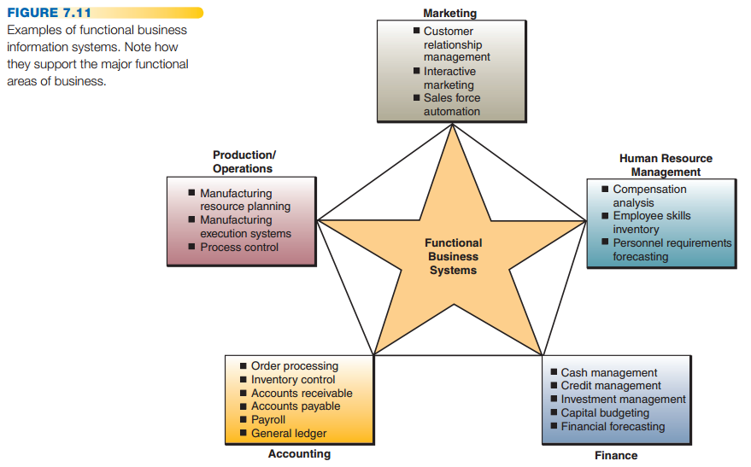

MARKETING SYSTEMS

The business function of marketing is concerned with the planning, promotion, and sale of existing products in existing markets, and the development of new products and new markets to better attract and serve present and potential customers.
Marketing information systems provide information technologies that support major components of the marketing function.

Interactive Marketing
It is a customer-focused marketing process that is based on using the Internet, intranets, and extranets to establish two-way transactions between a business and its customers or potential customers.
Its goal is to attract and keep customers who will become partners with the business in creating, purchasing, and improving products and services.
Interactive marketing encourages customers to become involved in product development, delivery, and service issues.

Targeted Marketing
Targeted marketing is an advertising and promotion management concept that includes five targeting components:
- Community: the group of people interested in the product
- Content: The content of these messages is aimed at the targeted audience.
- Context: advertising is targeted only at people who are already looking for information about subject matter (e.g., vacation travel) that is related to a company’s products (e.g., car rental services).
- Demographic/Psychographic: aimed only at specific types/classes of people.
- Online Behavior: track a person’s online behavior so the advertising can be targeted to the individual (using cookies)

Sales Force Automation
In many companies, the sales force is being outfitted with notebook computers, Web browsers, and sales contact management software that connect them to marketing Web sites on the Internet, extranets, and their company intranets.
Many companies are viewing sales force automation as a way to gain a strategic advantage in sales productivity and marketing responsiveness.

MANUFACTURING SYSTEMS

Manufacturing information systems support the production/operations function that includes all activities concerned with the planning and control of the processes producing goods or services.

Computer-Integrated Manufacturing (CIM)
CIM is an overall concept that emphasizes that the objectives of computer-based systems in manufacturing must be able to:
- Simplify (reengineer) production processes, product designs, and factory organization as a vital foundation to automation and integration.
- Automate production processes and the business functions that support them with computers, machines, and robots.
- Integrate all production and support processes using computer networks, cross-functional business software, and other information technologies.
The overall goal of CIM and other such manufacturing information systems is to create flexible, agile, manufacturing processes that efficiently produce products of the highest quality.

- Computer-aided manufacturing (CAM) systems are those that automate the production process.
- Manufacturing execution systems (MES) are performance-monitoring information systems for factory floor operations. They monitor, track, and control the five essential components involved in a production process: materials, equipment, personnel, instructions and specifications, and production facilities.
- Process control is the use of computers to control an ongoing physical process such as temperature and pressure.
- Machine control (numerical control) is the use of computers to control the actions of machines.

HUMAN RESOURCE SYSTEMS
Human resource information systems (HRIS) are designed to support:
- planning to meet the personnel needs of the business
- development of employees to their full potential
- control of all personnel policies and programs

HRM and the Internet
- Online HRM systems may involve recruiting for employees through recruitment sections of corporate Web sites.
- Companies are also using commercial recruiting services and databases on the Internet.
- Posting messages in selected Internet newsgroups.
- Communicating with job applicants via e-mail.

HRM and Corporate Intranets
Intranet technologies allow companies to process most common HRM applications over their corporate intranets.
Employee self-service (ESS) intranet applications allow employees to view benefits, enter travel and expense reports, verify employment and salary information, access and update their personal information, and enter time-sensitive data.
It can serve as a superior training tool by download instructions and processes.

ACCOUNTING SYSTEMS
Accounting information systems record and report business transactions and other economic events.
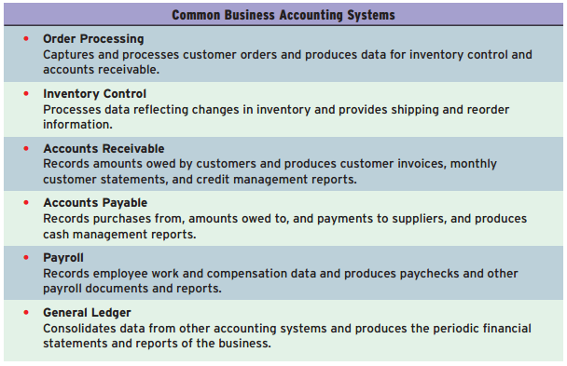
Online Accounting Systems
Many companies are using Internet and other network links to trading partners for online transaction processing systems.
Using the Internet and other networks changes how accounting information systems monitor and track business activity.
These systems are directly involved in the processing of transactions between a business and its customers and suppliers.

FINANCIAL MANAGEMENT SYSTEMS

Computer-based financial management systems support business managers and professionals in decisions concerning:

- The financing of a business
- The allocation and control of financial resources within a business

Major financial management system categories include:
- Capital budgeting: involves evaluating the profitability and financial impact of proposed capital expenditures.
- Financial planning: evaluate the present and projected financial performance of a business.
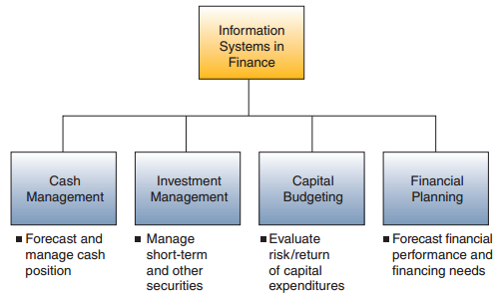

Chapter 08 - Business Across The Enterprise

Customer Relationship Management: The Business Focus

WHAT IS CRM?

Customer relationship management (CRM) uses information technology to create an enterprise-wide system that integrates and automates many of the customer-serving processes in sales, marketing, and other customer-related services that interact with a company’s customers.
It provides the organization with a single complete view of every customer, and providing the customer with a single complete view of the organization and its extended channels.

Contact and Account Management
CRM software helps sales, marketing, and service professionals capture and track relevant data about every past and planned contact with prospects and customers, as well as other business and life-cycle events of customers.

Sales
A CRM system provides sales representatives with the software tools and company data sources they need to support and manage their sales activities

- Cross-selling is an approach in which a customer of one product or service, might also be interested in purchasing a related product or service.
- Up-selling refers to the process of finding ways to sell a new or existing customer a better product than they are currently seeking.

Marketing and Fulfillment
CRM systems help marketing professionals accomplish direct marketing campaigns by automating such tasks as qualifying leads for targeted marketing, and scheduling and tracking direct marketing mailings and assist in scheduling responses and requests, while capturing relevant information for the marketing database.

Customer Service and Support
CRM helps customer service managers create, assign, and manage requests for service by customers.
- Call center software routes calls to customer support agents based on their skills and authority to handle specific kinds of service requests.
- Help desk software helps customer service reps assist customers who are having problems with a product or service by providing relevant service data and suggestions for resolving problems.

Retention and Loyalty Programs
Enhancing and optimizing customer retention and loyalty is a major business strategy because:
- It costs six times more to sell to a new customer than to sell to an existing one.
- A typical dissatisfied customer will tell 8 to 10 people about his or her experience.
- A company can boost its profits 85 percent by increasing its annual customer retention by only 5 percent.
- The odds of selling a product to a new customer are 15 percent, whereas the odds of selling a product to an existing customer are 50 percent.
- If a company takes care of a service problem quickly, 70 percent of complaining customers will do business with the company again.

THE THREE PHASES OF CRM

The three phases of the relationship between a business and its customers:
- Acquire: A business relies on CRM software tools and databases to help it acquire new customers by doing a superior job of contact management, sales prospecting, selling, direct marketing, and fulfillment.
- Enhance: Web-enabled CRM account management and customer service and support tools help keep customers happy by supporting superior service from a responsive networked team of sales and service specialists and business partners, plus cross-sell and up-sell to their customers.
- Retain: CRM analytical software and databases help a company proactively identify and reward its most loyal and profitable customers to retain and expand their business via targeted marketing and relationship marketing programs.

BENEFITS AND CHALLENGES OF CRM

- CRM allows a business to identify and target its best customers.
- It makes possible real-time customization and personalization of products and services based on customer wants, needs, buying habits, and life cycles.
- CRM can also keep track of when a customer contacts the company
- CRM systems can enable a company to provide a consistent customer experience and superior service.

CRM Failure
Although over 70% of firms plan to implement CRM, over 50% of CRM projects fail to produce promised results due to:
- Lack of senior management sponsorship
- Improper change management
- Projects take on too much too fast
- Poor integration between CRM and core business systems
- Lack of end-user incentives leading to low user adoption rates
Despite the above, research shows that the major reason for CRM failure is a familiar one: lack of understanding and preparation.

TRENDS IN CRM
The four types or categories of CRM that are being implemented by many companies today, and it summarizes their benefits to a business:
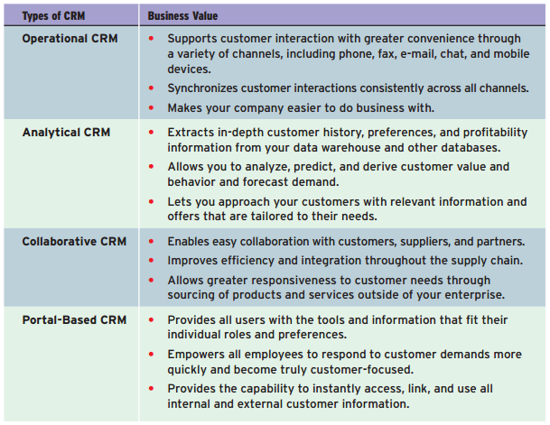

Enterprise Resource Planning: The Business Backbone

WHAT IS ERP?
Enterprise resource planning is a cross-functional enterprise system driven by an integrated suite of software modules that supports the basic internal business processes of a company.

For example, ERP software for a manufacturing company will typically process the data from and track the status of sales, inventory, shipping, and invoicing, as well as forecast raw material and human resource requirements.

ERP gives a company an integrated real-time view of its core business processes, such as production, order processing, and inventory management, tied together by the ERP application software and a common database maintained by a database management system.

ERP systems track business resources and the status of commitments made by the business, no matter which department has entered the data into the system.

ERP software suites typically consist of integrated modules of manufacturing, distribution, sales, accounting, and human resource applications.

BENEFITS AND CHALLENGES OF ERP
Many other companies have found major business value in their use of ERP in several basic ways:
- Quality and efficiency. ERP creates a framework for integrating and improving a company’s internal business processes
- Decreased costs. Significant reductions in transaction processing costs and hardware, software, and IT support staff.
- Decision support. ERP provides vital cross-functional information on business performance to managers quickly to significantly improve their ability to make better decisions in a timely manner.
- Enterprise agility. Implementing ERP systems breaks down many former departmental and functional walls of business processes, information systems, and information resources.

The Costs of ERP
Hardware and software costs are a small part of total costs, and that the costs of developing new business processes (reengineering) and preparing employees for the new system (training and change management) make up the bulk of implementing a new ERP system.
Converting data from previous legacy systems to the new cross-functional ERP system is another major category of ERP implementation costs.

Causes of ERP Failures
- #1 cause – underestimating the complexity of planning, development, and training necessary for success
- Failure to involve affected employees
- Trying to do too much too fast
- Overreliance on claims of software vendors/consulting firms
TRENDS IN ERP
- Companies that installed ERP systems pressured software vendors to adopt more open, flexible, standards-based software architectures. This makes the software easier to integrate with other application programs.
- Web-enabling ERP software is a second development in the evolution of ERP. This makes ERP systems easier to use and connect to other internal applications.
- Providing Web-enabled links between key business systems of a company and its customers, suppliers, distributors, and others.
- All of these developments have provided the business and technological momentum for the integration of ERP functions into e-business suites.
- The goal of these software suites is to enable companies to run most of their business processes using one Web-enabled system of integrated software and databases, instead of a variety of separate e-business applications.

Supply Chain Management: The Business Network

A successful supply chain management (SCM) strategy is based on accurate order processing, just-in-time inventory management, and timely order fulfillment.

Fundamentally, supply chain management helps a company get the right products to the right place at the right time, in the proper quantity and at an acceptable cost.

WHAT IS SCM?
Supply chain management is a cross-functional interenterprise system that uses information technology to help support and manage the links between some of a company’s key business processes and those of its suppliers, customers, and business partners. The goal of SCM is to create a fast, efficient, and low-cost network of business relationships, or supply chain ,to get a company’s products from concept
to market.

What exactly is a company’s supply chain?
Let’s suppose a company wants to build and sell a product to other businesses. Then it must buy raw materials and a variety of contracted services from other companies. The interrelationships with suppliers, customers, distributors, and other businesses that are needed to design, build, and sell a product make up the network of business entities, relationships, and processes that is called a supply chain.
Because each supply chain process should add value to the products or services a company produces, a supply chain is frequently called a value chain.

Electronic Data Interchange
- Electronic data interchange (EDI) was one of the earliest uses of information technology for supply chain management.
- EDI involves the electronic exchange of business transaction documents over the Internet and other networks between supply chain trading partners.
- Typically, EDI software is used to convert a company’s own document formats into standardized EDI formats as specified by various industry and international protocols. Formatted transaction data are transmitted over network links directly between computers without paper documents or human intervention.
- EDI is still a popular data-transmission format among major trading partners, primarily to automate repetitive transactions, although it is slowly being replaced by XML-based Web services.
- By digitally integrating the supply chain, EDI streamlines processes, saves time, and increases accuracy. In addition, by using Internet technologies, lower-cost Internet-based EDI services are now available to smaller businesses.

THE ROLE OF SCM
The top three levels of Figure 8.17 show the strategic, tactical, and operational objectives and outcomes of SCM planning, which are then accomplished by the business partners in a supply chain at the execution level of SCM. The role of information technology in SCM is to support these objectives with interenterprise information systems that produce many of the outcomes a business needs to manage its supply chain effectively.
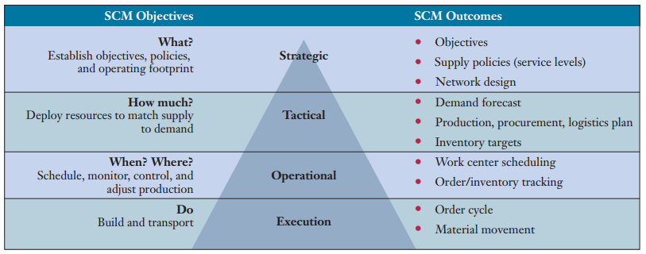

BENEFITS AND CHALLENGES OF SCM

SCM solutions are becoming more complex
Benefits:
- Faster, More Accurate Order Processing
- Reductions in Inventory Levels
- Quicker Times to Market
- Lower Transaction and Materials Costs
- Strategic Relationships with Suppliers
Challenges – SCM Failures Caused By:
- Lack of Knowledge about Demand Planning
- Inaccurate/Overly Optimistic Demand Forecasts
- Inaccurate Production, Inventory, and Other Business Data
- Lack of Adequate Collaboration Among Marketing, Production, and Inventory Management Departments

TRENDS IN SCM

3 Stages to SCM Implementation:
- In the first stage, a company concentrates on making improvements to its internal supply chain processes and its external processes and relationships with suppliers and customers.
- In stage two, a company accomplishes substantial supply chain management applications by using selected SCM software programs internally, and externally via intranet and extranet links among suppliers, distributors, customers, and other trading partners.
- In the third stage, a company begins to develop and implement collaborative supply chain management applications using advanced SCM software, full-service extranet links, and private and public e-commerce exchanges.

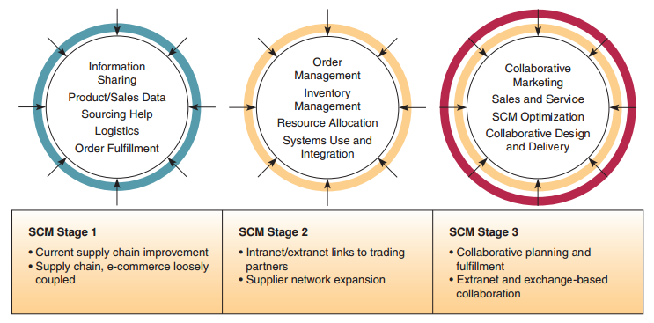

Chapter 09 - e-Commerce Systems

e-Commerce Fundamentals

Electronic commerce encompasses the entire online process of developing, marketing, selling, delivering, servicing, and paying for products and services transacted on internetworked, global marketplaces of customers, with the support of a worldwide network of business partners.

THE SCOPE OF e-COMMERCE

Companies involved in e-commerce as either buyers or sellers rely on Internet-based technologies and e-commerce applications and services to accomplish marketing, discovery, transaction processing, and product and customer service processes.

e-Commerce Technologies
Most information technologies and Internet technologies are, in some form, involved in e-commerce systems.

Categories of e-Commerce
- BUSINESS-TO-CONSUMER (B2C) e-COMMERCE:
businesses must develop attractive electronic marketplaces to sell products and services to consumers.
- CONSUMER-TO-CONSUMER (C2C) e-COMMERCE:
consumers (as well as businesses) can buy from and sell to one another in an auction process at an auction Web site.
Electronic personal advertising of products or services to buy or sell by consumers at electronic newspaper sites, consumer e-commerce portals, or personal Web sites is also an important form of C2C e-commerce.
- BUSINESS-TO-BUSINESS (B2B) e-COMMERCE:
involves both e-business marketplaces and direct market links between businesses. Every important are B2B e-commerce portals that provide auction and exchange marketplaces for businesses.

ESSENTIAL e-COMMERCE PROCESSES
There are 9 key components of an e-commerce process architecture that is the foundation of the e-commerce initiatives of many companies today.

Access Control and Security
E-commerce processes must establish mutual trust and secure access between the parties in an e-commerce transaction by authenticating users, authorizing access, and enforcing security features.

Profiling and Personalizing
User profiles are developed using profiling tools such as user registration, cookie files, Web site behavior tracking software, and user feedback.
These profiles are then used to recognize you as an individual user and provide you with a personalized view of the contents of the site, as well as product recommendations and personalized Web advertising as part of a one-to-one marketing strategy.

Search Management
Efficient and effective search processes provide a top e-commerce Web site capability that helps customers find the specific product or service they want to evaluate or buy.

Content and Catalog Management
Content management software helps e-commerce companies develop, generate, deliver, update, and archive text data and multimedia information at e-commerce Web sites.
Content and catalog management software works with the profiling tools we mentioned previously to personalize the content of Web pages seen by individual users.
Finally, content and catalog management may be expanded to include product configuration processes that support Web-based customer self-service and the mass customization of a company’s products.

Payment
Shopping cart - Payment method support - payment verification

Workflow Management
E-business workflow systems for enterprise collaboration help employees electronically collaborate to accomplish structured work tasks within knowledge-based business processes. Workflow management in both e-business and e-commerce depends on a workflow software engine containing software models of the business processes to be accomplished.

Event Notification
Most e-commerce applications are event-driven systems that respond to a multitude of events—from a new customer’s first Web site access, to payment and delivery processes, to innumerable customer relationship and supply chain management activities.
Event notification software works with workflow management software to monitor all e-commerce processes and record all relevant events, including unexpected changes or problem situations.

Collaboration and Trading
This major category of e-commerce processes consists of those that support the vital collaboration arrangements and trading services needed by customers, suppliers, and other stakeholders to accomplish e-commerce transactions.

ELECTRONIC PAYMENT PROCESSES

Web Payment Processes
Most e-commerce systems on the Web involving businesses and consumers (B2C) depend on credit card payment processes, but many B2B e-commerce systems rely on more complex payment processes based on the use of purchase orders. Both use an electronic shopping cart process, which enables customers to select products from Web site catalog displays and temporarily put them in a virtual shopping basket for later checkout and processing.

Electronic Funds Transfer
Electronic funds transfer (EFT) systems are a major form of electronic payment systems in banking and retailing industries.
EFT systems use a variety of information technologies to capture and process money and credit transfers between banks and businesses and their customers.
Very popular also are Web-based payment services, such as PayPal and BillPoint for cash transfers, and CheckFree and Paytrust for automatic bill payment.

Secure Electronic Payments
Several basic security measures are being used to solve sniffing the networks:
- Encrypt (code and scramble) the data passing between the customer and merchant.
- Encrypt the data passing between the customer and the company authorizing the credit card transaction.
- Take sensitive information offline.

e-Commerce Applications and Issues

e-Commerce Trends
- B2C e-commerce moves from simple Web storefronts to interactive marketing capabilities.
- B2C e-commerce is also moving toward a self-service model in which customers configure and customize
- the products and services they wish to buy.
- B2B e-commerce participants moved quickly from self-service on the Web to configuration and customization capabilities and extranets connecting trading partners.
- B2C e-commerce moves toward full-service and wide-selection retail Web portals.
- B2B moves toward the use of e-commerce portals that provide catalog, exchange, and auction markets for business customers within or across industries.

BUSINESS-TO-CONSUMER e-COMMERCE

e-Commerce Success Factors
- SELECTION AND VALUE.
A business must offer Web shoppers a good selection of attractive products and services at competitive prices.
- PERFORMANCE AND SERVICE.
A site must be efficiently designed for ease of access, shopping, and buying, with sufficient server power and network capacity to support Web site traffic.
Web shopping and customer service must also be friendly and helpful, as well as quick and easy.
Products offered should be available in inventory for prompt shipment to the customer.
- LOOK AND FEEL.
B2C sites can offer customers an attractive Web storefront, shopping areas, and multimedia product catalogs.
- ADVERTISING AND INCENTIVES.
Most web stores advertise on the Web with targeted and personalized banner ads and other Web page and e-mail promotions. They also offer shoppers incentives to buy and return.
- PERSONAL ATTENTION.
Thus, e-commerce software can automatically record details of your visits and build user profiles for you and other Web shoppers. This one-to-one marketing and relationship-building power is one of the major advantages of personalized Web retailing.
- COMMUNITY RELATIONSHIPS.
Web site relationship and affinity marketing programs build and promote virtual communities of customers, suppliers, company representatives, and others via a variety of Web-based collaboration tools.
- SECURITY AND RELIABILITY.
A successful Web store will secure security of customer information and transactions, trustworthy product information, reliable order fulfillment.
- GREAT CUSTOMER COMMUNICATIONS.
Easy-to-find contact information, online order status, product support

WEB STORE REQUIREMENTS
Most B2C e-commerce ventures are retail businesses on the Web; primary focus is to develop, operate, and manage the Website to attract and maintain customers for repeat sales.

Getting Customers to Find You
Your Web store needs to be discovered by your customers, and this means getting listed in the popular search engines.
Search engine optimization (SEO) is considered a subset of search engine marketing, and it focuses on improving the number and/or quality of visitors to a Web site over “natural” listings.

Serving Your Customers
A Web site should help serve customers personally and efficiently so they become loyal customers by:
- Creating incentives.
- Developing Web cookie files to identify returning visitors automatically.
- Contracting with Web site tracking companies like DoubleClick for software to record and analyze the details of the Web site behavior.
- Automatically sending customers e-mail notices to document when orders are processed and shipped.
- Establishing Web site discussion groups and chat rooms
- Providing links to related Web sites

Managing a Web Store
A Web retail store must be managed as both a business and a Web site. There are hosting companies which provide their hosting clients with a variety of management reports that record and analyze Web store traffic, inventory, and sales results. Other services build customer lists for e-mail and Web page promotions or provide customer relationship management features.

BUSINESS-TO-BUSINESS e-COMMERCE

Business-to-business e-commerce is the wholesale and supply side of the commercial process, where businesses buy, sell, or trade with other businesses.
B2B applications include electronic catalog systems, electronic trading systems such as exchange and auction portals, electronic data interchange, electronic funds transfers, and so on.

In addition, many businesses are integrating their Web-based e-commerce systems with their e-business systems for supply chain management, customer relationship management, and online transaction processing, as well as with their traditional, or legacy, computer-based accounting and business information systems.

e-COMMERCE MARKETPLACES

Five major types of e-commerce marketplaces used by businesses today:
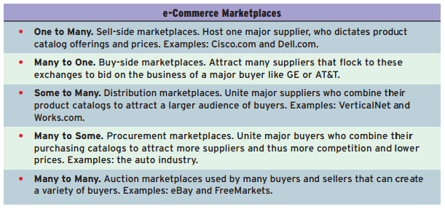

An example of a B2B e-commerce Web portal that offers exchange, auction, and reverse auction electronic markets:
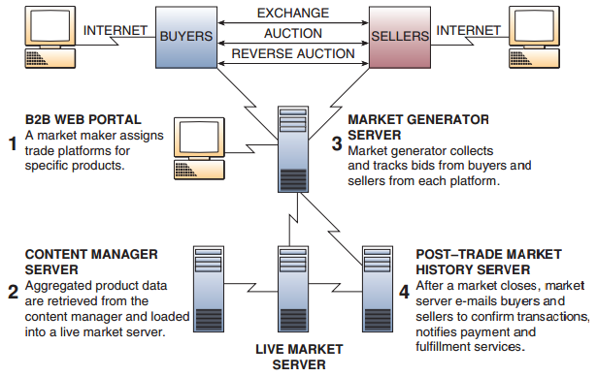

CLICKS AND BRICKS IN e-COMMERCE
E-business managers must answer this question: Should we integrate our e-commerce virtual business operations with our traditional physical business operations or keep them separate?

In today’s networked world, a bricks-and-mortar business that does not adopt a clicks-and-bricks strategy is sometimes referred to as a brink-and-mortar business, suggesting it is on the brink of extinction.

e-Commerce Integration
The business case for such strategies rests on:
- Capitalizing on any unique strategic capabilities that may exist in a company’s traditional business operations that could be used to support an e-commerce business.
- Gaining several strategic benefits of integrating e-commerce into a company’s traditional business, such as sharing established brands and key business information, joint buying power, and distribution efficiencies.

Other Clicks-and-Bricks Strategies
Partial integration of e-commerce into the physical business operations, or complete separation of the two.

e-Commerce Channel Choices
An e-commerce channel is the marketing or sales channel created by a company to conduct and manage its chosen e-commerce activities.

Chapter 10 - Supporting Decision Making

The length and breadth of an organization is held together by the relationship between a decision made in one area and a decision made in another.

Information, Decisions, and Management
The type of information required by decision makers in a company is directly related to the level of management decision making and the amount of structure in the decision situations they face.
Levels of managerial decision making that must be supported by information technology are:
- Strategic Management
A board of directors and an executive committee of the CEO and top executives develop overall organizational goals, strategies, policies, and objectives as part of a strategic planning process.
- Tactical Management
Business professionals in self-directed teams, business unit managers, develop short- and medium-range plans, schedules, and budgets and specify the policies, procedures, and business objectives for their subunits of the company.
- Operational Management
The members of self-directed teams, operating managers, or line personnel develop short-range plans such as weekly production schedules. They direct the use of resources and the performance of tasks according to procedures and within budgets and schedules they establish for the teams and other workgroups of the organization.

Information Quality
Information that is outdated (or late), inaccurate, or hard to understand is not very meaningful, useful, or valuable to a decision maker. People need information of high quality—that is, information products whose characteristics, attributes, or qualities make the information more valuable to them.
It is useful to think of information quality as having the three dimensions of time, content, and form.
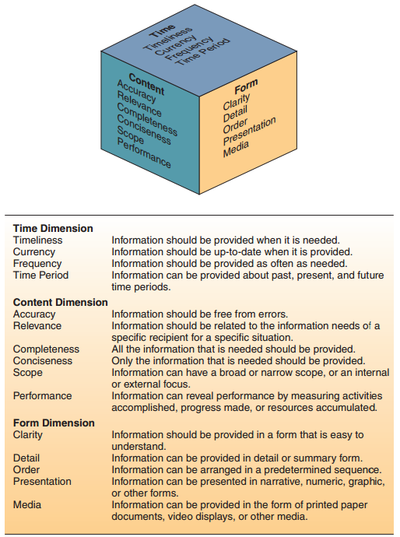

Decision Structure
Decision structure can be thought of as a continuum anchored on one end with highly structured
decisions and on the other end with highly unstructured decisions.

Decisions made at the operational management level tend to be more structured , those at the tactical
level are more semistructured , and those at the strategic management level are more unstructured .

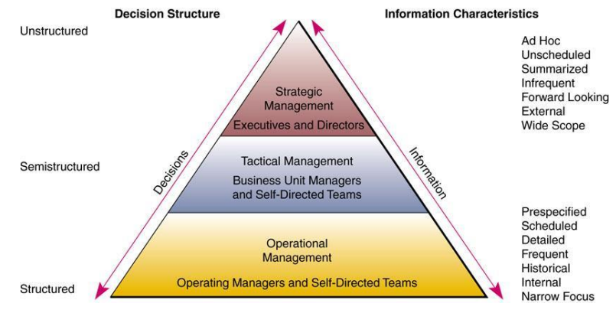

- Structured decisions involve situations in which the procedures to follow, when a decision is needed, can be specified in advance (operational level).
- Unstructured decisions involve decision situations in which it is not possible to specify in advance most of the decision procedures to follow (executive level - long-term strategy).
- Semistructured decisions: some decision procedures can be prespecified but not enough to lead to a definite recommended decision (managerial level - not as frequent, less information available)

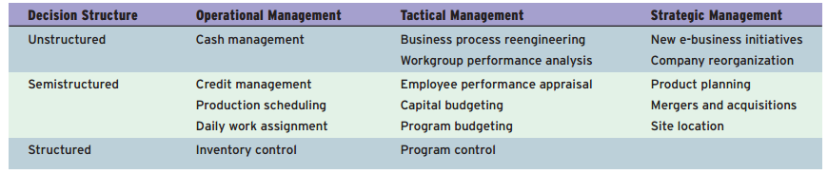

Therefore, information systems must be designed to produce a variety of information products to meet the changing needs of decision makers throughout an organization. For example, decision makers at the strategic management level may look to decision support systems and business analytical systems to provide them with more summarized, ad hoc, unscheduled reports, forecasts, and external intelligence to support their more unstructured planning and policymaking responsibilities.

Decision makers at the operational management level, in contrast, may depend on management information systems to supply more prespecified internal reports emphasizing detailed current and historical data comparisons that support their more structured responsibilities in day-to-day operations.

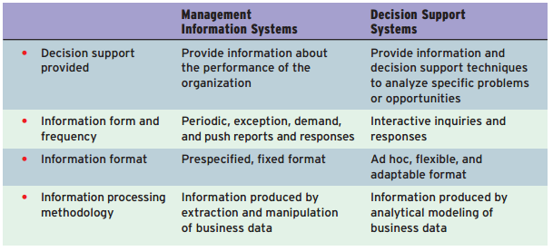

DECISION SUPPORT TRENDS
Using information systems to support business decision making has been one of the primary thrusts of the business use of information technology.
The e-business and e-commerce initiatives that are being implemented by many companies are also expanding the information and decision support uses and the expectations of a company’s employees, managers, customers, suppliers, and other business partners.

- Business intelligence (BI): concepts and methods to improve business decision making by using
fact-based support systems
Business intelligence has evolved from Dresner’s original definition focusing on concepts and methods to a more action-oriented approach referred to as business analytics .
- Business analytics (BA) refers to the skills, technologies, applications, and practices applied to a continuous iterative exploration and investigation of a business’s historical performance to gain insight and drive the strategic business planning process.
Business analytics focuses on developing new insights and understanding of business performance based on data and statistical methods.

Business analytics makes much more extensive use of data, statistical and quantitative analysis, explanatory and predictive modeling, and fact-based management to drive decision making.
Business intelligence is more associated with querying, reporting, online analytical processing (OLAP), and “alerts.” (what happened; how many; how often; where; where exactly is the problem; and what actions are needed)

DECISION SUPPORT SYSTEMS

Decision support systems are computer-based information systems that provide interactive information support to managers and business professionals during the decision-making process.
Decision support systems use:
- analytical models
- specialized databases
- a decision maker’s own insights and judgments
- an interactive, computer-based modeling process to support semistructured business decisions.

Example
Sales managers typically rely on management information systems to produce sales analysis reports. These reports contain sales performance figures by product line, salesperson, sales region, and so on.
The DSS could then use several criteria (e.g., expected gross margin and market share) to evaluate and rank alternative combinations of sales performance factors.

DSS Components
Decision support systems rely on model bases, as well as databases, as vital system resources.
A DSS model base is a software component that consists of models used in computational and analytical routines that mathematically express relationships among variables.
A DSS model base could also include models and analytical techniques used to express much more complex relationships.

MANAGEMENT INFORMATION SYSTEMS

An MIS produces information products that support many of the day-to-day decision-making needs of managers and business professionals.

Management Reporting Alternatives
- Periodic Scheduled Reports: uses a prespecified format designed to provide managers with information on a regular basis (examples: daily or weekly sales analysis reports and monthly financial statements).
- Exception Reports: In some cases, reports are produced only when exceptional conditions occur .
- Demand Reports and Responses: Information is available whenever a manager demands it.
- Push Reporting: Information is pushed to a manager’s networked workstation without being requested.

ONLINE ANALYTICAL PROCESSING
Online analytical processing enables managers and analysts to interactively examine and manipulate large amounts of detailed and consolidated data from many perspectives.
Online analytical processing involves several basic analytical operations:
- Consolidation involves the aggregation of data, which can involve simple roll-ups or complex groupings involving interrelated data.
- Drill-Down. OLAP can also go in the reverse direction and automatically display detailed data that comprise consolidated data.
- Slicing and Dicing refers to the ability to look at the database from different viewpoints.

OLAP Examples
Common business areas where OLAP can solve complex problems include:
- Marketing and sales analysis
- Clickstream data
- Database marketing
- Budgeting
- Financial reporting and consolidation
- Profitability analysis
- Quality analysis

Geographic Information (GIS) and Data Visualization Systems (DVS)
GIS and DVS are special categories of DSS that integrate computer graphics with other DSS features.

A geographic information system is a DSS that uses geographic databases to construct and display maps, as well as other graphics displays that support decisions affecting the geographic distribution of people and other resources.

Data visualization systems represent complex data using interactive, three-dimensional, graphical forms such as charts, graphs, and maps. DVS tools help users interactively sort, subdivide, combine, and organize data while the data are in their graphical form.

USING DECISION SUPPORT SYSTEMS

A decision support system involves an interactive analytical modeling process.
Four basic types of analytical modeling activities are involved in using a decision support system:
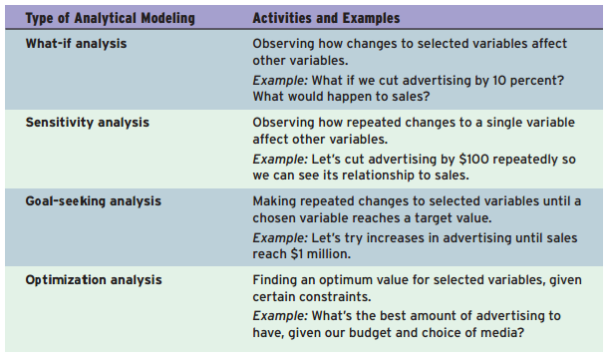

Data Mining for Decision Support
Data mining’s main purpose is to provide decision support to managers and business professionals through a process referred to as knowledge discovery.
Data mining software may perform regression, decision tree, neural network, cluster detection, or market basket analysis for a business.

Market basket analysis (MBA) is one of the most common and useful types of data mining for marketing and is a key technique in business analytics. The purpose of market basket analysis is to determine which products customers purchase together with other products.

Some of the typical applications of MBA:
- Cross-Selling. Offer the associated items when customer buys any items from your store.
- Product Placement. Items that are associated can be put physically near each other.
- Affinity Promotion. Design the promotional events based on associated products.
- Survey Analysis. Useful to analyze questionnaire data.
- Fraud Detection. Based on credit card usage data, we may be able to detect certain purchase behaviors that can be associated with fraud.
- Customer Behavior. Associating purchase with demographic, and socioeconomic data (such as age, gender, and preference) may produce very useful results for marketing.

EXECUTIVE INFORMATION SYSTEMS
More popular alternative names are enterprise information systems (EIS) and executive support systems (ESS).

Executive information systems (EIS) are information systems that combine many of the features of management information systems and decision support systems.

Features of an EIS
- Thee use of a graphical user interface and graphics displays that can be customized to the information preferences of executives using the EIS.
- Exception reporting and trend analysis
- The ability to drill down ,which allows executives to retrieve displays of related information
quickly at lower levels of detail

ENTERPRISE PORTALS AND DECISION SUPPORT

An enterprise information portal (EIP) is a Web-based interface and integration of MIS, DSS, EIS, and other technologies that give all intranet users and selected extranet users access to a variety of internal and external business applications and services.
Enterprise information portals are typically tailored or personalized to the needs of individual business users or groups of users, giving them a personalized digital dashboard of information sources and applications.
Benefits:
- Providing more specific and selective information to business users
- Providing easy access to key corporate intranet Web site resources
- Delivering industry and business news
- Providing better access to company data for selected customers, suppliers, or business partners.
- Help avoid excessive surfing by employees across company and Internet Web sites.

KNOWLEDGE MANAGEMENT SYSTEMS
Use of information technology to help gather, organize, and share business knowledge within
an organization.
The idea of a KMS is to enable employees to have ready access to the organization’s documented base of facts, sources of information, and solutions.
For many companies, enterprise information portals are the entry to corporate intranets that serve as their knowledge management systems. That’s why such portals are called enterprise knowledge portals by their vendors.

Advanced Technologies for Decision Support

BUSINESS AND AI

Artificial intelligence (AI) technologies are being used in a variety of ways to improve the decision support provided to managers and business professionals in many companies.

AN OVERVIEW OF ARTIFICIAL INTELLIGENCE
Artificial intelligence (AI) is a field of science and technology based on disciplines such as computer science, biology, psychology, linguistics, mathematics, and engineering.
The goal of AI is to develop computers that can simulate the ability to think, see, hear, walk, talk, feel, reasoning, learning, and problem solving.

Turing Test– if a human communicates with a computer and does not know it is a computer, the computer is exhibiting artificial intelligence.
CAPTCHA(Completely Automated Public Turing Test) – a test to tell people from computers – a distorted graphic with letters/numbers; a human can see the letters/numbers; a computer cannot.

The Domains of Artificial Intelligence
AI applications can be grouped under three major areas:

- COGNITIVE SCIENCE: It focuses on researching how the human brain works and how humans think and learn.
- ROBOTICS: Machines with intelligence and human-like physical capabilities.
- Natural Interfaces: speaking to a computer in a normal voice.

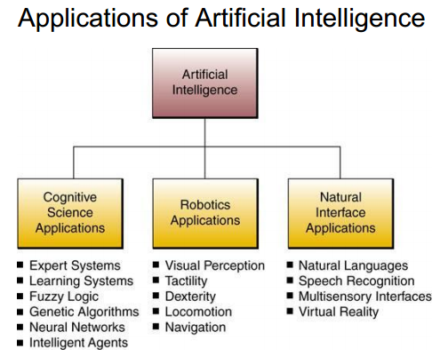
EXPERT SYSTEMS

A knowledge-based information system (KBIS) adds a knowledge base to the major components found in other types of computer-based information systems.
An expert system (ES) is a knowledge-based information system that uses its knowledge about a specific, complex application area to act as an expert consultant to end users.

Components of an Expert System

- Knowledge Base. The knowledge base of an expert system contains
  - Facts about a specific subject area (e.g., John is an analyst).
  - Heuristics (rules of thumb) that express the reasoning procedures of an expert on the subject (e.g., IF John is an analyst, THEN he needs a workstation).
- Software Resources. An expert system software package contains:
  - Inference engine - the program that processes the knowledge (such as rules and facts) related to a specific problem.
  - User interface programs for communicating with end users are also needed, including an explanation program to explain the reasoning process to a user if requested.

Expert System Applications
Using an expert system involves an interactive computer-based session in which the solution to a problem is explored, with the expert system acting as a consultant to an end user.
The expert system asks questions of the user, searches its knowledge base for facts and rules or other knowledge, explains its reasoning process when asked, and gives expert advice to the user in the subject area being explored.
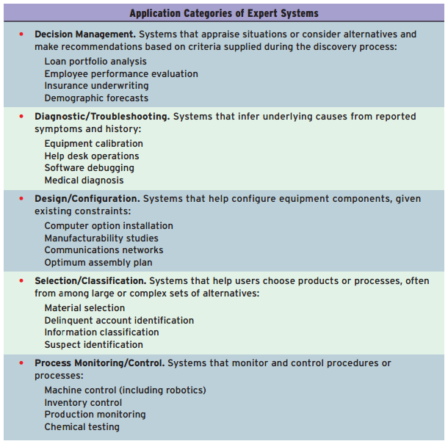
Benefits of Expert Systems
- Captures expertise of a specialist in a limited problem domain
- It can outperform a single human expert in many problem situations.
- Faster and more consistent
- Can have the knowledge of several experts
- Does not get tired or distracted by overwork or stress
- Help preserve and reproduce the knowledge of experts.

Limitations of Expert Systems
- Limited focus
- Inability to learn
- Maintenance problems
- Developmental cost
- Solving specific types of problems in a limited domain of knowledge
- Difficult and costly to develop and maintain
- They can’t learn from experience but instead must be taught new knowledge and modified as new expertise is needed to match developments in their subject areas.

DEVELOPING EXPERT SYSTEMS
The easiest way to develop an expert system is to use an expert system shell as a developmental tool which is a software package consisting of an expert system without its kernel, that is, its knowledge base. They allow trained users to develop the knowledge base for a specific expert system application.

Knowledge Engineering
A knowledge engineer (similar to a systems analyst) is a professional who works with experts to capture the knowledge (facts and rules of thumb) they possess then he builds the knowledge base (and the rest of the expert system if necessary), using an iterative, prototyping process until the expert system is acceptable.

NEURAL NETWORKS
Neural networks are computing systems modeled after the brain’s meshlike network of interconnected processing elements, called neurons.
For example, a neural network can be trained to learn which credit characteristics result in good or bad loans.

FUZZY LOGIC SYSTEMS
Fuzzy logic is a method of reasoning that resembles human reasoning, in that it allows for approximate values and inferences (fuzzy logic) and incomplete or ambiguous data (fuzzy data) instead of relying only on crisp data ,such as binary (yes/no) choices.
Fuzzy Logic in Business
Japan has implemented many fuzzy logic applications, especially the use of special-purpose fuzzy logic microprocessor chips, called fuzzy process controllers.
The list is growing and includes autofocus cameras, autostabilizing camcorders, energy-efficient
air conditioners, self-adjusting washing machines, and automatic transmissions.

GENETIC ALGORITHMS
The use of genetic algorithms is a growing application of artificial intelligence.
Genetic algorithm software uses Darwinian (survival of the fittest), randomizing, and other mathematical functions to simulate an evolutionary process that can yield increasingly better solutions to a problem.

VIRTUAL REALITY
Virtual reality (VR) is computer-simulated reality.
It relies on multisensory input/output devices such as a tracking headset with video goggles and stereo earphones, a data glove or jumpsuit with fiber-optic sensors that track your body movements, and a
walker that monitors the movement of your feet.

VR Applications
- Computer-aided design (CAD)
- Medical diagnostics and treatment
- Scientific experimentation in many physical and biological sciences
- Flight simulation for training pilots and astronauts
- Product demonstrations
- Employee training
- Entertainment—especially 3-D video arcade games

INTELLIGENT AGENTS
Intelligent agents (also called software robots or “bots”)are growing in popularity as a way to use artificial intelligence routines in software to help users accomplish many kinds of tasks in e-business and ecommerce.
An intelligent agent is a software surrogate for an end user or a process that fulfills a stated need or activity.

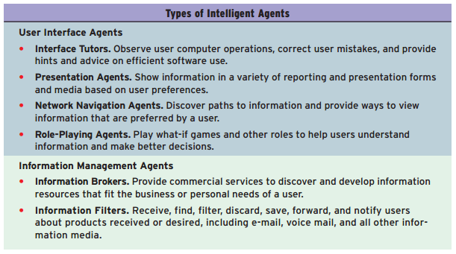

The wizards found in Microsoft Office and other software suites are among the most well-known examples of intelligent agents.
The use of intelligent agents is growing rapidly as a way to simplify software use, search Web sites on the Internet and corporate intranets, and help customers do comparison shopping among the many e-commerce sites on the Web.

Chapter 11 - Business/IT Strategies for Development

IT Planning Fundamentals

Simply knowing the importance and structure of e-business is not enough. A Plan is needed to transition from an old business design to a new e-business design.

ORGANIZATIONAL PLANNING
Companies often make the mistake of relying solely on the IT department to plan, design, develop, and implement introducing new IT/IS–based solutions into an organization.

The fundamental planning process consists of:
- team building, modeling, and consensus
- evaluating what an organization has accomplished and the resources they have acquired
- analyzing their business, economic, political, and societal environments
- anticipating and evaluating the impact of future developments
- building a shared vision and deciding what goals they want to achieve
- deciding which actions to take to achieve their goals

The result of this process is a plan.

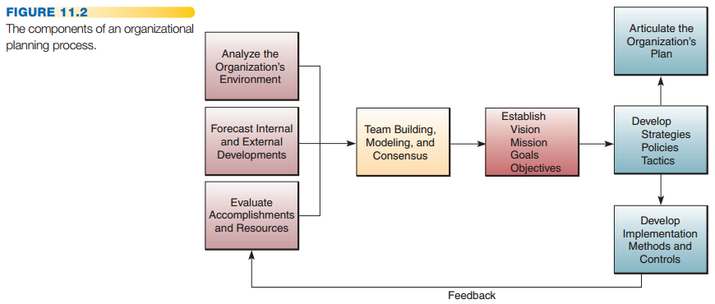

Strategic planning deals with the development of an organization’s mission, goals, strategies, and policies.
Corporations may begin the process by developing a shared vision using a variety of techniques, including team building, scenario modeling, and consensus-creating exercises. Team planning sessions frequently include answering strategic visioning questions
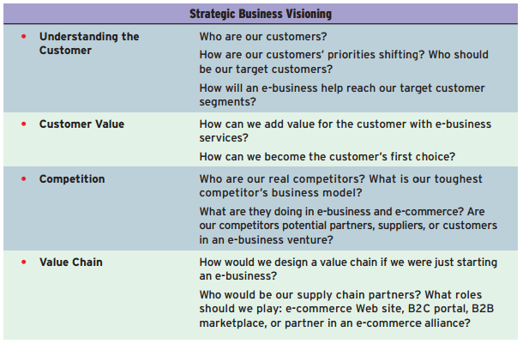

Tactical planning involves the setting of objectives and the development of procedures, rules, schedules, and budgets.

Operational planning is done on a short-term basis to implement and control day-to-day operations.

THE SCENARIO APPROACH
The scenario approach to planning has gained in popularity as a less formal, but more realistic, strategic planning methodology for business professionals to use.
In the scenario approach, teams of managers and other planners participate in what management author Peter Senge calls microworld, or virtual world, exercises.
In a microworld exercise, managers can safely create, experience, and evaluate a variety of scenarios of
what might be happening, or what might happen in the real world.

Scenario planning starts by dividing knowledge into two broad domains:
- Things we believe we know something about (trends)
- Elements we consider uncertain or unknowable (Uncertainties)

The art of scenario planning lies in blending the known and the unknown into a limited number of internally consistent views of the future that span a very wide range of possibilities.

Key business, political, and technological trends that could help guide business/IT planning.
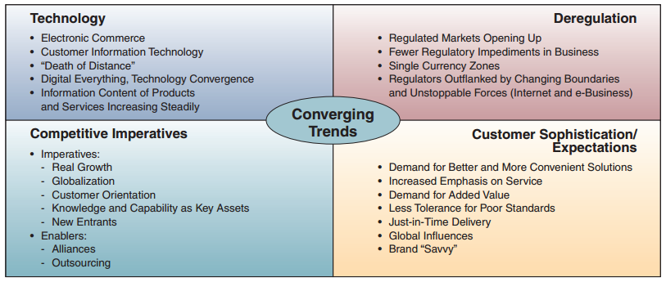

PLANNING FOR COMPETITIVE ADVANTAGE

In contrast to the scenario planning approach, planning for competitive advantage involves an evaluation of the potential benefits and risks a company faces when using IT-based strategies and technologies for competitive advantage.

Popular in strategic business/IT planning approach is the use of a strategic opportunities matrix to evaluate the strategic potential of proposed business/IT opportunities, as measured by their risk/payoff probabilities.
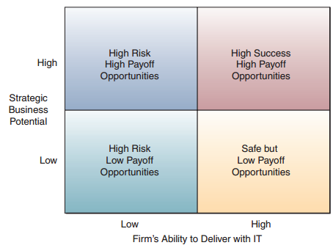

SWOT Analysis
SWOT analysis (strengths, weaknesses, opportunities, and threats) is used to evaluate the impact that each possible strategic opportunity can have on a company and its use of information technology.
- A company’s strengths are its core competencies and resources in which it is one of the market or industry leaders.
- Weaknesses are areas of substandard business performance compared to others in the industry or market segments.
- Opportunities are the potential for new business markets or innovative breakthroughs that might greatly expand present markets.
- Threats are the potential for business and market losses posed by the actions of competitors and other competitive forces, changes in government policies, disruptive new technologies, and so on.

BUSINESS MODELS AND PLANNING

A business model is a conceptual framework that expresses the underlying economic logic and system that prove how a business can deliver value to customers at an appropriate cost and make money.

More specific questions about the components of a business that all business models must answer:
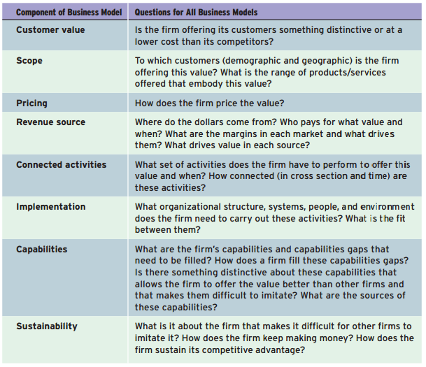

Questions that illustrate the essential components of e-business models:
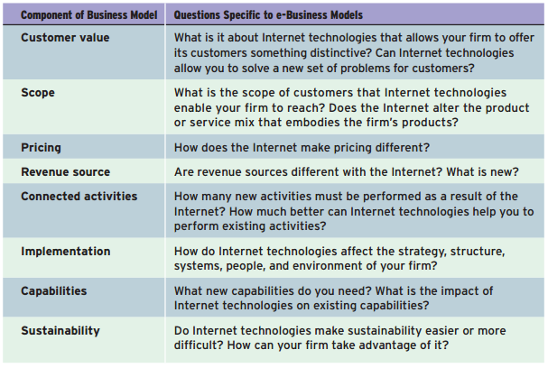

BUSINESS/IT ARCHITECTURE PLANNING

Business/IT planning process focuses on discovering innovative approaches to satisfying a company’s customer value and business value goals which leads to development of strategies and business models
for new e-business and e-commerce platforms, processes, products, and services.
Then a company can develop IT strategies and an IT architecture that supports building and implementing its newly planned business applications.

The business/IT planning process has three major components:
- Strategic Development. Developing business strategies that support a company’s business vision, for example, using information technology to create innovative e-business systems that focus on customer and business value.
- Resource Management. Developing strategic plans for managing or outsourcing a company’s IT resources.
- Technology Architecture. Making strategic IT choices that reflect an information technology architecture designed to support a company’s e-business and other business/IT initiatives.

Information Technology Architecture
The information technology architecture is a conceptual design, or blueprint, that includes the following major components:
- Technology Platform: complete infrastructure supporting strategic use of IT for e-commerce and
business/IT applications.
- Data Resources: Many types of operational and specialized databases, including data warehouses and Internet/intranet databases store.
- Applications Architecture: Business applications of information technology are designed as an integrated architecture of enterprise systems that support strategic business initiatives, as well as cross-functional business processes.
- IT Organization. The organizational structure of the IS function within a company and the distribution of IS specialists are designed to meet the changing strategies of a business.

Balanced Scorecard
It is a method for measuring a company’s activities in terms of its vision and strategies, not based on
proven economic theory or decision sciences.
BSC is a strategic management system that forces managers to focus on the important performance metrics that drive success.
The scorecard seeks to measure a business from the following perspectives:
- Financial Perspective. This measures reflecting financial performance; for example, number of debtors, cash flow, or return on investment.
- Customer Perspective. This measures having a direct impact on customers (results of customer surveys, number of complaints)
- Business Process Perspective. This measures reflecting the performance of key business processes; for example, time spent prospecting, number of units that required rework, or process cost.
- Learning and Growth Perspective. This measures describing the company’s learning curve

IDENTIFYING BUSINESS/IT STRATEGIES

Internet technologies and e-business and e-commerce applications can be used strategically for competitive advantage. However, in order to optimize this strategic impact, a company must continually assess the strategic value of such applications.

- Cost and Efficiency Improvements: a low amount of internal company, customer, and competitor connectivity and use of IT via the Internet and other networks. The use of e-mail, chat systems, discussion groups, and a company Web site are typical examples.
- Performance Improvement in Business Effectiveness. A company has a high degree of internal connectivity and pressures to improve its business processes substantially, but external connectivity by customers and competitors is still low.
- Global Market Penetration. A company must capitalize on a high degree of customer and competitor connectivity and use of IT. Developing e-business and e-commerce applications to optimize interaction with customers and build market share is recommended.
- Product and Service Transformation. Here a company and its customers, suppliers, and competitors are extensively networked.
BUSINESS APPLICATION PLANNING

The business application planning process begins after the strategic phase of business/IT planning has occurred.
The application planning process includes the evaluation of proposals made by the IT management of a company for using information technology to accomplish the strategic business priorities developed earlier in the planning process.
Then, company executives and business unit managers evaluate the business case for investing in proposed e-business development projects based on the strategic business priorities that they decide are most desirable or necessary at that time.
Finally, business application planning involves developing and implementing business applications of IT, as well as managing their development projects.
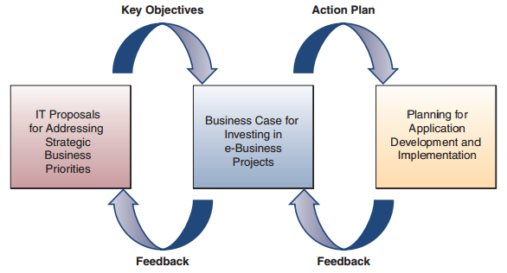

Business/IT Architecture Planning
E-business architecture planning combines contemporary strategic planning methods (for example, SWOT analysis and alternative planning scenarios) with more recent business modeling and application development methodologies (for example, component-based development).
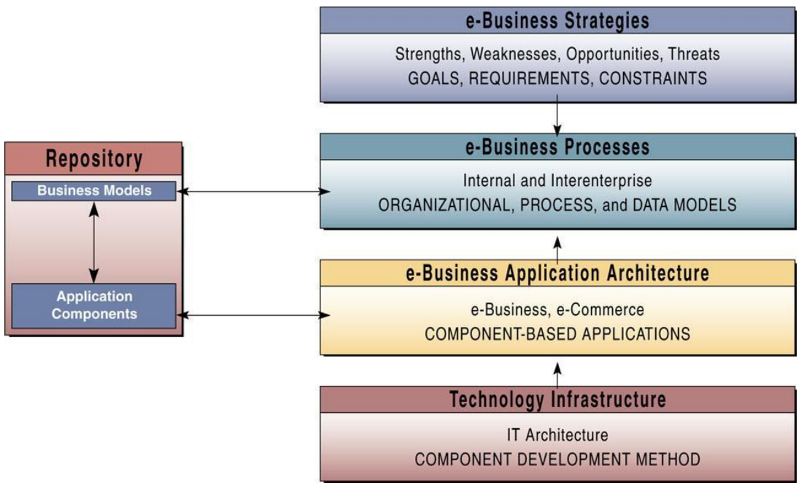
Implementation Challenges

In one sense, implementation is an event that happens: the system has been implemented. In yet another sense, implementation can be thought of as a process that is being applied to effect an outcome.
Implementation is just doing what you planned to do. You can view implementation as a process that carries out the plans for changes in business/IT strategies and applications that were developed in the planning process.

IMPLEMENTING INFORMATION TECHNOLOGY
Moving to e-business involves major organizational change. For example, implementing an application such as online transaction processing brings efficiency to single-function or core business processes. Yet, implementing e-business applications such as enterprise resource management or customer relationship management requires a reengineering of core business processes internally and with supply chain partners, thus forcing a company to model and implement business practices by leading firms in their industry.

END-USER RESISTANCE AND INVOLVEMENT
New ways of doing things always generates some resistance from those affected; end-user involvement in the change process can help minimize the resistance.
One of the keys to solving problems of end-user resistance to new information technologies is proper education and training, and end-user involvement in organizational changes and in the development of new information systems.

Some of the major obstacles to knowledge management systems in business:
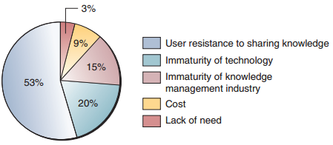

CHANGE MANAGEMENT

People factors have the highest level of difficulty and longest time to resolve of any dimension of change management.
This includes activities such as developing innovative ways to measure, motivate, and reward performance. Change management also involves analyzing and defining all changes facing the organization, as well as developing programs to reduce the risks and costs and to maximize the benefits of change.

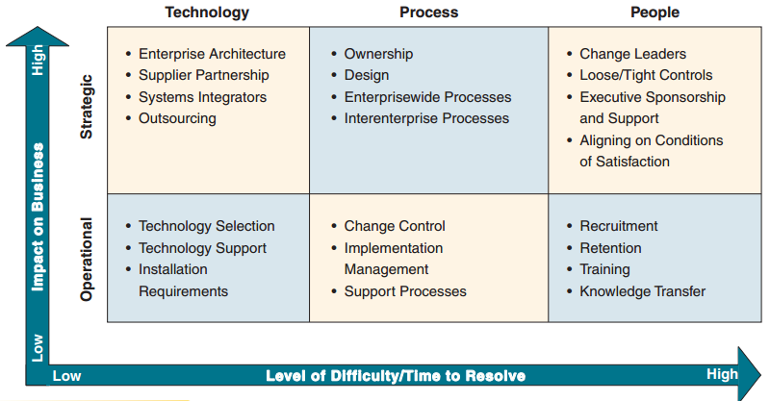

A Change Management Process
An eight-level process of change management for organizations is illustrated in Figure 11.18 . This change management model is only one of many that could be applied to manage organizational changes caused by new business/IT strategies and applications and other changes in business processes.
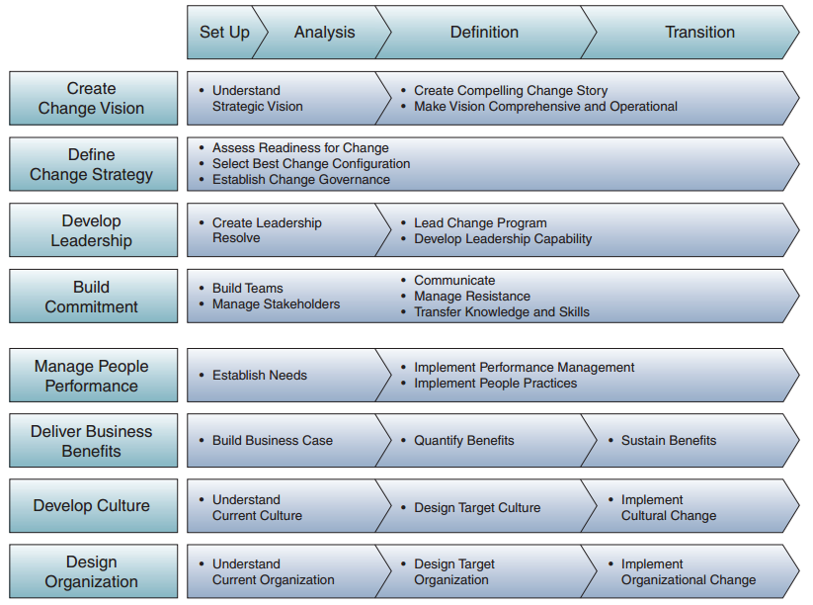

Chapter 12 - Implementing Business/IT Solutions

Developing Business Systems

IS DEVELOPMENT
When the systems approach to problem-solving is applied to the development of information systems solutions to business problems, it is called information systems development or application development .

THE SYSTEMS APPROACH
The systems approach to problem-solving uses a systems orientation to define problems and opportunities and then develop appropriate, feasible solutions in response.
There are specific steps in solving any problem:
- Recognize and define a problem or opportunity using systems thinking .
- Develop and evaluate alternative system solutions.
- Select the system solution that best meets your requirements.
- Design the selected system solution.
- Implement and evaluate the success of the designed system.

Systems Thinking (the fifth discipline)
The essence of the discipline of systems thinking is “seeing the forest and the trees” in any situation by:
- Seeing interrelationships among systems rather than linear cause-and-effect chains whenever events occur.
- Seeing processes of change among systems rather than discrete “snapshots” of change, whenever changes occur.

One way of practicing systems thinking is to try to find systems, subsystems, and components of systems in any situation you are studying. This is also known as using a systems context , or having a systemic view of a situation. Then to understand a problem and solve it, you would determine whether these basic systems functions are being properly performed.

You can better understand a sales problem or opportunity by identifying and evaluating the components of a sales system.
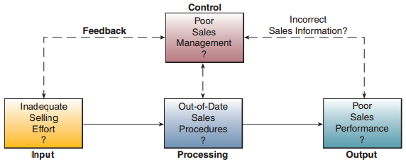
Is poor sales performance (output) caused by inadequate selling effort (input), out-of-date sales procedures (processing), incorrect sales information (feedback), or inadequate sales management (control)?

SYSTEMS ANALYSIS AND DESIGN
Today, there are many approaches to SAD. The two most common approaches are object-oriented analysis and design, and the life cycle approach.

THE SYSTEMS DEVELOPMENT LIFE CYCLE
One method of using the systems approach to develop information system solutions, and the most prevalent one in organization systems analysis and design, can be viewed as a multistep, iterative process called the systems development life cycle (SDLC).
Stage of this process: (1) investigation, (2) analysis, (3) design, (4) implementation, and (5) maintenance.
In actual practice, several developmental activities may be occurring at the same time, while certain activities within a given step may be repeated.

STARTING THE SYSTEMS DEVELOPMENT PROCESS
Systems development can be very costly. Therefore, investigations are made to determine whether to proceed.

Feasibility Studies
This is a preliminary study where the information needs of prospective users and the resource requirements, costs, benefits, and feasibility of a proposed project are determined.
A team of business professionals and IS specialists might then formalize the findings of this study in a written report that includes preliminary specifications and a developmental plan for a proposed business application.
By design, the preliminary feasibility study of a project is a very rough analysis of its viability that must be continually refined over time.
The goal of the preliminary feasibility study is to evaluate alternative system solutions and to propose the most feasible and desirable business application for development.

Operational Feasibility
The operational feasibility assessment focuses on the degree to which the proposed development project fits in with the existing business environment and objectives with regard to development schedule, delivery date, corporate culture, and existing business processes.

Economic Feasibility
The purpose of the economic feasibility assessment is to determine the extent to which the proposed system will provide positive economic benefits to the organization. This determination involves the identification, and quantification, of all benefits expected from the system, as well as the explicit identification of all expected costs of the project.
The assessment of economic feasibility typically involves the preparation of a cost/benefit analysis.

Technical Feasibility
The assessment of technical feasibility is focused on gaining an understanding of the present technical resources of the organization and their applicability to the expected needs of the proposed system.

Human Factors Feasibility
The human factors feasibility assessment focuses on the managers and end users.

Legal/Political Feasibility
The legal and political feasibility of a proposed project includes a thorough analysis of any potential legal ramifications resulting from the construction and implementation of the new system.
The political side of the assessment focuses on understanding who the key stakeholders are within the organization and the degree to which the proposed system may positively or negatively affect the distribution of power.

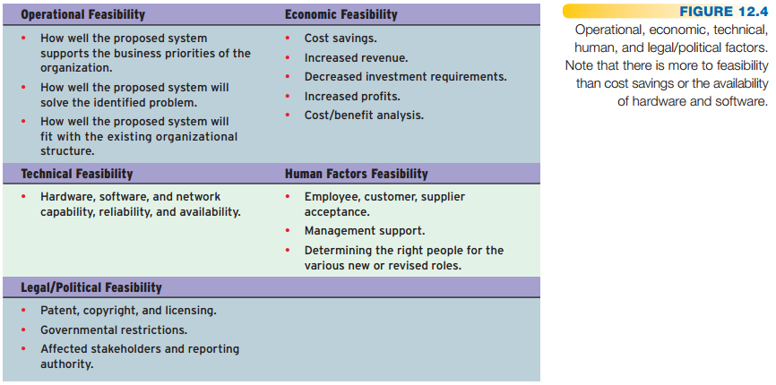

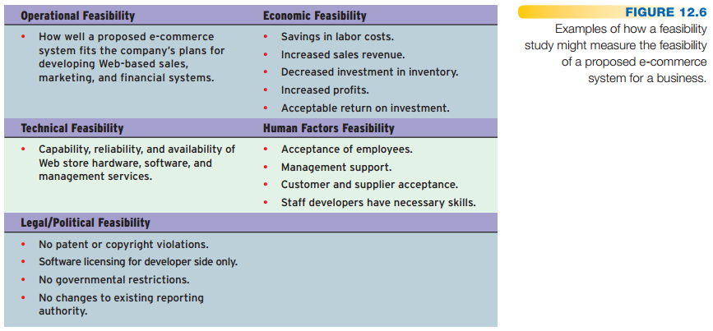

SYSTEMS ANALYSIS
Systems analysis is not a preliminary study, it is an in-depth study of end-user information needs that produces functional requirements that are used as the basis for the design of a new information system.

Systems analysis traditionally involves a detailed study of:
- The information needs of a company and end users like yourself.
- The activities, resources, and products of one or more of the present information systems being used.
- The information system capabilities required to meet your information needs, and those of other business stakeholders that may use the system.

Organizational Analysis
The members of a development team have to know something about the organization, its
management structure, its people, its business activities, the environmental systems it must deal with, and its current information systems.

Analysis of the Present System
You need to analyze how this system uses hardware, software, network, and people resources to convert data resources, such as transactions data, into information products, such as reports and displays.
Then you should document how the information system activities of input, processing, output,
storage, and control are accomplished.

Logical Analysis
The logical model can be thought of as a blueprint of the current system that displays only what the current system does without regard for how it does it.
Logical and physical models are not limited to use in the design of an information system.

Functional Requirements Analysis and Determination
This step of systems analysis is one of the most difficult. You may need to work as a team with IS analysts and other end users to determine your specific business information needs.
As with the construction of the logical model, your main goal is to identify what should be done, not how to do it.
Functional requirements are end-user information requirements that are not tied to the hardware, software, network, data, and people resources that end users presently use or might use in the new system.

SYSTEMS DESIGN
Once the analysis portion of the life cycle is complete, the process of systems design can begin.
During the physical design, users and analysts will focus on determining how the system will accomplish its objectives.
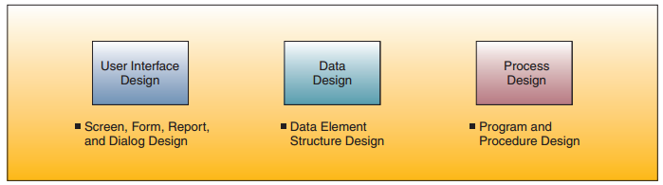

Prototyping
During the design phase, the development process frequently takes the form of, or includes, a prototyping approach. Prototyping is the rapid development and testing of working models, or prototypes , of new applications in an interactive, iterative process that can be used by both IS specialists and business professionals.

The Prototyping Process
A prototype of a business application needed by an end user is developed quickly and then it is repeatedly refined until it is acceptable.
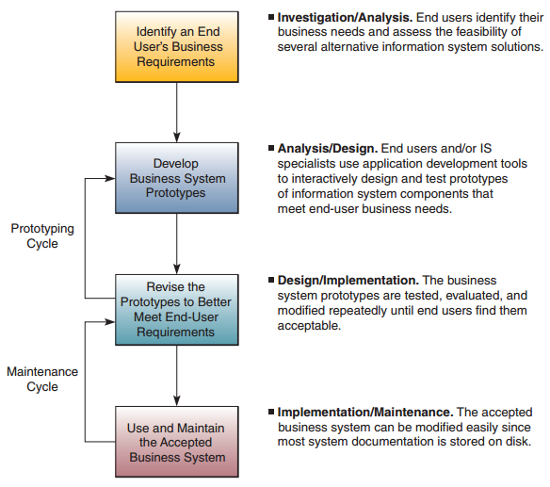

User Interface Design
It is the system component closest to business end users and the one they will most likely help design.

System Specifications
System specifications formalize the design of an application’s user interface methods and products, database structures, and processing and control procedures.

END-USER DEVELOPMENT
IS professionals work with you to analyze your problem and suggest alternative solutions. When you approve the best alternative, it is designed and implemented.
In end-user development, IS professionals play a consulting role while you do your own application development.

Focus on IS Activities
End-user development should focus on the fundamental activities of any information system: input, processing, output, storage, and control.

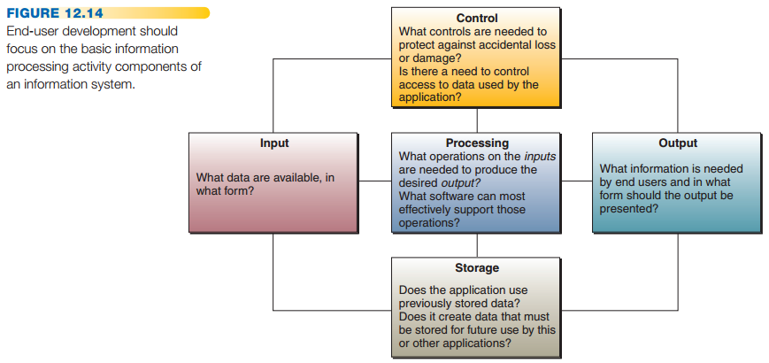

Control measures are needed to protect against accidental loss or damage to end-user files.

Doing End-User Development
In end-user development, you and other business professionals can develop new or improved ways to perform your jobs without the direct involvement of IS specialists.

TECHNICAL NOTE: OVERVIEW OF OBJECT-ORIENTED ANALYSIS AND DESIGN
SDLC remains the predominant approach to software development, the object-oriented approach is gaining favor, particularly among programmers focusing on complex systems that require handling a
wide variety of complex data structures, such as audio, video, images, documents, Web pages, and other types of data.
An object-oriented system is composed of objects. An object can be anything a programmer wants to manage or manipulate.
Once an object is defined by a programmer, its characteristics can be used to allow one object to interact with another object or pass information to another object.
Object-oriented programming (OOP) is the programming paradigm that uses “objects” to design applications and computer programs. It employs several techniques including:
- Inheritance. The ability of one object to inherit the characteristics of a higher-order object.
- Modularity. The extent to which a program is designed as a series of interlinked yet stand-alone modules.
- Polymorphism. The ability of an object to behave differently depending on the conditions in which its behavior is invoked.
- Encapsulation. Concealing all of the characteristics associated with a particular object inside the object itself. This paradigm allows objects to inherit characteristics simply by defining a subobject.
Object-oriented analysis (OOA) aims to model the problem domain, that is, the problem we want to solve, by developing an object-oriented (OO) system.
Object-oriented design (OOD) describes the activity when designers look for logical solutions to solve a problem using objects.

Implementing Strategic Business Systems

Once a new information system has been designed, it must be implemented as a working system and maintained to keep it operating properly.
Implementation is a vital step in the deployment of information technology to support the employees, customers, and other business stakeholders of a company.

IMPLEMENTING NEW SYSTEMS
The systems implementation stage involves hardware and software acquisition, software development, testing of programs and procedures, conversion of data resources, and a variety of conversion alternatives.
Implementation can be a difficult and time-consuming process; however, it is vital in ensuring the success of any newly developed system.
The implementation process typically requires a project management effort on the part of IT and business unit managers.

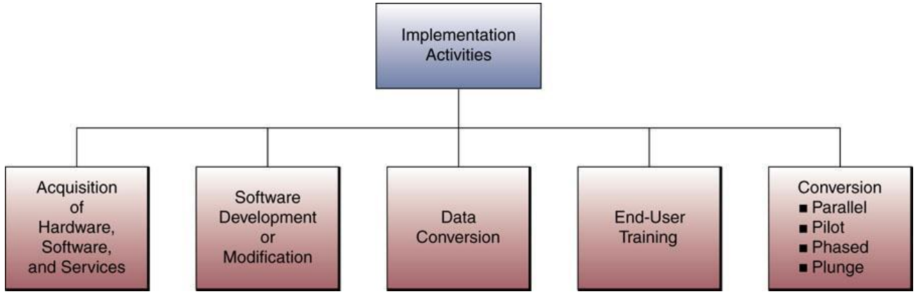

PROJECT MANAGEMENT

What Is a Project?
A project is a special set of activities with a clear beginning and end. Every project has a set of goals, objectives ,and tasks .Every project must also deal with a set of limitations or constraints . Finally, although the content can vary from one project to the next, there are many important similarities in the process.
Three elements will be necessary to manage it effectively and efficiently: process, tools ,and techniques.

The Process of Project Management:
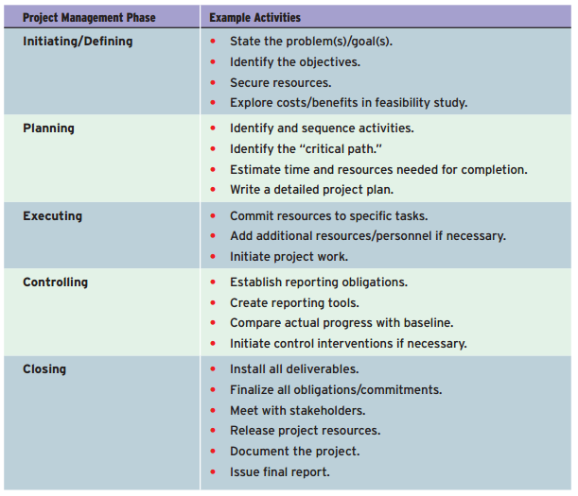

EVALUATING HARDWARE, SOFTWARE, AND SERVICES

Large companies may require suppliers to present bids and proposals based on system specifications developed during the design stage of systems development.
Large companies frequently evaluate proposed hardware and software by requiring the processing of special benchmark test programs and test data.

Hardware Evaluation Factors
When you evaluate the hardware needed by a new business application, you should investigate specific physical and performance characteristics for each computer system or peripheral component to be acquired. Examples: performance, cost, reliability, compatibility, connectivity, scalability, support .. Etc.

Software Evaluation Factors
The factors of performance, cost, reliability, availability, compatibility, modularity, technology, ergonomics, and support should be used to evaluate proposed software acquisitions. Additional factors include: Quality, efficiency, flexibility, security, maintenance and documentation.

Evaluating IS Services
Most suppliers of hardware and software products and many other firms offer a variety of IS services to end users and organizations. Examples include assistance in developing a company Web site, employee training; and hardware maintenance.
Other types of IS services needed by a business can be outsourced to an outside company for a negotiated price.
Evaluation factors include: performance, systems development, maintenance, conversion, training, backup, business position, hardware and software.

OTHER IMPLEMENTATION ACTIVITIES

Testing
System testing may involve testing and debugging software, testing Web site performance, and testing new hardware.
Testing should not occur only during the system’s implementation stage, but throughout the system’s development process.

Data Conversion
Implementing new information systems for many organizations today frequently involves replacing a previous system and its software and databases.
For example, installing new software packages may require converting the data elements in databases that are affected by a new application into new data formats.
Other data conversion activities that are typically required include correcting incorrect data, filtering out unwanted data, consolidating data from several databases, and organizing data into new data subsets.

Documentation
Developing good user documentation is an important part of the implementation process. Sample data entry display screens, forms, and reports are good examples of documentation.
Documentation serves as a method of communication among the people responsible for developing, implementing, and maintaining a computer-based system.

Training
Training is a vital implementation activity. IS personnel, such as user consultants, must be sure that end users are trained to operate a new business system.

System Conversion Strategies
System conversion is the process from the use of a present system to the operation of a new or improved application.
Four major forms of system conversion:
- Direct Conversion
The simplest conversion strategy, and probably the most disruptive to the organization.
The old system is just turned off, and the new system is turned on in its place.
- Parallel Conversion
The old and new systems are run simultaneously until the end users and project coordinators
are fully satisfied that the new system is functioning correctly and the old system is no longer necessary (the most expensive conversion form).
- Pilot Conversion
This approach allows for the conversion to the new system, using either a direct or parallel method, at a single location. Once the installation is complete at the pilot site, the process can be evaluated and any changes to the system made to prevent problems encountered at the pilot site from reoccurring at the remaining installations.
- Phased Conversion
Gradual conversion one module at a time, combines best of both direct and modular while minimizing risks.

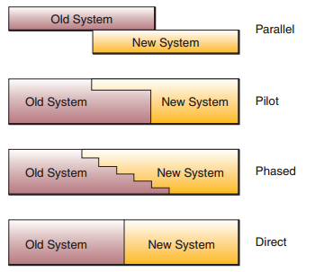

Postimplementation Activities
When all is said and done, the single most costly activity occurs after the system implementation is complete: the postimplementation maintenance phase . The primary objectives associated with systems maintenance are to correct errors or faults in the system, provide changes to effect performance improvement, or adapt the system to changes in the business environment.

Systems Maintenance
Four basic categories of maintenance can be identified:
- Corrective (fixing errors)
- Adaptive (adding new functionality)
- Perfective (improving performance)
- Preventive (reducing chances of future system failure)

Postimplementation Review
Ensuring that newly implemented systems meet the business objectives established for them.
Errors in the development or use of a system must be corrected by the maintenance process.

Chapter 13 - Security and Ethical Challenges

Security, Ethical, and Societal Challenges of IT

The Nexus of IT, Ethics, Security, and Safety
It is important to understand that information technology has had beneficial results, as well as detrimental effects, on society and people in each of these areas.

ETHICAL RESPONSIBILITY OF BUSINESS PROFESSIONALS

As a business professional, you have a responsibility to promote ethical uses of information technology in the workplace.
That includes properly performing your role as a vital human resource in the business systems you help develop and use in your organization.
As a business professional, it is your responsibility to make decisions about business activities and the use of information technologies that may have an ethical dimension that must be considered.

Business Ethics
Business ethics is concerned with the numerous ethical questions that managers must confront as part of their daily business decision making.

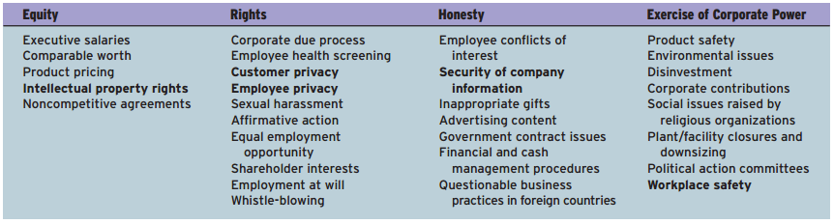

Ethical Use of Technology
One common example of technology ethics involves some of the health risks of using computer workstations for extended periods in high-volume data entry job positions.

Ethical Guidelines
Many companies follow guidelines with detailed policies for ethical computer and Internet usage by their employees.
For example, most policies specify that company computer workstations and networks are company resources that must be used only for work-related uses, whether using internal networks or the Internet.

COMPUTER CRIME

Computer crime, a pervasive threat to society, is caused by the criminal or irresponsible actions of individuals who are taking advantage of the widespread use and vulnerability of computers and the Internet and other networks.

Computer crime is defined by the Association of Information Technology Professionals (AITP) as including:
- the unauthorized use, access, modification, and destruction of hardware, software, data, or network resources
- the unauthorized release of information
- the unauthorized copying of software
- denying an end user access to his or her own hardware, software, data, or network resources
- using or conspiring to use computer or network resources to obtain information or tangible property illegally .

Hacking and Cracking
Hacking is the obsessive use of computers or the unauthorized access and use of networked computer systems.
Hackers can monitor e-mail, Web server access, or file transfers to extract passwords, steal network files, or plant data that will cause a system to welcome intruders.
A hacker may also use remote services that allow one computer on a network to execute programs on another computer to gain privileged access within a network.

A cracker (also called a black hat or darkside hacker) is a malicious or criminal hacker.
Usually a cracker is a person who maintains knowledge of the vulnerabilities he or she finds and exploits them for private advantage, not revealing them to either the general public or the manufacturer for correction.
Crackers may seek to expand holes in systems; any attempts made to patch software are generally to
prevent others from also compromising a system over which they have already obtained secure control. In the most extreme cases, a cracker may work to cause damage maliciously or make threats to do so for blackmail purposes.

Cyber-Theft
Many computer crimes involve the theft of money. In the majority of cases, they are inside jobs that involve unauthorized network entry and fraudulent alteration of computer databases to cover the tracks of the employees involved.
Companies don’t usually reveal that they have been targets or victims of computer crime. They fear scaring customers and provoking complaints by shareholders.

Cyberterrorism
Cyberterrorism is the leveraging of an organization’s or government’s computers and information, particularly via the Internet, to cause physical, real-world harm or severe disruption of infrastructure.
Cyberterrorism can have a serious large-scale influence on significant numbers of people. It can significantly weaken a country’s economy, thereby denying it access to vital resources and making it more vulnerable to military attack.
Cyberterror can also affect Internet-based businesses.

Cyber-Warfare
It is defined as “ actions by a nation-state to penetrate another nation’s computers or networks for the purposes of causing damage or disruption.”

Unauthorized Use at Work
The unauthorized use of computer systems and networks can be called time and resource theft. A common example is unauthorized use of company-owned computer networks by employees. This use may range from doing private consulting or personal finances to playing video games to unauthorized use of the Internet on company networks.

Software Piracy
unauthorized copying of software, or software piracy, is a major form of software theft. Software piracy by company employees is widespread, which has resulted in lawsuits by the Software Publishers Association, an industry association of software developers, against major corporations that allowed unauthorized copying of their programs.

Theft of Intellectual Property
Other intellectual property theft occurs in the form of infringements of copyrighted material, such as music, videos, images, articles, books, and other written works, which most courts have deemed illegal.

Computer Viruses and Worms
A virus is a program code that cannot work without being inserted into another program.
A worm is a distinct program that can run unaided.
In either case, these programs copy annoying or destructive routines into the networked computer systems of anyone who accesses computers infected with the virus or who uses copies of magnetic disks taken from infected computers.

Adware and Spyware
Adware is software that allows Internet advertisers to display advertisements as banners and pop-up ads without the consent of the computer user.
Spyware is a special class of adware that can also collect information about the user of its host computer and send it over the Internet to its owner without their knowledge or explicit permission.
So, not all adware programs are spyware.

PRIVACY ISSUES

The power of information technology to store and retrieve information can have a negative effect on the right to privacy of every individual.
For example, confidential e-mail messages by employees are monitored by many companies. Personal information is being collected about individuals every time someone visits a site on the World Wide Web.
An opt-in system automatically protects consumers who do not specifically allow data to be compiled about them. Most business interests back opt-out, arguing it doesn’t disrupt the flow of e-commerce.
In the United States, opt-out is the default position, whereas in Europe, consumers must opt-in or their information cannot be used.
Additional privacy issues under debate include:
- Accessing private e-mail conversations and computer records and collecting and sharing information about individuals gained from their visits to Internet Web sites and newsgroups (violation of privacy).
- Always knowing where a person is, especially as mobile and paging services become more closely associated with people rather than places (computer monitoring).
- Using customer information gained from many sources to market additional business services (computer matching).
- Collecting telephone numbers, e-mail addresses, credit card numbers, and other personal information to build individual customer profiles (unauthorized personal files).

Privacy on the Internet
The Internet is notorious for giving its users a feeling of anonymity when in reality they are highly visible and open to violations of their privacy.
Information about Internet users is captured legitimately and automatically each time you visit a Web site or newsgroup and is recorded as a “cookie file” on your hard disk. Then the Web site owners or online auditing services like DoubleClick may sell the information from cookie files and other records of your Internet use to third parties.

Computer Matching
Computer profiling and mistakes in the computer matching of personal data are other controversial threats to privacy.
Individuals have been mistakenly arrested and jailed and people have been denied credit because their physical profiles or personal data have been used by profiling software to match them incorrectly or improperly with the wrong individuals.

Privacy Laws
Many countries strictly regulate the collection and use of personal data by business corporations and government agencies. Many government privacy laws attempt to enforce the privacy of computer-based files and communications.
Because the Internet includes federal-related computer systems, privacy attorneys argue that the laws also require notifying employees if a company intends to monitor Internet usage.

- HIPAA. The Health Insurance Portability and Accountability Act. It is a broad piece of legislation intended to address a wide variety of issues related to individual health insurance. Two important sections of HIPAA include the privacy rules and the security rules. These rules lay out three types of security safeguards required for compliance: administrative, physical, and technical.
- SARBANES-OXLEY is a U.S. federal law enacted on July 30, 2002, as a reaction to a number of major corporate and accounting scandals.

Computer Libel and Censorship
The opposite side of the privacy debate is the right of people to know about matters others may want to keep private (freedom of information), the right of people to express their opinions about such matters (freedom of speech), and the right of people to publish those opinions (freedom of the press).
- Spamming is the indiscriminate sending of unsolicited e-mail messages ( spam ) to many Internet users.
- Flaming is the practice of sending extremely critical, derogatory, and often vulgar e-mail messages ( flame mail) or newsgroup postings to other users on the Internet or online services.

THE CURRENT STATE OF CYBER LAW

Cyber law is the term used to describe laws intended to regulate activities over the Internet or via the use of electronic data communications. The intersection of technology and the law is often controversial.
Cyber law is a new phenomenon, having emerged after the onset of the Internet.

OTHER CHALLENGES

Employment Challenges
There can be no doubt that the use of information technologies has created new jobs and increased productivity while also causing a significant reduction in some types of job opportunities.
However, there can be no doubt that Internet technologies have created a host of new job opportunities.

Computer Monitoring
Computers are being used to monitor the productivity and behavior of millions of employees while they work.
Computer monitoring has been criticized as unethical because it monitors individuals, not just work, and is done continually, which violates workers’ privacy and personal freedom.

Challenges in Working Conditions
Information technology has eliminated monotonous or obnoxious tasks in the office and the factory that formerly had to be performed by people.
Information technology can be said to upgrade the quality of work because it can upgrade the quality of working conditions and the content of work activities.
Some jobs in information technology—data entry, for example—are quite repetitive and routine.
Many automated operations are criticized for relegating people to a “do-nothing” standby role, where workers spend most of their time waiting for infrequent opportunities to push some buttons.

Challenges of Individuality
Computer-based systems are criticized as impersonal systems that dehumanize and depersonalize activities that have been computerized because they eliminate the human relationships present in noncomputer systems.
Another aspect of the loss of individuality is the regimentation that seems required by some computer-based systems.

HEALTH ISSUES

The use of information technology in the workplace raises a variety of health issues.
Heavy use of computers is reportedly causing health problems like job stress, damaged arm and neck muscles, eyestrain, radiation exposure, and even death by computer-caused accidents.

Ergonomics
Solutions to some of these health problems are based on the science of ergonomics ,
sometimes called human factors engineering.
The goal of ergonomics is to design healthy work environments that are safe, comfortable, and pleasant for people to work in, thus increasing employee morale and productivity.
Other health issues may require ergonomic solutions emphasizing job design rather than workplace design.

SOCIETAL SOLUTIONS

We can use information technologies to solve human and social problems through societal solutions such as medical diagnosis, computer-assisted instruction, governmental program planning, environmental quality control, and law enforcement.
Information technologies can be used for crime control through various law-enforcement applications.

Security Management of IT

TOOLS OF SECURITY MANAGEMENT

The goal of security management is the accuracy, integrity, and safety of all information system processes and resources.
Security managers must acquire and integrate a variety of security tools and methods to protect a company’s information system resources.
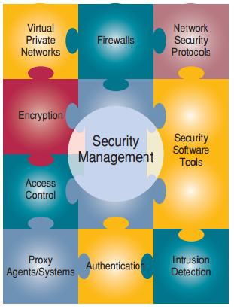

INTER-NETWORKED SECURITY DEFENSES

Encryption
Passwords, messages, files, and other data can be transmitted in scrambled form and unscrambled by computer systems for authorized users only. Encryption involves using special mathematical algorithms, or keys, to transform digital data into a scrambled code before they are transmitted, and then to decode the data when they are received.
The most widely used encryption method uses a pair of public and private keys unique to each individual.
Encryption programs are sold as separate products or built into other software used for the encryption process.

Firewalls
A network firewall can be a communications processor, typically a router, or a dedicated server, along with firewall software.
A firewall serves as a gatekeeper system that protects a company’s intranets and other computer networks from intrusion by providing a filter and safe transfer point for access to and from the Internet and other networks.
Firewalls can deter, but not completely prevent, unauthorized access (hacking) into computer networks.

Denial of Service Attacks
Denial of service assaults via the Internet depend on three layers of networked computer systems:
- the victim’s Web site,
- the victim’s Internet service provider (ISP)
- the sites of “zombie” or slave computers that the cyber-criminals commandeered.

The basic steps companies can take to protect their Web sites from denial of service and other hacking attacks:
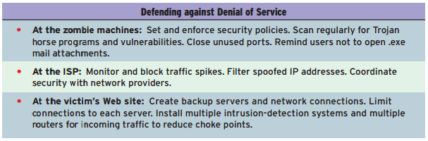

E-mail Monitoring
E-mail is the battleground for attempts by companies to enforce policies against illegal, personal, or damaging messages by employees versus the demands of some employees and others who see such policies as violations of privacy rights.

VIRAL DEFENSES

Many companies are building defenses against the spread of viruses by centralizing the distribution and updating of antivirus software as a responsibility of their IS departments. Other companies are outsourcing the virus protection responsibility to their Internet service providers or telecommunications or security management companies.

OTHER SECURITY MEASURES

Security Codes
Typically, a multilevel password system is used for security management. First, an end user logs on to the computer system by entering his or her unique identification code, or user ID. Second, the end user is asked to enter a password to gain access into the system.
Backup Files
Backup files are duplicate files of data or programs. Files can also be protected by file retention measures that involve storing copies of files from previous periods.
Such files may be stored off-premises, that is, in a location away from a company’s data center, sometimes in special storage vaults in remote locations.

Security Monitors
System security monitors are programs that monitor the use of computer systems and networks and protect them from unauthorized use, fraud, and destruction.
Security monitors also control the use of the hardware, software, and data resources of a computer system.

Biometric Security
These are security measures provided by computer devices that measure physical traits that make
each individual unique, such as voice verification, fingerprints, hand geometry, signature dynamics, keystroke analysis, retina scanning, face recognition, and genetic pattern analysis.

Computer Failure Controls
A variety of controls can prevent such computer failure or minimize its effects.
Programs of preventive maintenance of hardware and management of software updates are commonplace.
A backup computer system capability can be arranged with disaster recovery organizations.

Fault-Tolerant Systems
Many firms also use fault-tolerant computer systems that have redundant processors, peripherals, and software that provide a fail-over capability to back up components in the event of system failure.
Many fault-tolerant computer systems, however, offer a fail-soft capability so that the computer system can continue to operate at a reduced but acceptable level in the event of a major system failure.
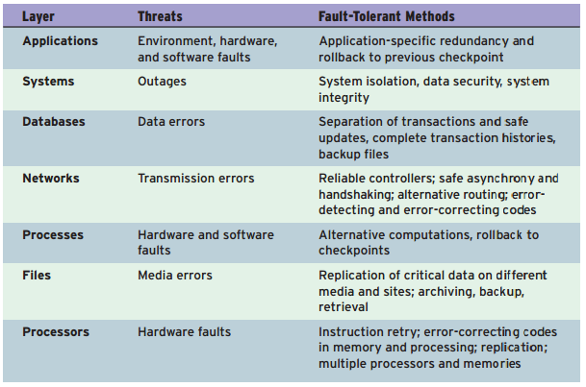
Disaster Recovery
It specifies which employees will participate in disaster recovery and what their duties will be; what hardware, software, and facilities will be used; and the priority of applications that will be processed.

SYSTEM CONTROLS AND AUDITS

Information System Controls
Information system controls are methods and devices that attempt to ensure the accuracy, validity, and propriety of information system activities.
IS controls are designed to monitor and maintain the quality and security of the input, processing, output, and storage activities of any information system.

Auditing IT Security
IT security management should be periodically examined, or audited, by a company’s internal auditing staff or external auditors from professional accounting firms.
Such audits review and evaluate whether proper and adequate security measures and management policies have been developed and implemented.
Another important objective of business system audits is testing the integrity of an application’s audit trail. An audit trail can be defined as the presence of documentation that allows a transaction to be traced through all stages of its information processing.

Chapter 14 - Enterprise and Global Management of IT

Managing IT for the Enterprise

MANAGING INFORMATION TECHNOLOGY
One popular approach to managing information technology in a large company:
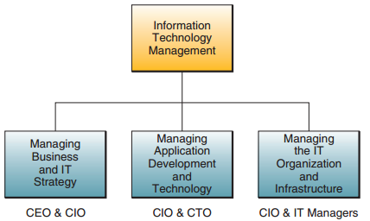

This managerial approach has three major components:

- Managing the Joint Development and Implementation of Business/IT Strategies.
  - Led by CEO and CIO.
  - Proposals are developed by business and IT managers and professionals.
  - This business/IT planning process aligns IT with strategic business goals.
- Managing the Development and Implementation of New Business/IT Applications and Technologies.
  - CIO and CTO managing the processes for information systems development and implementation.
  - Responsibility for research into the strategic business uses of new information technologies.
- Managing the IT Organization and the IT Infrastructure.
  - The CIO and IT managers share responsibility for managing the work of IT professionals, who are typically organized into a variety of project teams and other organizational subunits.
  - They are responsible for managing the IT infrastructure of hardware, software, databases, telecommunications networks, and other IT resources.

BUSINESS/IT PLANNING

Business/IT planning process focuses on discovering innovative approaches to satisfying a company’s customer value and business value goals. This planning process leads to the development of strategies and business models for new business applications, processes, products, and services.
Then a company can develop IT strategies and an IT architecture that supports building and implementing its newly planned business applications.

The business/IT planning process has three major components:
- Strategy Development. Developing business strategies that support a company’s business vision.
- Strategy Development. Developing business strategies that support a company’s business vision.
- Technology Architecture. Making strategic IT choices that reflect an information technology architecture designed to support a company’s business/IT initiatives.

Information Technology Architecture
It is a conceptual design, or blueprint, that includes the following major components:
- Technology Platform:
The Internet, intranets, extranets, and other networks,
computer systems, system software, and integrated enterprise application software
provide a computing and communications infrastructure, or platform.
- Data resources:
Many types of operational and specialized databases, including data warehouses and Internet/intranet databases.
- Applications Architecture.
Business applications of information technology are designed as an integrated architecture or portfolio of enterprise systems that support strategic business initiatives, as well as cross-functional business processes.
- IT Organization.
The organizational structure of the IS function within a company and the distribution of IS specialists are designed to meet the changing strategies of a business.

MANAGING THE IT FUNCTION

The Internet boom inspired businesses to connect all those networks; companies put on their intranets essential applications without which their businesses could not function; and it became apparent that maintaining PCs on a network is very, very expensive. Such changes create an urgent need for centralization.

ORGANIZING IT

In the early years of computing, the development of large mainframe computers caused a centralization of computer hardware and software and databases. The development of minicomputers and microcomputers accelerated a downsizing trend, which prompted a move back toward decentralization by many business firms.

Lately, the trend is to establish more centralized control over the management of the IT resources of a company while still serving the strategic needs of its business units, especially their e-business and e-commerce initiatives.
This trend has resulted in the development of hybrid structures with both centralized and decentralized
components.

Managing Application Development
Application development management involves managing activities such as systems analysis and design, prototyping, applications programming, project management, quality assurance, and system maintenance for all major business/IT development projects.

Managing IS Operations
IS operations management is concerned with the use of hardware, software, network, and personnel resources in the corporate or business unit data centers (computer centers) of an organization. This includes computer system operations, network management, production control, and production support.

IT Staff Planning
Many firms consider IT staff planning ,or recruiting, training, and retaining qualified IS personnel, as one of their greatest challenges. One job of IS managers is to recruit qualified personnel and develop, organize, and direct the capabilities of existing personnel.

The CIO and Other IT Executives
The CIO oversees all use of information technology in many companies and brings it into alignment with strategic business goals. The CIO does not direct day-to-day information services activities; instead, CIOs concentrate on business/IT planning and strategy.
They also work with the CEO and other top executives to develop strategic uses of information technology in e-business and e-commerce that help make the firm more competitive in the marketplace.

Technology Management
Changes in information technology have come swiftly and dramatically and are expected to continue into the future.
In many companies, technology management is the primary responsibility of a chief technology officer (CTO), who is in charge of all information technology planning and deployment.

Managing User Services
Many companies have created user services, or client services, functions to support and manage end-user and workgroup computing.
For example, some firms create an information center group staffed with user liaison specialists or Web-enabled intranet help desks.

OUTSOURCING AND OFFSHORING IT AND IS

Outsourcing
Outsourcing is the purchase of goods or services that were previously provided internally from third-party partners.
A commonly outsourced IS function is software application development. This process includes contracting (or subcontracting) with an external organization for the development of complete or partial software products/projects, the purchase of packaged or customized package software products, or activities and/or resources that aid in the software development life cycle.

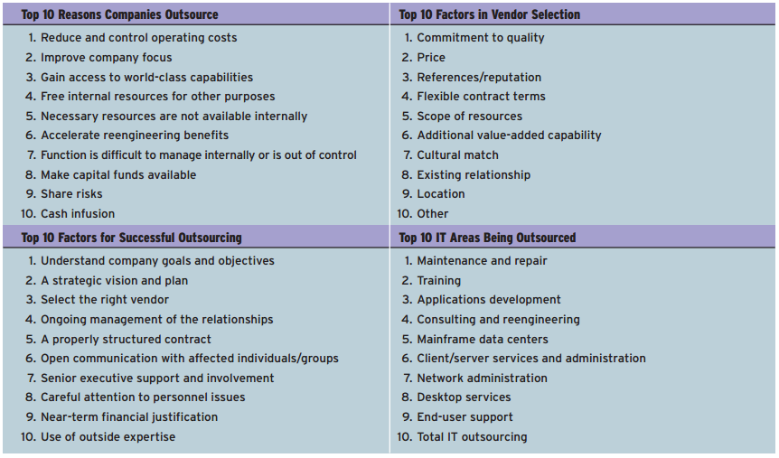

Five main reasons behind a decision to outsource:
- Save Money—Achieve Greater Return on Investment (ROI)
Companies that take a well-managed approach to outsourcing can gain cost savings of upwards of 40–80 percent.
- Focus on Core Competencies
Outsourced professionals allow an organization and its employees to focus on the business they are in rather than a business in which they are not.
- Achieve Flexible Staffing Levels
Strategic use of an outsourcing approach to IS/IT functions can result in business growth without increasing overhead.
- Gain Access to Global Resources
Using global expertise allows an organization to gain the advantage of skilled labor, regardless of location, and significantly increase the quality of its deliverables.
- Decrease Time to Market
Outsourcing allows smaller organizations to compete effectively against bigger firms.

Offshoring
Offshoring can be defined as a relocation of an organization’s business processes (including production/manufacturing) to a lower-cost location, usually overseas.

Trends in Outsourcing and Offshoring
Originally outsourcing and offshoring were used to lower costs, but now are used to find highly talented IS/IT personnel

FAILURES IN IT MANAGEMENT
In many organizations, information technology is not being used effectively and efficiently, and there have been failures in IT management.

Management Involvement
Extensive and meaningful managerial and end-user involvement is the key ingredient of high-quality information systems performance.
Many organizations have policies that require managers to be involved in IT decisions that affect their business units.

IT Governance
ITG is a subset discipline of corporate governance focused on the information technologies (IT), information systems (IS), their performance, use, and associated risks.
A characteristic theme of IT governance discussions is that the IT capability can no longer be thought of as a mystical black box, the contents of which are known only to the IT personnel.

Managing Global IT

GLOBAL IT MANAGEMENT

All global IT activities must be adjusted to take into account the cultural, political, and geoeconomic challenges that exist in the international business community.

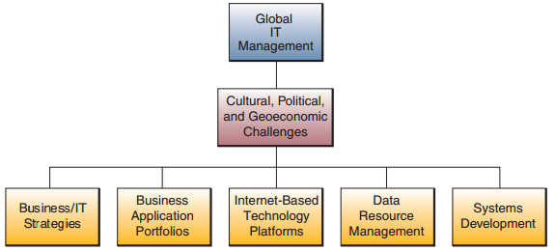

CULTURAL, POLITICAL, AND GEOECONOMIC CHALLENGES.

There are too many cultural, political, and geoeconomic (geographic and economic) realities that must be confronted for a business to succeed in global markets.
- Political – laws are different in each country
For example, a major political challenge is that many countries have rules regulating or prohibiting transfer of data across their national boundaries ( transborder data flows ),
especially personal information such as personnel records.
- Geoeconomic challenges in global business and IT refer to the effects of geography on the economic realities of international business activities.
For example, it is still difficult to communicate in real time across the world’s 24 time zones. It is still difficult to get good-quality telephone and telecommunications service in many countries.
- Cultural challenges facing global business and IT managers include differences in languages, cultural interests, religions, customs, social attitudes, and political philosophies.
For example, should the most experienced person lead, or should leadership be shared?

GLOBAL BUSINESS/IT STRATEGIES

Businesses are moving away from international strategies in which foreign subsidiaries are autonomous but depend on headquarters for new processes, products, and ideas; or from global strategies, in which a company’s worldwide operations are closely managed by corporate headquarters. Instead, companies are moving toward a transnational strategy ,where the company’s business depends heavily on its information systems and Internet technologies to help it integrate its global business activities.
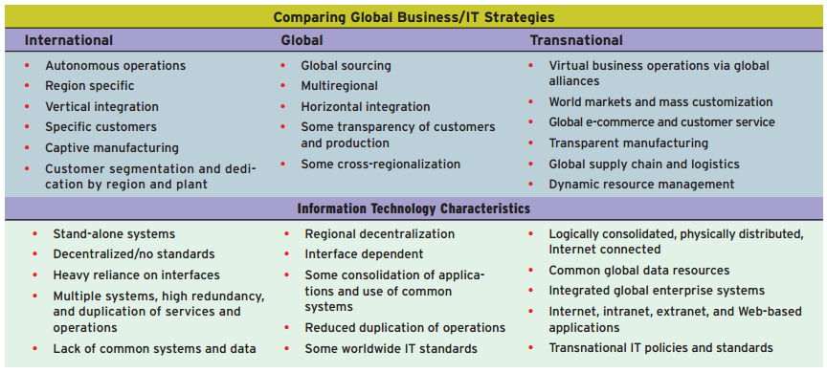

GLOBAL BUSINESS/IT APPLICATIONS

The applications of information technology developed by global companies depend on their global business/IT strategies and their expertise and experience in IT. Their IT applications, however, also depend on a variety of global business drivers, that is, business requirements caused by the nature of the industry and its competitive or environmental forces.

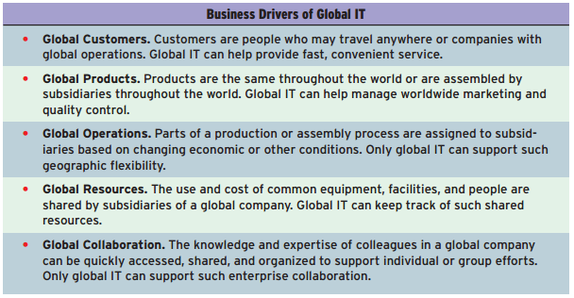
GLOBAL IT PLATFORMS

It is, managing the hardware, software, data resources, telecommunications networks, and computing facilities
that support global business operations.
The management of a global IT platform not only is technically complex but also has major political and cultural implications.

Managing international data communications networks, including Internet, intranet, extranet, and other networks, is a key global IT challenge. Establishing computing facilities internationally is another global challenge. Companies with global business operations usually establish or contract with systems integrators for additional data centers in their subsidiaries in other countries.

The Internet as a Global IT Platform
The Internet and the World Wide Web have now become vital components in international business and commerce.
By connecting their businesses to this online global infrastructure, companies can expand their markets, reduce communications and distribution costs, and improve their profit margins without massive cost outlays for new telecommunications facilities.
The Internet, along with its related intranet and extranet technologies, provides a low-cost interactive channel for communications and data exchange with employees, customers, suppliers, distributors, manufacturers, product developers, financial backers, information providers, and so on.

GLOBAL DATA ACCESS ISSUES

A major example is the issue of transborder data flows (TDF), in which business data flow across international borders over the telecommunications networks of global information systems.
Many countries, especially those in the European Union (E.U.), may view transborder data flows as a violation of their privacy legislation because, in many cases, data about individuals are being moved out of the country without stringent privacy safeguards.

Internet Access Issues
Figure 14.19 outlines the restrictions to public Internet access by the governments of the countries deemed most restrictive by the Paris-based Reporters Without Borders (RSF).
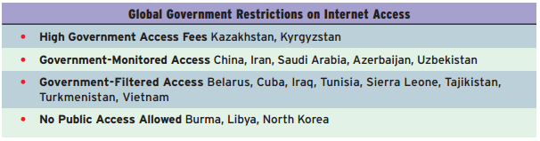

GLOBAL SYSTEMS DEVELOPMENT

Imagine the challenges of developing a domestic system, then multiply that by the number of countries/cultures where that
systems will be used. That’s the challenge of managing global systems development.
Other systems development issues arise from disturbances caused by systems implementation and maintenance activities.
Other important global systems development issues are concerned with global standardization of data definitions.
For example, a sale may be called an “order booked” in the United Kingdom, an “order scheduled” in Germany, and an “order produced” in France.

Systems Development Strategies
- Transform an application used in the home office into a global application.
- Set up a multinational development team with key people from several subsidiaries to ensure that the system design meets the needs of local sites, as well as corporate headquarters.
- Parallel development, in which parts of the system are assigned to different subsidiaries and the home office to develop at the same time, based on the expertise and experience at each site.
- Centers of excellence. In this approach, an entire system may be assigned for development to a particular subsidiary based on its expertise in the business or technical dimensions needed for successful development.
- outsource the development work to global or offshore development companies that have the skills and experience required to develop global business/IT applications.
All of these approaches require development team collaboration and managerial oversight to meet the global needs of a business.

